**EDUTRACKER**

***A Summer Internship Report submitted in partial fulfillment of the***

***requirements for the award of degree of***

**BACHELOR OF TECHNOLOGY**

**In**

**COMPUTER SCIENCE and ENGINEERING**

**ELECTRONICS COMMUNICATION ENGINEERING**

## Submitted by:

* TOGARU SURYA SIVA HARSHINI (21A91A05J4)
* KARRI JAYA MADHURI (21A91A05J8)
* SAI SURYAVATHI (21MH1A0417)
* AMBATI SATYA KALYANI (21MH1A0471)
* B.V.RAGHAVA(21MH1A0474)
* SUNKARA JYOTHI (21A91A04B3)



**Department Of Computer Science and Engineering**

**Electronics Communication Engineering**

**ADITYA ENGINEERING COLLEGE (A)**

**Approved by AICTE, Permanently affiliated to JNTUK & Accredited by NAAC with ‘A’ Grade**

**Recognized by UGC under the sections 2(f) and 12(B) of the UGC act 1956**

**Aditya Nagar, ADB Road –Surampalem 533437, E.G. Dist., A.P.,**

**2023-2024**

ADITYA ENGINEEERING COLLEGE

**TEAM NO**:24

**PROJECT NAME**: EDUTRACKER

**PROJECT MEMBERS**:

* TOGARU SURYA SIVA HARSHINI (21A91A05J4)
* KARRI JAYA MADHURI (21A91A05J8)
* SAI SURYAVATHI (21MH1A0417)
* AMBATI SATYA KALYANI (21MH1A0471)
* B.V.RAGHAVA(21MH1A0474)
* SUNKARA JYOTHI (21A91A04B3)

**CONTENTS**

**Title Page No**

Problem statement 4

Project Description 5-6

Project Implementation 7-11

Conclusion 12

EDUTRACKER

**PROBLEM STATEMENT:**

In educational institutions, managing administrative tasks, facilitating effective communication, and ensuring comprehensive performance tracking are pivotal but often challenging aspects. The existing methods for managing these tasks manually or through disparate systems can lead to inefficiencies, errors, and communication gaps. Therefore, there is a critical need for a unified College Management System that leverages modern web technologies to streamline administrative operations, enhance communication between stakeholders (students, faculty, and administrators), and provide insightful analytics for performance assessment.

**Key Challenges:**

**Administrative Inefficiencies:** Managing student records, faculty information, class schedules, and academic resources manually leads to inefficiencies and errors.

**Communication Gaps:** Lack of a centralized platform for communication between students, faculty, and administrators hinders effective information sharing and collaboration.

**Attendance Tracking Complexity:** Manual attendance marking and tracking are time-consuming and prone to inaccuracies, impacting data reliability and student engagement.

**Performance Assessment Oversight:** Difficulty in maintaining comprehensive student performance records and providing timely feedback to enhance learning outcomes.

**Data Fragmentation:** Information stored in disparate systems or formats makes it challenging to consolidate and analyse data for informed decision-making.

**PROJECT DESCRIPTION:**

**PROJECT TITLE: EDUTRACKER**

**INTRODUCTION:** "Edu Tracker" is a comprehensive College Management System designed to streamline administrative tasks, enhance communication channels, and facilitate efficient academic management within educational institutions. Built using the MERN (MongoDB, Express.js, React.js, Node.js) stack, this web-based application caters to the needs of students, faculty, and administrators by providing a unified platform for managing various aspects of college life.

**FEATURES:**

1. **USER ROLES AND PERMISSIONS:**
   * **Admin:** Manages user accounts, creates classes, assigns faculty, and oversees system configurations.
   * **Faculty:** Takes attendance, assesses student performance, and communicates with students.
   * **Student:** Views attendance records, academic performance, and communicates with faculty.
2. **ADMIN DASHBOARD:**
   * Centralized interface for administrators to manage all system functionalities.
   * Add or remove users, define user roles, and configure system settings.
   * Create and manage classes, assign faculty members, and allocate resources.
3. **ATTENDANCE TRACKING:**
   * Faculty members can take attendance for their classes digitally.
   * Mark students as present, absent, or late, with automated notifications to students and administrators.
   * Generate detailed attendance reports for individual students and classes.
4. **PERFORMANCE ASSESSMENT:**
   * Faculty can assess students' academic performance by assigning grades, providing feedback, and maintaining grading records.
   * Students can view their grades, track their academic progress over time, and receive feedback from faculty.
5. **DATA VISUALIZATION:**
   * Interactive charts and tables provide students with visual insights into their academic performance.
   * Helps faculty and administrators analyze attendance trends, class performance metrics, and student progress.
6. **COMMUNICATION TOOLS:**
   * Integrated messaging system enables seamless communication between students, faculty, and administrators.
   * Announcements, reminders, and notifications keep all stakeholders informed about important events and deadlines.

**BENEFITS:**

* **EFFICIENCY:** Automates routine administrative tasks, saving time and reducing errors.
* **TRANSPARENCY:** Provides stakeholders with real-time access to attendance records, grades, and performance metrics.
* **COMMUNICATION:** Facilitates instant communication between students, faculty, and administrators, fostering collaboration and engagement.
* **INSIGHTS:** Data-driven insights help in making informed decisions regarding curriculum planning, resource allocation, and student support.

**PROJECT IMPLEMENTATION:**

Landing page consists of some information of our website and login button for respective logins and sign up button for new member to create an account.

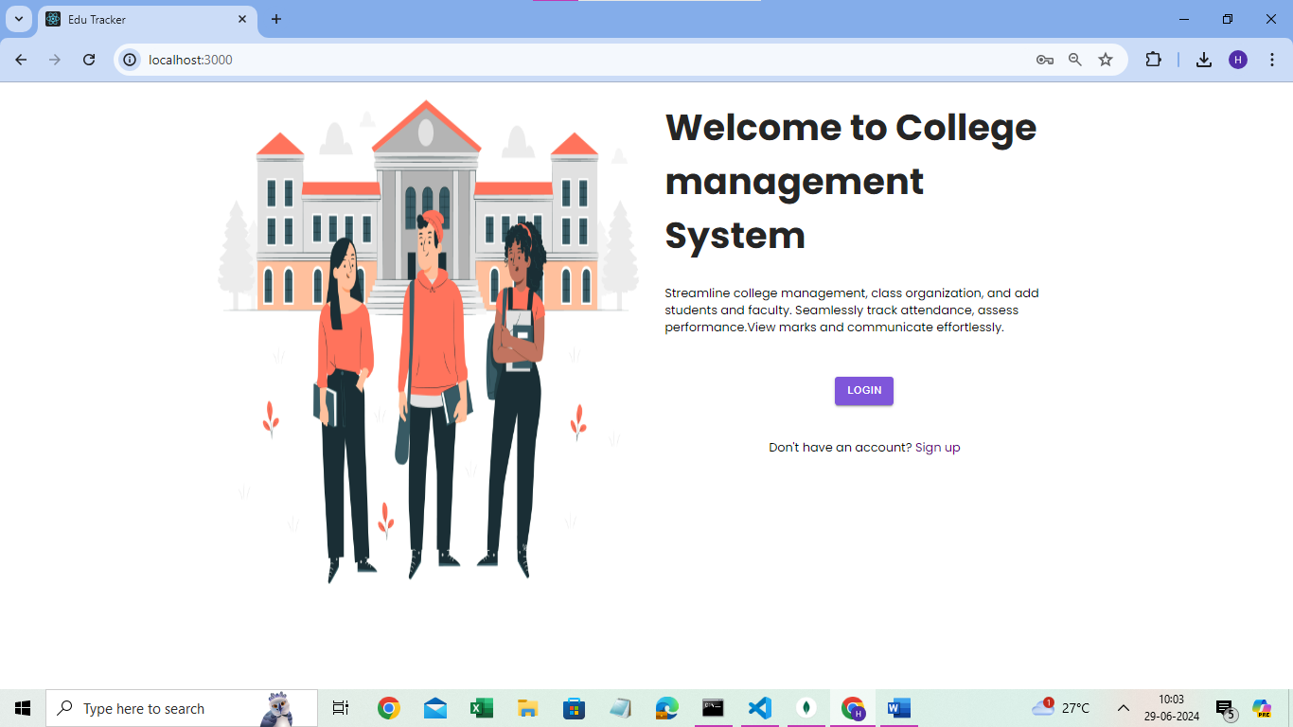

After clicking on login button it redirects a page consisting of individual logins.

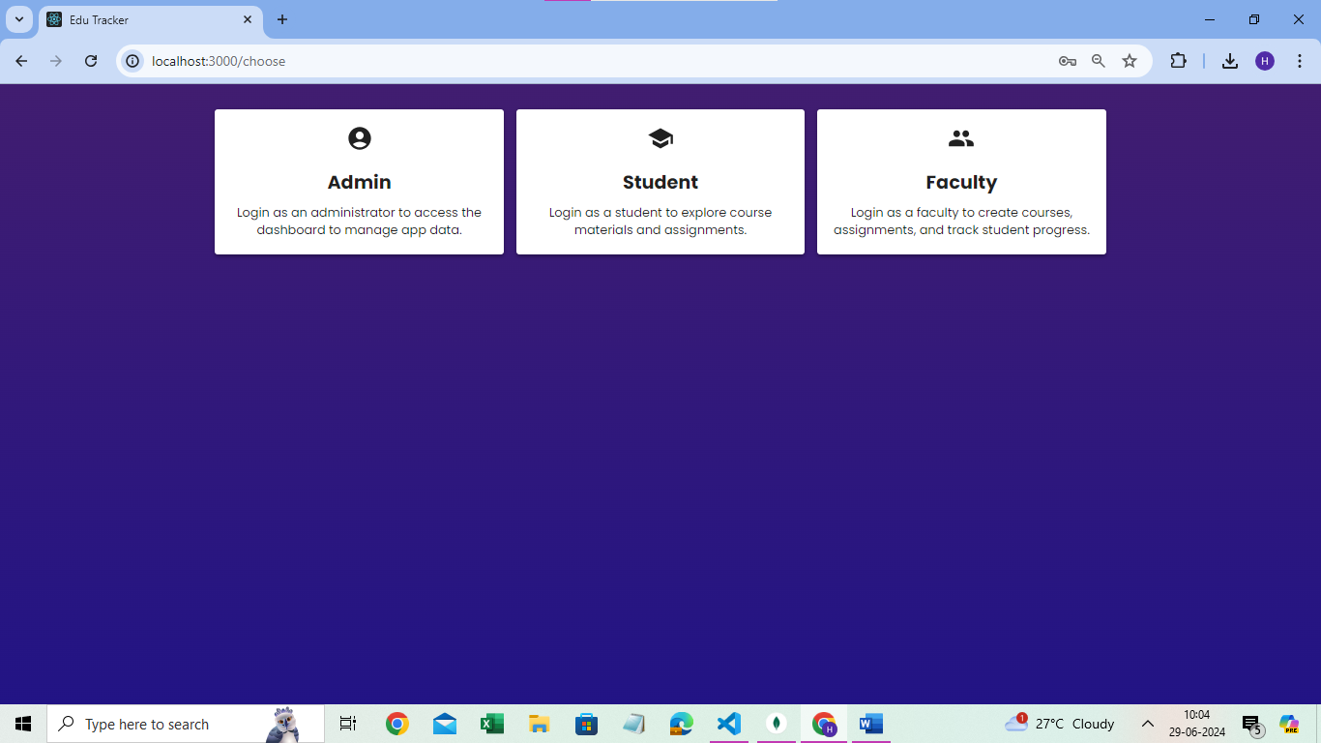

By clicking on the admin card it redirects to an admin login form displayed as below.

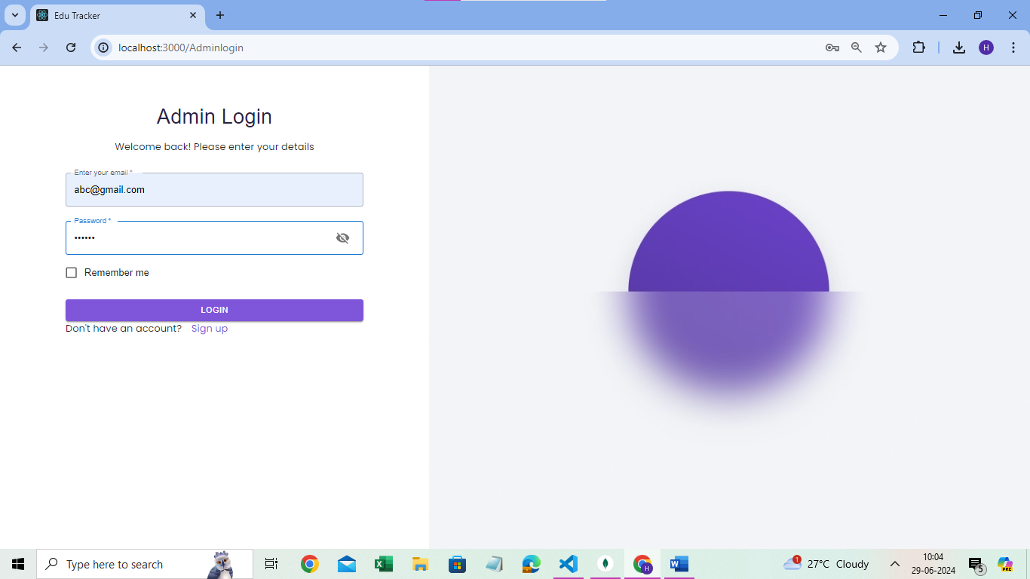

After successful login it displays the home page of admin dashboard, which contains the details of the count of students,clasess,faculty.

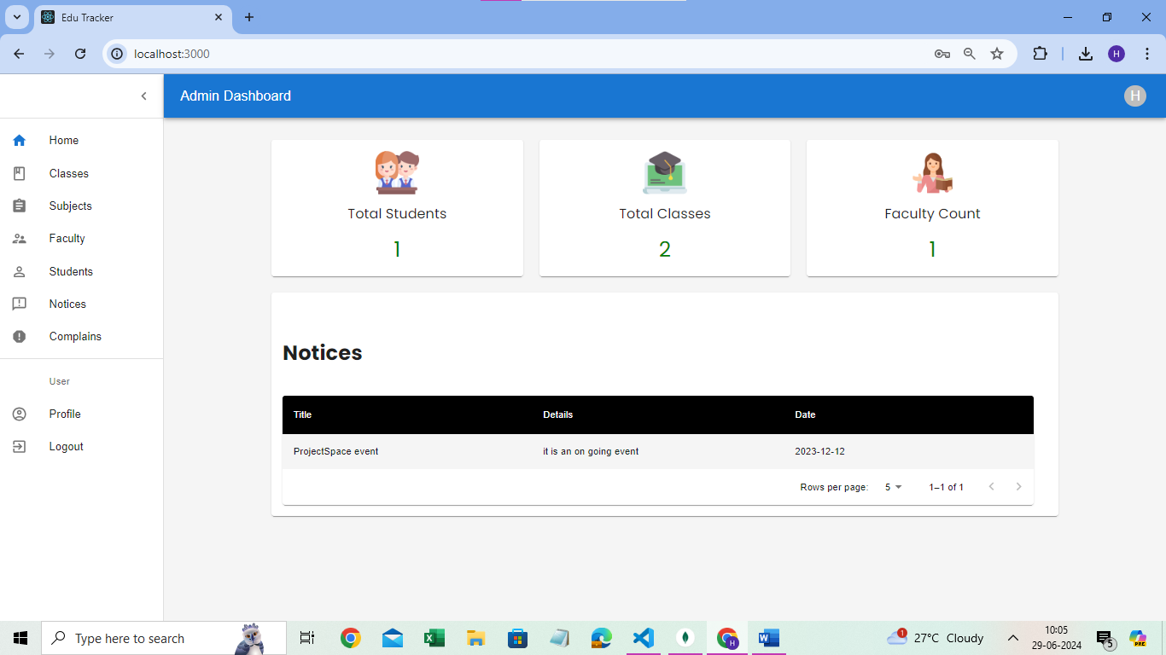

After the successful login of student the home page of student dashboard appears.

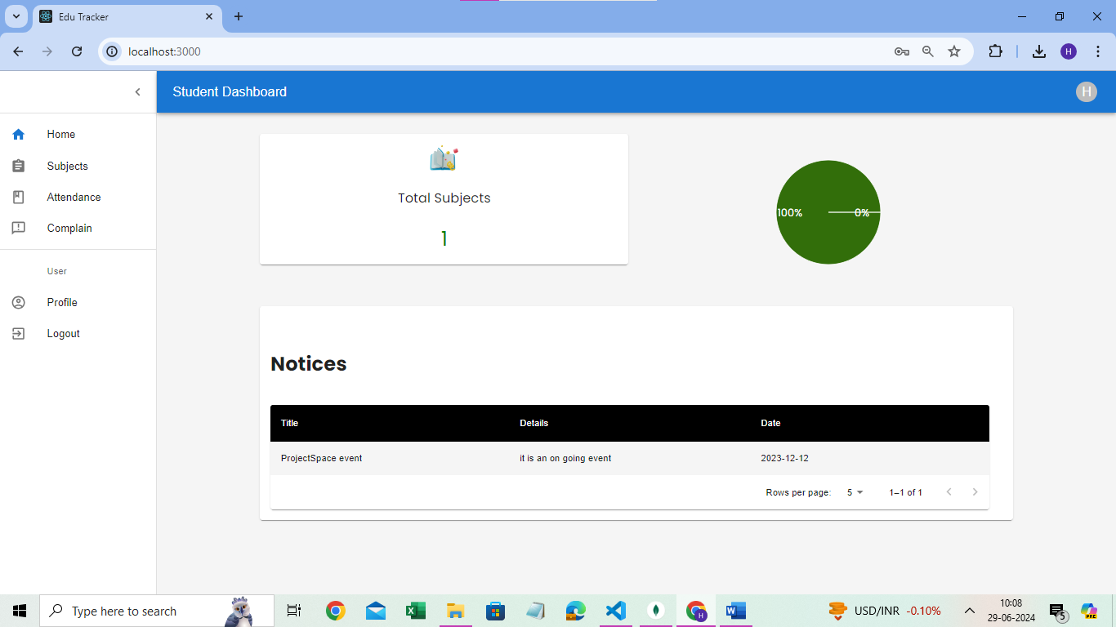

After the successful login of the faculty then the home page of faculty dashboard appears.

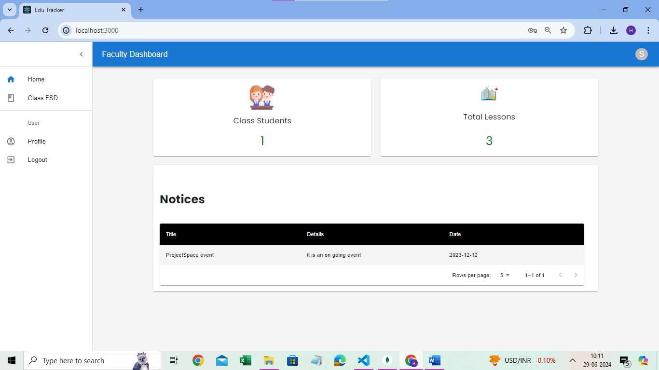

The picture displays about the class details of the class allocated to faculty.

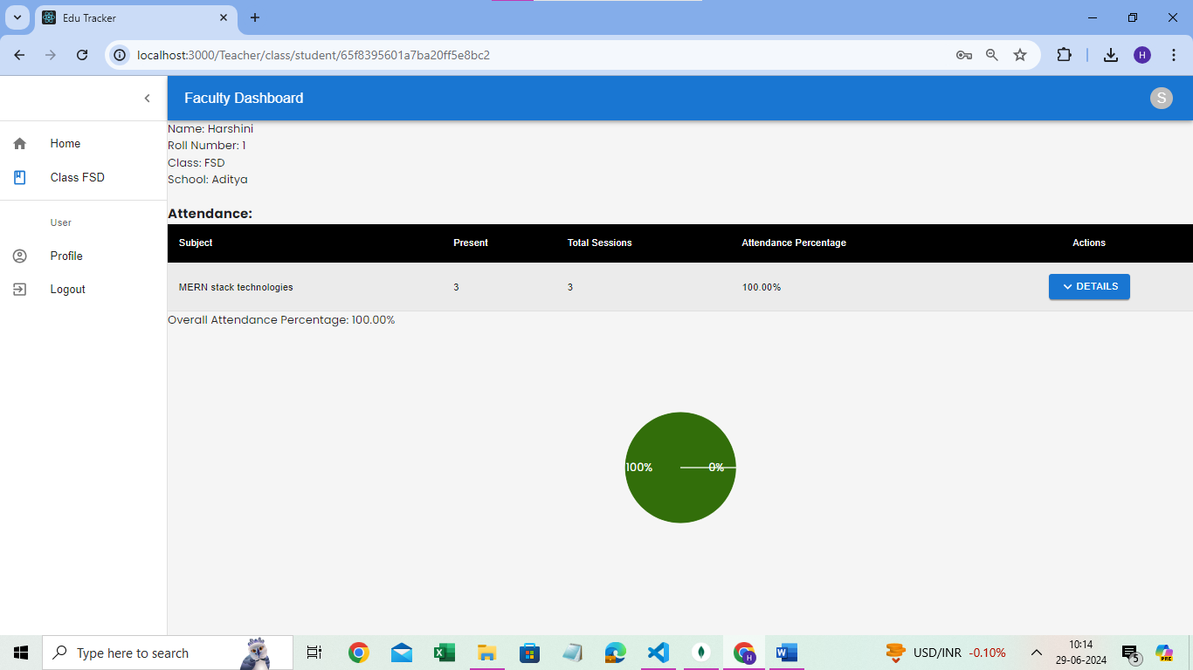

The below image describes about the attendance details of the student in table format in student dashboard.

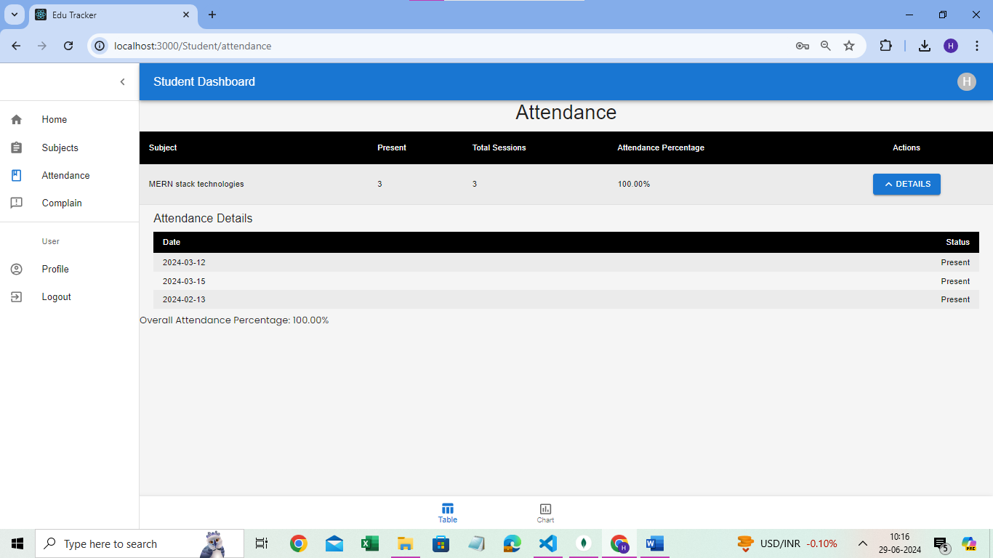

The below image describes about the student attendance in bar graph format for the better understanding.

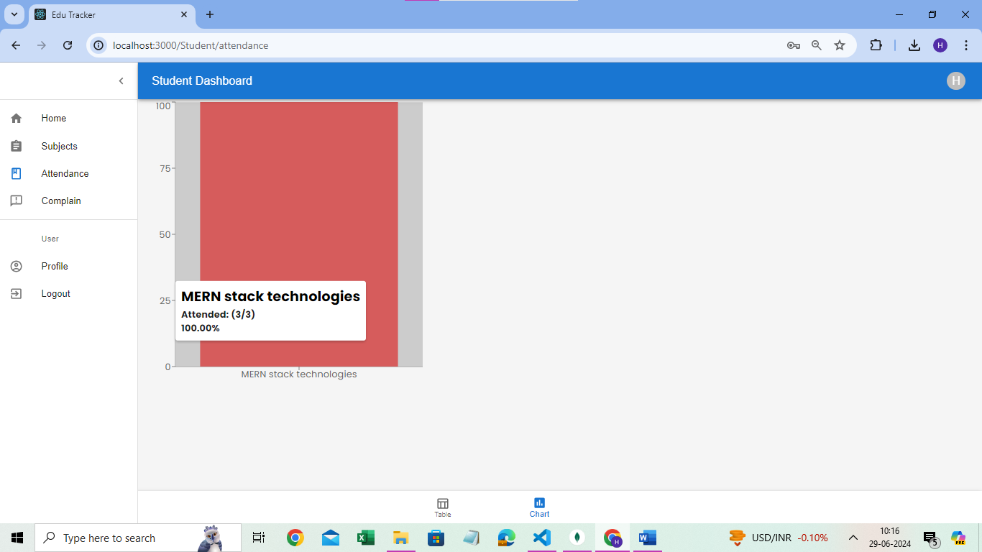

**CONCLUSION**

EduTracker is a comprehensive, web-based application designed to enhance the efficiency and effectiveness of college administration. Built using the robust MERN stack (MongoDB, Express.js, React.js, Node.js), this system integrates essential functionalities into a cohesive platform that benefits administrators, faculty, and students alike.

With its multi-role capabilities, EduTracker ensures that each user group has access to tailored features that suit their specific needs. Administrators benefit from an intuitive dashboard that allows them to manage user accounts, oversee system settings, and facilitate class and subject creation. Faculty members are equipped with tools for tracking attendance and assessing student performance, enabling them to provide timely feedback and generate insightful reports.

Students, on the other hand, have access to dynamic data visualization tools that help them track their academic progress through interactive charts and tables. This not only fosters self-awareness but also motivates continuous improvement. Furthermore, the integrated communication feature bridges the gap between teachers and students, promoting a collaborative learning environment.

Overall, EduTracker exemplifies the power of modern web technologies to transform educational administration. By streamlining operations and enhancing communication, it creates a more organized, responsive, and engaging academic ecosystem.