**Annual Salary vs Department**

From this graph we can identify the department which has the highest annual salary.

**Steps for plotting chart.**

* For plotting the below graph we first need to select the Annual Salary and Department columns.

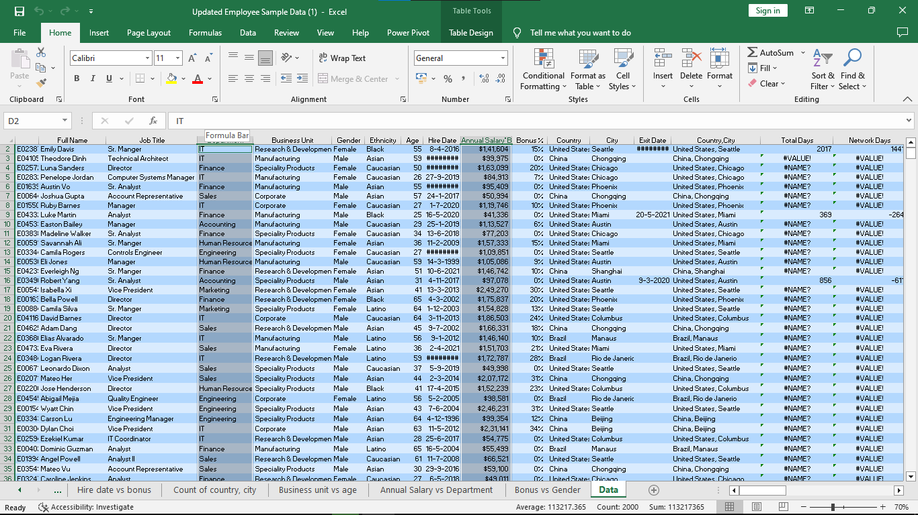

* After selecting column we will select Insert menu from Menu bar and in that We will select recommended charts option to plot graph.

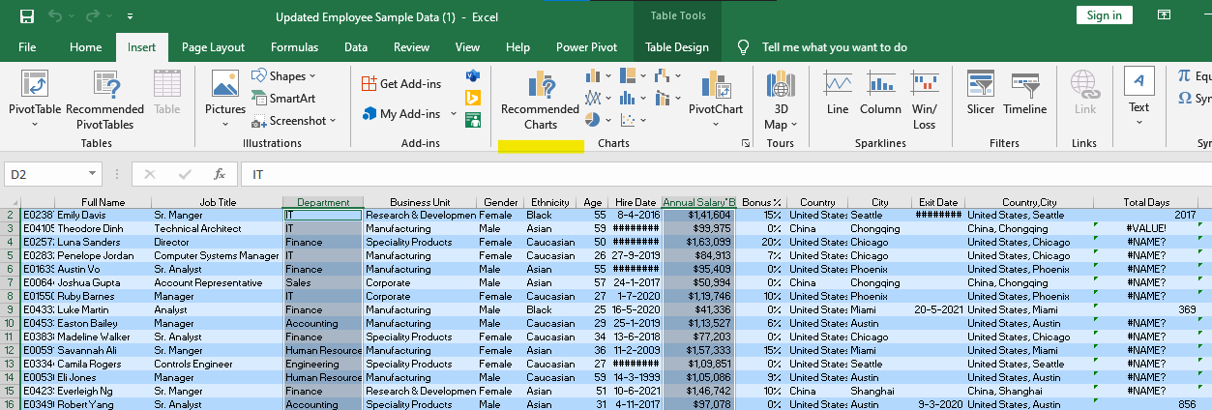

* From the recommendation we will select **clustered column chart to get better understanding of Annual salary as per Department.**

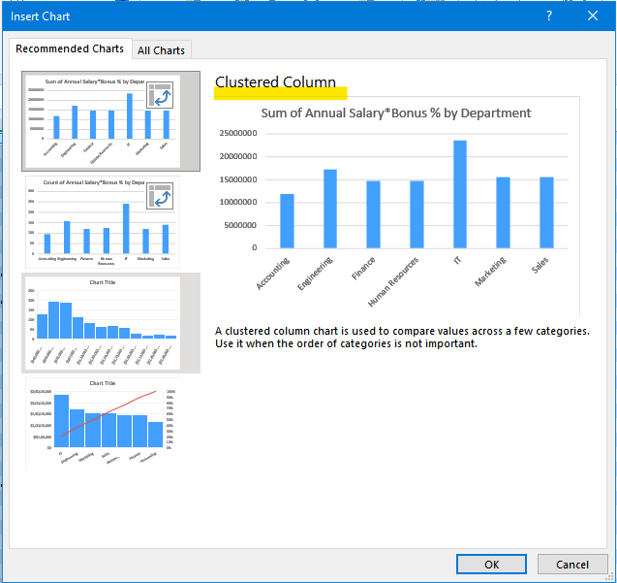

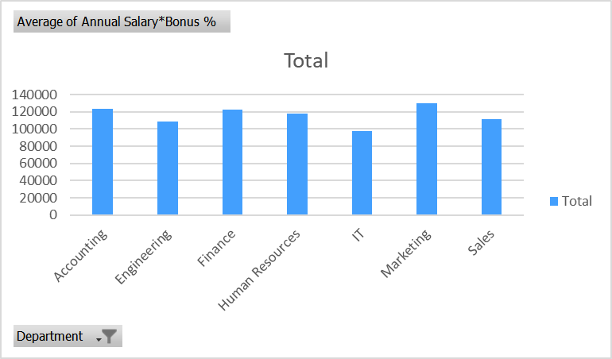

* Here x-axis represents the department and y-axis represents the average of annual salary for that department.
* We can observe from the above graph that the Marketing department has the highest annual salary.
* IT department has the lowest annual salary.

**Annual Salary vs Job Title**

**Steps for plotting chart.**

For plotting this chart we will use the Annual Salary and Job title column

* 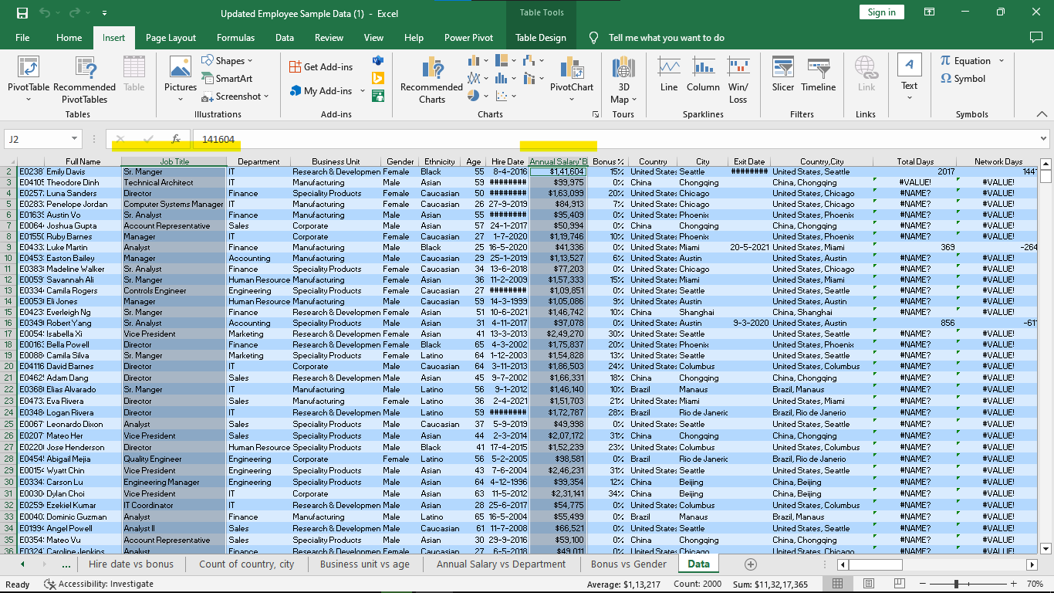
* After selecting column we will select Insert menu from Menu bar and in that We will select recommended charts option to plot graph.
* 
* After selecting recommended chart option we opt for clustered column chart to plot a graph.
* 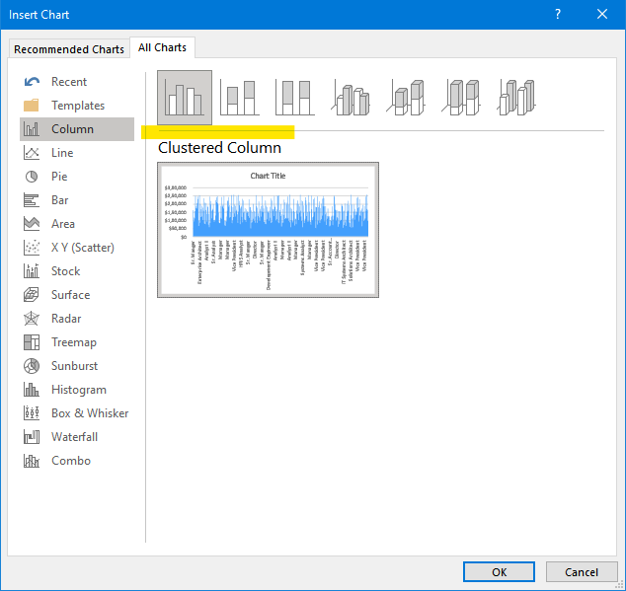
* After plotting graph we can move this chart to new sheet for better visualization.

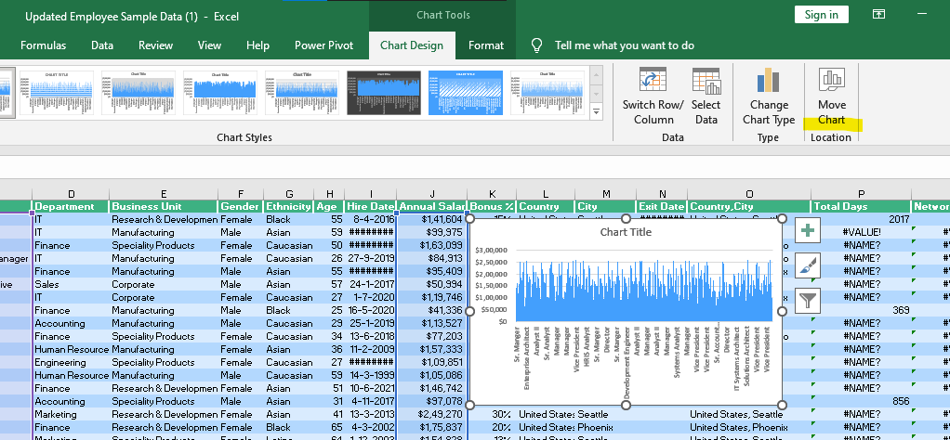

* After this option we will select new sheet from the opened dialogue box and rename the sheet for better visualization of graph.

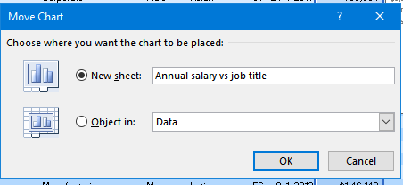

* After plotting graph we can select various chart design from the highlighted menu.

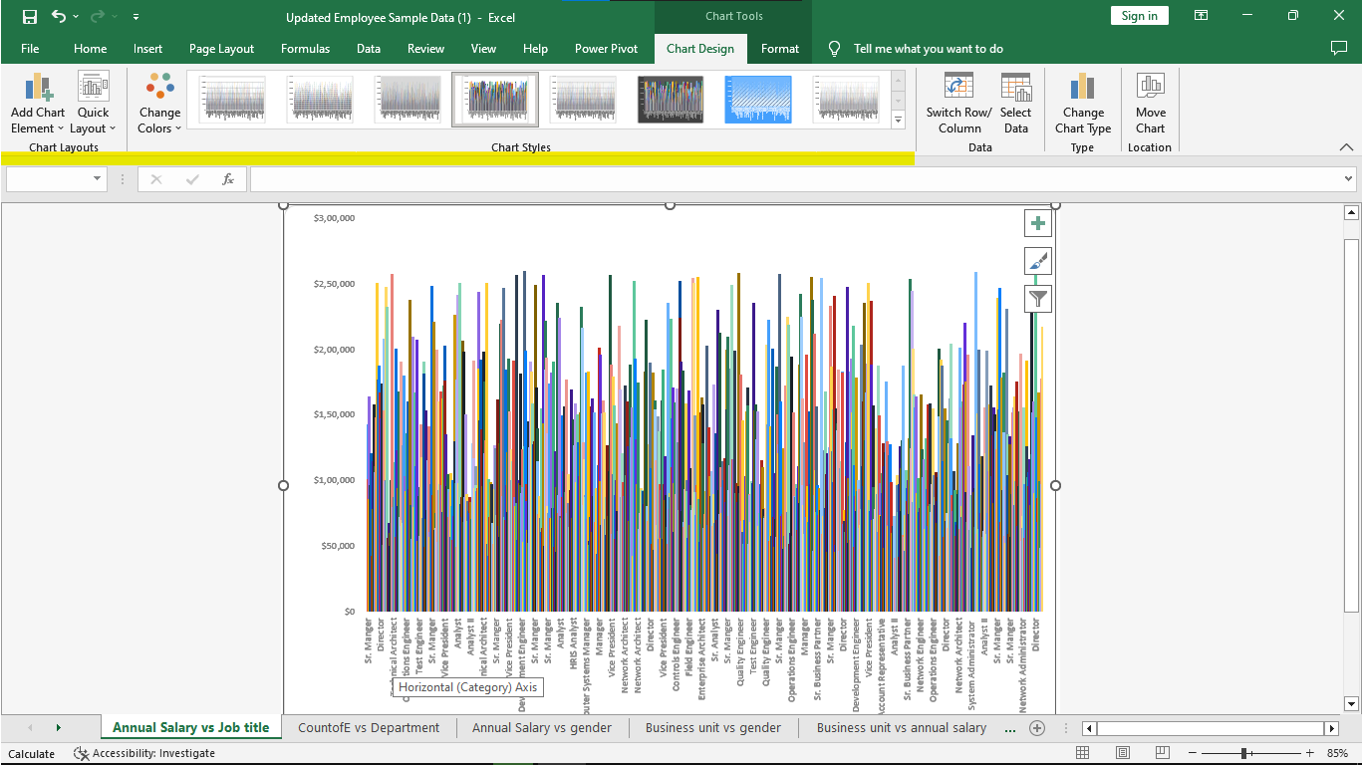

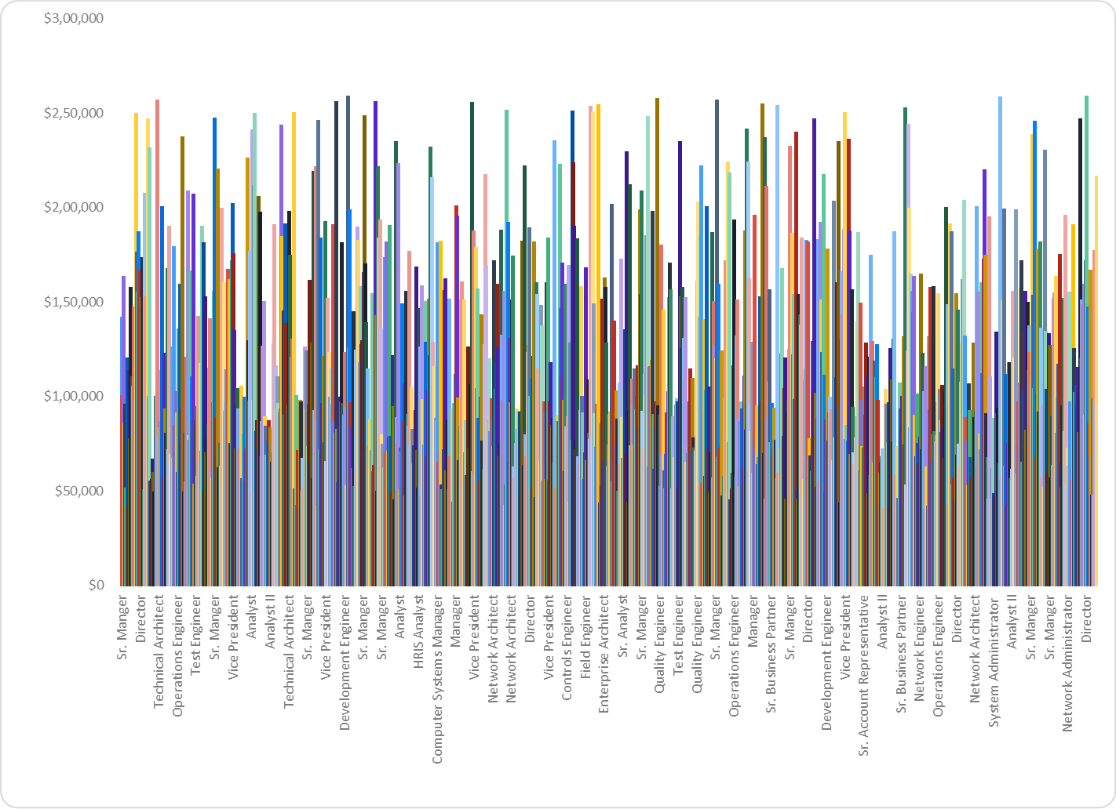

* Here from the above graph we can conclude that the Vice President and system administrator role has the highest salary.
* Analyst II has the lowest salary.

| **Descriptive Statistics Table for Age Column**   * For generating Descriptive statistics table first we select age column from the given data.      * Now we will go to data menu and select the data analysis option from the menu bar. |  |
| --- | --- |

* After selecting data analysis option we have lot of options to perform on a specific column so we will choose descriptive statistics method and click ok.

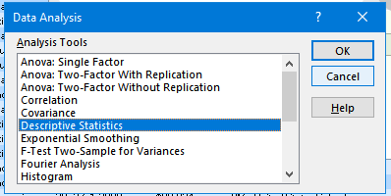

* After selecting it we will need to give input and output range we will select age column for input range and for output we can select the cell where we want to print table or we can choose new sheet option to print table on new sheet.

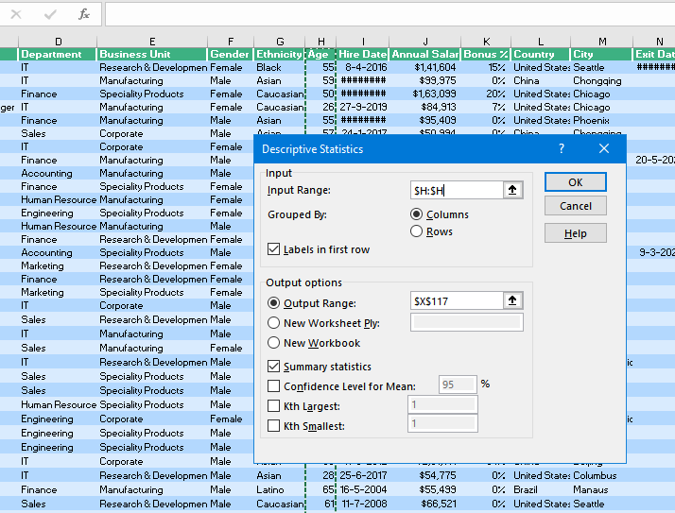

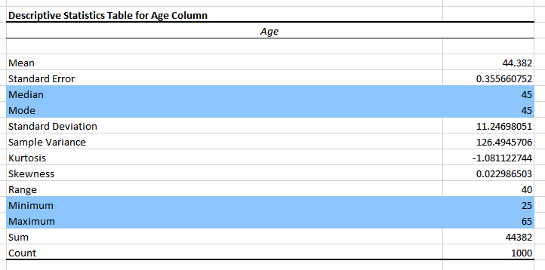

* From the above table we can notice the Mean , Median , Maximum , Minimum and total count for the Age column.

**Annual Salary Vs Gender**

From this graph we can find that which gender has the maximum salary

Steps to plot chart.

* First of all we need to select Annual salary and gender column after that we will select recommended chart option.
* From that option we select pareto chart to plot the chart.

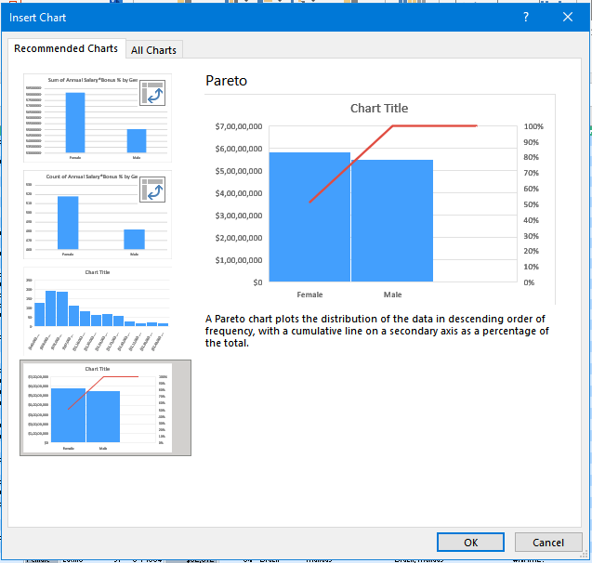

* After selecting it we will choose move chart option to plot chart in new sheet from chart design option and we will also rename the sheet..

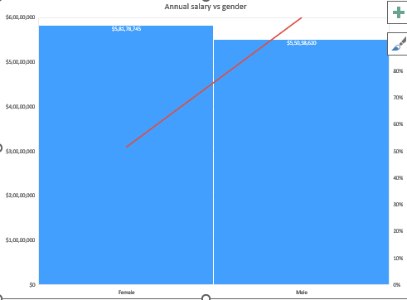

* From the above graph we can see that Annual salary of Female is higher than the Salary.

**Annual Salary vs Country**

* **Steps to plot this chart.**
* First of all we select the annual salary and country column from the data.
* From the recommendation option we will choose clustered column chart to get better visualization of Annual salary sv country.

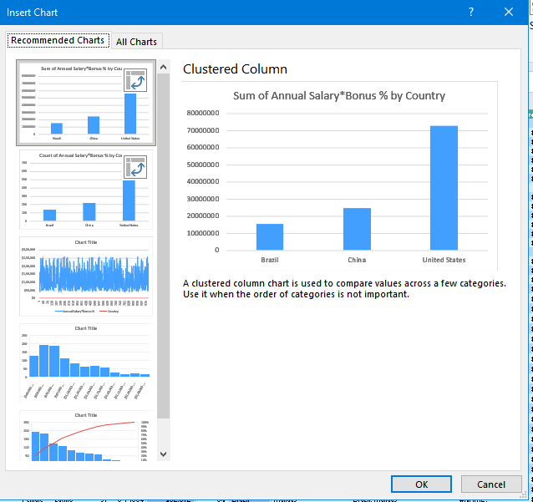

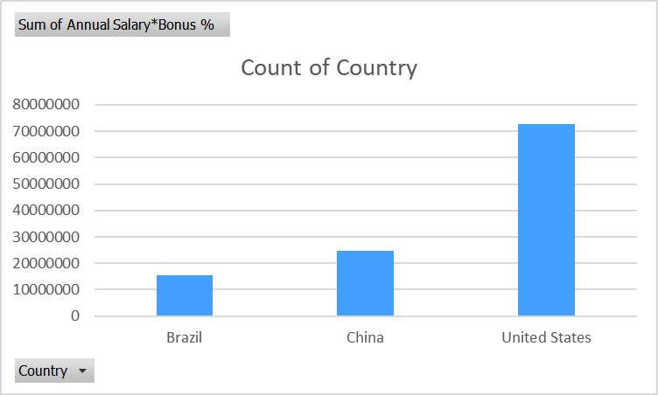

* From this graph we can notice that Brazil has the lowest annual salary.
* United States has the highest Annual Salary.

**Business Unite vs Gender**

From this graph we can observe which Business Unit has the Highest number of male or female employees.

Steps for plotting this chart

* For plotting this pivot chart we will select recommended chart option.



* Now from that chart we will select clustered column chart and we will select business unit and gender as pivot chart fields.

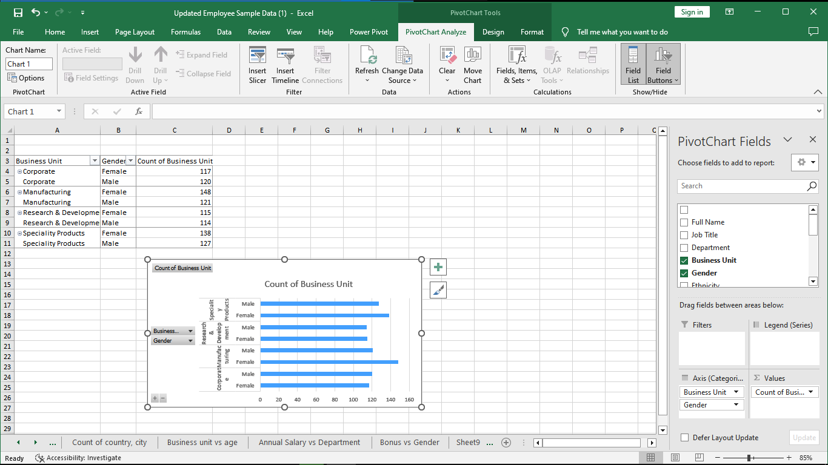

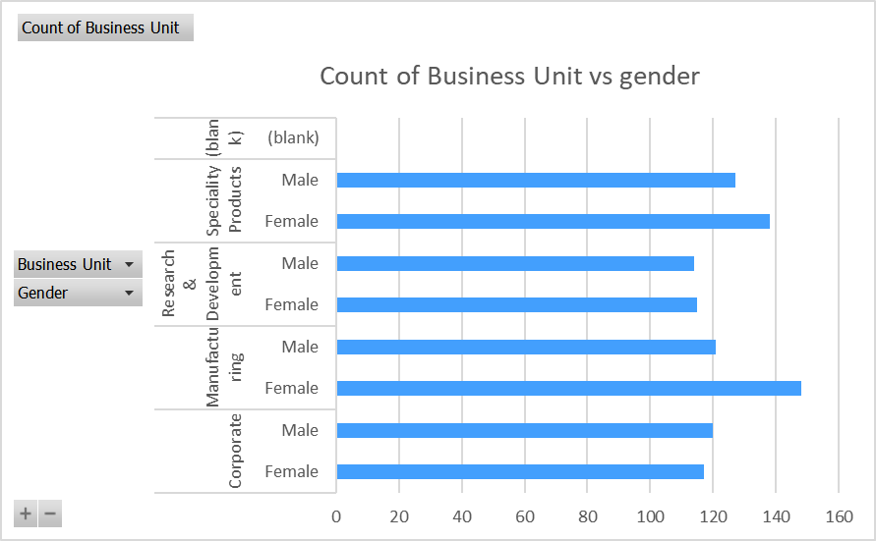

* Here we can identify that Manufacturing Unit has the highest number of female employees among all Business Unit.
* Research and Development unit has the lowest number of employees in all business unit.

**Business unit vs Annual Salary**

From this graph we can notice that which business unit provide highest salary.

Steps to plot the chart

* Here we select business unit and annual salary column to plot this chart.
* After selecting column we will go to insert menu and select recommended charts menu to see the best chart option.

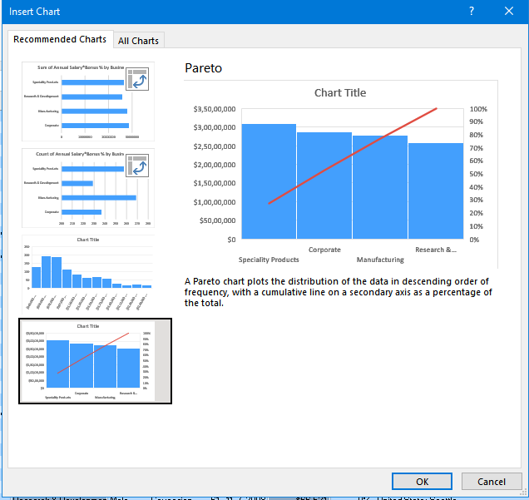

* From that option we will select pareto chart option to visualize the business unit vs annual salary chart.

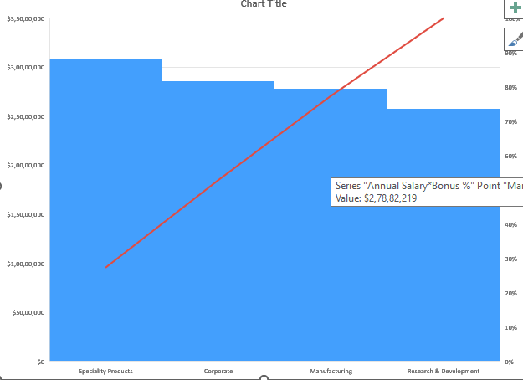

* Here we can observe that highest salary provided by Speciality Products units.
* Lowest annual salary has been provided by Research and Development Unit.

**Business unit vs Departments**

From this graph we can observe that which department of business unit has the highest number of count.

Steps for plotting chart.

* For plotting this graph first of all we select the business unit and Department column.
* After that we will select recommended chart option from that we will select clustered bar graph option.

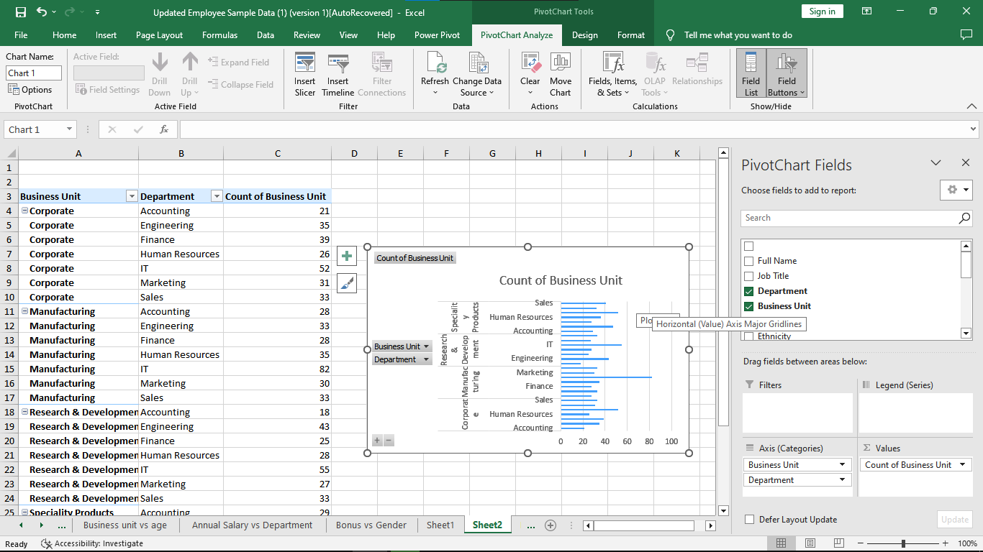

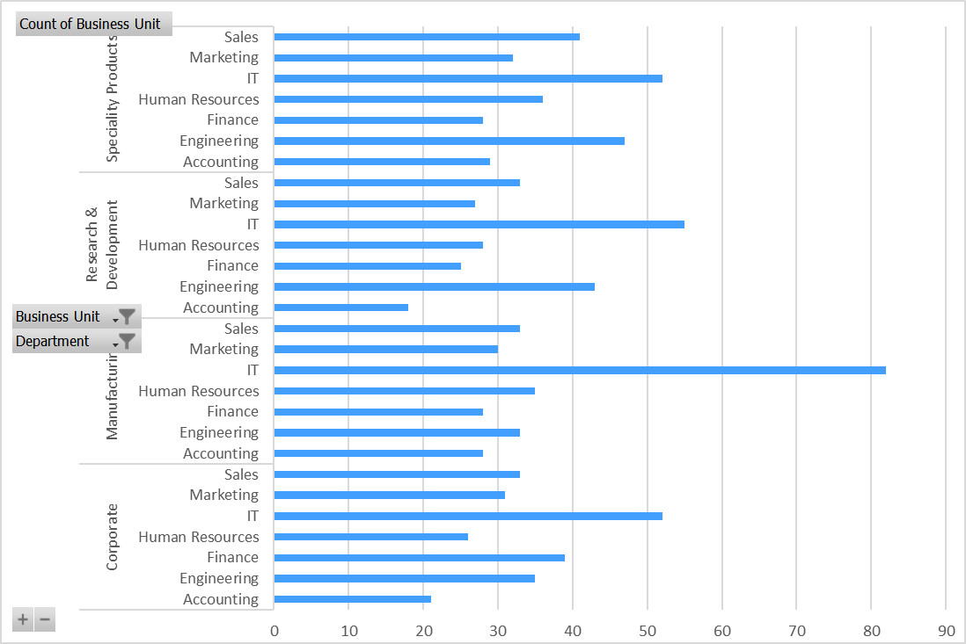

* Here we can notice that IT department of Manufacturing unit has the highest number of counts of business units.
* Accounting department of Research and Development unit has the lowest number of counts of business units.

**Business unit vs age**

From this graph we can identify the average age of the employee by the business unit.

Steps for plotting chart.

* For plotting this graph first of all we select the business unit and Age column.
* After that we will select recommended chart option from that we will select clustered bar graph option.

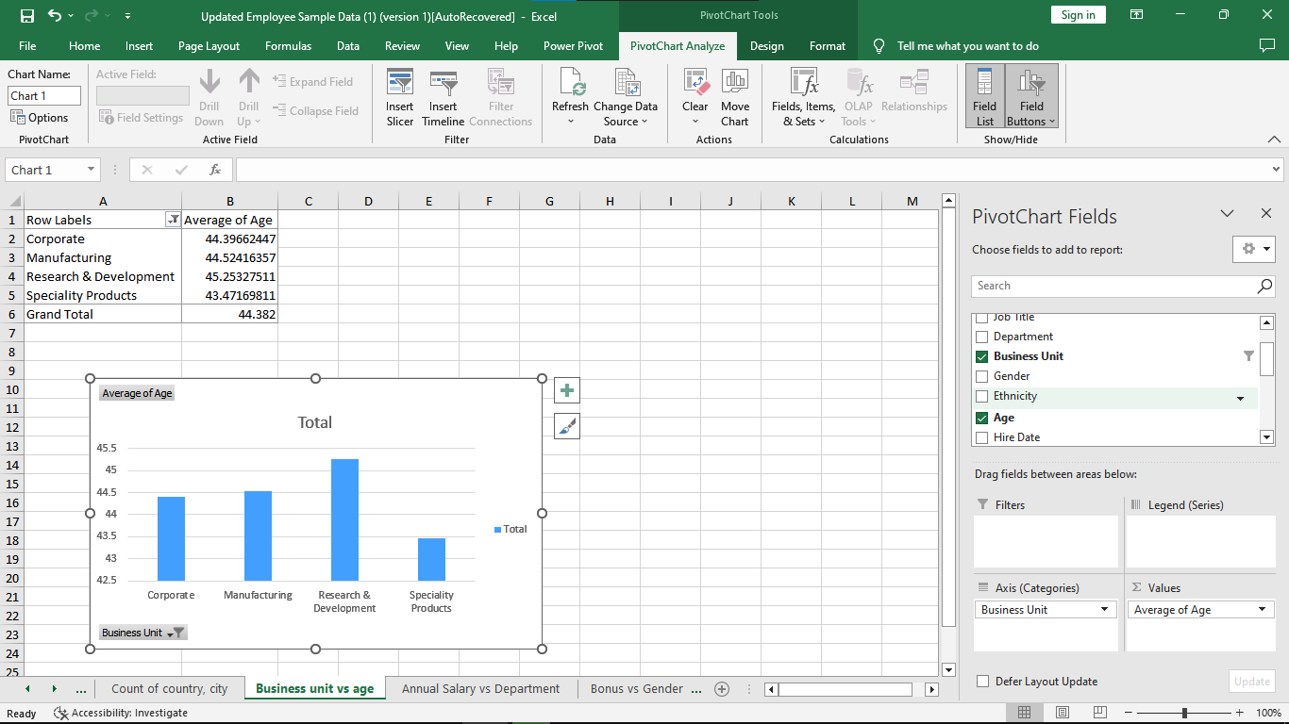

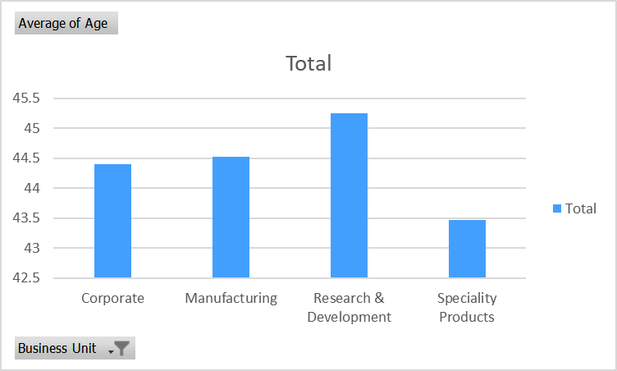

* From the above graph we can observe that Research and Development unit has the highest average of age.
* Speciality Products has the lowest average of employee.

**Hire date and Bonus**

From this graph we can notice the bonus percentage with respect to hire date.

Steps to plot this chart.

* For plotting this graph first of all we select the Hire date and Bonus column.
* After that we will select recommended chart option from that we will select clustered column graph option.

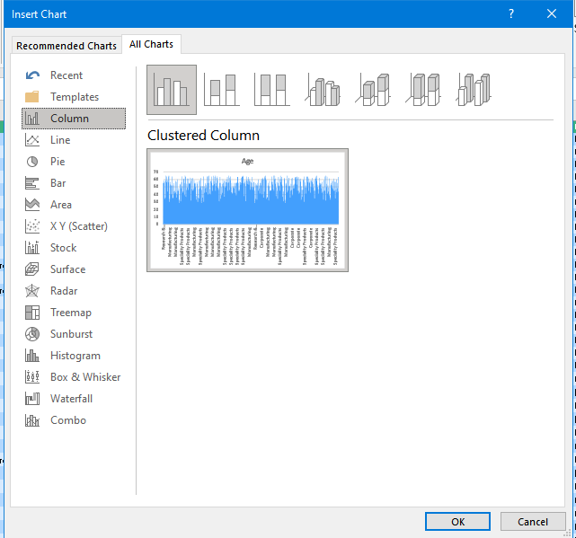

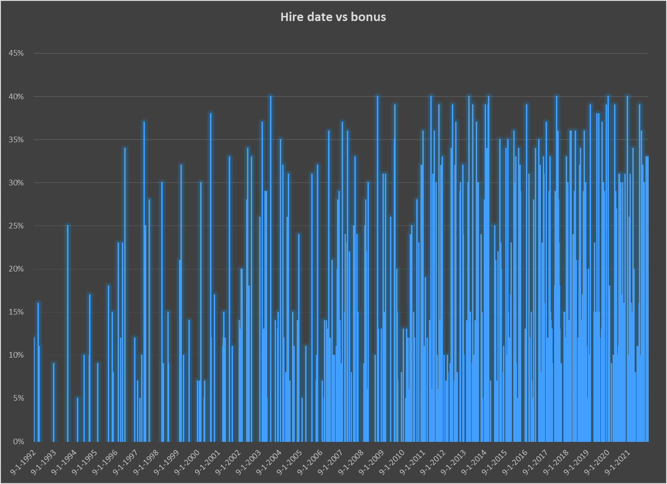

* From this graph we can observe that employee hired on 9-1-2004 has the highest bonus.
* The employee hired on 9-1-1997 has the lowest bonus percentage.

**Business unit vs bonus**

From this graph we can identify the trend of the bonus among business units.

Steps to plot this chart.

* For plotting this graph first of all we select the business unit and bonus column.
* After that we will select recommended chart option from that we will select clustered column graph option.

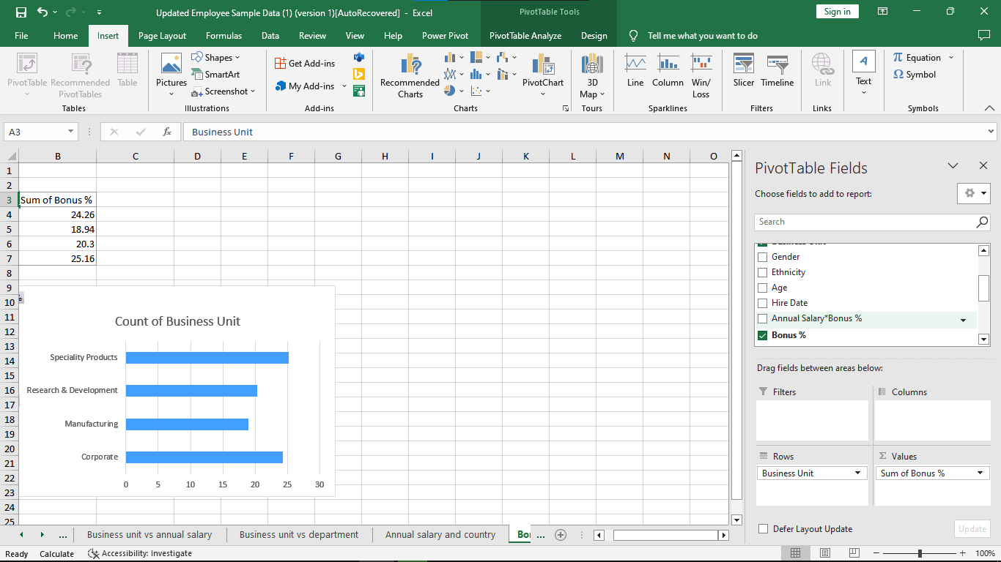

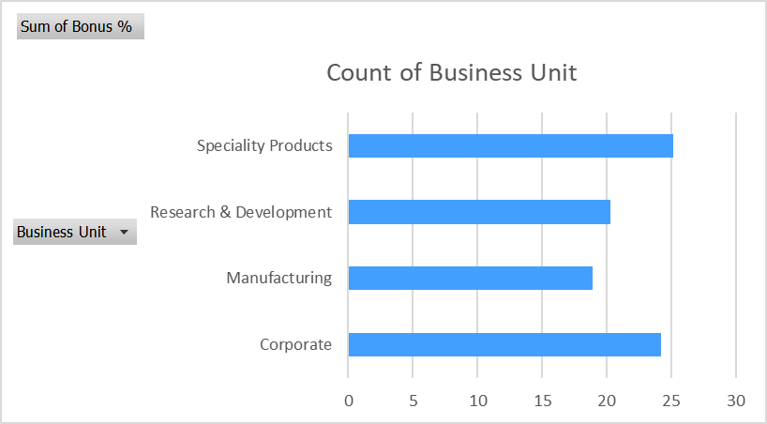

* From this graph we can observe that Speciality Unit has the highest percentage of bonus.
* Manufacturing unit has the lowest percentage of bonus.

**Department vs bonus**

From this graph we can observe that the highest bonus provided by department wise.

Steps to plot this chart.

* For plotting this graph first of all we select the Department and Bonus column.
* After that we will select recommended chart option from that we will select clustered column graph option.

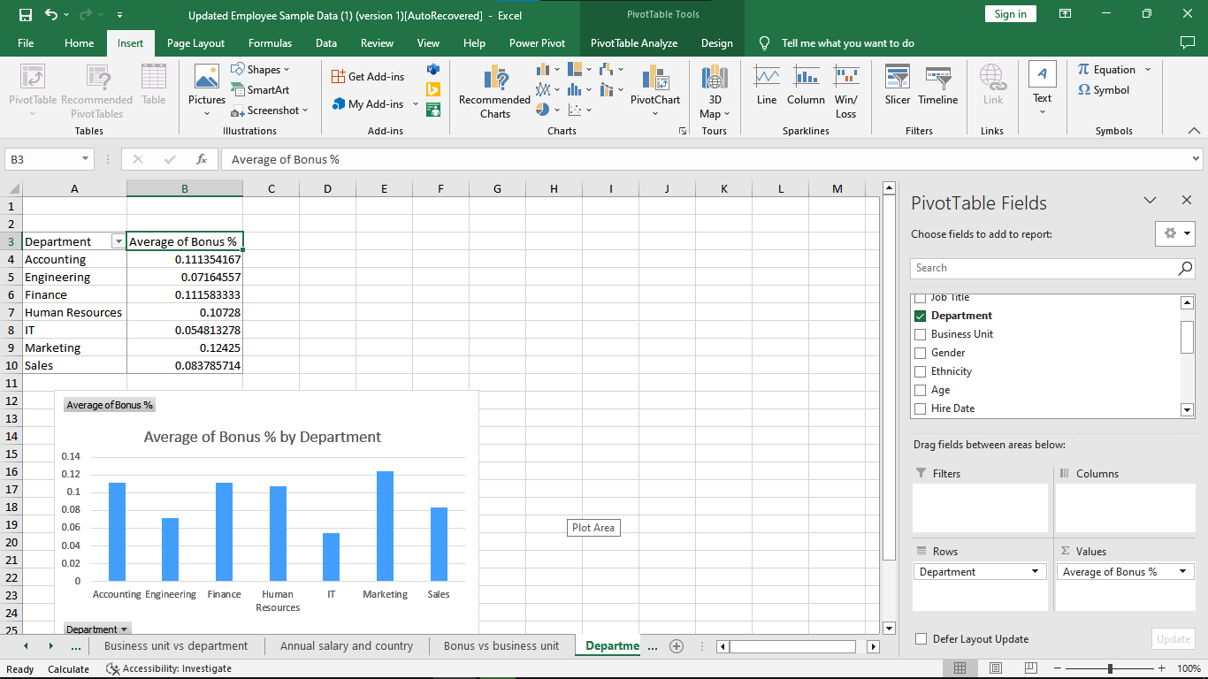

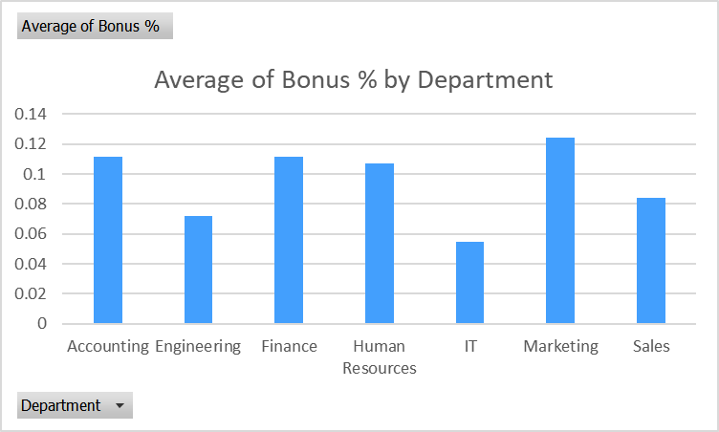

* Here we can notice that Marketing department has the highest bonus percentage and IT department has the lowest percentage of bonus.

**Job Title vs Bonus**

From this graph we can notice the Bonus rate with respect to Job Title.

Steps to plot this chart.

* For plotting this graph first of all we select the Job Title and Bonus column.
* After that we will select recommended chart option from that we will select clustered column graph option.

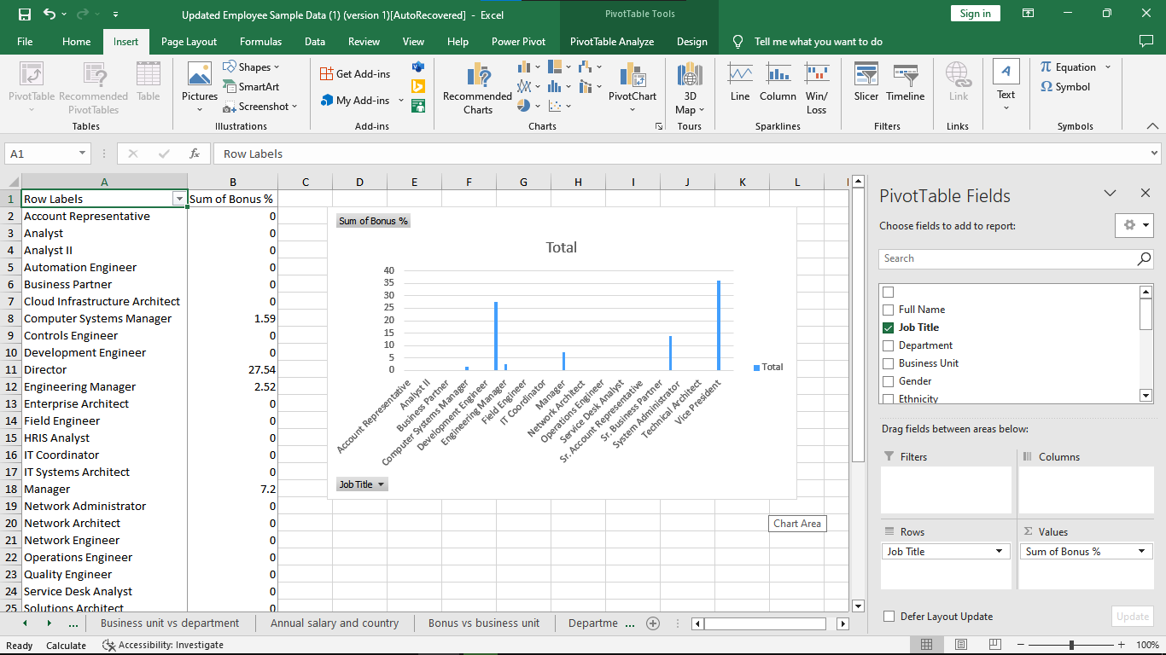

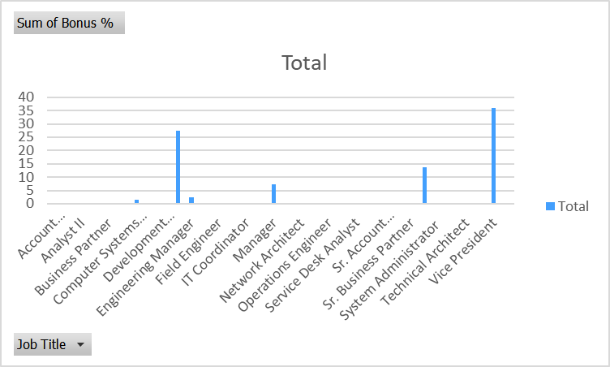

* Here we can identify that the highest rate of bonus is provided to Vice President and lowest rate of bonus has been provided to Computer System Manager.

**Gender vs Bonus**

From this graph we can observe the bonus rates with respect to gender.

Steps to plot this chart.

* For plotting this graph first of all we select the Gender and bonus column.
* After that we will select recommended chart option from that we will select clustered column graph option.

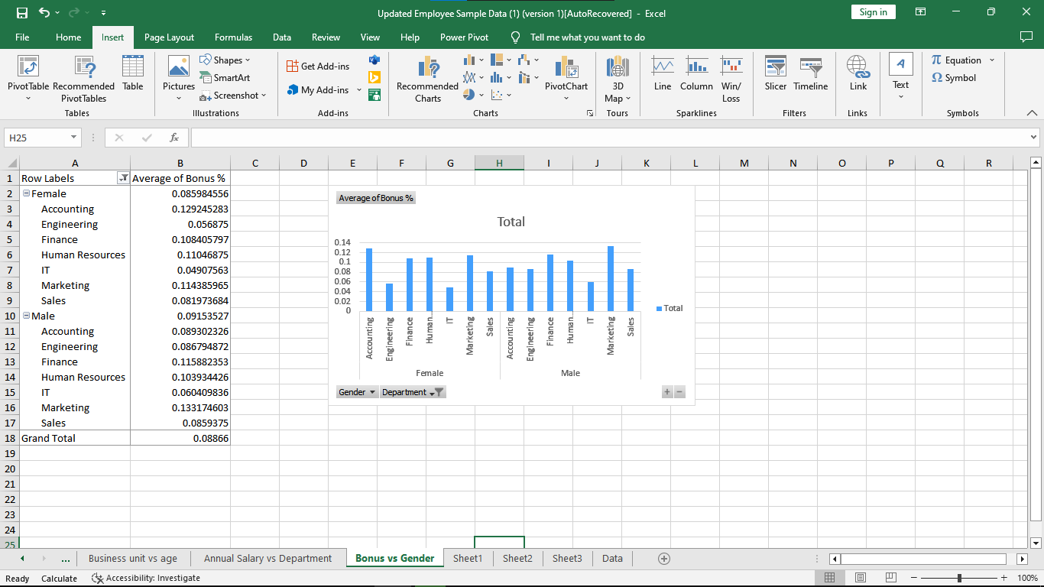

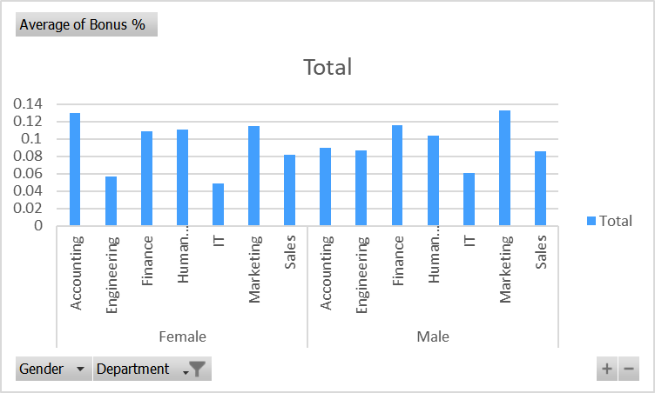

* From the above graph we can observe that male employees from marketing department have the highest average bonus rates whereas female from IT department have the lowest ratio.

**Count of Ethnicity vs Department**

From this graph we can observe which ethnicity has the highest count for which department.

Steps to plot this chart.

* For plotting this set of graphs first of all we select the Count of Ethnicity and Department column.
* After that we will select recommended chart option from that we will select the multiple appropriate graph option.

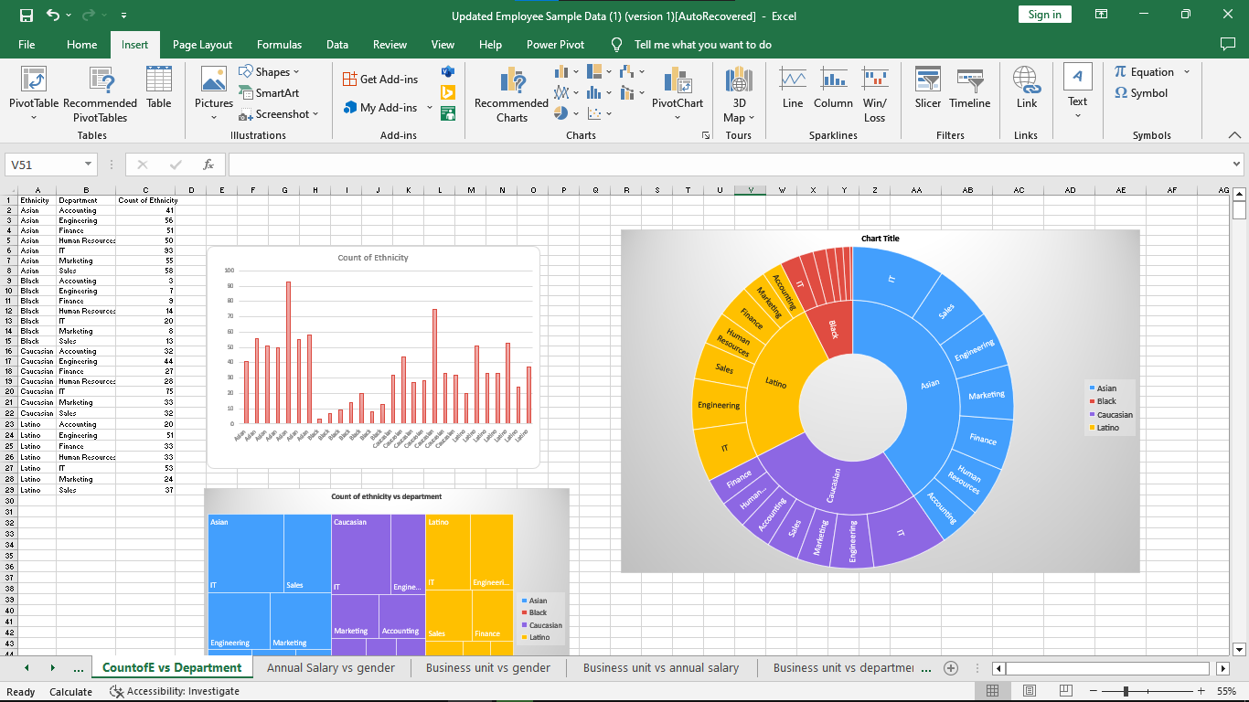

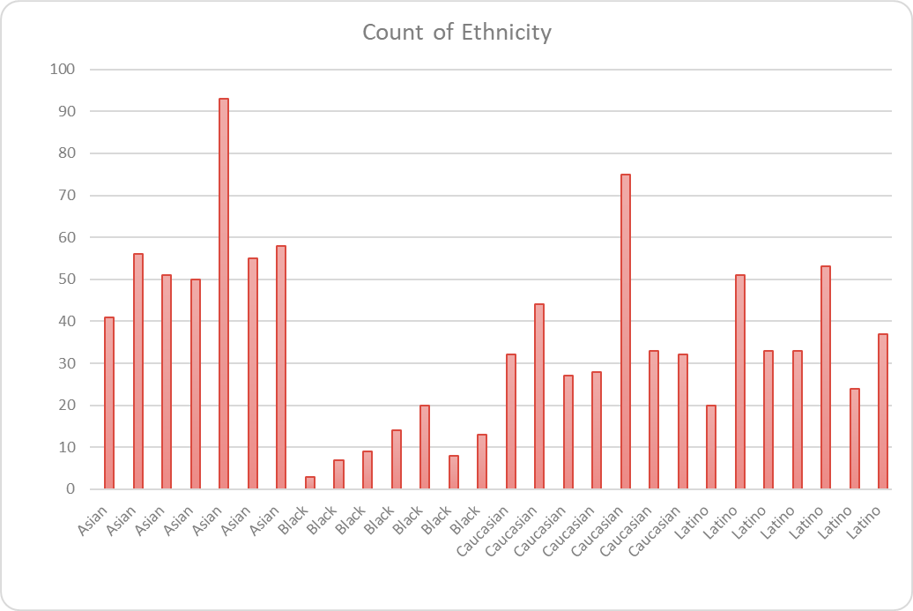

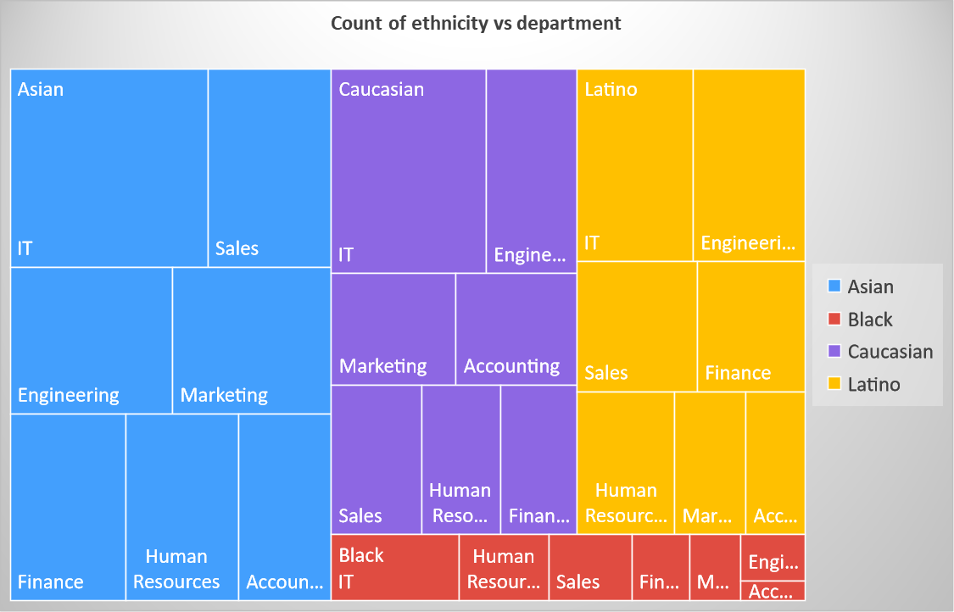

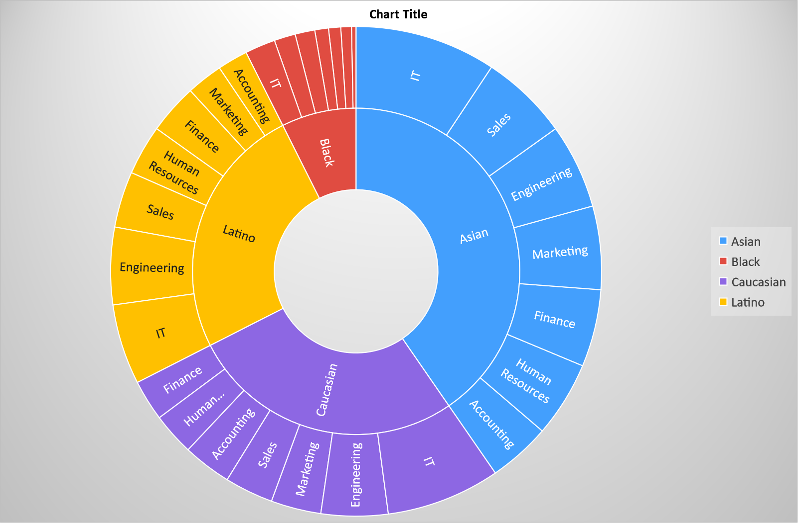

* From the above graphs we can notice that Asian Ethnicity for IT department has the highest count among all the counts.
* Black ethnicity for accounting department has the lowest count of 3.

**Average annual salary vs Department**

Steps to plot this chart.

* For plotting this set of graph first of all we select the Count of Ethnicity and Department column.
* After that we will select recommended chart option from that we will select the multiple appropriate graph option.

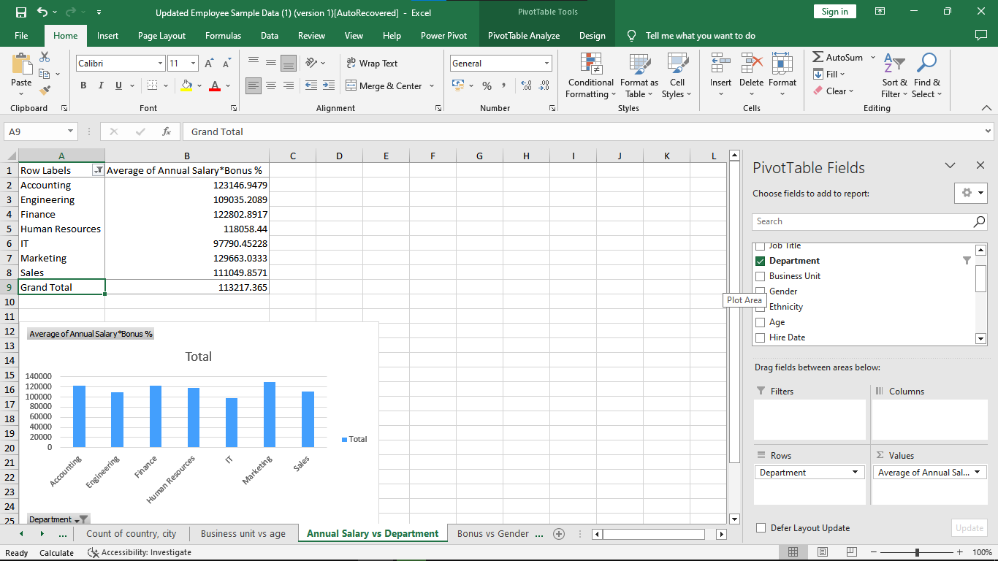



* From the above graph we can conclude that Marketing Department has the highest average annual salary and IT department has the lowest annual salary.

**Count of Country and City**

Steps to plot this chart.

* For plotting this set of graph first of all we select the Count of Ethnicity and Department column.
* After that we will select recommended chart option from that we will select the multiple appropriate graph option.

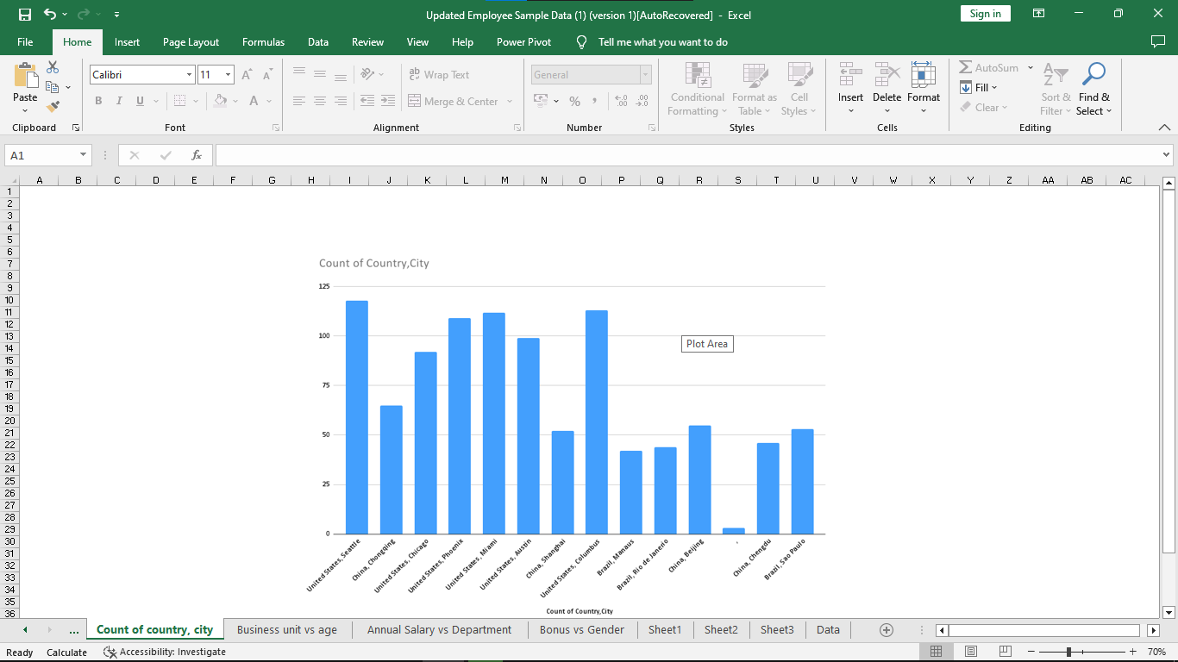

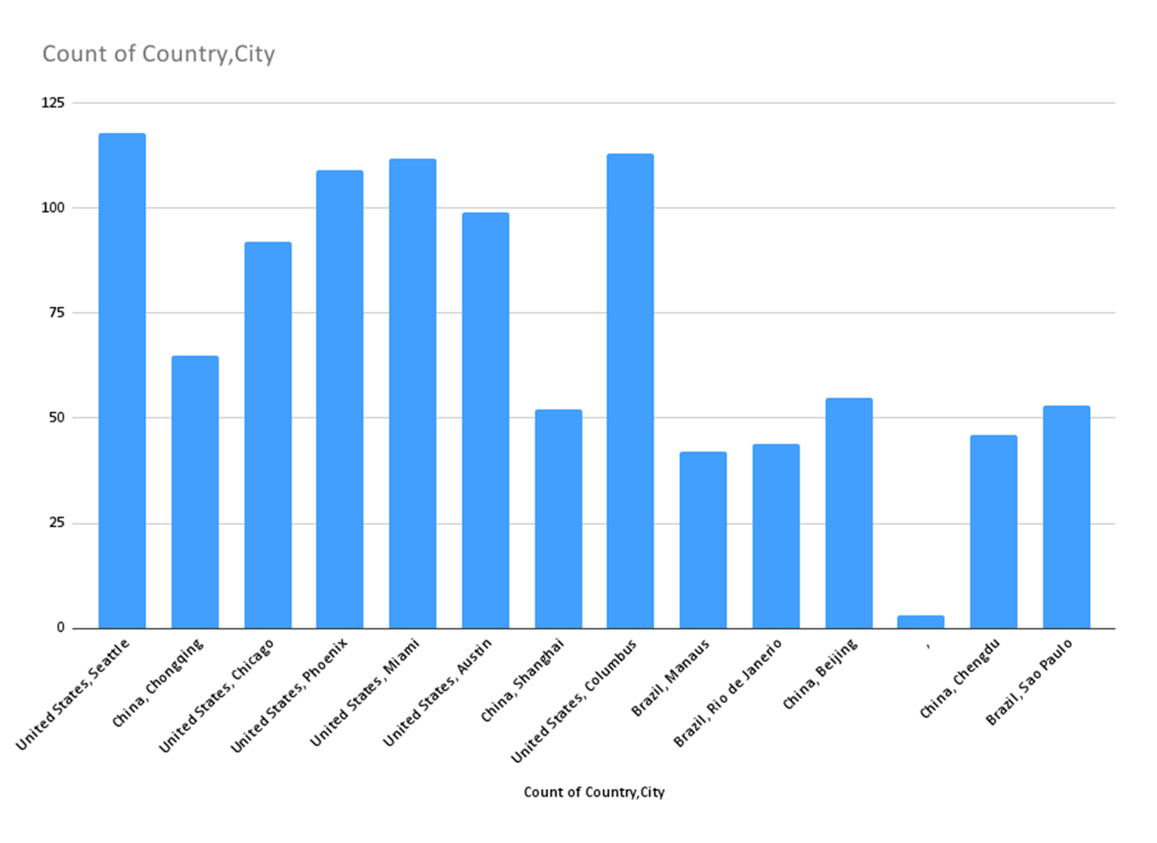

* Here from the graph we can observe that United States , Seattle has the highest number of employees.

**Bonus vs Gender**

From this graph we can find the highest bonus rate provided by which department and gender.

Steps to plot this chart.

* For plotting this set of graph first of all we select the Count of Ethnicity and Department column.
* After that we will select recommended chart option from that we will select the multiple appropriate graph option.

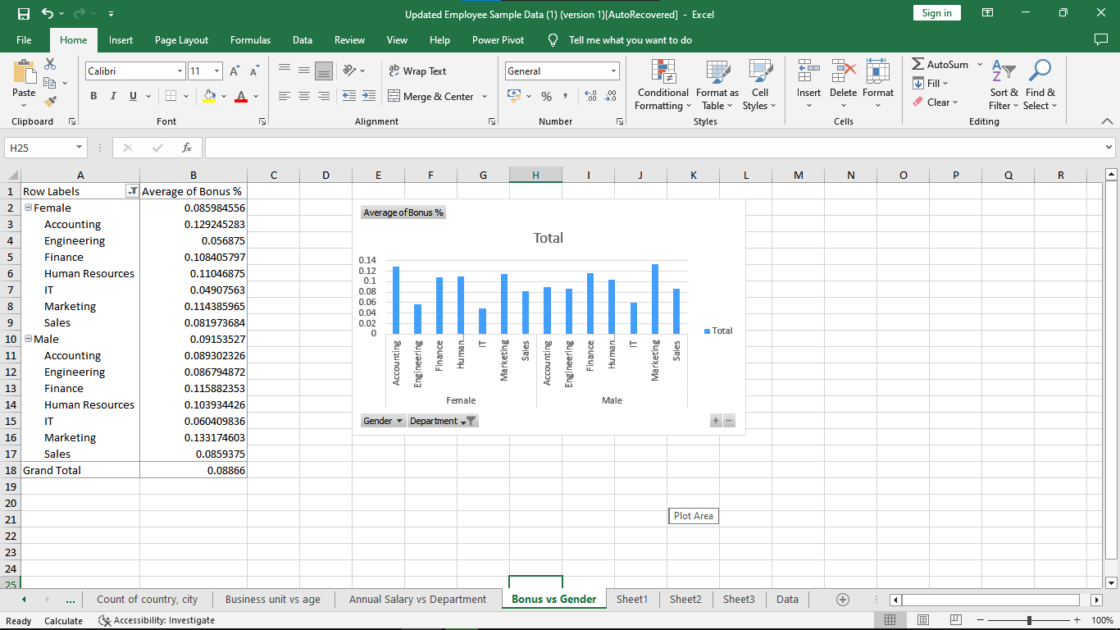



* Here from the above graph we can notice that male employees of the marketing department has the highest bonus ratio while female of IT department has the lowest.

**Create a column by merging Country and City.**

For creating separate column first we will select a cell of a new column.

Here we write a formula for merging column.

=CONCATENATE(L2,”,”,M2)

Here L2 refers to country column and M2 refers to city column.

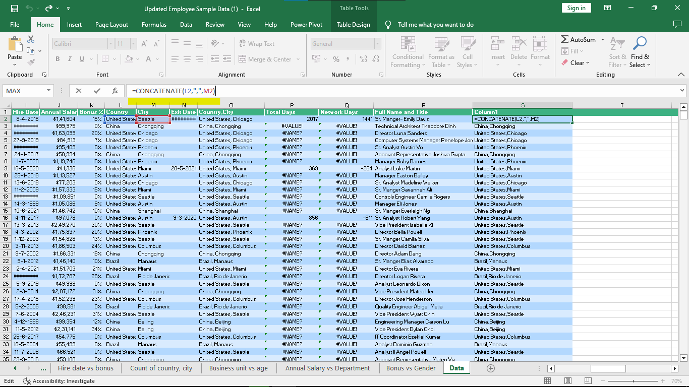

| **Analysis Table for Annual Salary Column**   * For generating Descriptive statistics table first we select annual salary column from the given data. * Now we will go to data menu and select the data analysis option from the menu bar. |  |
| --- | --- |

* After selecting data analysis option we have lot of options to perform on a specific column so we will choose descriptive statistics method and click ok.



* After selecting it we will need to give input and output range we will select age column for input range and for output we can select the cell where we want to print table or we can choose new sheet option to print table on new sheet.



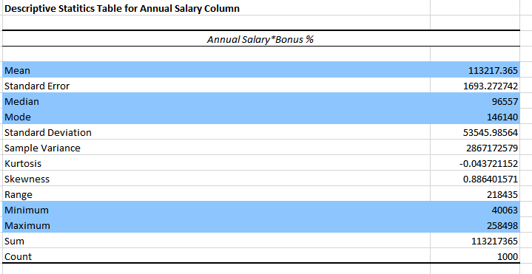

* From the above table we can notice the Mean , Median , Maximum , Minimum and total count for the Age column.

**Create a column Total days which counts total days.**

* For generating this column first we select empty cell where we want to add new column.
* Here we add formula for calculating total days based on hire date and exit date.
* So we will select the hire date and exit date and add this formula for calculating total days.

=DAYS(N2,I2)

Here N2 refers to Exit date of employee and I2 refers to hire date of employee.

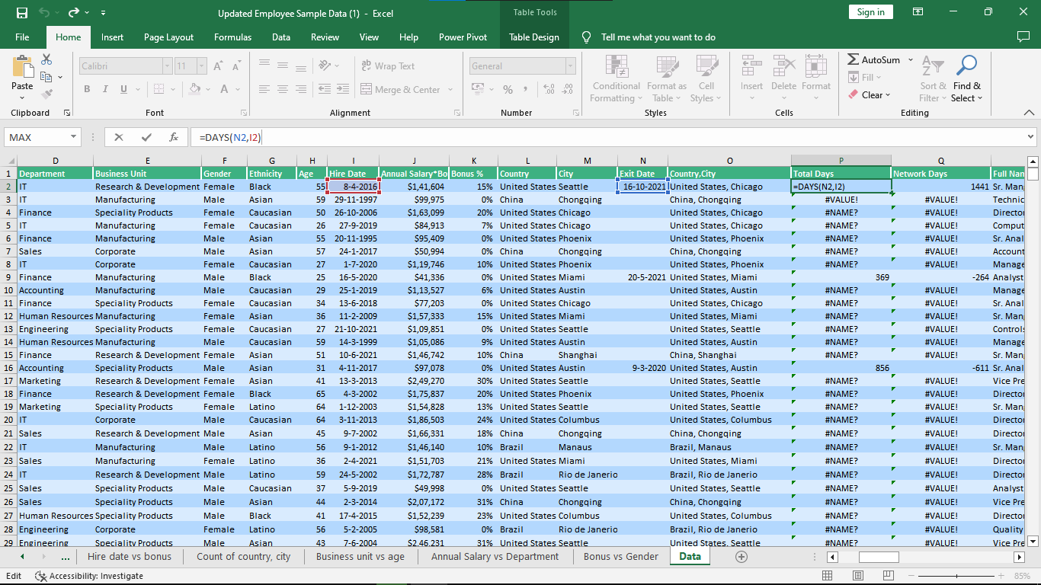

**Create a column by combining Full name and Job title.**

* For creating separate columns by combining full name and job title we first select an empty cell.
* Here we will apply following formula for combining full name and job title

=CONCATENATE($Data.$C2,"- ",$Data.$B2)

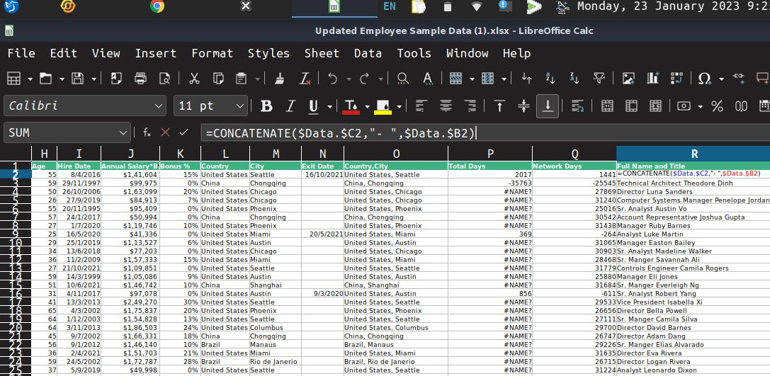

**Create a column for Network days by utilizing hire and Exit dates**

* For creating a column network days we utilize the hire and Exit date columns.
* It will count the actual working days starting from the hire date to the exit date.
* =NETWORKDAYS($Data.$I2,$Data.$N2,)
* Here N2 refers to exit date and I2 refers to hire date.

