**EXERCISE NO:2 21BBT035**

FASTA SEQUENCE

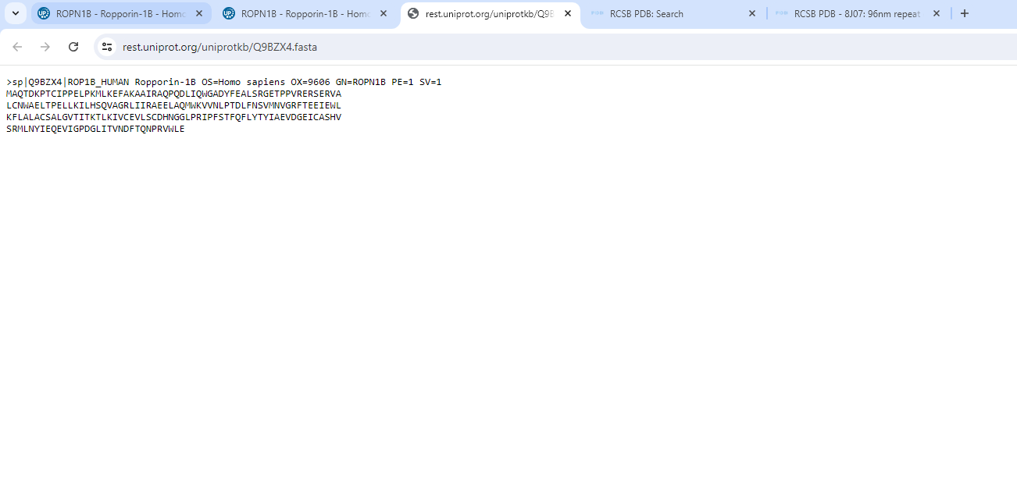

Figure 1

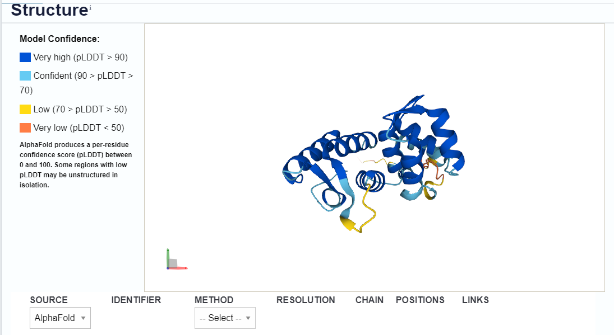

The source of the 3D structure of the protein is Alpha Fold and hence this is the predicted structure.

Figure 2

3D structure

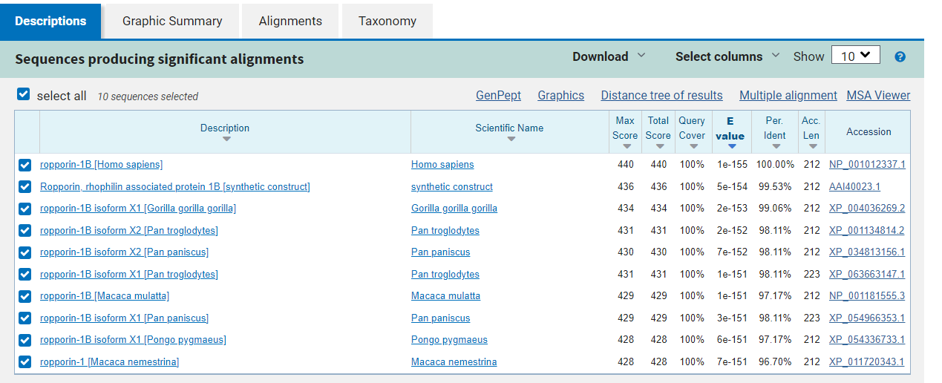

Case A

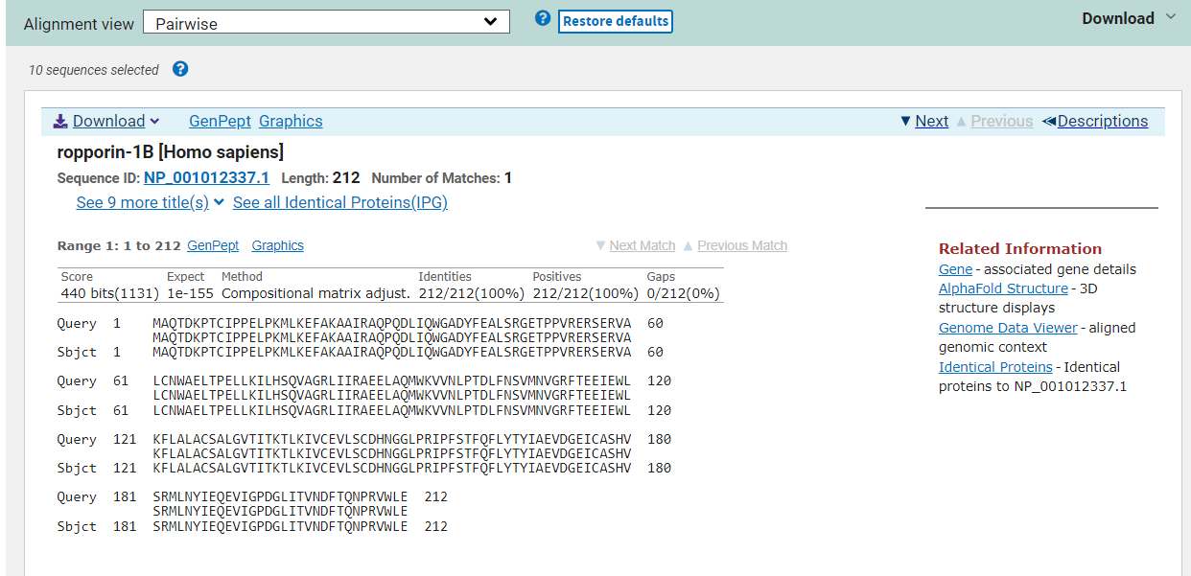

The **BLAST** results for the best 10 HSP shows that the sequences are homologs upto 96% identity

Figure 3-Alignment

Figure 4- Description

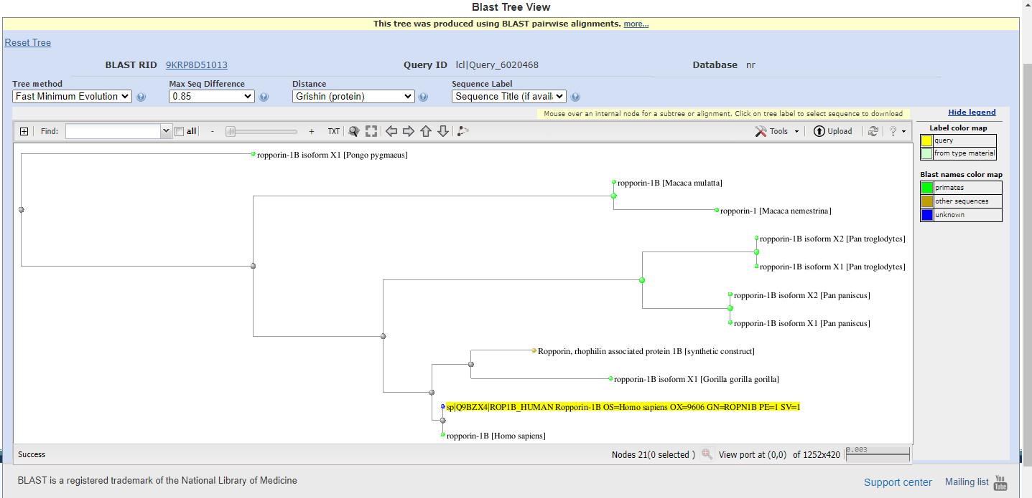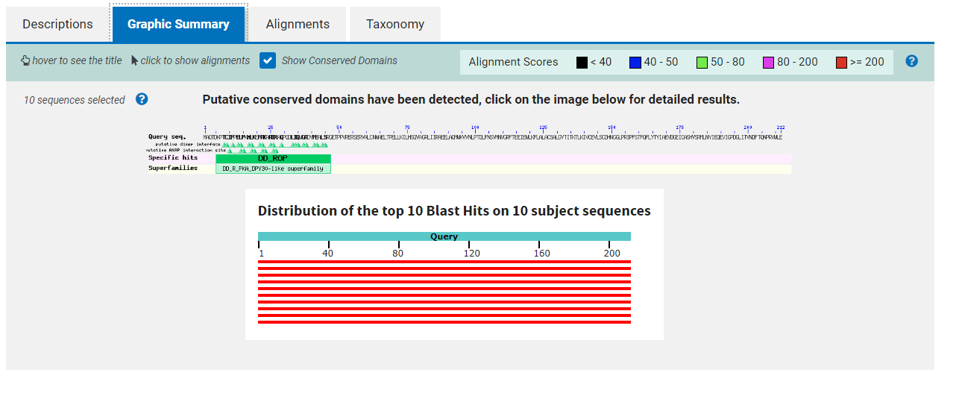

The graphical summary represents that they are homologues sequences and the distance tree shows the relationship with the homologues sequences.

Figure 5- Distance Tree

Figure 4-Graphic summary

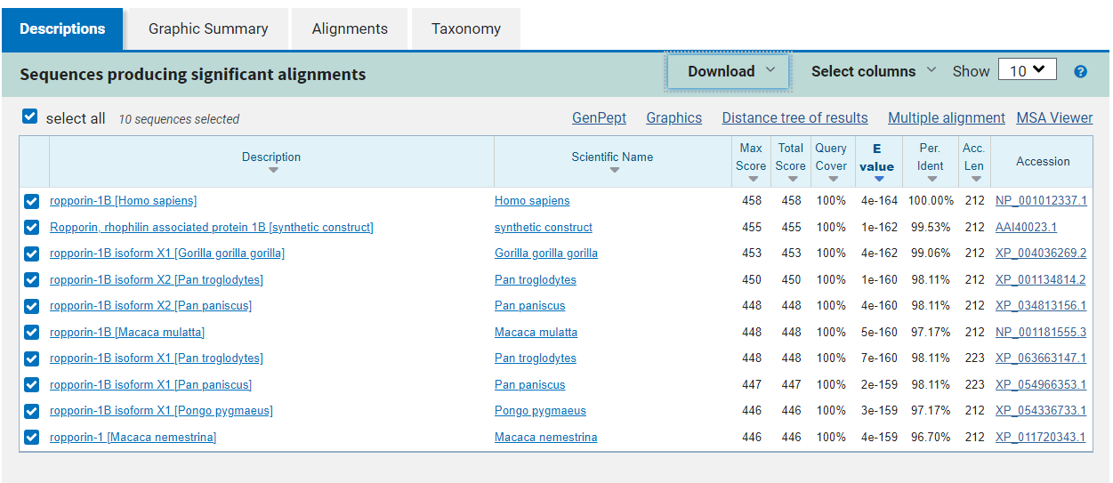

Figure 6- description

Case B

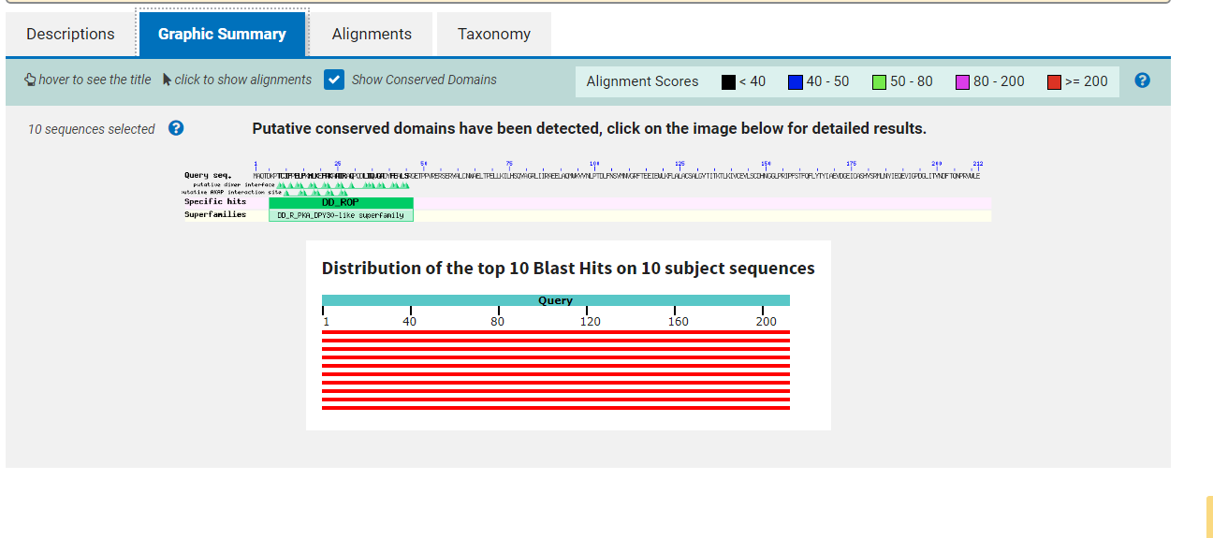

Figure 7- Graphic Summary

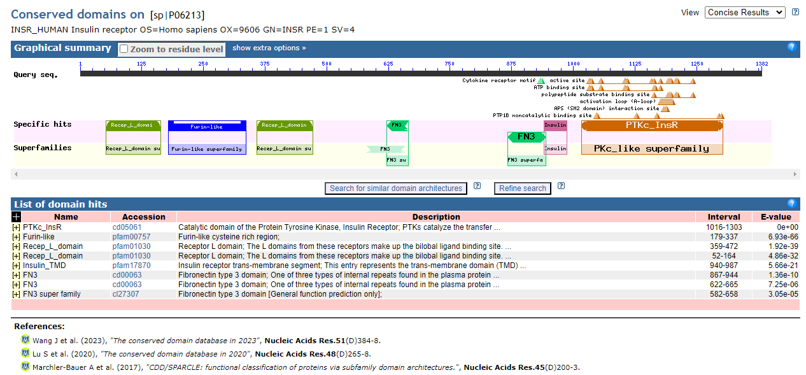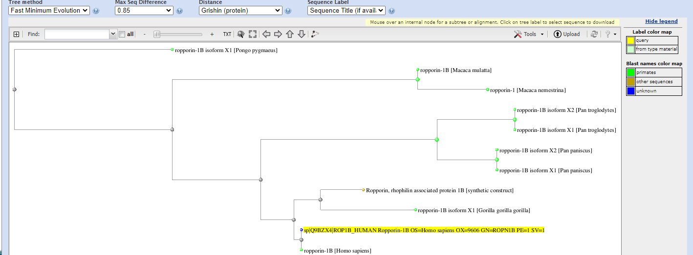

Figure 9- Conserved domains

Figure 8- Distance Tree

The case B represents the BLAST for E value =0.1 and the matrix = BLOSUM45. The conserved domains shows that the L domains from these receptors make up the bilobal ligand binding site. Each L domain consists of a single-stranded right hand beta-helix. This Pfam entry is missing the first 50 amino acid residues of the domain.