**Assignment 2: Design An IOT Egg Incubator**

‭Deepanshi‬ ‭456807‬

**‭Bow Valley College‬**

TECH1102:Internet of Things

‭Instructor: Dima Marachi

‭March 21, 2024.‬

Ques 1) Paste the picture of the block diagram.

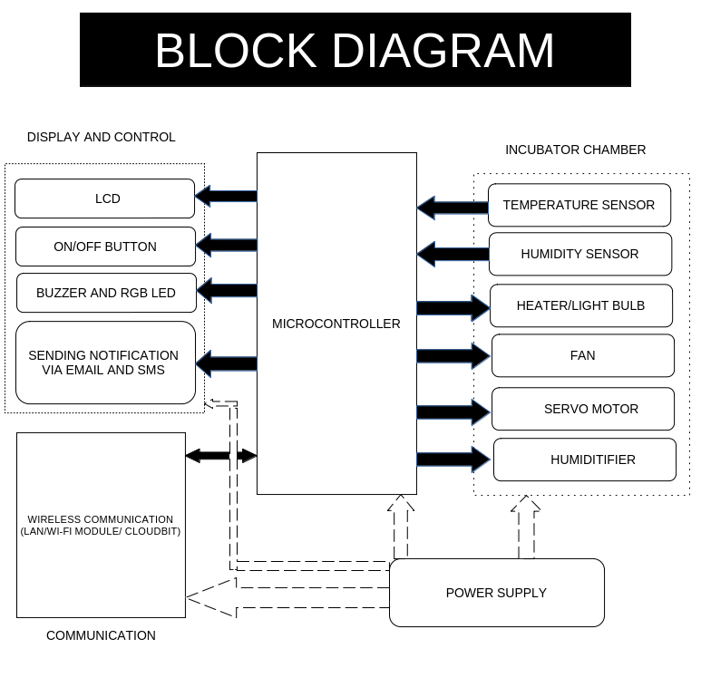

Ques 2) Please paste in your spell-checked and grammar-checked design summary.

Ans:

This is an Ardunio-controlled incubator for chicken eggs. The aim is to create artificial incubators designed to maintain specific temperature and humidity levels required for successful egg hatching.

**Components:**

1. **Power supply:** The power supply for the system is 12 volts. The system functions at a maximum of 12 volts.
2. **Heater/Light Bulb:** A 25-watt bulb serves as a heat source. These light bulbs or heaters help maintain temperature within the incubator, which is important for the proper development of the chick that is inside the egg. To supply the necessary warmth to replicate natural incubation conditions for the eggs.
3. **DHT11 Sensor (Temperature and Humidity Sensor):** It senses temperature and humidity and gives digital values.
4. **Humidifier (designed to increase humidity levels in a room):** The humidifier converts water into a mist composed of very fine droplets as it passes through. The effectiveness of this equipment relies heavily on maintaining optimal moisture levels during the incubation and hatching phases. Consequently, the humidifier is responsible for precisely regulating the humidity level within the incubation chamber.
5. **Fan:** The fan does not need to be controlled; it is constantly running and distributes heat and humidity equally in the incubator. The Arduino monitors the fan using its rpm signal and sets an alarm if it fails. The fan also cools the heating wire; the heating is turned off if the fan fails.
6. **Servo Motor:** A servo motor can be connected to a mechanism that holds the eggs and rotates them during an interval.

**Display and control:**

1. An LCD is used to display the current temperature.
2. Allows the user to communicate with the device by setting up the following: On/Off: to turn on the equipment and its operation indicator; Set the incubation temperature and humidity. Keyboard

Here's a step-by-step procedure outlining how the Arduino-controlled incubator works for hatching chicken eggs:

1. **Power On and Initializing the Process**: The user switches on the incubator, supplying power to all components and integrating the NodeMCU ESP8266 with Arduino Mega 2560. I used Wi-Fi connectivity for communication, enabling remote monitoring, control, and data exchange capabilities.
2. The DHT11 sensor starts taking readings of temperature and humidity inside the incubator at regular intervals.
3. The Arduino processes the sensor readings and sends the data to the LCD for the user to see.
4. The user interacts with the on/off button or keypad to input the parameters, like setting the target temperature and humidity.
5. The DHT11 sensor has a user-defined target temperature. If the temperature is too low, the Arduino activates the light bulb or heater to increase the temperature. If it is **too high**, it turns off the light bulb or heater.
6. **Humidity Control**: Similarly, the humidity reading matches the user-defined target humidity. If the humidity is too low, the Arduino **activates the humidifier** to increase humidity. If it's too high, it **turns off the humidifier**.
7. **Fan**: The fan runs continuously to ensure a uniform distribution of heat and humidity inside the incubator. If it fails, it turns on the buzzer.
8. **Turning of eggs with a servo motor**: The servo motor rotates the eggs at some intervals. This prevents the embryos from sticking to the shell membrane and promotes uniform development.
9. **Monitoring and Feedback**:
   * Throughout the incubation process, the Arduino continuously monitors temperature, humidity, fan operation, and egg turning.
   * If any parameter deviates from the desired range or if there's a system malfunction (e.g., fan failure), the Arduino triggers an alarm to alert the user.
   * The data is stored on the memory card to prevent data logging, and we can check our data any time we want from any smartphone, laptop, etc. by placing the memory card on the device.
10. **Completion**: Once the incubation period is complete and the chicks have hatched, the user can power off the incubator and remove the chicks for further care.

Ques 3) Please list three alternative network communication methods you considered for the Arduino, and indicate why you selected the one in your design. Be specific!

Ans:

1. **Wi-Fi modules using ESP8266:** The NodeMcu ESP8266 module enables your microcontroller to connect to Wi-Fi networks and establish basic IP connections using simple commands. With its built-in Wi-Fi features, programming becomes easier, allowing communication with web servers, cloud platforms, or other devices over Wi-Fi networks.
2. **LAN:** We can utilize a LAN connection directly with a computer to link the Arduino incubator and computer, which allows us to be informed as well as monitor from any device.
3. **CloudBit:** The easiest way to create internet-connected devices. Retrofit your temperature, humidity, and other parameters from anywhere in the world using a smartphone, tablet, or computer. We can use cloudBit, and no programming, soldering, or wiring is required.
4. **Bluetooth:** Bluetooth technology can be really helpful in our incubator project. It allows us to connect sensors wirelessly to our system, making setup a breeze. Plus, we can check in on our incubator from anywhere using our smartphone or computer. Bluetooth lets us see real-time data about things like temperature and humidity inside the incubator, and we can even adjust settings remotely if we need to. It's also handy for sending data to our mobile devices for analysis. And if something goes wrong, like the temperature getting too high, Bluetooth can send us an alert right away, so we can fix the problem quickly. Overall, Bluetooth makes our incubator smarter, more convenient, and easier to manage.

Ques 4) Please list three alternative data logging strategies you considered for the incubator and indicate why you selected the one in your design. Be specific!

Ans:

1. **Memory Card (e.g., SD card):** For data logging, your egg incubator offers several advantages. Firstly, memory cards provide **non-volatile storage**, meaning data is retained even when the power is turned off, ensuring the secure preservation of your incubator's environmental data even during power outages. Secondly, memory cards typically offer **enough storage capacity**, allowing you to log a large amount of data over an extended period, which is beneficial for maintaining detailed records for analysis and troubleshooting. Additionally, memory cards are **easily accessible**; they can be removed from the incubator and inserted into a computer or other device for data retrieval and analysis.
2. **Cloud-based data logging:** It offers a robust solution for maintaining a permanent record of your incubator's environment. By transmitting data from the incubator to a remote server or cloud platform for storage, this method ensures that even if the power to the incubator is lost, the data remains securely stored in the cloud. This remote storage capability allows for easy access to the data from anywhere with an internet connection, facilitating remote monitoring and analysis. Moreover, cloud platforms typically incorporate advanced security measures to safeguard stored data against loss or unauthorized access.
3. **ROM memory (e.g., EEPROM):** EEPROM is commonly used in microcontrollers like Arduino for storing small amounts of data that need to be retained even when power is removed. It is somehow similar to an SD memory card, the same non-volatile memory that can store data even if the power is removed, but there is little difference between a memory card and an electrically erasable, programmable read-only memory. EEPROM is typically integrated directly into the microcontroller or embedded system. It is a small, dedicated area of memory within the microcontroller itself, whereas memory cards are external storage devices that can be connected to a microcontroller or computer.
4. **Battery-Backup System:** Including a battery backup system in an incubator project is crucial. It guarantees that our data logging tools keep running smoothly even if there's a power outage. This ensures we don't miss any important information about the environment inside the incubator. With this system in place, we can trust that our records remain accurate and complete, no matter what happens with the power supply. Plus, it makes maintenance much easier, boosting the overall reliability of the incubation process and helping ensure its success.

Ques 5) Please list two alternative notification strategies you considered for your incubator and indicate why you selected the one in your design. Be specific!

Ans: **For local notifications:** Two alternative warning methods are a buzzer and an RGB LED.

* 1. The **buzzer** can be used to notify the user when an egg is damaged or collapsed due to a high temperature.
  2. An **RGB LED** could be used to change color to notify the user when an egg hatches, as well as to indicate failure.
* Bright **red LED**: When the incubator is too hot or a mistake has occurred.
* Egg hatching is indicated by a **green LED.**
* When it is too cold inside the incubator, the **blue LED** isturned on to display that the temperature is low.
  1. Sending notifications via email or SMS messages to the user's mobile device or computer. (Another Method) When the device is connected to smartphones, tablets, or computers through a CloudBit, LAN, or WI-FI module.

**REFERENCES**

1. Kuriakose A. (n.d.). Incubator**,** from<https://github.com/aln0071/Incubator>
2. Quantenschaum. April 03, 2018. ProjectHub, from <https://projecthub.arduino.cc/quantenschaum/egg-incubator-e47cd6>
3. Swagatam. Incubator Using Arduino with Automatic Temperature and Humidity Control. Retrieved on January 3, 2024, from <https://www.homemade-circuits.com/incubator-using-arduino-with-automatic-temperature-and-humidity-control/>
4. Kapen P, Mohamadou Y, Momo F, Manfouo H. November 2020. Design and prototyping of a low-cost, energy-efficient eggs incubator in developing countries: A case study of Cameroon, from <https://www.researchgate.net/publication/345763026_Design_and_prototyping_of_a_low-cost_energy_efficient_eggs_incubator_in_developing_countries_A_case_study_of_Cameroon>
5. R. Rakhmawati, Irianto, F. D. Murdianto, A. Luthfi, and A. Y. Rahman, "Thermal Optimization on Incubator using Fuzzy Inference System based IoT”, from<https://ieeexplore.ieee.org/document/8834530>
6. littleBits cloudBit Module. (n.d). Adafruit, from <https://www.adafruit.com/product/2330>
7. Edin Mujčić and Una Drakulić 2021 IOP Conf. Ser.: Mater. Sci. Eng. 1208 012038, from <https://iopscience.iop.org/article/10.1088/1757-899X/1208/1/012038/pdf>
8. Vilaswkhade. June 19, 2020. IoT - Eggs Incubator. Hackster.io, from <https://www.hackster.io/vilaswkhade/iot-eggs-incubator-d6188b>
9. Maroma, Allen N.; Maroma, Dolly P.; and Pangilinan, Bernardo A. (2023). Development of Automated Egg Incubator With Backup Power Supply. from <https://scholarhub.ui.ac.id/cgi/viewcontent.cgi?article=1222&context=ajce>
10. Yudhi Gunardi, March 03, 2019. Design of Monitoring of Egg Incubator Machine Based on the Internet of Things with ESP8266 and Web Server, from <https://ijeeet.com/index.php/ijeeet/article/view/27>