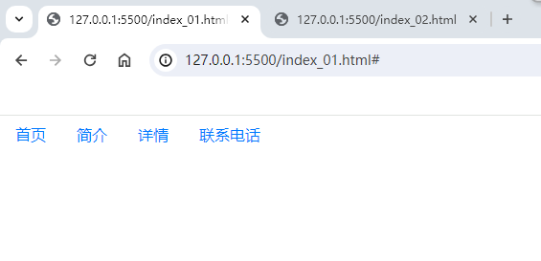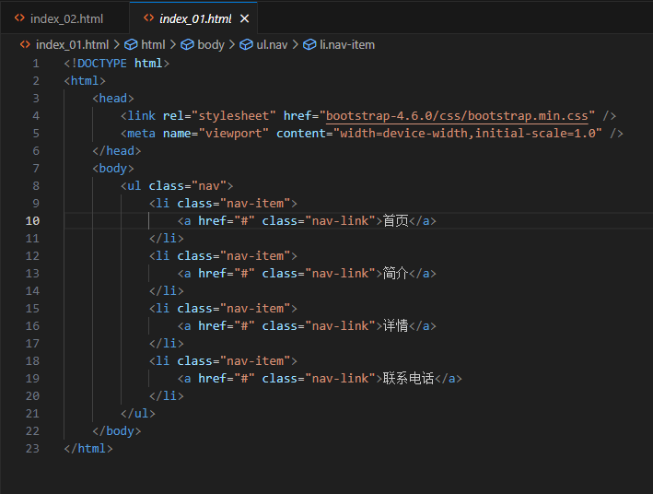

<!DOCTYPE html>

<html>

<head>

<link rel="stylesheet" href="bootstrap-4.6.0/css/bootstrap.min.css" />

<meta name="viewport" content="width=device-width,initial-scale=1.0" />

</head>

<body>

<ul class="nav">

<li class="nav-item">

<a href="#" class="nav-link">首页</a>

</li>

<li class="nav-item">

<a href="#" class="nav-link">简介</a>

</li>

<li class="nav-item">

<a href="#" class="nav-link">详情</a>

</li>

<li class="nav-item">

<a href="#" class="nav-link">联系电话</a>

</li>

</ul>

</body>

</html>

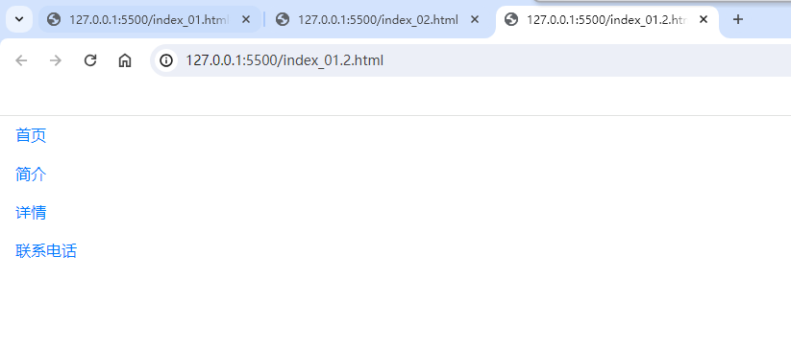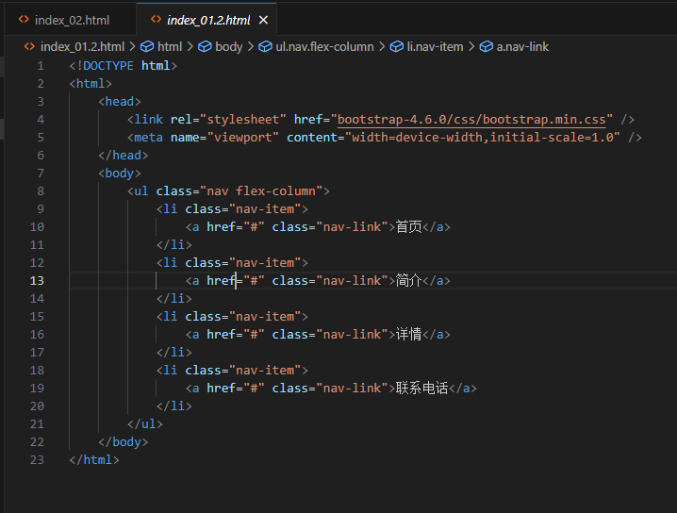

<!DOCTYPE html>

<html>

<head>

<link rel="stylesheet" href="bootstrap-4.6.0/css/bootstrap.min.css" />

<meta name="viewport" content="width=device-width,initial-scale=1.0" />

</head>

<body>

<ul class="nav flex-column">

<li class="nav-item">

<a href="#" class="nav-link">首页</a>

</li>

<li class="nav-item">

<a href="#" class="nav-link">简介</a>

</li>

<li class="nav-item">

<a href="#" class="nav-link">详情</a>

</li>

<li class="nav-item">

<a href="#" class="nav-link">联系电话</a>

</li>

</ul>

</body>

</html>

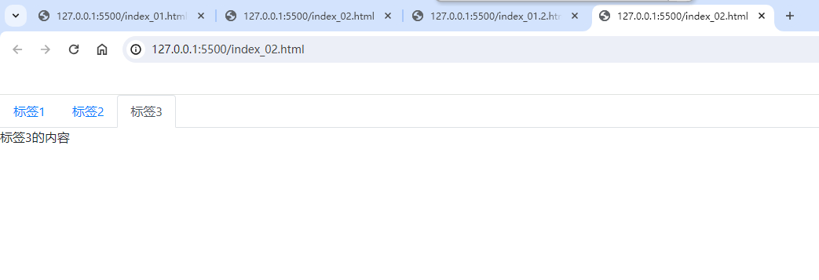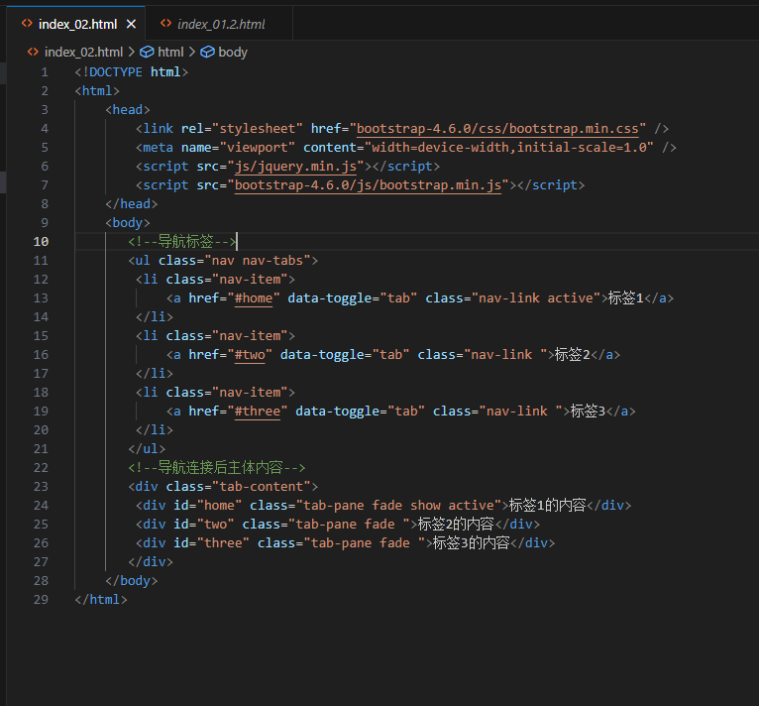

<!DOCTYPE html>

<html>

<head>

<link rel="stylesheet" href="bootstrap-4.6.0/css/bootstrap.min.css" />

<meta name="viewport" content="width=device-width,initial-scale=1.0" />

<script src="js/jquery.min.js"></script>

<script src="bootstrap-4.6.0/js/bootstrap.min.js"></script>

</head>

<body>

<!--导航标签-->

<ul class="nav nav-tabs">

<li class="nav-item">

<a href="#home" data-toggle="tab" class="nav-link active">标签1</a>

</li>

<li class="nav-item">

<a href="#two" data-toggle="tab" class="nav-link ">标签2</a>

</li>

<li class="nav-item">

<a href="#three" data-toggle="tab" class="nav-link ">标签3</a>

</li>

</ul>

<!--导航连接后主体内容-->

<div class="tab-content">

<div id="home" class="tab-pane fade show active">标签1的内容</div>

<div id="two" class="tab-pane fade ">标签2的内容</div>

<div id="three" class="tab-pane fade ">标签3的内容</div>

</div>

</body>

</html>

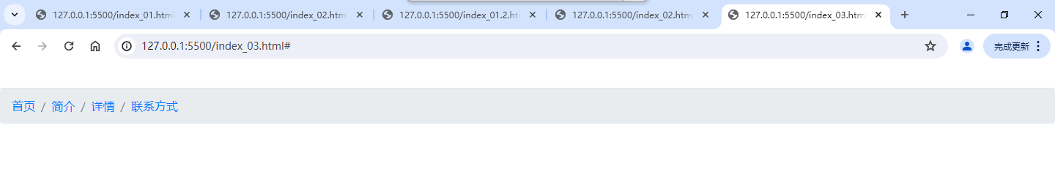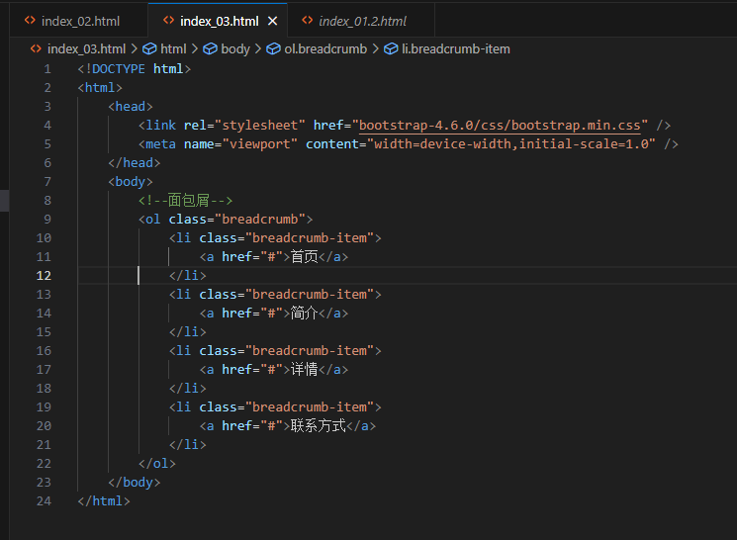

<!DOCTYPE html>

<html>

<head>

<link rel="stylesheet" href="bootstrap-4.6.0/css/bootstrap.min.css" />

<meta name="viewport" content="width=device-width,initial-scale=1.0" />

</head>

<body>

<!--面包屑-->

<ol class="breadcrumb">

<li class="breadcrumb-item">

<a href="#">首页</a>

</li>

<li class="breadcrumb-item">

<a href="#">简介</a>

</li>

<li class="breadcrumb-item">

<a href="#">详情</a>

</li>

<li class="breadcrumb-item">

<a href="#">联系方式</a>

</li>

</ol>

</body>

</html>

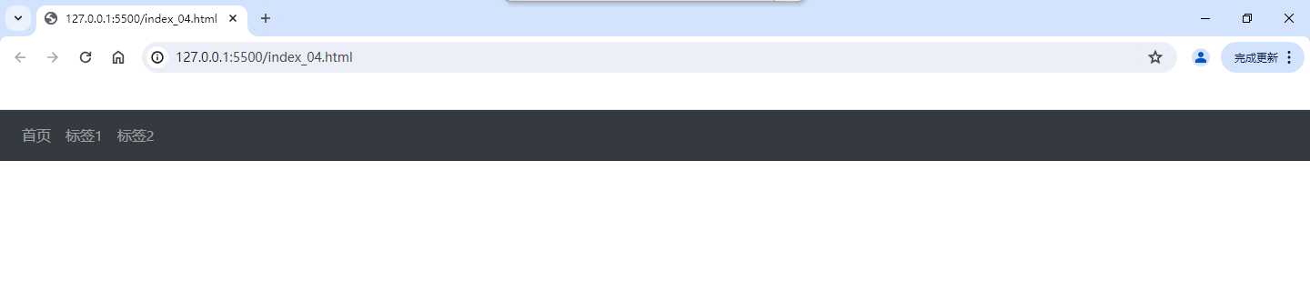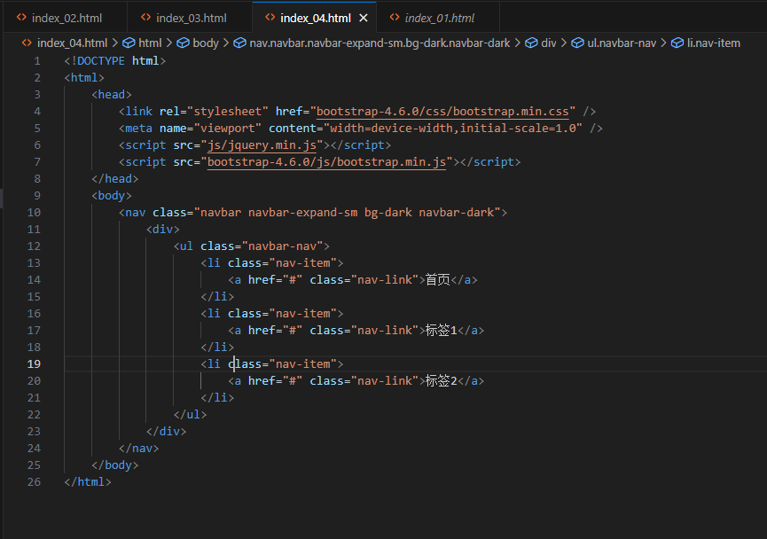

<!DOCTYPE html>

<html>

<head>

<link rel="stylesheet" href="bootstrap-4.6.0/css/bootstrap.min.css" />

<meta name="viewport" content="width=device-width,initial-scale=1.0" />

<script src="js/jquery.min.js"></script>

<script src="bootstrap-4.6.0/js/bootstrap.min.js"></script>

</head>

<body>

<nav class="navbar navbar-expand-sm bg-dark navbar-dark">

<div>

<ul class="navbar-nav">

<li class="nav-item">

<a href="#" class="nav-link">首页</a>

</li>

<li class="nav-item">

<a href="#" class="nav-link">标签1</a>

</li>

<li class="nav-item">

<a href="#" class="nav-link">标签2</a>

</li>

</ul>

</div>

</nav>

</body>

</html>

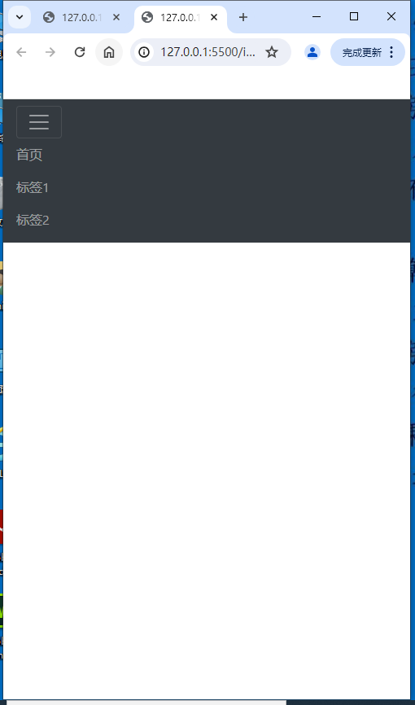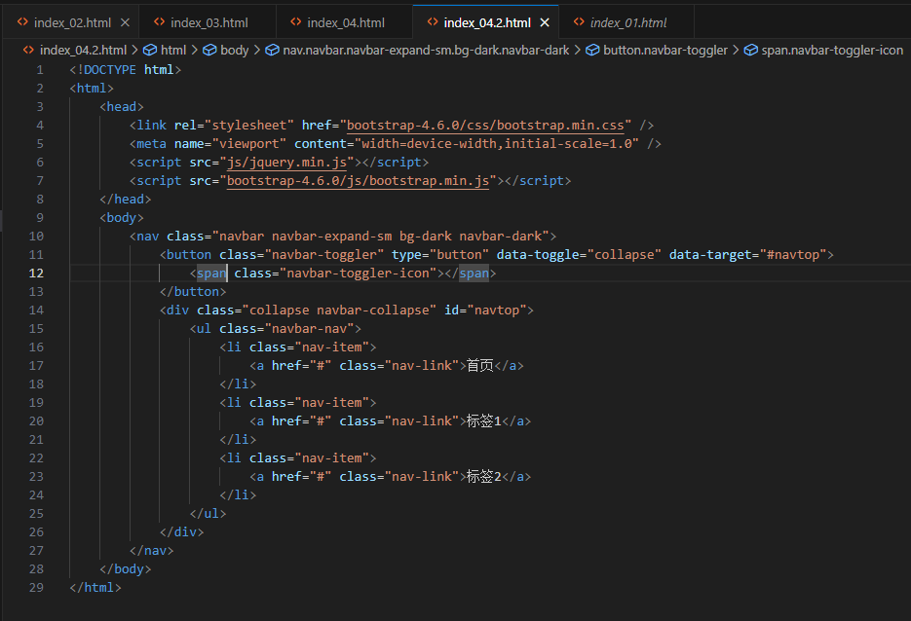

<!DOCTYPE html>

<html>

<head>

<link rel="stylesheet" href="bootstrap-4.6.0/css/bootstrap.min.css" />

<meta name="viewport" content="width=device-width,initial-scale=1.0" />

<script src="js/jquery.min.js"></script>

<script src="bootstrap-4.6.0/js/bootstrap.min.js"></script>

</head>

<body>

<nav class="navbar navbar-expand-sm bg-dark navbar-dark">

<button class="navbar-toggler" type="button" data-toggle="collapse" data-target="#navtop">

<span class="navbar-toggler-icon"></span>

</button>

<div class="collapse navbar-collapse" id="navtop">

<ul class="navbar-nav">

<li class="nav-item">

<a href="#" class="nav-link">首页</a>

</li>

<li class="nav-item">

<a href="#" class="nav-link">标签1</a>

</li>

<li class="nav-item">

<a href="#" class="nav-link">标签2</a>

</li>

</ul>

</div>

</nav>

</body>

</html>

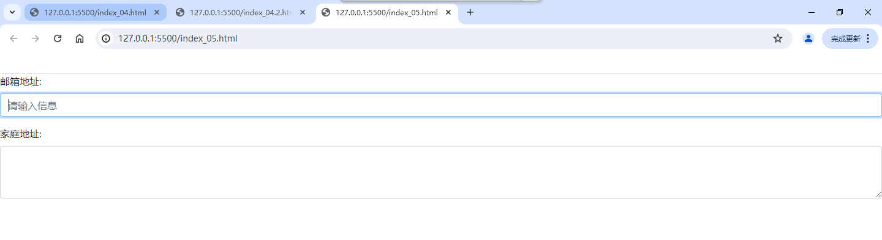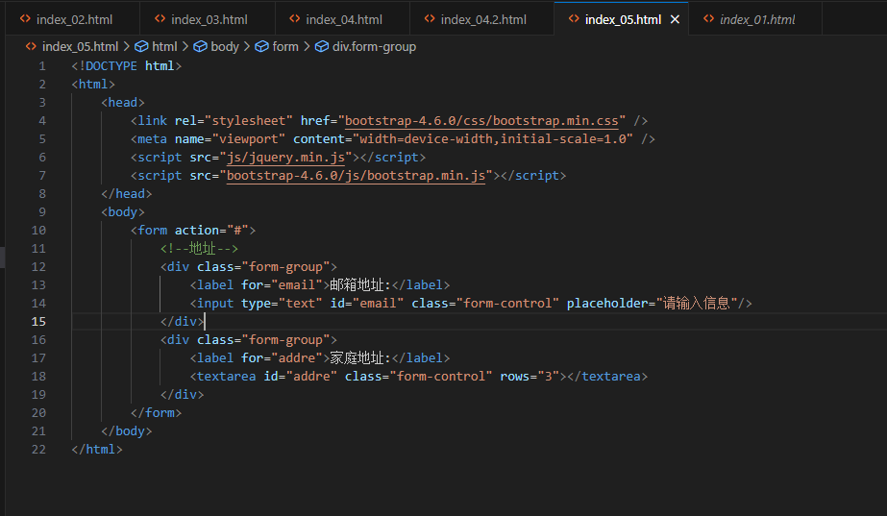

<!DOCTYPE html>

<html>

<head>

<link rel="stylesheet" href="bootstrap-4.6.0/css/bootstrap.min.css" />

<meta name="viewport" content="width=device-width,initial-scale=1.0" />

<script src="js/jquery.min.js"></script>

<script src="bootstrap-4.6.0/js/bootstrap.min.js"></script>

</head>

<body>

<form action="#">

<!--地址-->

<div class="form-group">

<label for="email">邮箱地址:</label>

<input type="text" id="email" class="form-control" placeholder="请输入信息"/>

</div>

<div class="form-group">

<label for="addre">家庭地址:</label>

<textarea id="addre" class="form-control" rows="3"></textarea>

</div>

</form>

</body>

</html>

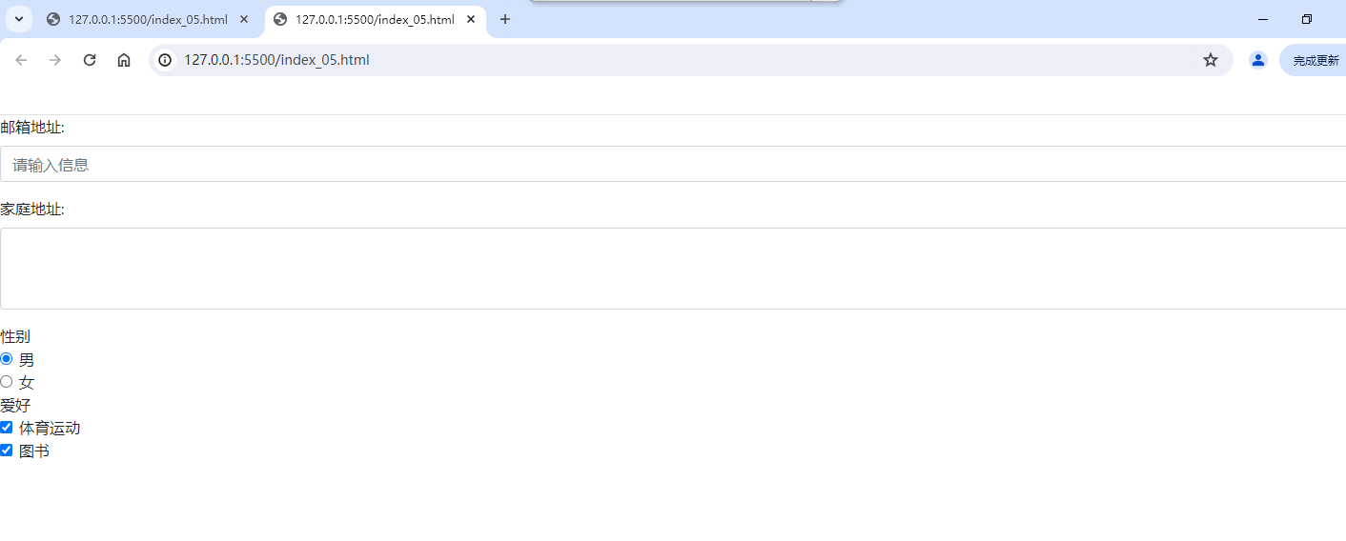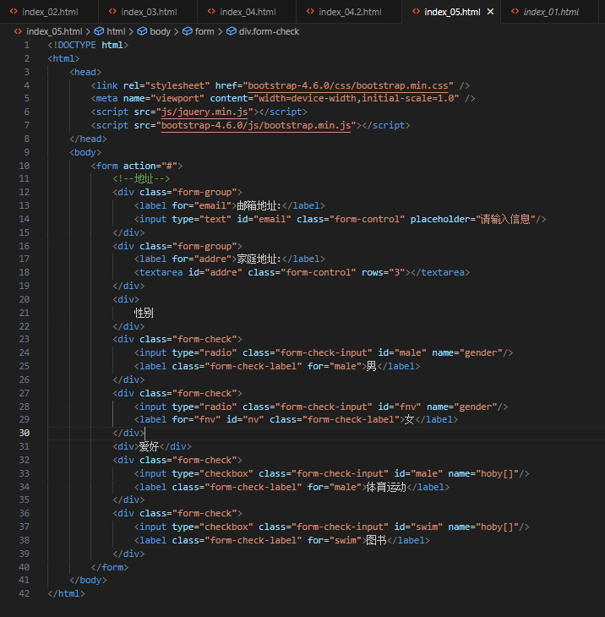

<!DOCTYPE html>

<html>

<head>

<link rel="stylesheet" href="bootstrap-4.6.0/css/bootstrap.min.css" />

<meta name="viewport" content="width=device-width,initial-scale=1.0" />

<script src="js/jquery.min.js"></script>

<script src="bootstrap-4.6.0/js/bootstrap.min.js"></script>

</head>

<body>

<form action="#">

<!--地址-->

<div class="form-group">

<label for="email">邮箱地址:</label>

<input type="text" id="email" class="form-control" placeholder="请输入信息"/>

</div>

<div class="form-group">

<label for="addre">家庭地址:</label>

<textarea id="addre" class="form-control" rows="3"></textarea>

</div>

<div>

性别

</div>

<div class="form-check">

<input type="radio" class="form-check-input" id="male" name="gender"/>

<label class="form-check-label" for="male">男</label>

</div>

<div class="form-check">

<input type="radio" class="form-check-input" id="fnv" name="gender"/>

<label for="fnv" id="nv" class="form-check-label">女</label>

</div>

<div>爱好</div>

<div class="form-check">

<input type="checkbox" class="form-check-input" id="male" name="hoby[]"/>

<label class="form-check-label" for="male">体育运动</label>

</div>

<div class="form-check">

<input type="checkbox" class="form-check-input" id="swim" name="hoby[]"/>

<label class="form-check-label" for="swim">图书</label>

</div>

</form>

</body>

</html>

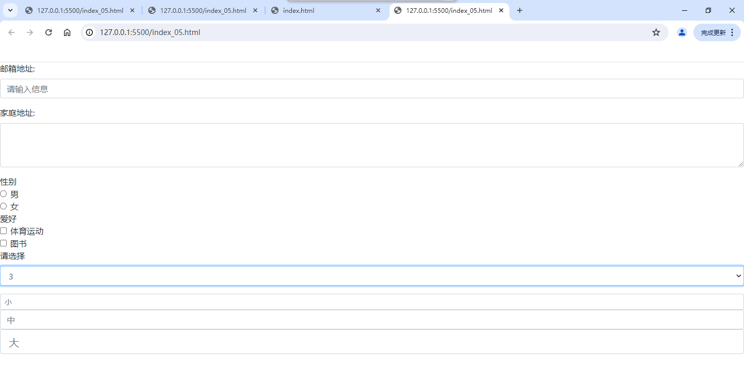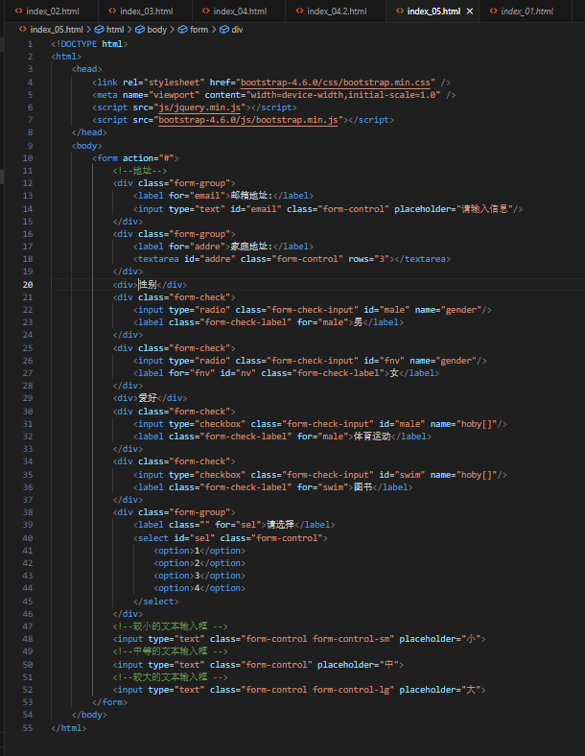

<!DOCTYPE html>

<html>

<head>

<link rel="stylesheet" href="bootstrap-4.6.0/css/bootstrap.min.css" />

<meta name="viewport" content="width=device-width,initial-scale=1.0" />

<script src="js/jquery.min.js"></script>

<script src="bootstrap-4.6.0/js/bootstrap.min.js"></script>

</head>

<body>

<form action="#">

<!--地址-->

<div class="form-group">

<label for="email">邮箱地址:</label>

<input type="text" id="email" class="form-control" placeholder="请输入信息"/>

</div>

<div class="form-group">

<label for="addre">家庭地址:</label>

<textarea id="addre" class="form-control" rows="3"></textarea>

</div>

<div>性别</div>

<div class="form-check">

<input type="radio" class="form-check-input" id="male" name="gender"/>

<label class="form-check-label" for="male">男</label>

</div>

<div class="form-check">

<input type="radio" class="form-check-input" id="fnv" name="gender"/>

<label for="fnv" id="nv" class="form-check-label">女</label>

</div>

<div>爱好</div>

<div class="form-check">

<input type="checkbox" class="form-check-input" id="male" name="hoby[]"/>

<label class="form-check-label" for="male">体育运动</label>

</div>

<div class="form-check">

<input type="checkbox" class="form-check-input" id="swim" name="hoby[]"/>

<label class="form-check-label" for="swim">图书</label>

</div>

<div class="form-group">

<label class="" for="sel">请选择</label>

<select id="sel" class="form-control">

<option>1</option>

<option>2</option>

<option>3</option>

<option>4</option>

</select>

</div>

<!--较小的文本输入框 -->

<input type="text" class="form-control form-control-sm" placeholder="小">

<!--中等的文本输入框 -->

<input type="text" class="form-control" placeholder="中">

<!--较大的文本输入框 -->

<input type="text" class="form-control form-control-lg" placeholder="大">

</form>

</body>

</html>