## 

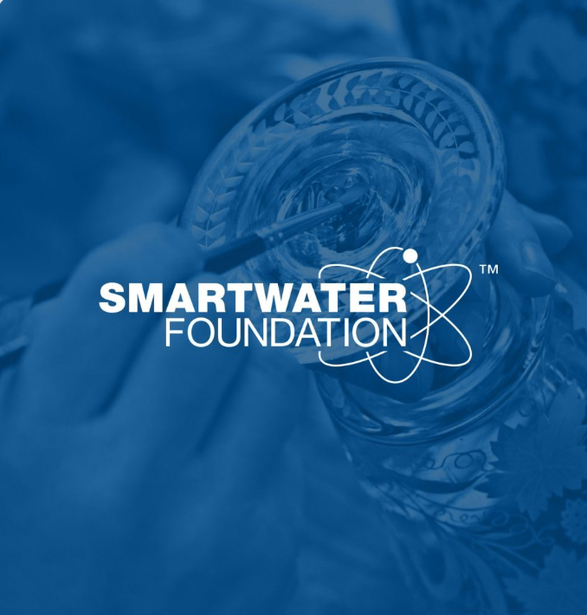

Smart water foundation using IOT

# Overview

Implementation of IOT technology contributes to improving water management practices specifically through the smart water foundation approach

# Goals

1. To ensure the availability of clean water for future generations while preserving the environment
2. To develop and implement smart water management strategies that enable communities and industries to utilize water resources efficiently
3. Aim to achieve this by leveraging advanced technologies, conducting research, and promoting education and awareness

# Current projects

# Smart Irrigation Systems

We are working on developing intelligent irrigation systems that optimize water usage in agriculture, minimizing waste while maximizing crop yield.

**Water Quality Monitoring**

Through our partnerships, we are implementing real-time monitoring systems to assess water quality and identify potential risks and contamination sources.

**Smart Leak Detection**

Our teams are actively researching and deploying smart leak detection technologies to minimize water loss and prevent infrastructure damage..

# Future Plans and Aspirations

## Expansion of Projects

We aim to expand our current projects to reach more communities and industries, extending the impact of our sustainable water management efforts.

## Technology Advancements

We will continue to explore and invest in cutting-edge technologies and innovations to enhance our water management solutions and address emerging water-related challenges.