**DESIGN**

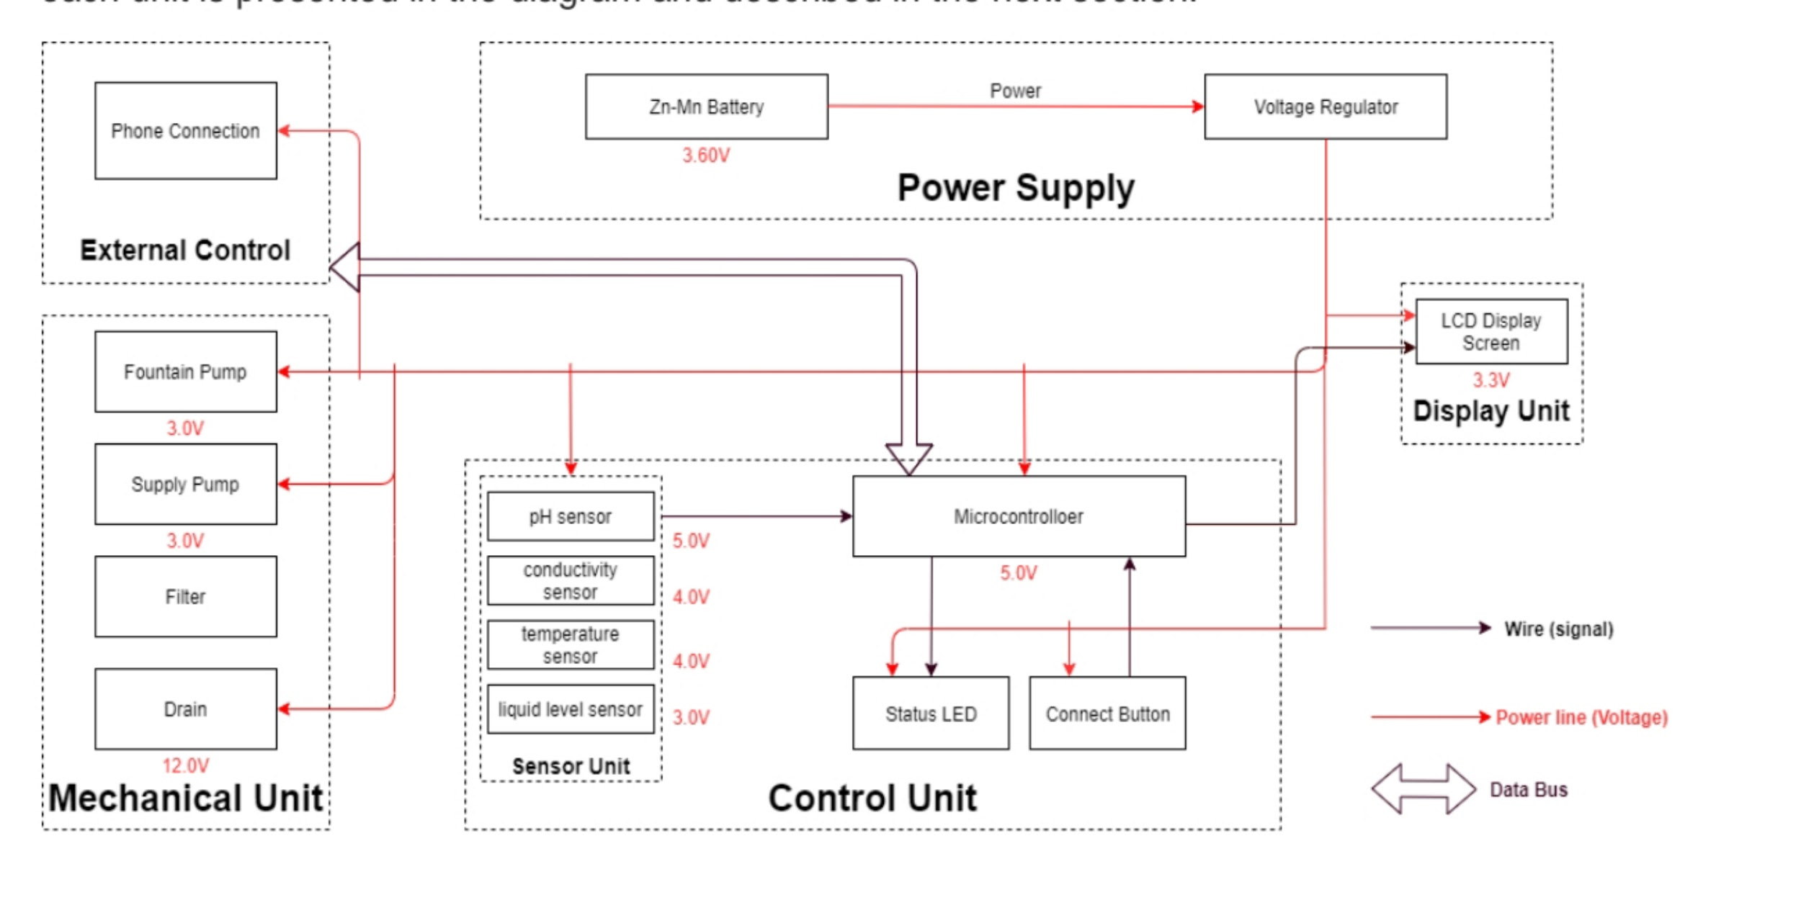

**Sensor Unit :**

* This block contains the four sensors.
* The data acquired from the sensors will be transmitted to the control unit.
* Control unit will then have some logic designed to send corresponding signals to control other blocks of the water fountain.
* At the same time, the display screen on the water fountain will display the readings along with the determined water quality level and remaining water quantity.
* For the PH-value sensor, temperature sensor and conductivity sensor, values will be retrieved and calculated to determine the overall water quality level.
* When poor water quality is determined, the water replacement procedures will take place.
* The weight sensor readings will be used to determine the amount of fresh water left in the water tank.
* **Temperature Sensor:**

A water-proof temperature sensor is going to be used. Part number from sparkfun is:

DS18B20 [6]. This temperature sensor is compatible with a relatively wide range of power

supply from 3.0V to 5.5V. The measured temperature ranges from -55 to +125 celsius

degrees. Between -10 to + 85 degrees, the accuracy is up to +-0.5 degrees. This sensor can

fulfill all requirements needed for this project.

* **PH-sensor:**

PH value is a valued indicator of water quality. This PH-sensor[7] works with 5V voltage,

which is also compatible with the temperature sensor. It can 6measure the PH value from 0

to 14 with an accuracy of +- 0.1 at the temperature of 25 degrees.

* **Conductivity sensor:**

Conductivity sensor is also part of the water quality assessment. The input voltage is from

3.0 to 5.0V. The error is small, +-5%F.S. The measurement value ranges from 0 to 20

ms/cm which is enough for water quality monitoring.

* **Liquid Level Sensor:**

This sensor [9] is responsible for reflecting how much freshwater is left in the water tank.

When the water level is low, fresh water will be pumped to the water tank to ensure the

water fountain keeps running with freshwater. This sensor is 0.5 Watts. For water level from

0 to 9 inches, the corresponding sensor outputs readings from 0 to 1.6. From that, the

quantity of freshwater left can be determined.

**Display unit:**

* **Screen**:

The screen will be used to display the readings from the sensors in a real-time manner.

In addition, other necessary information will also be displayed. As described in the sensor

part, the water quality and remaining water quantity will be displayed. The screen will be

programmed so that it makes it easy for users to read information.

This 20*4 LCD display screen is going to be used to display the relevant information. After

programming the screen, a conclusion of water quality(Good, Average, Poor) will be

displayed along with the remaining water level.

**Power Supply Unit**

* **Zn-Mn Battery**

The Zn-Mn battery must be able to continuously support the functioning of the circuit, display

unit, and the mechanical unit.

Requirement: Commercial batteries will be used to maintain a continuous 3.60V power

supply for at least 24 hours. If the chosen battery is not powerful enough, 120V power

outlets will be considered.

* **Voltage regulator**

The integrated circuit will regulate the power supply for each module to maintain their

functionality. This chip must be able to handle the maximum voltage supplied by the battery

(3.60V ± 0.5V) while ensuring the voltage at each module does not exceed their limit.

Requirement: Must maintain thermal stability below 100°C.

**Mechanical Unit**

* **Fountain Pump**

The fountain pump must maintain a continuous water supply through the fountain

mechanism. The pump must work 24 hours a day, 7 days a week unless the user manually

turns off the power supply.

Requirement 1: The fountain pump must lift a cylindrical water stream of diameter 6mm for a

height of 400mm.

Requirement 2: The fountain pump must serve for a duration of 2 years without maintenance

or replacement under heavy workload. Requirement 3: The fountain pump should have an operational condition around 3V, 200mA.

* **Supply Pump**

The supply pump must function when a low water level alert is raised. While no water supply

is requested, the pump must prevent water flow between the main supply and the fountain.

Requirement: The supply pump should have an operational condition around 3V, 200mA.

* **Filter**

The filter must maintain the water quality through controlling the pH value and conductivity of

the water.

Requirement 1: The filter must have a cost less than $5 each for frequent replacement.

Each new filter must serve a duration no less than 3 month.

Requirement 2: The filter must be designed for easy removal and installation, while the

connection mechanism must have a low degenerate rate when submerged in water.

* **Drain**

The drain must be able to hold and release water in the fountain. When water in the

fountain should be replaced, the faucet should automatically drain the fountain once

instruction is received from the integrated circuit.

**PYTHON SCRIPT:**

import time

import RPi.GPIO as GPIO # Assuming you're using a Raspberry Pi

# Define GPIO pins for sensors and actuators

WATER_LEVEL_SENSOR_PIN = 17

PUMP_PIN = 18

# Initialize GPIO

GPIO.setmode(GPIO.BCM)

GPIO.setup(WATER_LEVEL_SENSOR_PIN, GPIO.IN)

GPIO.setup(PUMP_PIN, GPIO.OUT)

def check_water_level():

# Function to check water level using the sensor

# Implement logic to read the sensor and return water level status

pass

def control_pump(status):

# Function to control the pump

# Turn pump on (status = True) or off (status = False)

pass

if __name__ == "__main__":

try:

while True:

water_level = check_water_level()

if water_level:

print("Water level is low. Turning on the pump.")

control_pump(True)

else:

print("Water level is sufficient.")

control_pump(False)

time.sleep(10) # Adjust the delay based on your requirements

except KeyboardInterrupt:

GPIO.cleanup() # Cleanup GPIO on exit