**Practical – 1**

**AIM:**

**Create a webpage demonstrating “Spoural Event '' and its description, providing a link for registration page. Registration form of the student for “Spoural Event'' having different fields like type of event, event listing, Student ID/Group, Branch, etc**

**Source Code:**

<!DOCTYPE html>

<html lang="en">

<head>

    <meta charset="UTF-8">

    <meta http-equiv="X-UA-Compatible" content="IE=edge">

    <meta name="viewport" content="width=device-width, initial-scale=1.0">

    <title>Charusat</title>

</head>

<body>

    <form action="">

        <h1 style="text-align:center ;">Registration Form</h1>

        <div>

            <table align="center";>

                <tr> <td>NAME</td> <td><input type="text" placeholder="enter first name"></td></tr>

                <tr> <td>ID</td> <td><input type="text" placeholder="enter your id"></td></tr>

                <tr> <td>E-mail</td> <td><input type="email" placeholder="enter your email"></td></tr>

                <tr> <td>Phone Number</td> <td><input type="tel" placeholder="enter your mobile number"></td></tr>

                <tr> <td>Gender</td><td>

                        <input type="radio" name="1">Male

                        <input type="radio" name="1">Other

                        <input type="radio" name="1">Female

                     </td>

                </tr>

                <tr> <td>College</td><td>

                        <select>

                            <option value="">select</option>

                            <option value="cspit">CSPIT</option>

                            <option value="depstar">DEPSTAR</option>

                            <option value="cmpica">CMPICA</option>

                            <option value="pdpias">PDPIAS</option>

                            <option value="i2im">I2IM</option>

                            <option value="rpcp">RPCP</option>

                        </select>

                    </td>

                </tr>

                <tr> <td>Branch</td><td><input type="text" placeholder="enter your branch"></td></tr>

                <tr> <th colspan="2">Sport-Event</th></tr>

                <tr><td><input type="checkbox">Cricket</td><td><input type="checkbox">Volleyball</td></tr>

                <tr><td><input type="checkbox">Tug of war</td><td><input type="checkbox">Kabbadi</td></tr>

                <tr><td><input type="checkbox">Football</td><td><input type="checkbox">Table tennis</td></tr>

                <tr><td><input type="checkbox">Basketball</td><td><input type="checkbox">Chess</td></tr>

                <tr><th colspan="2">Cultural-Event</th></tr><tr><th colspan="2"><input type="text-area" placeholder="enter cultural event"></th></tr>

                <tr><th colspan="2"><button type="submit" value="Submit" style="background-color:rgb(63, 204, 124);">Submit</button></th></tr>

            </table>

        </div>

    </form>

</body>

</html>

**Output:**

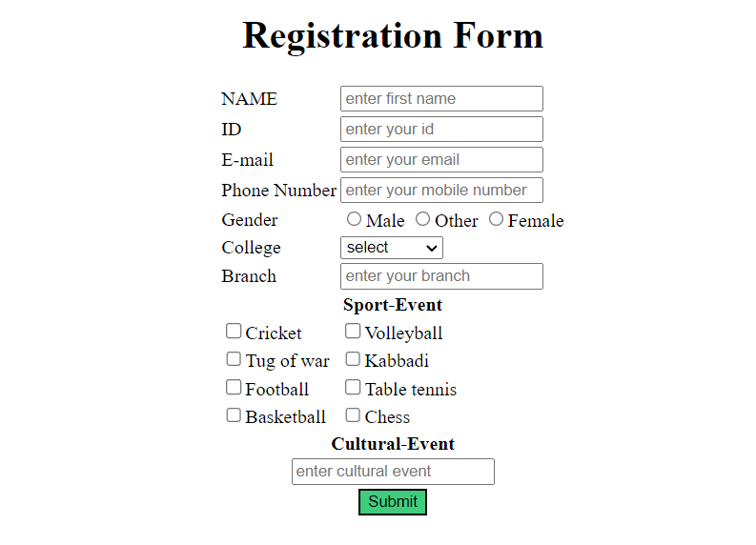

**Conclusion:** I learned about HTML. Different types of tags available to use to create a structural webpage or forms. From html we can create a structure like blueprint.

**Course Outcome:**

We should understand the tools and technology to improve our webpages.