**Practical-2**

**Aim:** Create Basic Calculator using prompt.

Create Basic Calculator using input box.

Do temperature Conversion using the input box and display the result on the Web Page. (Celsius to Fahrenheit)

**Source Code:**

HTML code:

<!DOCTYPE html>

<html lang="en">

<head>

    <meta charset="UTF-8">

    <meta http-equiv="X-UA-Compatible" content="IE=edge">

    <meta name="viewport" content="width=device-width, initial-scale=1.0">

    <title>Document</title>

    <script src="../example.js"></script>

</head>

<body>

    <h3>Calculator Using Prompt</h3>

        <select id="cal" onchange="calc()">

            <option value="null">Select</option>

            <option value="sum">Addition</option>

            <option value="sub">Subtraction</option>

            <option value="mul">Multiplication</option>

            <option value="div">Division</option>

        </select><br>

    <div id="demo1"></div><br><br>

    <h3>Calculator Using Textbox</h3>

    <input type="text" id="data1" placeholder="1st number"><br>

    <input type="text" id="data2" placeholder="2nd number"><br>&ensp;<button id="cal1" onclick="get(value)" value="sum">Addition</button>&emsp;&emsp;&emsp;<button id="cal1" onclick="get(value)" value="sub">Subtraction</button><br>

    &emsp;&emsp;&emsp;<button id="cal1" onclick="get(value)" value="mul">Multiplication</button>&emsp;&emsp;&ensp;<button id="cal1" onclick="get(value)" value="div">Division</button>

    <div id="demo2"></div><br><br>

    <h3>Temperature conversion</h3>

    <input type="text" id="data3" placeholder="0"><button id="b1" onclick="temp()">Convert</button>

    <h4 id="demo3"></h4>

</body>

</html>

JAVASCRIPT code:

function calc(){

    let x=document.getElementById("cal").value;

    let p = parseInt(prompt("Enter 1st number "));

    let q = parseInt(prompt("Enter 2nd number "));

    let c = 0

    if(x=="sum"){

    c = sum(p,q);

    }

    else if(x=="sub")

    c = sub(p,q);

    else if(x=="mul")

    c = mul(p,q);

    else if(x=="div")

    c = div(p,q);

    document.getElementById("demo1").innerHTML = "Answer is: " + c;

}

function get(y){

  // let y=document.getElementById("cal1").value;

  let p = parseInt(document.getElementById("data1").value);

  let q = parseInt(document.getElementById("data2").value);

  let c = 0

  if(y=="sum"){

    c = sum(p,q);

  }

  else if(y=="sub"){

    c = sub(p,q);

  }

  else if(y=="mul"){

    c = mul(p,q);

  }

  else if(y=="div"){

    c = div(p,q);

  }

  document.getElementById("demo2").innerHTML = "Answer is: " + c;

}

function sum(p1,p2) {

    let sm=p1+p2;

    return sm

  }

  function sub(p1,p2) {

    let sm=p1-p2;

    return sm

  }

  function mul(p1,p2) {

    let sm=p1*p2;

    return sm

  }

  function div(p1,p2) {

    let sm=p1/p2;

    return sm;

  }

  function temp(){

    let t1 = parseFloat(document.getElementById("data3").value)

    let t2 = parseFloat((t1 * parseFloat(9/5)) + 32);

    document.getElementById("demo3").innerHTML = t2;

  }

**Output:**

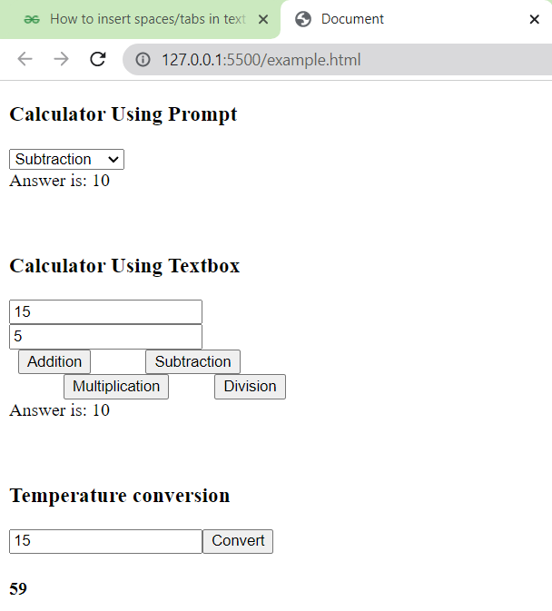

**Conclusion:** In this practical we have learned about basics of java script and how to take input using prompt and from checkbox how to do function calling for different tasks. and trace values from webpage to java script code for logical computing.