

KGiSL Institute of Technology

NAAN MUDHALVAN

Project title :

Public Health Awareness

TEAM MEMBERS:

* Mersheena.F
* Dhiviya Shree.K
* Navin.c
* Surya.S P P

PROJECT DESCRIPTION :

**PHASE 4 : Development On The Public Health Awareness DataSet**

OBJECTIVE :

STEPS :

IN GOOGLE COLAB NOTEBOOK:

* Mount the google drive
* Load the DataSet to the Google ColabNotebook

DESCRIPTIVE ANALYSIS :

* Frequency
* Proposition
* Summary Statistics & Reports
* Corelation
* Graph Representation

DESCRIPTIVE ANALYSIS :

FREQUENCY:

code :

# Frequency of treatement :

response_counts = id['treatment'].value_counts()

print(response_counts)

output:

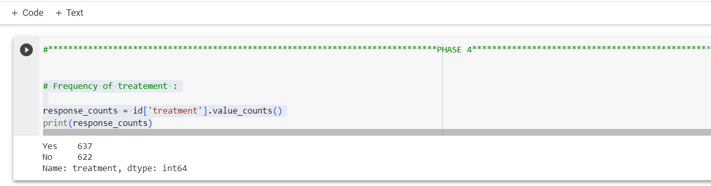

PROPOSITION:

code:

#Proposition :

response_proportions = id['treatment'].value_counts(normalize=True)

print(response_proportions)

output:

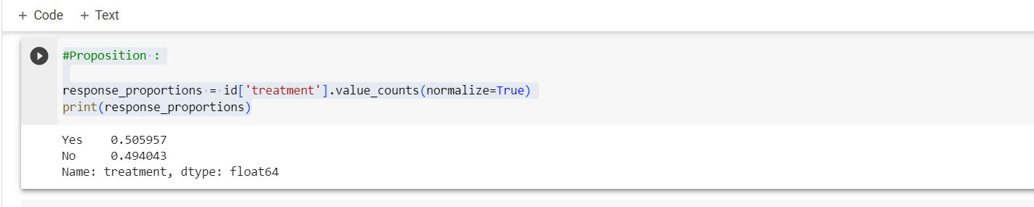

SUMMARY STATISTICS :

code :

#SUMMARY STATISTICS FOR TREATMENT :

# summary statistics for "Yes" responses

yes_stats = id[id['treatment'] == 'Yes'].describe()

print(yes_stats)

output :

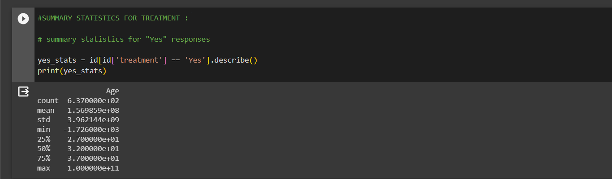

code:

#summary statistics for "No" responses

no_stats = id[id['treatment'] == 'No'].describe()

print(no_stats)

output:

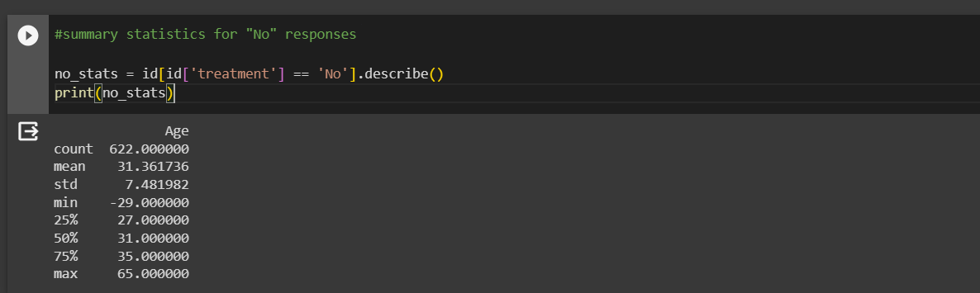

GRAPH REPRESENTATION :

code:

#BAR GRAPH :

import matplotlib.pyplot as plt

plt.bar(response_counts.index,response_counts.values,color='skyblue',edgecolor='k')

plt.xlabel('Treatment')

plt.ylabel('Count')

plt.title('Distribution of Satisfaction Responses')

plt.show()

output :

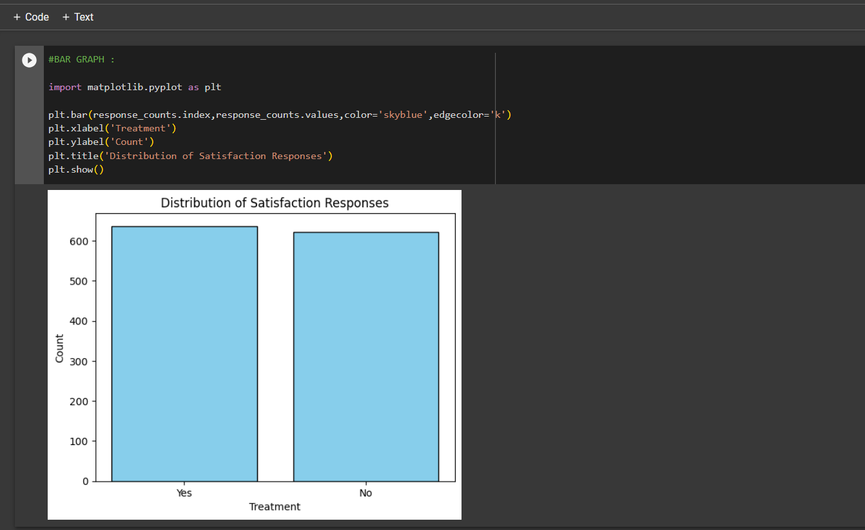

code :

#HISTOGRAM FOR AGE DISTRIBUTION :

data=id.Age

plt.hist(data, bins=5, edgecolor='k',color='pink')

plt.xlabel('Values')

plt.ylabel('Frequency')

plt.title('Histogram for Age  Distribution')

plt.show()

output :

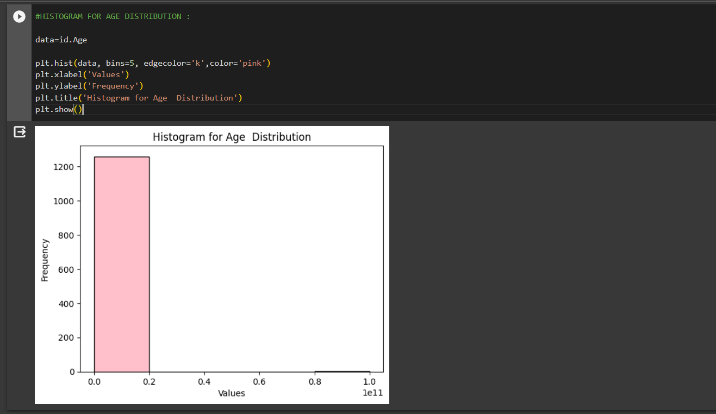

CORELATION :

code:

#CORELATION :

import pandas as pd

import matplotlib.pyplot as plt

import seaborn as sns

# Correlation heatmap

correlation_matrix = id .corr()

plt.figure(figsize=(8, 6))

sns.heatmap(correlation_matrix, annot=True, cmap='coolwarm', fmt=".2f")

plt.title('Correlation Heatmap')

plt.show()

output :

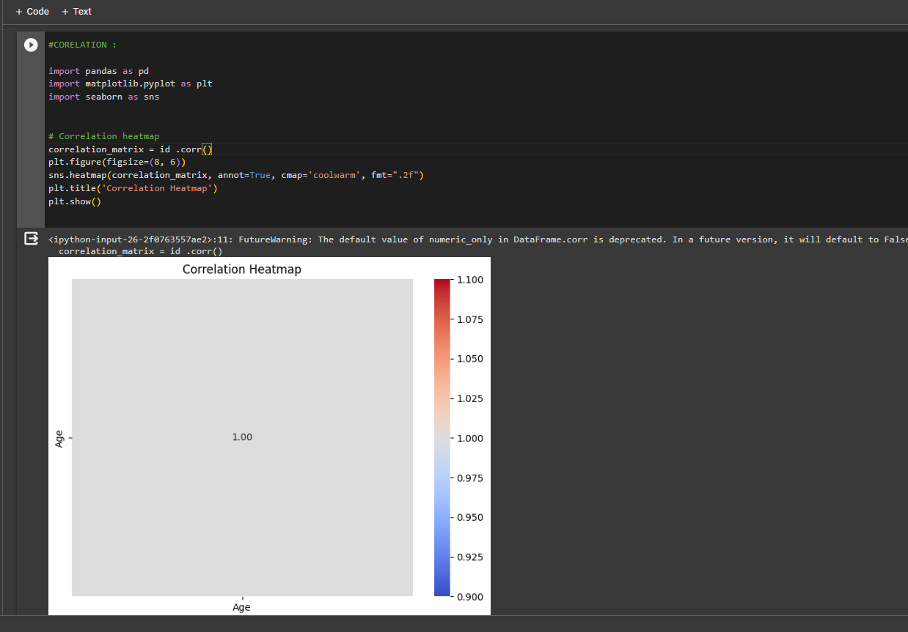

SUMMARY REPORTS:

code:

#SUMMARY REPORTS FOR TREATMENT MADE :

# Calculate key statistics

total_responses = len(id)

yes_responses = (id['treatment'] == 'Yes').sum()

no_responses = total_responses - yes_responses

yes_percentage = (yes_responses / total_responses) * 100

no_percentage = 100 - yes_percentage

# Generate a summary report

summary_report = f"""

--------------------------

Summary Report

--------------------------

Total Responses: {total_responses}

Yes Responses: {yes_responses} ({yes_percentage:.2f}%)

No Responses: {no_responses} ({no_percentage:.2f}%)

Distribution of Satisfaction Responses:

See the bar chart below.

--------------------------

"""

print(summary_report)

output :

