

**DEPARTMENT OF ELECTRICAL AND ELECTRONICS ENGINEERING**

**(2023-2024)**

**Internship and mini project based on python programming with Data Engineer**

**Project title: scholastic achievement dashboard**

**In**  **accordance with requirement of degree of**

**BACHELOR OF TECHNOLOGY**

**In**

**ELECTRICAL AND ELECTRONICS ENGINEERING**

**Submitted by:**

**G.sireesha**

**21KQ1A0207**

**Date: 11-06-2024**

**STUDENT’S DECLARATION**

I ,G.sireeshaa student of **Bachelor of Technology** Program, Reg. No. **21KQ1A0207** of the Department of **Electrical and Electronics Engineering, PACE Institute of Technology and Sciences, Ongole** do hereby declare that I have completed the Skill Oriented Course-III from **25/10/2023** to **31/10/2023** in **SV TECHNOLOGIES, NELLORE** under the Faculty Mentorship of **B.VENKATESH** Asst. Prof, Department of **Electrical and Electronics Engineering**.

**(Signature of student & date)**

Scholastic achievement dashboard

Description:- Firstly, it computes the total marks for each student by summing up their scores across all subjects. Secondly, it identifies the minimum and maximum marks attained by each student, providing insights into their performance spectrum. Furthermore, the code sorts the marks of each subject, allowing for a clearer understanding of the distribution and trends within individual subjects. Lastly, it ensures accuracy by avoiding the duplication of marks while calculating the total sum for each student, thereby presenting a reliable overview of their scholastic achievements. By integrating these functionalities, the code offers a comprehensive and organized platform for assessing student performance, aiding educators, students, and parents alike in monitoring progress and identifying areas for improvement.

Requirement:-Top of Form

1.sum of all subjects score of each student

2.sorting of total score

3.printing the sum of all subjects of each student without duplicates.

4.minmum,maximum marks among all subjects of each student.

5.average marks among all subjects of each student

6.sorting of each student marks in all subjects

7.maximum score in each subject

8.minimum,maximum of sum of total marks in all subjects.

Approach:-

1. Finding the sum of all subjects:

I can create a function that takes in the marks of each student as input and calculates the sum of all subjects for that student. Within this function, you'll iterate over the marks for each subject and accumulate the sum.

2. Minimum and maximum marks gained by each student:

Similar to finding the sum, We can create a function that takes in the marks of each student as input and calculates both the minimum and maximum marks. Within this function, I iterate over the marks and update variables to track the minimum and maximum values.

3. Sorting of each subject's marks:

For this functionality, We can create a function that takes in the marks of all students for a particular subject and sorts them in ascending or descending order using Python's built-in sorting functions (sorted() or .sort()).

4. Avoiding duplicate sum of marks:

To prevent counting the same subject's marks multiple times for a student, I can use a data structure like a set or dictionary to keep track of which subjects have been included in the total sum calculation for each student. Before adding marks to the total sum, you'll check if the subject has already been included.

Code:-

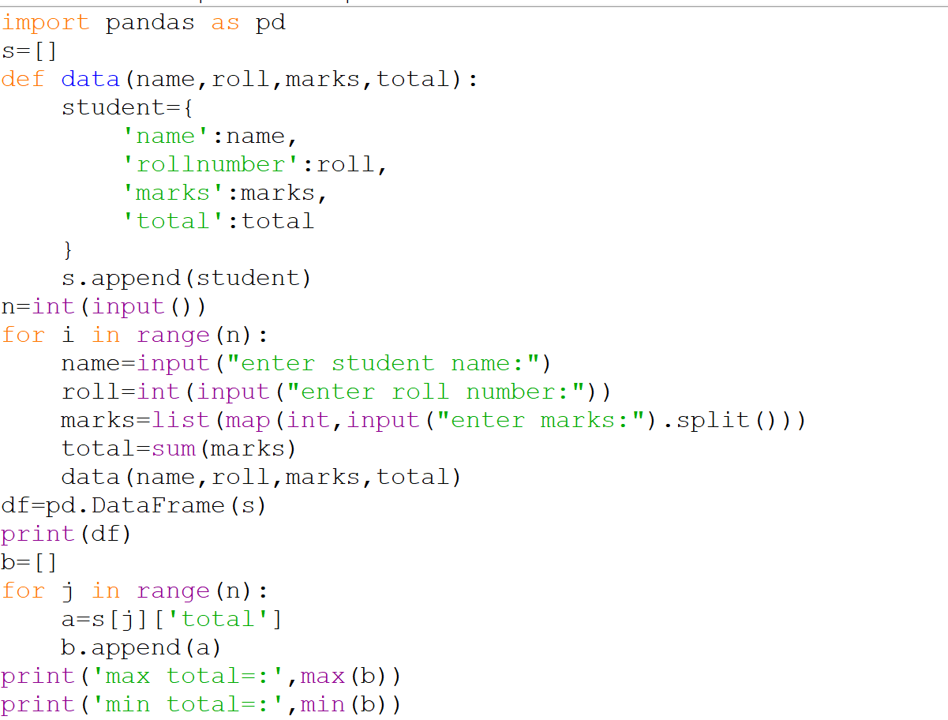

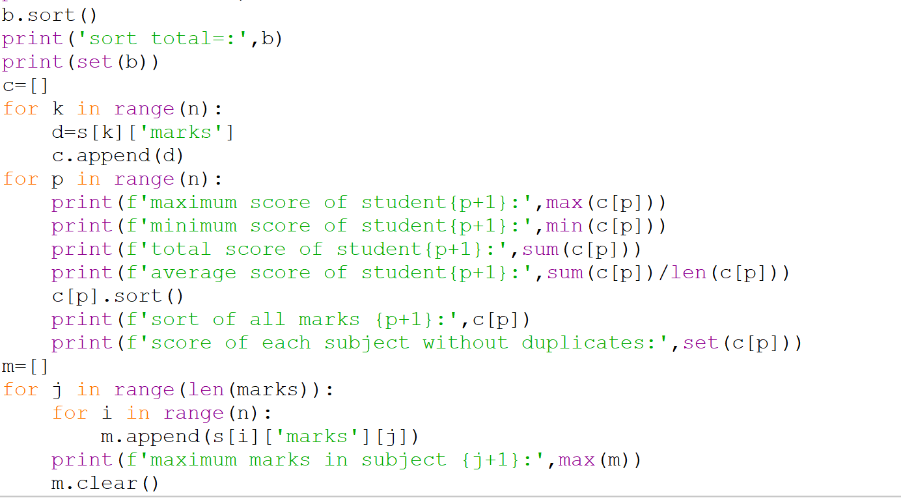

Output:-

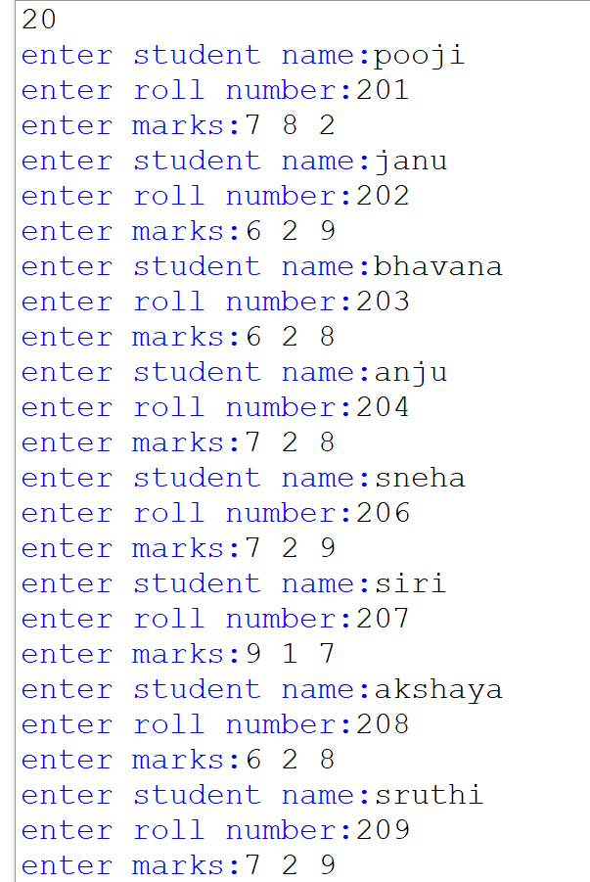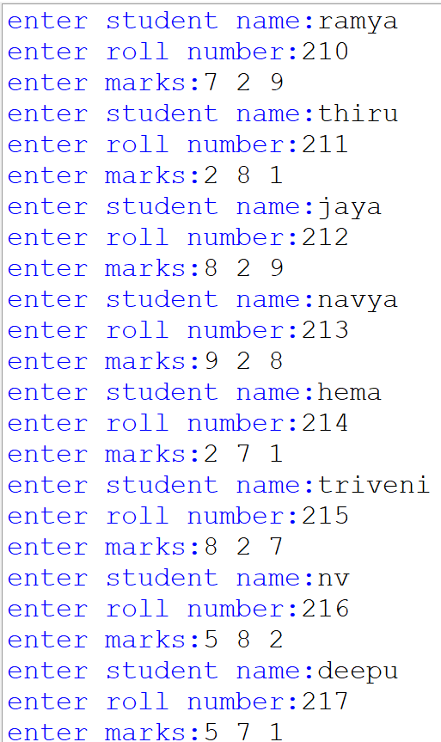

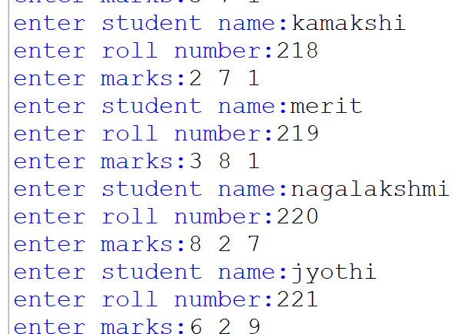

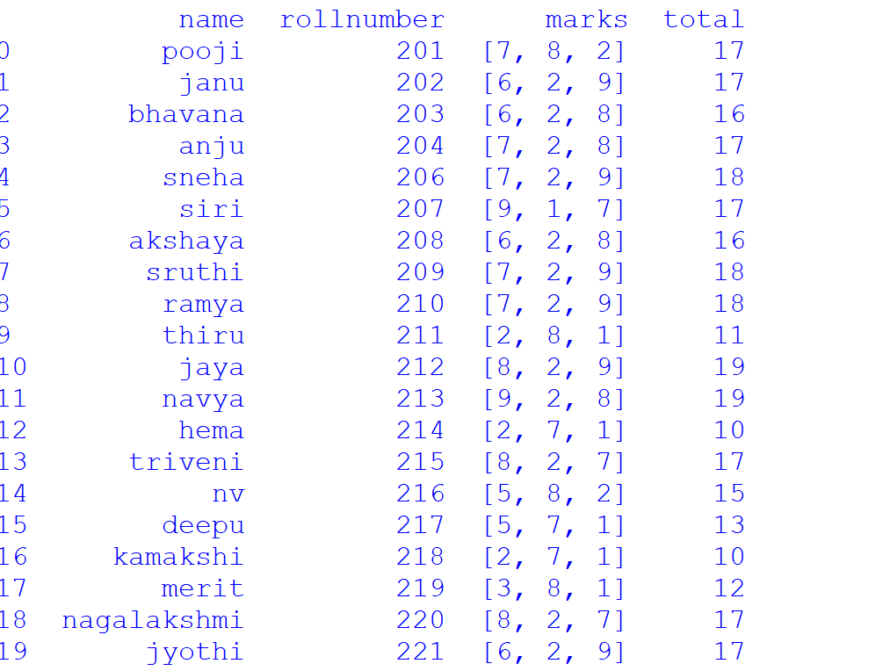

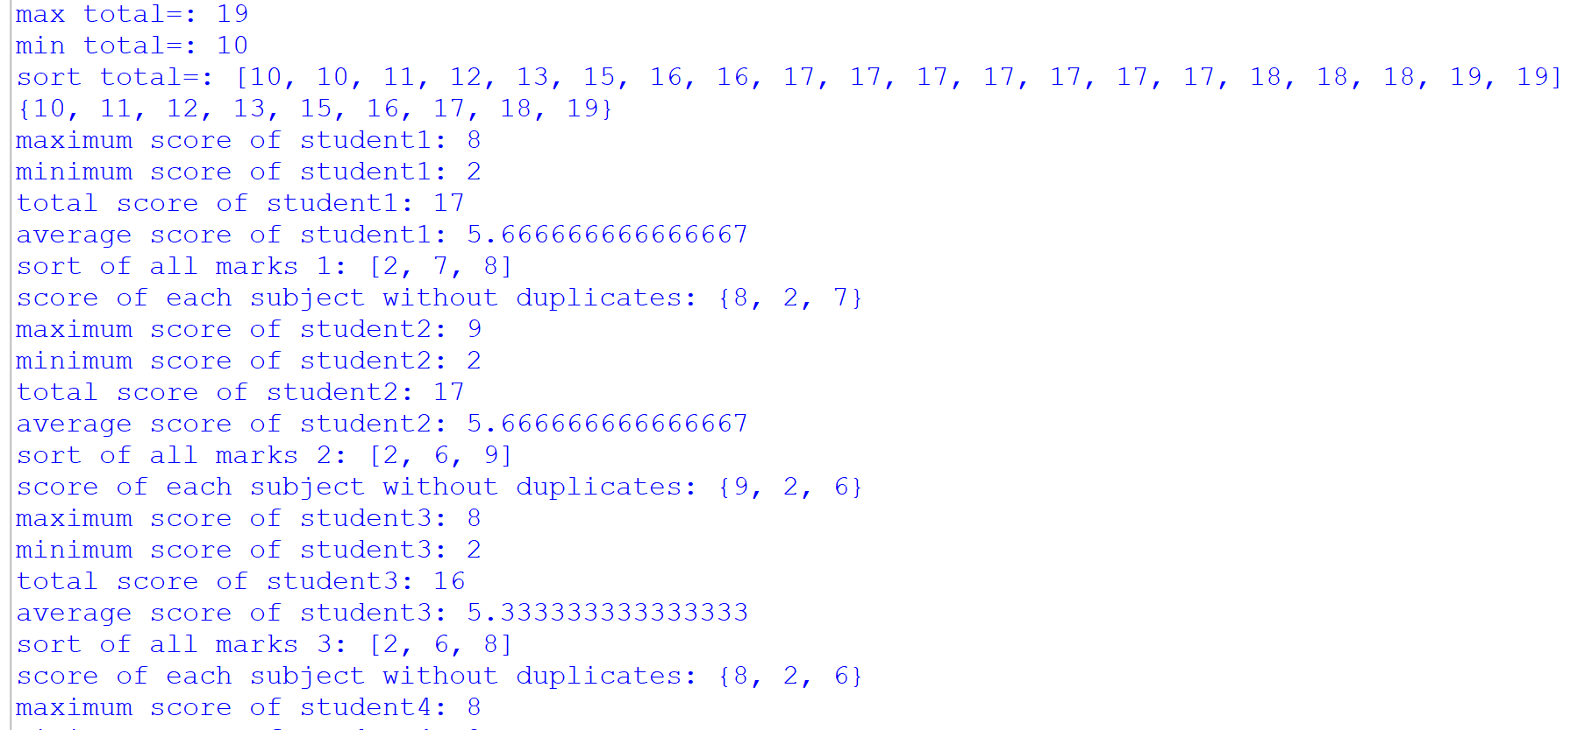

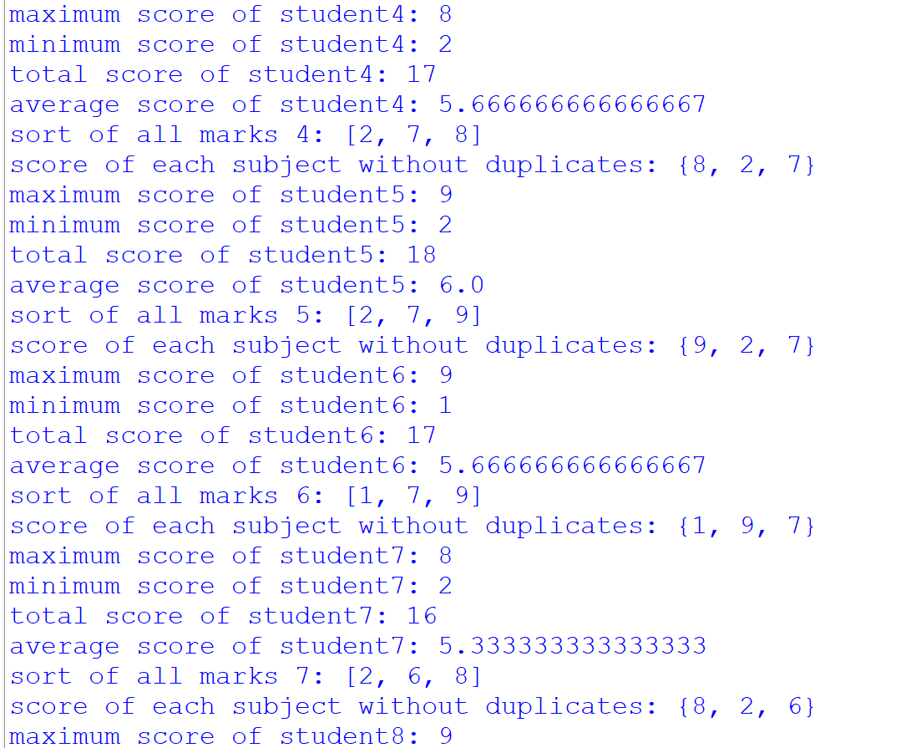

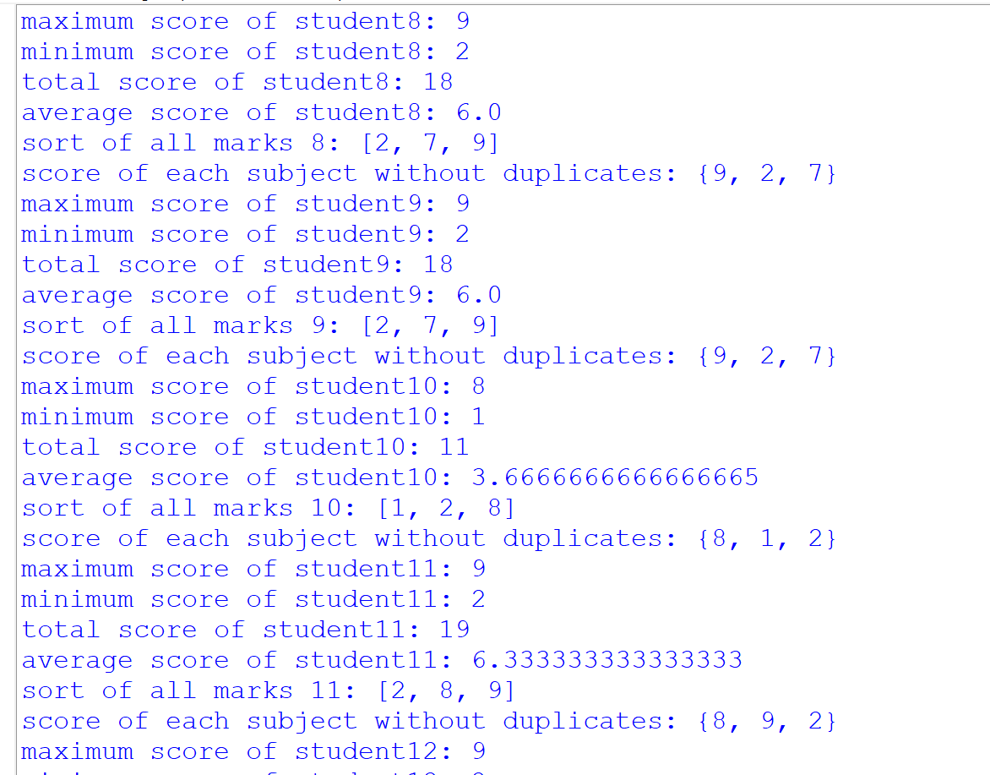

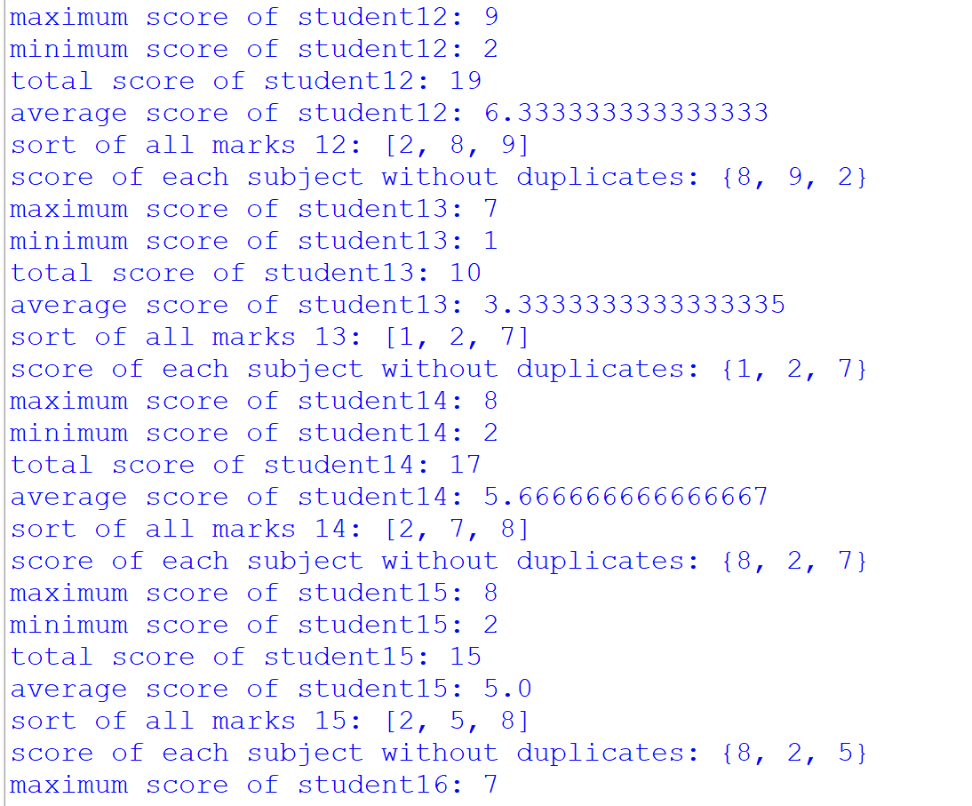

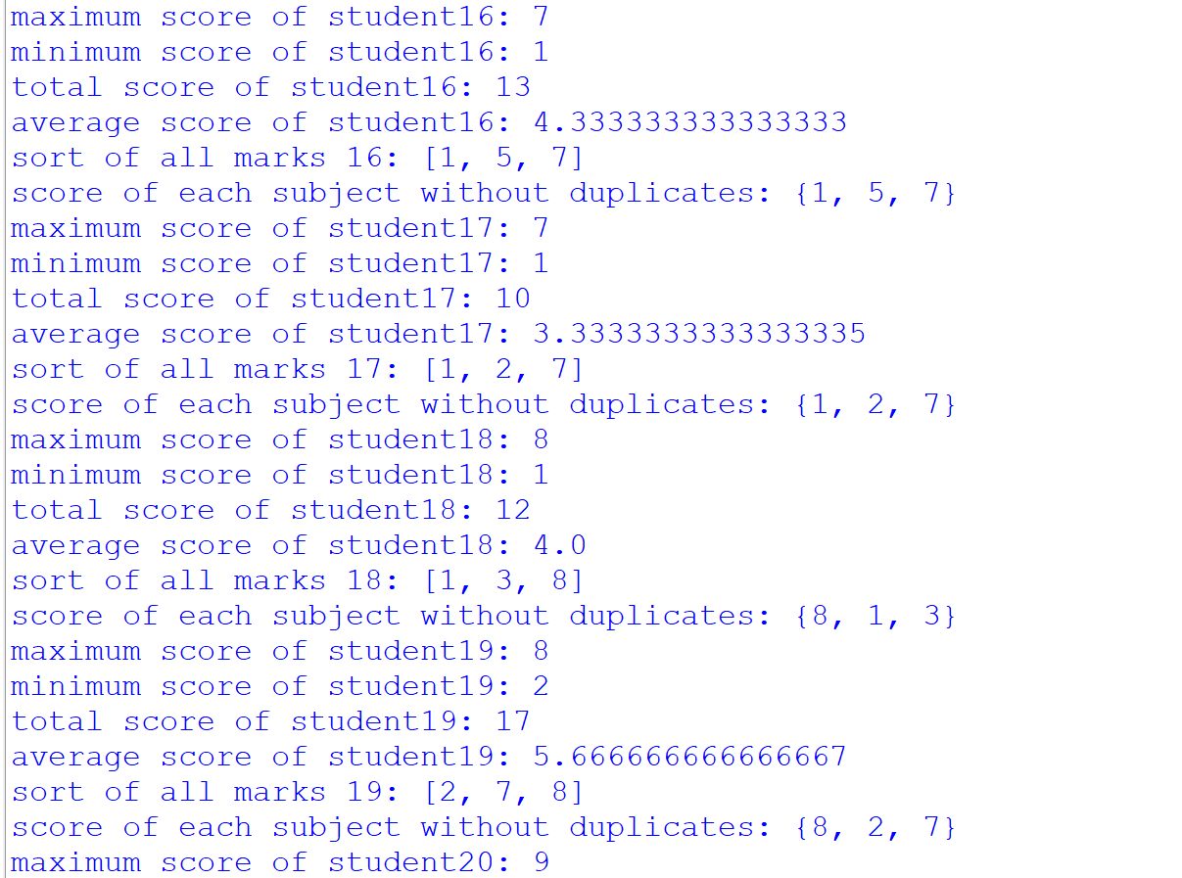

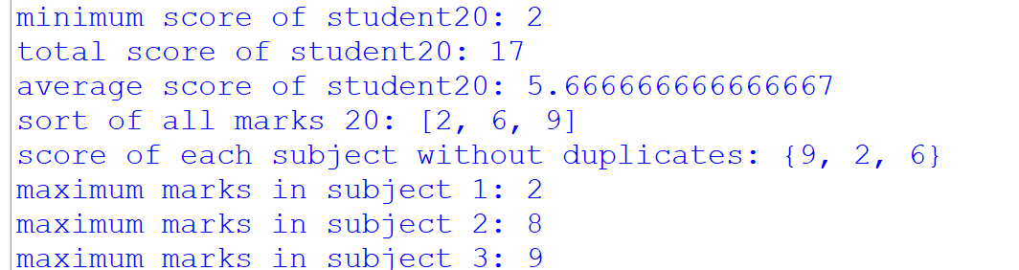

Conclusion:- our Python code for the student scholastic dashboard efficiently computes total marks, minimum and maximum scores per student, sorts subject marks, and ensures accurate summation without duplication. This comprehensive tool offers educators, students, and parents valuable insights into academic performance, facilitating targeted interventions and informed decision-making. Overall, your program streamlines academic assessment, aiding in optimizing student learning outcomes and fostering academic success.