1. Create a Flask application with an /api route. When this route is accessed, it should return a JSON list. The data should be stored in a backend file, read from it, and sent as a response.
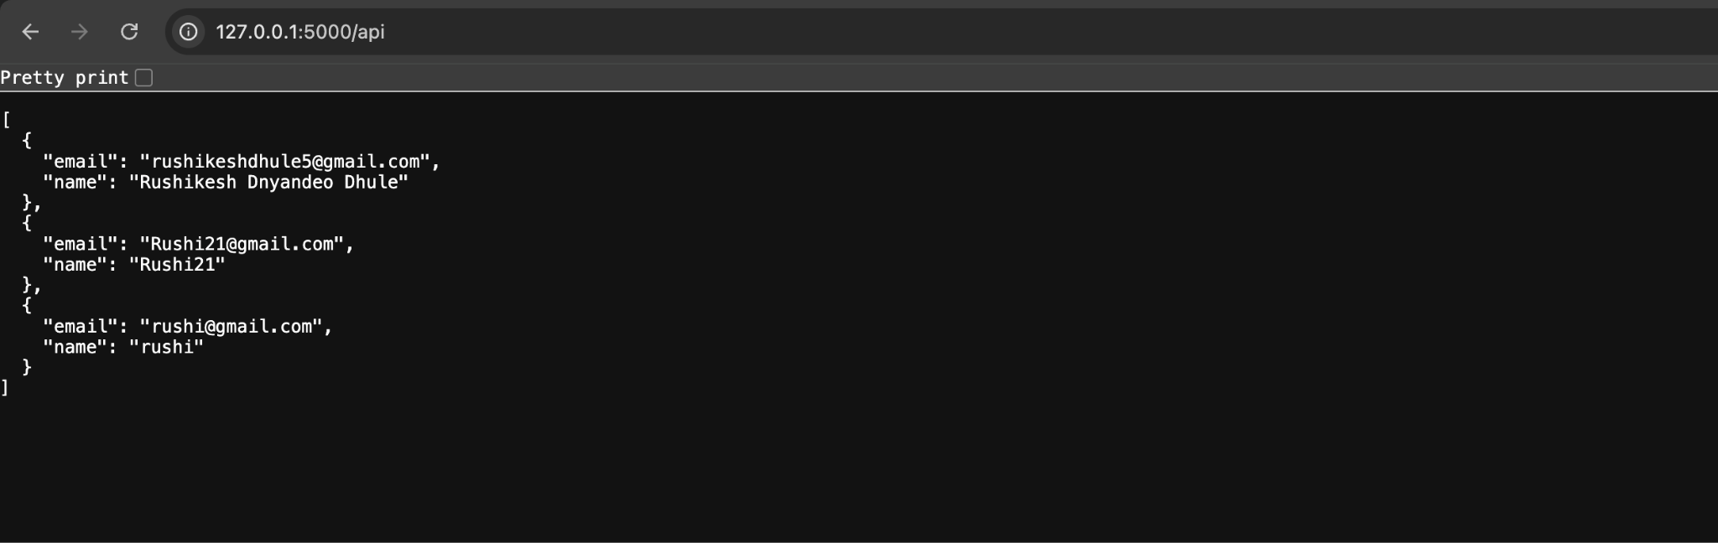
MongoDB OutPut:
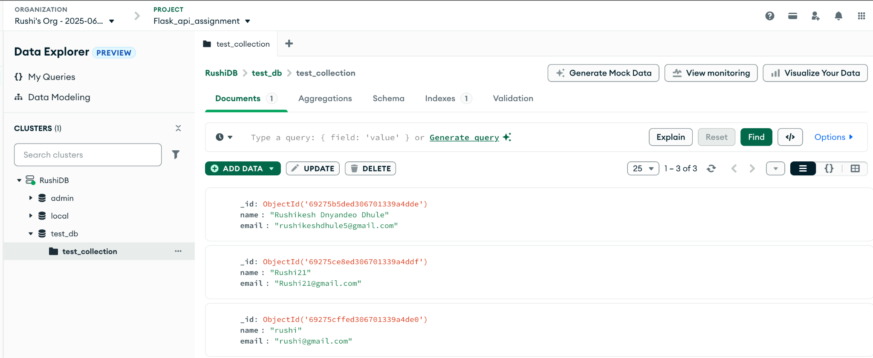

2. Create a form on the frontend that, when submitted, inserts data into MongoDB Atlas. Upon successful submission, the user should be redirected to another page displaying the message "Data submitted successfully". If there's an error during submission, display the error on the same page without redirection.

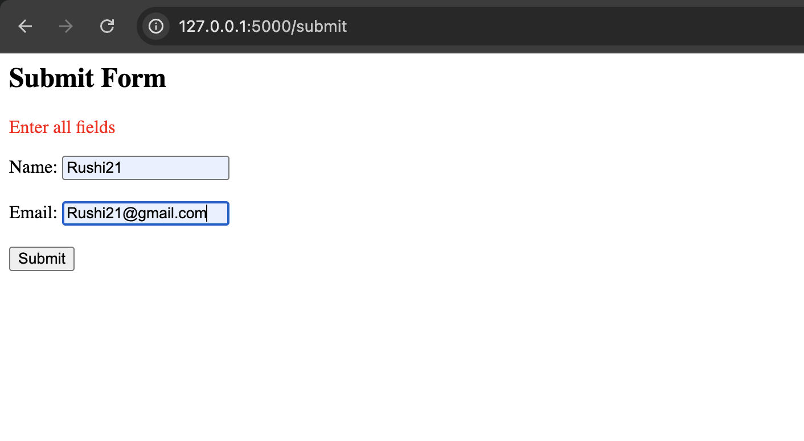
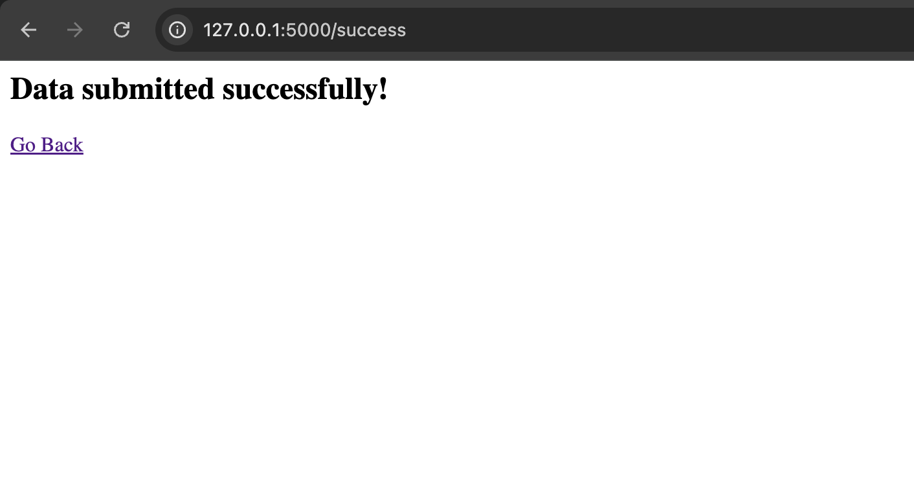

Task 1:

/api Route
Create a Flask app
Make a file called data.json
Store some list data inside it
In /api route → open this file, read data, and return it as JSON

Task 2:
Create an HTML form with name and email
When the user submits → send data to Flask /submit
Flask inserts data into MongoDB Atlas
If insert is successful → redirect to success.html page
If there is an error → show error message on same page

Project structure:
project/
│── BackEnd/
│ ├── app.py
│ ├── data.json
│── FrontEnd/
├── templates/
├── index.html
├── success.html

Project structure:
