Database Design and Modelling MID ASSESMENT LAB
Submitted By: 25MCB1010, Patsamatla Bhaavya Ramita
Date: 25-09-2025

Question:
Design and Query rooms the Database for Hotel Management System
- Create Rooms Table with RoomID, RoomType, PricePerNight, Availability attributes.
- Display total revenue by each room type
- List GuestName, RoomType, ReservationDate
- Display rooms that have never been reserved.
- Rank room types by revenue
- Insert rooms and reservations
- Create a front desk user with reservation access

- The table Rooms have been created with RoomID, RoomType, PricePerNight, Availability attributes, here the RoomType is declared as Primary key. For further query processing, I have created a table called Guests consisting of GuestID, name, reservationdate and room type (foreign key from Rooms table) as attributes.

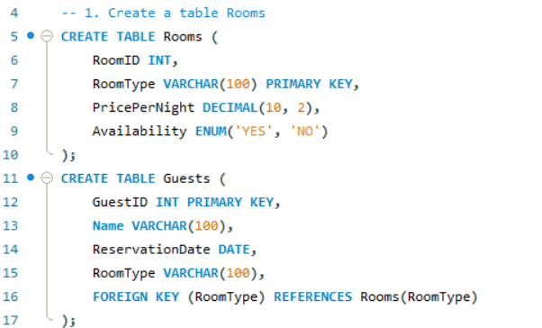
The Below code shows the insertion of values into the Rooms and Guests table.
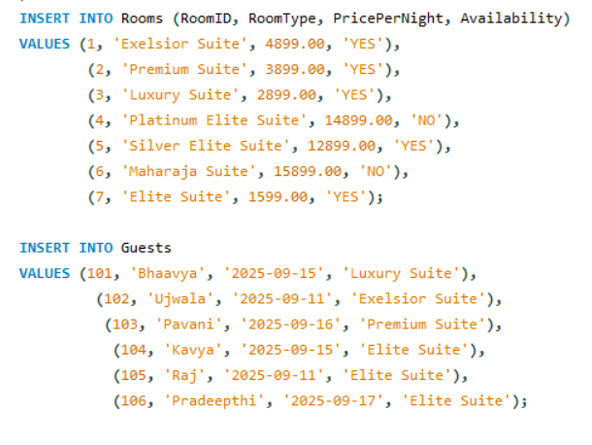

- The query requires us to find the total revenue generated by each room. We perform left join and check whether the room is reserved if yes (i.e the guest made a reservation hence the Guests table will have a record, so we check if the GuestID for that RoomType is not null hence its reserved), we calculate the revenue.
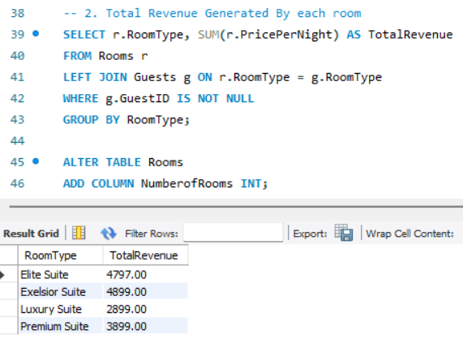
- The next query is a projection operation using DQL where we display the guest named, their room type and reservation day which are stored in Guests table.
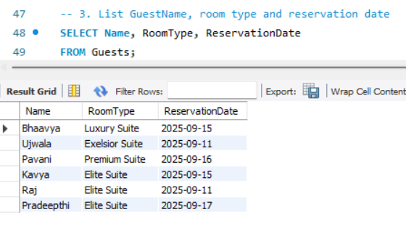

- To find the rooms that have not been reserved we perform a left join upon Rooms and Guests and check for which tables is the GuestID null for which we know that no guest reserved that RoomType.
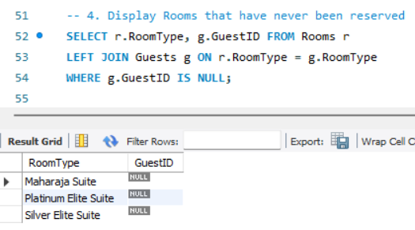

- The next query could be done by ranks but I’ve implemented using aggregate functions and joins. Its logic is similar to the 2nd query but here, we use INNER join and get the values that match both tables (no nulls) and then we calculate using SUM hence we get the total revenue of the rooms that have been reserved and they are ordered in Descending order.
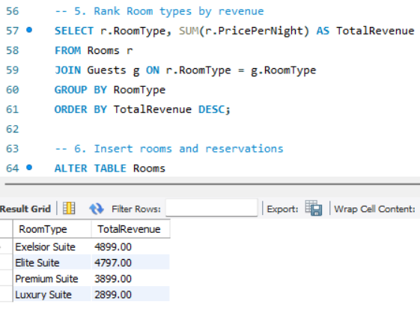

- The next is a DML query where we insert (NoOfRooms) number of rooms available for that RoomType and how many have been reserved (NoOfRes). We use ALTER query where we ADD COLUMN to Rooms Table.
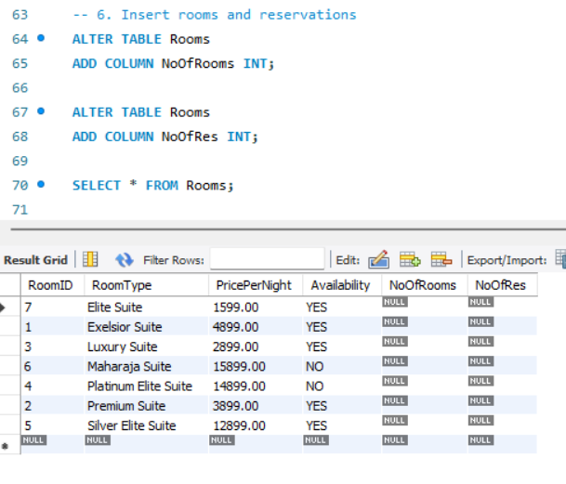
- The 7th query is a DCL operation where we create a user ‘frontDesk’@’localhost’ and give him INSERT, UPDATE and DELETE privileges to Guests table for reservation acess.
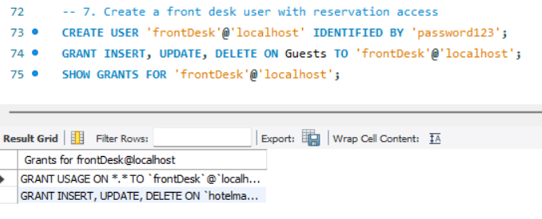

Thank you!
Submitted By: 25MCB1010, Patsamatla Bhaavya Ramita
Date: 25-09-25

