DBMS Digital Assignment – 1:
Question 1:
Scenario summary:
We have a hospital with three kinds of Person i.e doctors, patients, and staff, all sharing some basic details like ID, name, and contact info. Doctors also have a specialization and license number. Patients have a medical history and insurance ID. Staff have a role and department. Doctors and patients are connected through a treatment relationship where each doctor can treat many patients, and each patient can have many doctors. For every treatment, we note date of consultation and diagnosis summary. The hospital also has departments, each with a unique ID and name. Doctors and staff belong to departments. Each department has one head, who is a staff member. Sometimes, teams of doctors are formed to treat one specific patient. Each team is temporary, has a case ID, and records the treatment duration. It’s basically about mapping out these people, their extra details, and the ways they interact.

EER Diagram based on the scenario:
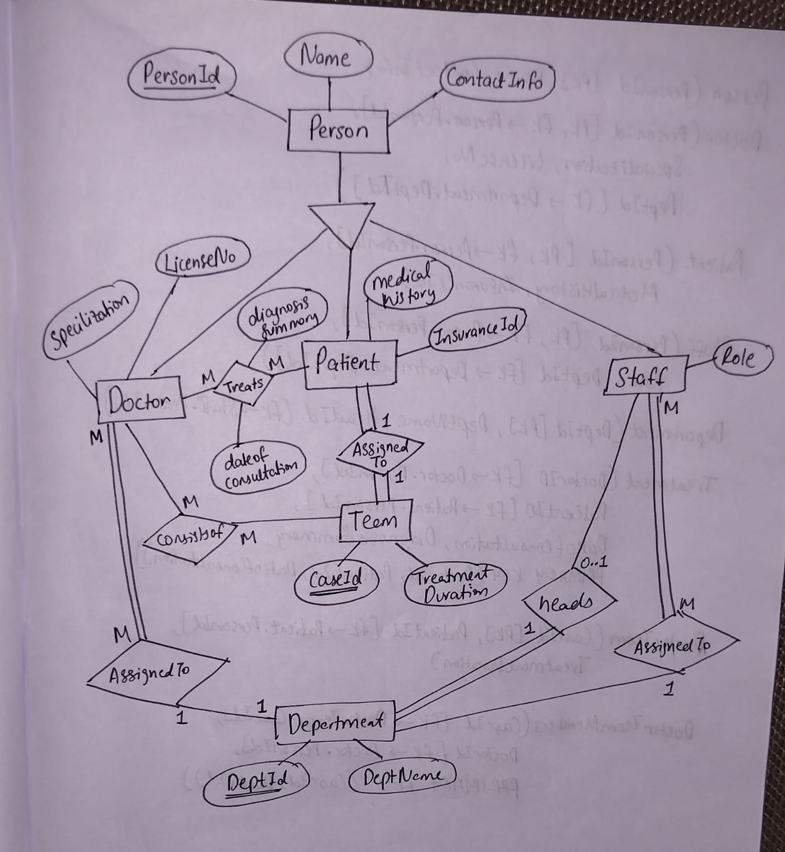

Relational Schema based on EER Diagram:
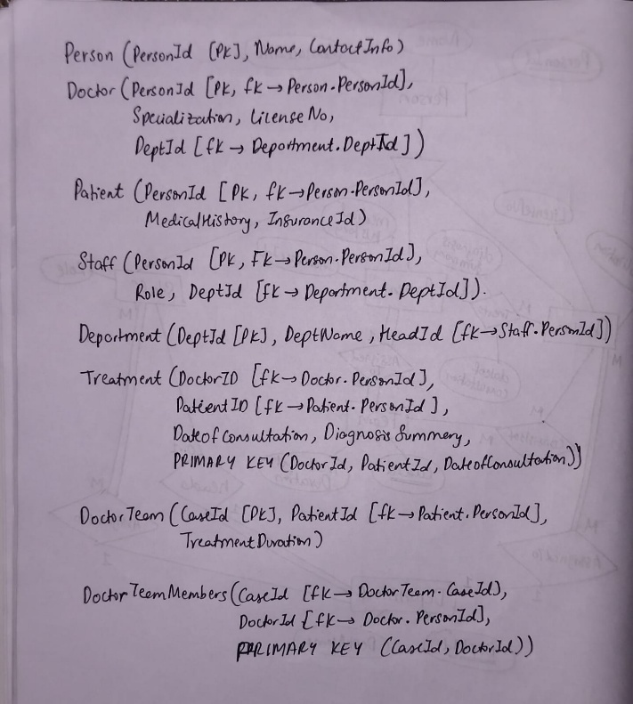

Question 2: Leetcode based SQL problem solving and implementation in MySQL
- Problem Title and link: 177. Nth Highest Salary (Medium)

SQL Query:
CREATE FUNCTION getNthHighestSalary(N INT) RETURNS INT
BEGIN
SET N = N-1;
RETURN (
# Write your MySQL query statement below.
SELECT DISTINCT salary FROM Employee
ORDER BY salary DESC LIMIT 1 OFFSET N
);
END

Explanation:
The driver code consists of user defined function getNthHighestSalary(N int), where N is the integer input. We must find the Nth largest input among the database. For that we must arrange the data based on salaries in descending order using ORDER BY DESC clause. Since we only need one salary we set LIMIT 1 and since we need the Nth highest salary we sent an OFFSET to N-1 (i.e for first highest salary we don’t need any offset or step hence it’s 0, for second highest we need OFFSET 1, similarly for Nth highest we need N-1 offset), to do that we set the N value as N-1 intially. We use DISTINCT to get unique salaries.

Query Execution:
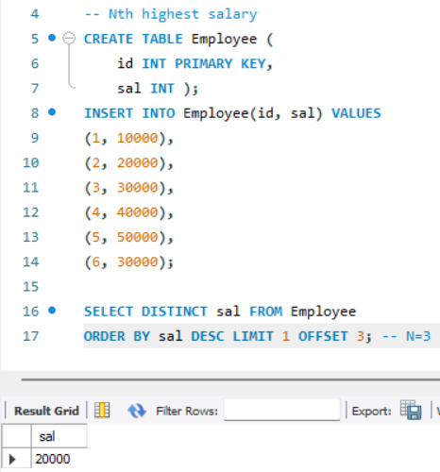

- Problem Statement and Link: 608. Tree Node (Medium)

SQL Query:
# Write your MySQL query statement below
SELECT id, CASE
WHEN p_id IS NULL THEN 'Root'
WHEN id in (SELECT p_id FROM Tree) THEN 'Inner'
ELSE 'Leaf'
END AS type
FROM Tree;

Explanation:
CASE is used like if-else blocks in MySQL. The question says to identify the type of node in a tree (i.e ROOT, INNER, LEAF). The given database consisits of 2 columns ID and P_ID (id of the node and its parent id) if the parent id is Null that means it is the root node, if the parent id of a node is some other previously known id, then it denotes it’s the child node of that particular id. So we use multiple select statements to identify if the id of a node is the pid of other nodes that denotes it’s a inner node (this works like for loop). In case it is no repeating and its considered a leaf node.

Query Execution:
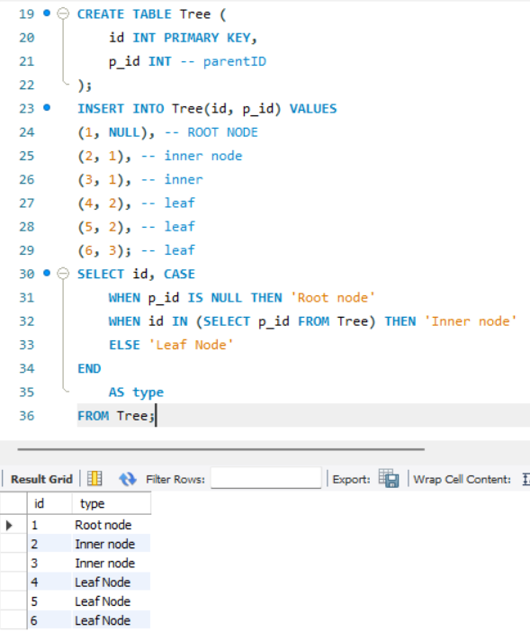

- Problem Statement and link: 1045. Customers Who Bought All Products (Medium)

SQL Query:
# Write your MySQL query statement below
SELECT c.customer_id FROM Customer c
GROUP BY c.customer_id
HAVING COUNT(DISTINCT c.product_key) IN (SELECT COUNT(DISTINCT product_key) FROM Product);

Explanation:
The query is used to find customers who have bought all the products listed in the Product table. We group the data by each customer_id and count how many distinct products each customer has purchased. Then we compare this count with the total number of distinct products available in the Product table. If the counts match, it means the customer has bought every product, so we return their customer_id.

Query Execution:
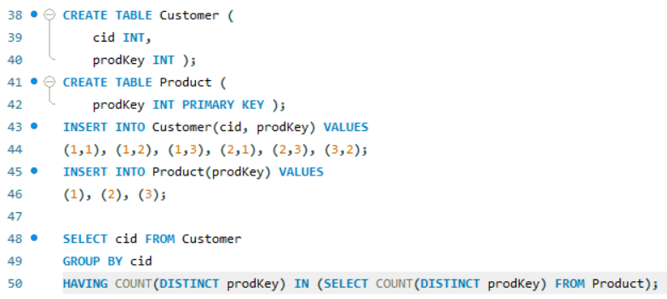

- Problem Statement and Link: 1341. Movie Rating (Medium)

SQL query:
# Write your MySQL query statement below
(SELECT u.name AS results FROM Users u
JOIN MovieRating m ON u.user_id = m.user_id
GROUP BY u.name
ORDER BY COUNT(*) DESC, name LIMIT 1)
UNION ALL
(SELECT m.title FROM MovieRating mr
JOIN Movies m ON m.movie_id = mr.movie_id
WHERE created_at BETWEEN '2020-02-01' AND '2020-02-29'
GROUP BY m.title
ORDER BY AVG(mr.rating) DESC, m.title LIMIT 1);

Explanation:
The most active user (who gave the most ratings) and the highest-rated movie in February 2020 is required to find out. We use UNION ALL to combine two SELECT statements, one joins Users and MovieRating, groups by user’s name, and sorts by rating count and name to get the top user. The other joins Movies and MovieRating, filters for Feb 2020, groups by movie title, and sorts by average rating and title to get the top movie.

Query Execution:
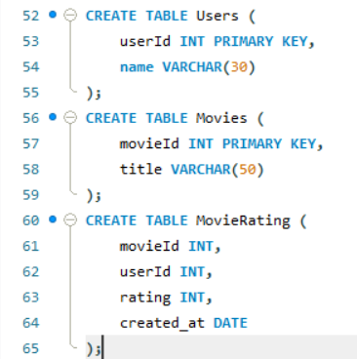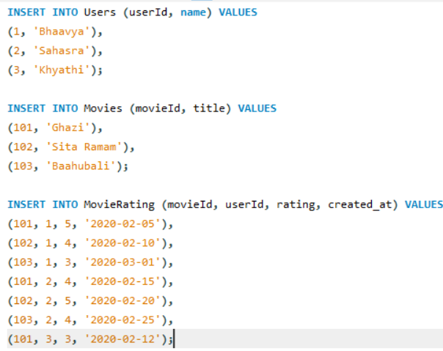
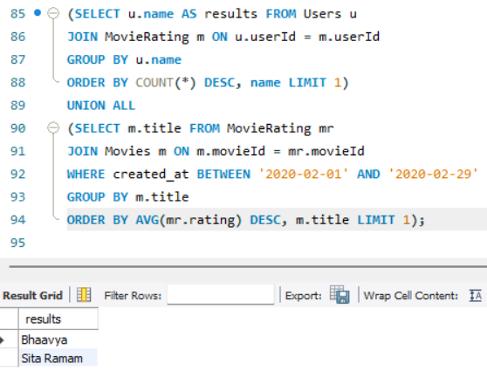

- Problem Statement and link: 185. Department Top Three Salaries (Hard)
SQL Query:
# Write your MySQL query statement below
SELECT d.name AS Department, e.name AS Employee, e.salary AS Salary FROM Employee e
JOIN Department d ON e.departmentId = d.id
WHERE (SELECT COUNT(DISTINCT salary) FROM Employee e2
WHERE (e.departmentId = e2.departmentId) AND (e.salary < e2.salary)) < 3;

Explanation:
This query finds employees whose salary ranks in the top 3 unique salaries within their department. It joins Employee with Department, then uses a subquery to count how many distinct salaries in the same department are higher than the current employee’s. If that count is less than 3, that denotes the employee is among the top earners.

Query Execution:

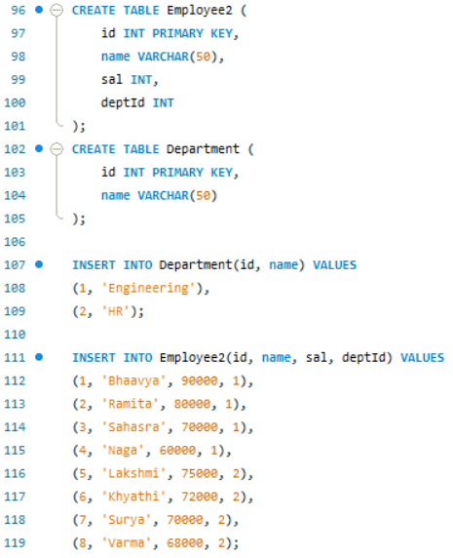
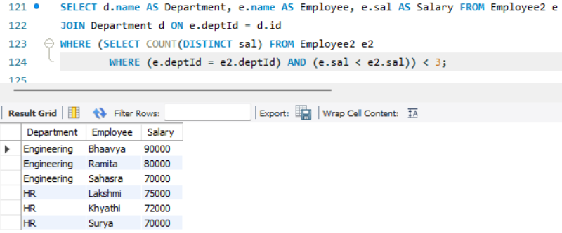

Submitted By: 25MCB1010, Patsamatla Bhaavya Ramita

