Database Lab Task 3 - Assessment
Submitted By: 25MCB1010, Patsamatla Bhaavya Ramita

Q1.1 Write a query to count the total number of customers from the sample database assigned to a variable “count”.
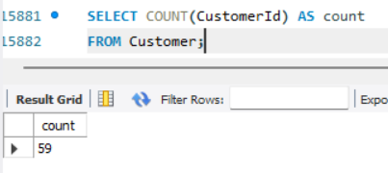
Understanding: COUNT() is an aggregate function that is used to count the number of records of a particular attribute (here, CustomerId). AS is used for alias.

Q1.2 List the number of customers from each country, sorted by highest count first.
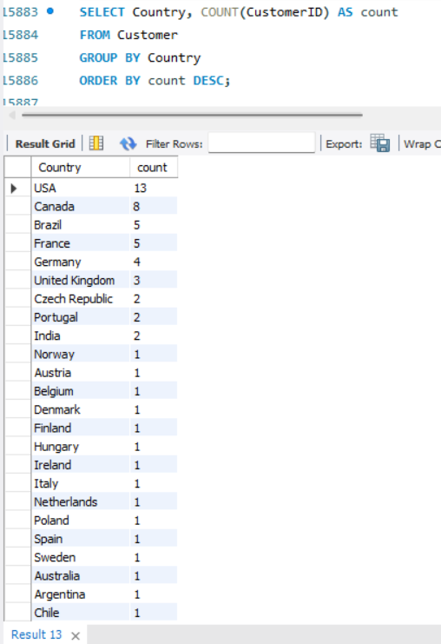
Understanding: To show the number o Customers we use aggregate function count, and since CustomerId is unique I considered that attribute. GROUP BY clause groups rows based on the common values in countries and ORDER BY clause is implemented after SELECT statement, which sorts the number of customers in a descending order (DESC).

Q2.1 Retrieve the top 5 invoices (Attr = InvoiceId) based on the highest “Total” amounts.
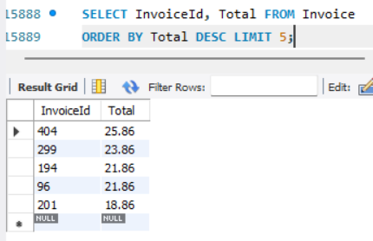
Understanding: We select the InvoiceIds and Total attributes from the Invoice entity and sort the values based on Total attribute in descending order using ORDER BY clause. Since we need the top 5 highest Total values, we use LIMIT 5 to restrict the result to 5 records.

Q2.2 List all “Invoices” issued to customer ID 5, sorted by date (latest first).
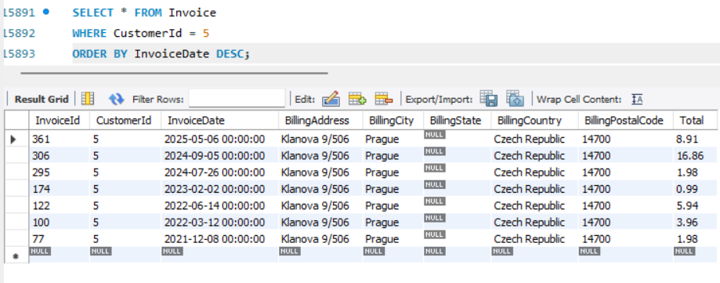
Understanding: We use SELECT * to select all attributes for a given condition. Here the condition is represented by the WHERE clause stating that CustomerId = 5, so only records having CustomerId as 5 will be displayed. Furthermore, ORDER BY clause is used to sort dates by latest first (DESC).

Q2.3 Analyze from InvoiceLine relation to display the total revenue generated for each InvoiceId.
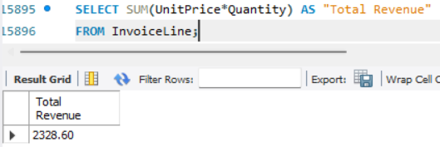
Understanding: Since Revenue isn’t an attribute by itself in the InvoiceLine relation table, we calculate it from multiplying UnitPrice and Quantity. The total revenue can be accessed by using SUM() function.
Q3.1 Find the top 5 most sold tracks based on total quantity purchased.
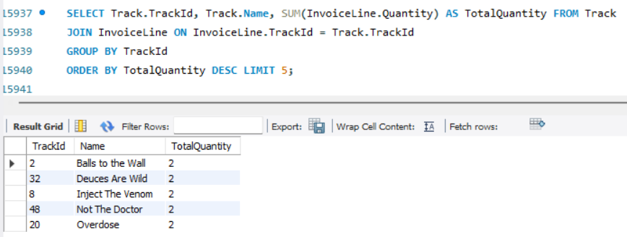
Understanding: Track and InvoiceLine are linked together through JOIN to access the Name of the track and TrackId (from Track entity) and its total quantity purchased (from InvoiceLine entity). The JOIN condition joins these tables on a common attribute TrackId. Since we require the top 5 of the Total Quantity we use SUM() for finding total quantity GROUP BY for grouping them with respect to the TrackId and ORDER BY to get the highest quantity (DESC) sold tracks and LIMIT 5 to restrict results to 5. The below is the verification that the MAX total quantity is 2 which is shown in the result above for TrackIds IN (2, 32, 8, 48, 20).
Verification:
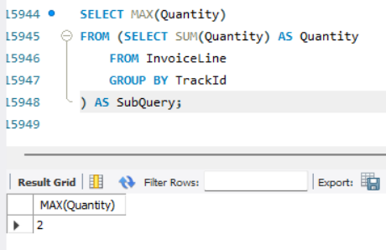

Q3.2 List all tracks that are longer than 6 minutes, showing their names and length in minutes.
Understanding: Since the length of the song is in Milliseconds in the Track enity we must display in minutes by dividing each value of the attribute by 60000. The question states we must display Name of the track that is greater than 6 minutes (360000 milliseconds) hence we mention that in the WHERE clause.
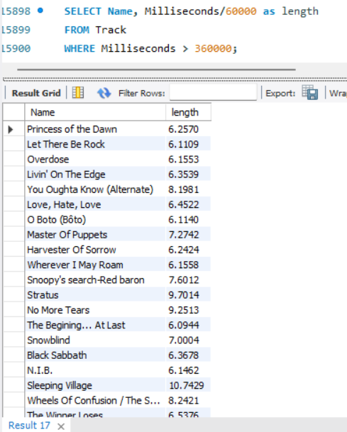

Q3.3 What is the average duration (in milliseconds) of all tracks?
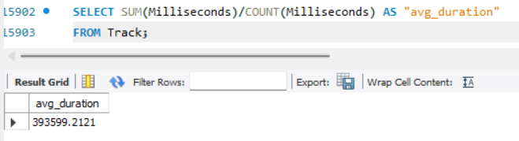
Understanding: The average duration can be calculated by sum of length of the track divided by the total number of tracks. Hence we used SUM() and COUNT() to get the average duration of all records (tracks) from Track entity.

Q3.4 Show the maximum and minimum unit price of all tracks.
Understanding: The UnitPrice attribute in Track entity represents the price of a track. To get the minimum and maximum price we use MIN() and MAX() aggregate functions over the Unitprice attribute.
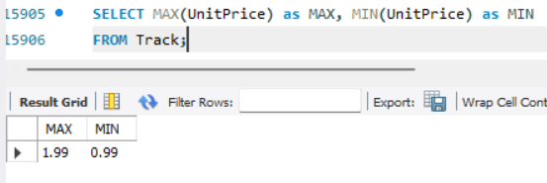

Q4.1 Display the top 5 artists based on the number of tracks they have.
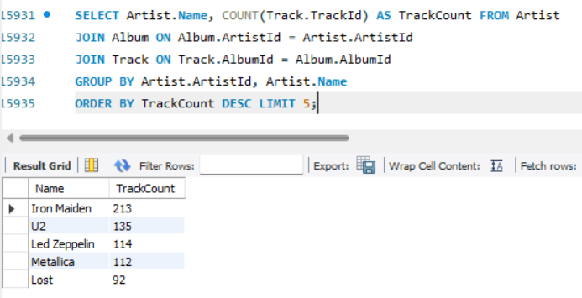

Understanding: Since we need the TrackId for calculating the highest tracks and Artist name who composed those tracks we get them from two different tables Track and Artist respectively. But they don’t have a common attribute togther hence to JOIN them we use another entity Album that consists of TrackId and ArtistId. We calculate the total number of tracks (COUNT()) sold by each artist (GROUP BY) and sort this total count using ORDER BY in descending order with LIMIT 5 for top 5 highest numbe rof tracks sold by aritists.

Q5.1 Find the top 5 music genres based on the number of tracks in each genre.
Understanding: Since the genre name is in Genre entity and TrackId (used to calculate the total number of tracks with that genre) is in Track entity we use JOIN to combine them upon their common attribute (GenreId) and we sort them with 5 limit for displaying top 5 music genres.
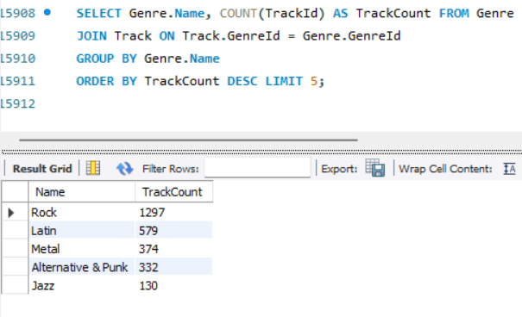

Q5.2 List all media types available in the store and the number of tracks under each.
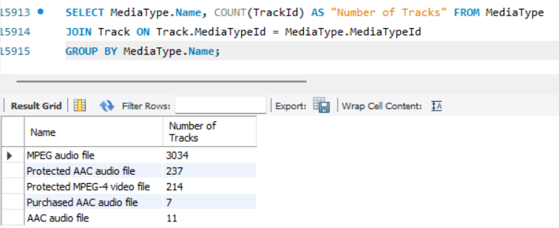
Understanding: The Media Types are listed by name from MediaType entity and the number of tracks with those media types are taken from the TrackId attribute from Track entity, hence we use JOIN to merge them on MediaTypeId common attribute. The number of track ids can be acquired by COUNT() and we group this count by their media type using GROUP BY.

Q6.1 Show the total revenue handled by each support representative.
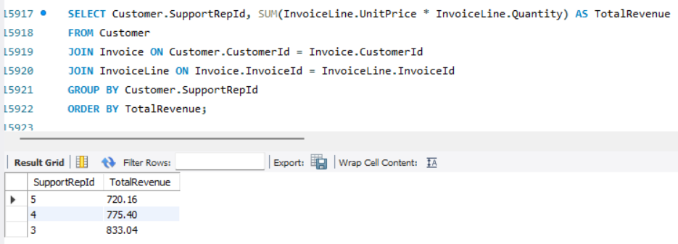
Understanding: We calculate total revenue generated per support rep by joining Customer, Invoice, and InvoiceLine tables. Revenue is calculated by UnitPrice*Quantity, and SUM() aggregates it per SupportRepId. GROUP BY groups the values, and ORDER BY sorts the reps based on their total revenue.
Q6.2 For each support rep, show the number of customers they manage.
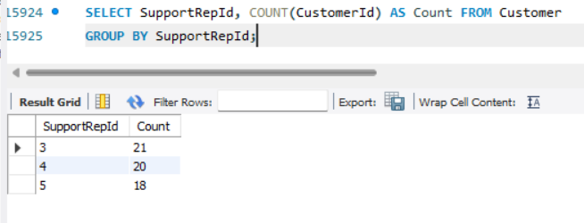
Understanding: We count how many customers are assigned to each support representative using COUNT(CustomerId). The GROUP BY clause groups the customer data based on SupportRepId to get a per-rep customer count.

Q6.3 Display the name of the customer who has spent the most total money.
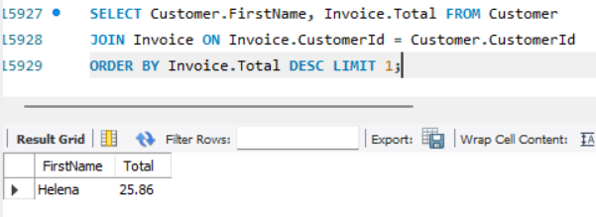
Understanding: We join Customer and Invoice to display each customer’s name and their invoice total. We use ORDER BY on Total in descending order and apply LIMIT 1 to fetch the customer with the highest invoice amount.

EER Diagram:
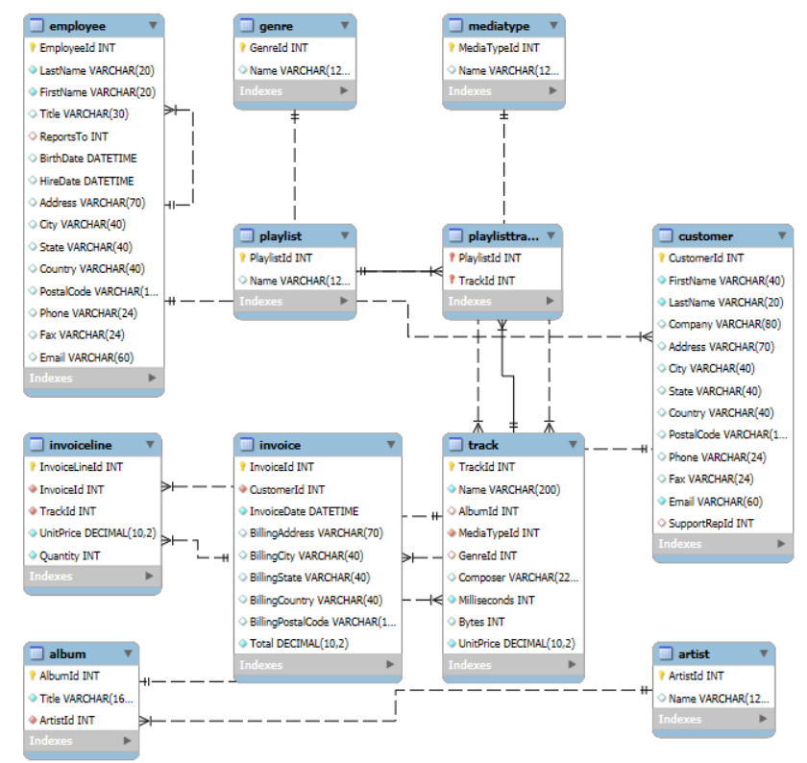

THANK YOU for your time and evaluation. I’m open to feedback and corrections.
Submitted By: Patsamatla Bhaavya Ramita, 25MCB1010

