DSA Lab Exercise-3
Submitted by: Patsamatla Bhaavya Ramita, 25MCB1010

Q1.Problem Statement

Tisha wants to learn mathematical expressions and she wants to create a program to accept multiple infix expressions from the user and convert them into postfix expressions using a Stack-based algorithm. The program should prompt the user to enter the number of expressions they wish to convert, and then accept each expression one by one. After converting each infix expression to a postfix, the program should print the corresponding postfix expression to the console.

Code:
#include <stdio.h>
#include <ctype.h>

#define N 100
char stack[N];
int top = -1;

void push(char c) {
if (top == N-1) {
printf("Stack overflow\n");
return;
}
stack[++top] = c;
}

char pop() {
if (top == -1) {
printf("Stack underflow\n");
return -1;
}
return stack[top--];
}

char peek() {
if (top == -1)
return -1;
return stack[top];
}

int precedence(char op) {
if (op == '^') return 3;
if (op == '*' || op == '/') return 2;
if (op == '+' || op == '-') return 1;
return 0;
}

int main() {
int test;
printf("Enter the number of infix expressions: ");
scanf("%d", &test);
for(int t=0; t<test; t++) {
char infix[N], postfix[N];
int i = 0, j = 0;
char symbol;

printf("Enter infix expression: ");
scanf("%s", infix);
while ((symbol = infix[i++]) != '\0') {
if (isalnum(symbol)) {
postfix[j++] = symbol;
} else {
while (top != -1 && precedence(stack[top]) >= precedence(symbol)) {
postfix[j++] = pop();
}
push(symbol);
}
}
while (top != -1) {
postfix[j++] = pop();
}
postfix[j] = '\0';
printf("Postfix expression %d: %s\n", t+1, postfix);
}
return 0;
}

Output:

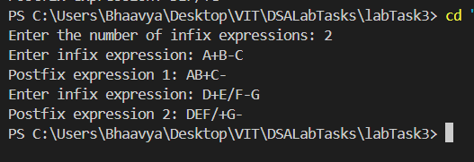

Q2. Problem Statement

You are delving into the classical Towers of Hanoi problem, a puzzle that involves transferring a set of numbered disks from one peg to another while adhering to specific rules. To simplify the problem, each disk is represented by integers from 1 to n, where n is the total number of disks. The pegs are labeled A, B, and C. The goal is to devise an iterative solution, utilizing a stack data structure, to efficiently move all disks from peg A to peg C.

Code:

#include <stdio.h>
#include <stdlib.h>
#include <math.h>

#define MAX 100

typedef struct {
int arr[MAX];
int top;
char name;
} Stack;

void init(Stack *s, char name) {
s->top = -1;
s->name = name;
}

int isEmpty(Stack *s) {
return s->top == -1;
}

void push(Stack *s, int value) {
s->arr[++s->top] = value;
}

int pop(Stack *s) {
if (isEmpty(s))
return -1;
return s->arr[s->top--];
}

int peek(Stack *s) {
if (isEmpty(s))
return -1;
return s->arr[s->top];
}

void moveDisk(Stack *src, Stack *dest) {
int diskSrc = pop(src);
int diskDest = pop(dest);

if (diskSrc == -1) {
push(src, diskDest);
printf("Move disk %d from %c to %c\n", diskDest, dest->name, src->name);
}

else if (diskDest == -1) {
push(dest, diskSrc);
printf("Move disk %d from %c to %c\n", diskSrc, src->name, dest->name);
}

else if (diskSrc > diskDest) {
push(src, diskSrc);
push(src, diskDest);
printf("Move disk %d from %c to %c\n", diskDest, dest->name, src->name);
}

else {
push(dest, diskDest);
push(dest, diskSrc);
printf("Move disk %d from %c to %c\n", diskSrc, src->name, dest->name);
}
}

void towerOfHanoiMovesWithStack(int n) {
Stack src, aux, dest;
init(&src, 'A');
init(&aux, 'B');
init(&dest, 'C');

char tempName;
if (n % 2 == 0) {
tempName = aux.name;
aux.name = dest.name;
dest.name = tempName;
}

for (int i = n; i >= 1; i--)
push(&src, i);

int totalMoves = (int)pow(2, n) - 1;

for (int i = 1; i <= totalMoves; i++) {
if (i % 3 == 1)
moveDisk(&src, &dest);
else if (i % 3 == 2)
moveDisk(&src, &aux);
else if (i % 3 == 0)
moveDisk(&aux, &dest);
}

printf("Total number of moves: %d\n", totalMoves);
}

int main() {
int n;
scanf("%d", &n);
towerOfHanoiMovesWithStack(n);
return 0;
}

Output:
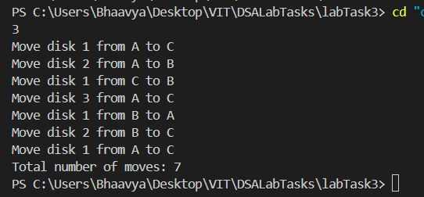

Q3.Problem Statement

Priya is designing a supermarket checkout queue system to efficiently manage customer flow at the supermarket. Customers join the checkout queue, and cashiers process their orders. Her goal is to implement the core functionality of this system using a queue data structure with an array.
- Add Customer to Queue: Add a customer to the checkout queue. Each customer is identified by a unique customer ID.
- Delete Customer: Remove the customer at the front of the queue.
- Display Queue: Display the customer IDs of all customers in the queue.
Help her in designing the program.

Code:

#include <stdio.h>
#include <stdlib.h>

#define N 5

int queue[N];
int front = -1, rear = -1;

void enqueue(int id) {
if ((rear + 1) % N == front) {
printf("Checkout queue is full.\n");
return;
}
if (front == -1) {
front = 0;
}
rear = (rear + 1) % N;
queue[rear] = id;
printf("Customer ID %d joined the checkout queue.\n", id);
}

void dequeue() {
if (front == -1) {
printf("Checkout queue is empty.\n");
return;
}
printf("Processed Customer ID: %d\n", queue[front]);
if (front == rear) {
front = rear = -1;
} else {
front = (front + 1) % N;
}
}

void display() {
if (front == -1) {
printf("Checkout queue is empty.\n");
return;
}
printf("Customers waiting in the checkout queue: ");
int i = front;
while (1) {
printf("%d ", queue[i]);
if (i == rear) break;
i = (i + 1) % N;
}
printf("\n");
}

int main() {
int choice, id;
while (1) {
if (scanf("%d", &choice) != 1) break;
switch (choice) {
case 1:
scanf("%d", &id);
enqueue(id);
break;
case 2:
dequeue();
break;
case 3:
display();
break;
case 4:
printf("Exiting Program\n");
exit(0);
default:
printf("Invalid option.\n");
}
}
return 0;
}

Output:
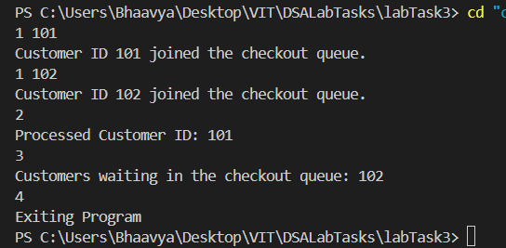

Q4. Problem Statement

A bank has a customer service counter where customers line up to receive assistance. The bank can handle a maximum of 10 customers in the queue at any given time. Customers arrive at the bank and are added to the queue in the order they arrive. The bank teller serves the customers one by one in the order they are in the queue.

Code:
#include <stdio.h>
#include <stdlib.h>

#define N 10

int main() {
int n;
scanf("%d", &n);

if (n > N) {
printf("Queue is full\n");
return 0;
}

int queue[N];
for (int i = 0; i < n; i++) {
scanf("%d", &queue[i]);
}

printf("Dequeuing customers: ");
for (int i = 0; i < n; i++) {
printf("%d", queue[i]);
if (i < n - 1) printf(" ");
}
printf("\n");

return 0;
}

Output:
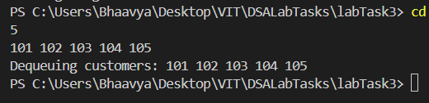

Q5. Problem Statement
In a computer science course project, students are required to write a program to insert values at the end of a singly linked list and remove the last node from the list. The program should traverse the list and delete the last node, adjusting pointers accordingly. Assist students in the task.

Code:
#include <stdio.h>
#include <stdlib.h>
struct Node {
int data;
struct Node *next;
} *head = NULL, *newnode, *temp;
int main() {
int n;
printf("Enter the list size: ");
scanf("%d", &n);
temp = head;
int x;
for(int i=0; i<n; i++) {
newnode = (struct Node*)malloc(sizeof(struct Node));
printf("Enter the data: ");
scanf("%d", &x);
newnode->data = x;
newnode->next = NULL;

if(head == NULL) {
head = newnode;
temp = head;
}
else {
temp->next = newnode;
temp = newnode;
}
}
if(head == NULL) {
return 0;
}
else if(head->next == NULL) {
free(head);
head = NULL;
}
else {
temp = head;
while(temp->next->next != NULL) {
temp = temp->next;
}
free(temp->next);
temp->next = NULL;
}
temp = head;
while(temp != NULL) {
if(temp->next != NULL) {
printf("%d -> ", temp->data);
}
else {
printf("%d", temp->data);
}
temp = temp->next;
}
return 0;
}

Output:
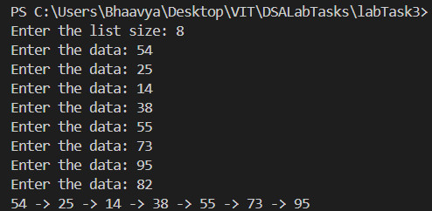

Q6. Problem Statement

Ram wants to create a program to manage a singly linked list. He wants to insert elements at the beginning of the list based on user input, insert a new element after the first element of the list and finally display the entire list after performing the insertion operations. Can you assist Ram in completing this?

Code:
#include <stdio.h>
#include <stdlib.h>
struct Node {
int data;
struct Node* next;
} *head = NULL, *newnode, *temp;
int main() {
int n;
printf("Enter the number of elements: ");
scanf("%d", &n);
int x;
for(int i=0; i<n; i++) {
printf("Enter the element: ");
scanf("%d", &x);
newnode = (struct Node*)malloc(sizeof(struct Node));
newnode->data = x;
newnode->next = head;
head = newnode;
}
int new;
printf("Enter the element to be inserted: ");
scanf("%d", &new);
if(head != NULL) {
newnode = (struct Node*)malloc(sizeof(struct Node));
newnode->data = new;
newnode->next = head->next;
head->next = newnode;
}
temp = head;
while(temp != NULL) {
if(temp->next != NULL) {
printf("%d -> ", temp->data);
}
else {
printf("%d", temp->data);
}
temp = temp->next;
}
return 0; }
Output:
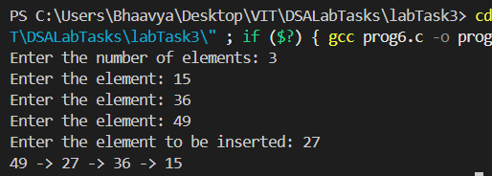
Q7. Problem Statement
Krishna needs to create a doubly linked list to store and display a sequence of integers. Your task is to help write a program to read a list of integers from input, store them in a doubly linked list, and then display the list.

Code:
#include <stdio.h>
#include <stdlib.h>
struct Node {
int data;
struct Node *next;
struct Node *prev;
} *head = NULL, *tail = NULL, *temp, *newnode;
int main() {
int n;
printf("Enter the number of elements: ");
scanf("%d", &n);
int x;
for(int i=0; i<n; i++) {
newnode = (struct Node*)malloc(sizeof(struct Node));
printf("Enter the element: ");
scanf("%d", &x);
newnode->data = x;

if(head == NULL && tail == NULL) {
newnode->prev = NULL;
head = tail = newnode;
}
else {
newnode->prev = tail;
tail->next = newnode;
tail = newnode;
}
}
temp = head;
for(int i=0; i<n; i++) {
printf("%d ", temp->data);
temp = temp->next;
}
return 0;
}

Output:
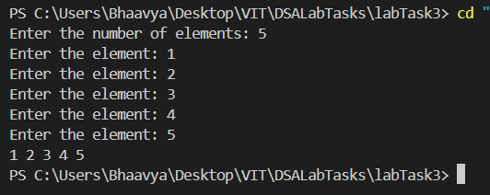

Q8. Problem Statement

You are tasked with developing a company's employee record management system. The system needs to maintain a list of employee records using a doubly linked list. Each employee is represented by a unique integer ID. Write a program that adds employee records at the front, traverses the list, and prints the same for each addition of employees to the list.

Code:
#include <stdio.h>
#include <stdlib.h>
struct Node {
int data;
struct Node *next;
struct Node *prev;
} *head = NULL, *tail = NULL, *temp, *newnode;
int main() {
int n;
printf("Enter the number of elements: ");
scanf("%d", &n);
int x;
for(int i=0; i<n; i++) {
newnode = (struct Node*)malloc(sizeof(struct Node));
printf("Enter the element: ");
scanf("%d", &x);
newnode->data = x;
newnode->next = NULL;
newnode->prev = NULL;

if(head == NULL && tail == NULL) {
head = tail = newnode;
printf("Node Inserted\n%d\n", newnode->data);
}
else {
newnode->next = head;
head->prev = newnode;
head = newnode;
printf("Node Inserted\n%d\n", newnode->data);
}
}
temp = head;
for(int i=0; i<n; i++) {
printf("%d ", temp->data);
temp = temp->next;
}
}

Output:
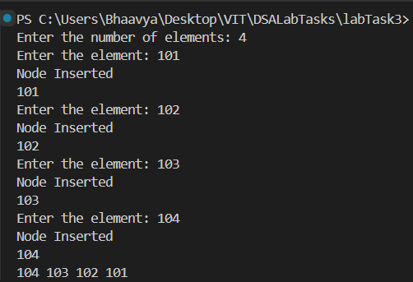

Thank you,
Submitted by: 25MCB1010, Patsamatla Bhaavya Ramita

