LAB EXCERCISE 2
Q1. Problem Statement
Jake, a sales representative, recorded the number of sales made each week of the month. He needs to sort the sales figures at odd positions in descending order and those at even positions in ascending order using insertion sort. This sorting will help him analyze the performance trends effectively.
Code:
#include <stdio.h>
void descSort(int odd[], int n)
{
for (int i=1; i<n; i++) {
int key = odd[i];
int j = i-1;
while(j >= 0 && odd[j] < key) {
odd[j+1] = odd[j];
j = j-1;
}
odd[j+1] = key;
}
}
void ascSort(int even[], int n) {
for(int i=1; i<n; i++) {
int key = even[i];
int j = i-1;
while(j >=0 && even[j] > key) {
even[j+1] = even[j];
j = j-1;
}
even[j+1] = key;
}
}
int main() {
int n;
printf("Enter the total number of employees: ");
scanf("%d", &n);
int arr[n];
for(int i=0; i<n; i++) {
scanf("%d", &arr[i]);
}
int even[100];
int odd[100];
int oddpos = 0;
int evenpos = 0;
for(int i=0; i<n; i++) {
if((i + 1)%2 == 1) {
odd[oddpos++] = arr[i];
}
else {
even[evenpos++] = arr[i];
}
}
descSort(odd, oddpos);
ascSort(even, evenpos);
oddpos = 0;
evenpos = 0;
for(int j=0; j<n; j++) {
if((j+1)%2 == 1) {
arr[j] = odd[oddpos];
oddpos += 1;
}
else {
arr[j] = even[evenpos];
evenpos += 1;
}
}
for(int k=0; k<n; k++) {
printf("%d ", arr[k]);
}
return 0;
}
Output:
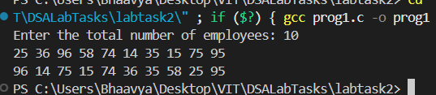

Q2. Problem statement
Sarah is a historian working on organizing a series of historical events that are recorded only by their occurrence dates. She needs a program that can sort these dates in ascending order to help her understand the chronological progression of these events. Each date is given as three integers representing the day, month, and year. Your task is to develop a program that reads a list of dates and outputs them sorted from the earliest to the latest using selection sort.
Code:
#include <stdio.h>
int sort(int d1, int m1, int y1, int d2, int m2, int y2) {
if(y1 < y2)
return 1;
if(y1==y2 && m1 < m2)
return 1;
if(y1==y2 && m1==m2 && d1 < d2)
return 1;
return 0;
}
void ascSort(int date[], int month[], int year[], int n) {
int min, temp;
for(int i=0; i<n-1; i++) {
min = i;
temp = 0;
for(int j=i+1; j<n; j++) {
if(sort(date[j], month[j], year[j], date[min], month[min], year[min])) {
min = j;
}
}
temp = year[i];
year[i] = year[min];
year[min] = temp;

temp = month[i];
month[i] = month[min];
month[min] = temp;

temp = date[i];
date[i] = date[min];
date[min] = temp;
}
}
int main() {
int n;
printf("Enter the number of events: ");
scanf("%d", &n);
int date[n];
int month[n];
int year[n];
printf("Enter the date, month, year: ");
for(int i=0; i<n; i++) {
scanf("%d", &date[i]);
scanf("%d", &month[i]);
scanf("%d", &year[i]);
}
ascSort(date, month, year, n);
for(int i=0; i<n; i++) {
printf("%d %d %d\n", date[i], month[i], year[i]);
}
return 0;
}
Output:
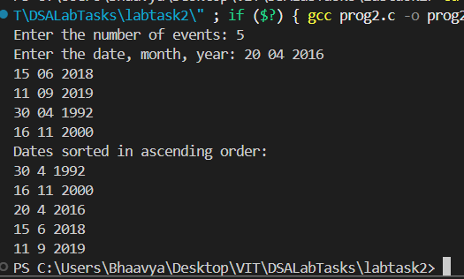

Q3. Problem Statement
Hemanth is focused on creating a program to organize a list of employees based on their employee IDs. Assist him in implementing a function to sort the employee IDs using the bubble sort algorithm. The sorting should prioritize even-numbered employee IDs first, followed by odd-numbered employee IDs. Display the sorted list of employee IDs according to the specified condition.
Code:
#include <stdio.h>
void sort(int arr[], int n) {
for (int i = 0; i < n-1; i++) {
for (int j = 0; j < n-i-1; j++) {
if (arr[j]%2 != 0 && arr[j+1]%2 == 0) {
int temp = arr[j];
arr[j] = arr[j + 1];
arr[j + 1] = temp;
} } } }
int main() {
int test;
printf("Enter the number of test cases: ");
scanf("%d", &test);
for(int t=0; t<test; t++) {
int n;
printf("Enter the number of elements: ");
scanf("%d", &n);
int ids[n];
for (int i = 0; i < n; i++) {
scanf("%d", &ids[i]);
}
sort(ids, n);
for (int i = 0; i < n; i++) {
printf("%d ", ids[i]);
}
printf("\n");
}
return 0;
}
Output:
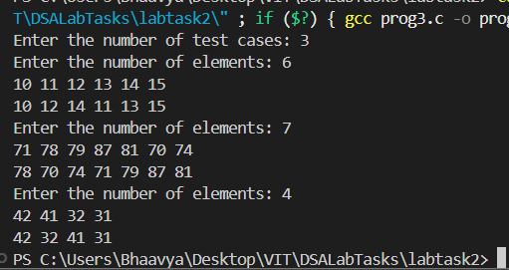
Q4.Problem Statement
Micheal is tasked with developing a system to manage and sort student records for a university. Each student record contains the student's name, GPA, age, and major. The goal is to implement a program that allows the user to input multiple student records and then sort these records based on a chosen criterion: GPA, age, or major.Can you guide Micheal in developing the program using a quick sort algorithm?
Code:
#include <stdio.h>
#include <string.h>
#define MAX 10
int n;
char name[MAX][50], major[MAX][50];
float gpa[MAX];
int age[MAX];
void swap(int i, int j) {
char tempName[50], tempMajor[50];
float tempGPA;
int tempAge;
strcpy(tempName, name[i]);
strcpy(name[i], name[j]);
strcpy(name[j], tempName);
tempGPA = gpa[i];
gpa[i] = gpa[j];
gpa[j] = tempGPA;
tempAge = age[i];
age[i] = age[j];
age[j] = tempAge;
strcpy(tempMajor, major[i]);
strcpy(major[i], major[j]);
strcpy(major[j], tempMajor);
}
int partition(int low, int high, char criterion[]) {
int i = low - 1;
int j;
for (j = low; j < high; j++) {
int condition = 0;
if (strcmp(criterion, "gpa") == 0)
condition = (gpa[j] < gpa[high]);
else if (strcmp(criterion, "age") == 0)
condition = (age[j] < age[high]);
else if (strcmp(criterion, "major") == 0)
condition = (strcmp(major[j], major[high]) < 0);
if (condition) {
i++;
swap(i, j);
}
}
swap(i + 1, high);
return i + 1;
}
void quickSort(int low, int high, char criterion[]) {
if (low < high) {
int pi = partition(low, high, criterion);
quickSort(low, pi - 1, criterion);
quickSort(pi + 1, high, criterion);
}
}
int main() {
printf("Enter the number of student records: ");
scanf("%d", &n);
int i;
for (i = 0; i < n; i++) {
printf("Name: ");
scanf("%s", name[i]);
printf("GPA: ");
scanf("%f", &gpa[i]);
printf("Age: ");
scanf("%d", &age[i]);
printf("Major: ");
scanf("%s", major[i]);
}
char criterion[10];
scanf("%s", criterion);
quickSort(0, n - 1, criterion);
printf("Sorted Student Records:\n");
printf("Name\t\tGPA\tAge\t\tMajor\n");
for (i = 0; i < n; i++) {
printf("%-10s\t%.2f\t%d \t\t%-10s\n", name[i], gpa[i], age[i], major[i]);
}
return 0;
}
Output:
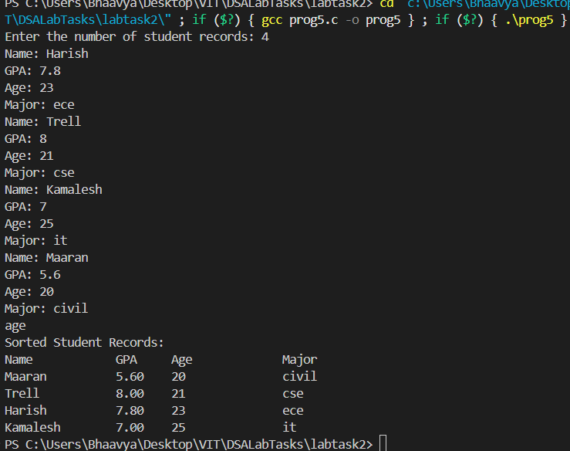

Q5.Problem Statement
A computer science society of a college asks students to register for a workshop organized by them. The final list of registered students consists of College ID. Anand, the organizer needs to sort that list using Quick Sort and print the PIVOT element after every sorting pass. Also, some of the students have registered more than once. So he needs to remove the duplicate IDs as well (Remove the duplicate after sorting). Help Anand to complete this task.
Code:
#include <stdio.h>
#include <stdbool.h>
int partition(int arr[], int start, int end) {
int pivot = arr[end];
int i= start-1;
for(int j=start; j<end; j++) {
if(arr[j] < pivot) {
i++;
int temp = arr[i];
arr[i] = arr[j];
arr[j] = temp;
}
}
i++;
int temp = arr[i];
arr[i] = arr[end];
arr[end] = temp;
printf("Pivot element: %d\n", arr[i]);
return i; //location of pivot
}
void quickSort(int arr[], int start, int end) {
if(start >= end) {
return;
}
int pivot = partition(arr, start, end);
quickSort(arr, start, pivot-1);
quickSort(arr, pivot+1, end);
}
int main() {
int test;
printf("Enter the number of test cases: ");
scanf("%d", &test);
for(int t=0; t<test; t++) {
int n;
printf("Enter the number of students: ");
scanf("%d", &n);
int ids[n];
for(int i=0; i<n; i++) {
scanf("%d", &ids[i]);
}
quickSort(ids, 0, n-1);
int size = 0;
int p[n];
for(int j=0; j<n; j++) {
if (j==0 || ids[j] != ids[j-1]) {
p[size++] = ids[j];
}
}
printf("Final Array: ");
for(int i=0; i<size; i++) {
printf("%d ", p[i]);
}
printf("\n");
}
return 0;
}
Output:
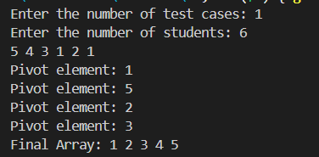
Q6. Problem Statement
You are working as a data analyst at a research institute. As part of a data analysis project, you are given an array of integers representing various data points collected during an experiment. Your task is to sort the array in increasing order based on the frequency of the values. Here's how the sorting should be done:
- First, count the frequency of each unique integer in the array.
- Sort the integers based on their frequencies in increasing order. If two or more integers have the same frequency, sort them in decreasing order.
Write a program using the Merge Sort algorithm to sort the array based on the specified conditions and return the sorted array.
Code:
#include <stdio.h>
int a[100], n;
int freq[100], uniq[100], u = 0;
void countFreq() {
for (int i = 0; i < n; i++) {
int f = 1, found = 0;
for (int j = 0; j < u; j++) {
if (a[i] == uniq[j]) {
found = 1;
break;
}
}
if (!found) {
for (int k = i + 1; k < n; k++) {
if (a[i] == a[k])
f++;
}
uniq[u] = a[i];
freq[u] = f;
u++;
}
}
}
int getFreq(int x) {
for (int i = 0; i < u; i++) {
if (x == uniq[i])
return freq[i];
}
return 0;
}
void merge(int l, int m, int r) {
int i = l, j = m + 1, k = 0;
int temp[100];

while (i <= m && j <= r) {
int f1 = getFreq(a[i]);
int f2 = getFreq(a[j]);

if (f1 < f2)
temp[k++] = a[i++];
else if (f1 > f2)
temp[k++] = a[j++];
else {
if (a[i] > a[j])
temp[k++] = a[i++];
else
temp[k++] = a[j++];
}
}
while (i <= m) temp[k++] = a[i++];
while (j <= r) temp[k++] = a[j++];

for (i = l, j = 0; i <= r; i++, j++)
a[i] = temp[j];
}
void mergeSort(int l, int r) {
if (l < r) {
int m = (l + r) / 2;
mergeSort(l, m);
mergeSort(m + 1, r);
merge(l, m, r);
}
}
int main() {
printf("Enter number of elements: ");
scanf("%d", &n);
printf("Enter elements:\n");
for (int i = 0; i < n; i++)
scanf("%d", &a[i]);
countFreq();
mergeSort(0, n - 1);
printf("Sorted array:\n");
for (int i = 0; i < n; i++)
printf("%d ", a[i]);
return 0;
}
Output:
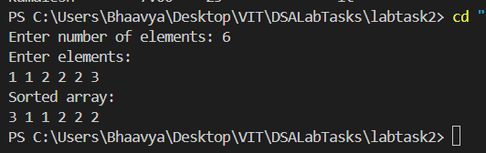

Q7. Problem Statement
Imagine you are working on a system that handles a large number of student records for different subjects in a university. Each subject's student records are stored as sorted arrays based on the student's ID. The system needs to merge the sorted arrays into a single sorted array to perform further analysis and generate reports. You are asked to implement a function that takes the number of subjects k and their corresponding sorted arrays as input and returns a single sorted array containing all the student records merged together.
Code:
#include <stdio.h>
void mergeSort(int arr[], int l, int r) {
if (l >= r) return;
int m = (l + r) / 2;
mergeSort(arr, l, m);
mergeSort(arr, m + 1, r);
int temp[400], i = l, j = m + 1, k = 0;
while (i <= m && j <= r) {
if (arr[i] < arr[j])
temp[k++] = arr[i++];
else
temp[k++] = arr[j++];
}
while (i <= m) temp[k++] = arr[i++];
while (j <= r) temp[k++] = arr[j++];
for (i = l, j = 0; i <= r; i++, j++)
arr[i] = temp[j];
}
int main() {
int k, a[400], val;
int total = 0;
printf("Enter number of subjects: ");
scanf("%d", &k);
for (int i = 0; i < k; i++) {
printf("Enter %d sorted student IDs:\n", k);
for (int j = 0; j < k; j++) {
scanf("%d", &val);
a[total++] = val;
}
}
mergeSort(a, 0, total - 1);
printf("Merged and Sorted Array: ");
for (int i = 0; i < total; i++)
printf("%d ", a[i]);
return 0;
}
Output:
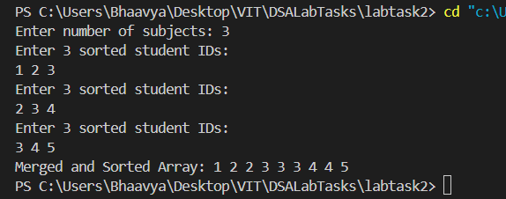
Q8. Problem Statement
Joel is a data analyst working for a manufacturing company. His task is to update the layout of the factory floor, which is represented by a matrix of integers. Each cell in the matrix represents a section of the factory floor, with some sections containing machinery (represented by zeros) and others being empty. Joel needs to modify the factory floor matrix based on the following rules:
- If any cell in a row contains a zero, all cells in that row should be set to zero.
- If any cell in a column contains a zero, all cells in that column should be set to zero.
Code:
#include<stdio.h>
int main() {
int test;
printf("Enter the number of test cases: ");
scanf("%d", &test);
for(int t=0; t<test; t++) {
int r, c;
printf("Enter the rows and columns: ");
scanf("%d %d", &r, &c);
int mat[r][c];
int rows[r];
for(int k=0; k<r; k++) rows[k] = 1;
int cols[c];
for(int k=0; k<c; k++) cols[k] = 1;
for(int i=0; i<r; i++) {
for(int j=0; j<c; j++) {
scanf("%d", &mat[i][j]);
if(mat[i][j] == 0) {
rows[i] = 0;
cols[j] = 0;
}
}
}
for(int i=0; i<r; i++) {
if(rows[i] == 0) {
for(int j=0; j<c; j++) {
mat[i][j] = 0;
}
}
}
for(int j=0; j<c; j++) {
if(cols[j] == 0) {
for(int i=0; i<r; i++) {
mat[i][j] = 0;
}
}
}
for(int k=0; k<r; k++) {
for(int x=0; x<c; x++) {
printf("%d", mat[k][x]);
}
printf("\n");
}
}
return 0;
}
Output:
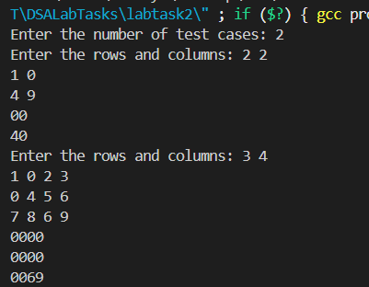

Q9. Problem Statement
In a vibrant town, the villagers have a unique tradition to celebrate their birthdays. Instead of celebrating with age, they celebrate with the concept of a "digital root." The digital root of a number is obtained by repeatedly summing its digits until a single-digit number is obtained. You are tasked with writing a program to help the villagers determine their digital root. The program should accept a positive integer representing a villager's age and output their digital root. Digital Root: The single-digit value obtained by recursively summing the digits of the number until a single-digit result is obtained. For example, if the given number is 1234, the sum of 1+2+3+4 = 10. So the digital root will be 1+0 = 1.
Code:
#include<stdio.h>
int digitSum(int num) {
int sum = 0, rem = 0;
while(num > 0) {
rem = num%10;
sum += rem;
num = num/10;
}
if(sum/10 > 0) {
return digitSum(sum);
}
else {
return sum;
}
}
int main() {
int test;
printf("Enter the number of test cases: ");
scanf("%d", &test);
for(int t=0; t<test; t++) {
int num;
printf("Enter the number: ");
scanf("%d", &num);
int sum = digitSum(num);
printf("The digital root of %d is %d\n", num, sum);
}
return 0;
}
Output:
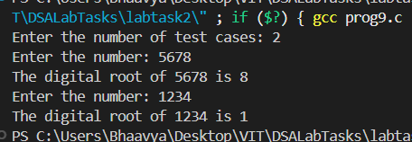

Q10. Problem Statement
In a bustling city, there is an annual festival known as the "Festival of Prizes," where attendees can win exciting rewards based on their ticket numbers. This year, the festival organizers introduced a unique game to determine if a ticket number is "lucky." A ticket number is deemed lucky if the sum of the digits of its square equals the original ticket number. Participants are eager to find out if their ticket numbers are lucky, as only lucky ticket holders will be eligible for special prizes. You are tasked with writing a program that checks if a given ticket number is lucky. Use a recursive function.
Code:
#include<stdio.h>
#include<math.h>
int squaresSum(int num) {
int rem = 0, sum = 0;
while(num > 0) {
rem = num%10;
sum += rem;
num = num/10;
}
if(sum/10 > 0) {
return squaresSum(sum);
}
return sum;
}
int main() {
int test;
printf("Enter the number of test cases: ");
scanf("%d", &test);
for(int t=0; t<test; t++) {
int num;
printf("Enter the number: ");
scanf("%d", &num);
int sq = squaresSum(pow(num,2));
(sq == num) ? printf("Yes, %d is a lucky number\n", num) : printf("No, %d is not a lucky number\n", num);
}
return 0;
}
Output:
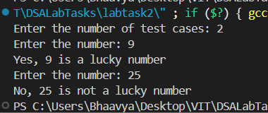
Q11. Problem Statement
Meredith is a cashier at a local convenience store. To improve the efficiency of making change for customers, Meredith wants to develop a small program that calculates the number of different ways she can give change using a given set of coin denominations. This will help her quickly figure out the number of ways to make change for a particular amount of money using the available coins. Meredith has a list of coin denominations and a specific amount of money for which she needs to provide change. She wants to write a program to determine the number of possible ways to achieve the given amount using the available denominations. This will help her understand all possible combinations without having to manually calculate them each time.
Code:
#include <stdio.h>
int main() {
int n, m, coins[100];
int dp[101] = {0};
printf("Enter number of coin denominations: ");
scanf("%d", &n);
printf("Enter the coin denominations:\n");
for (int i = 0; i < n; i++)
scanf("%d", &coins[i]);
printf("Enter the target amount: ");
scanf("%d", &m);
dp[0] = 1;
for (int i = 0; i < n; i++) {
for (int j = coins[i]; j <= m; j++) {
dp[j] += dp[j - coins[i]];
}
}
printf("Number of ways to make change: %d\n", dp[m]);
return 0;
}
Output:
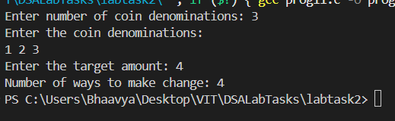
Submitted By: Patsamatla Bhaavya Ramita, 25MCB1010

