OS LAB EXPERIMENT – 4: CPU Scheduling Algorithms
Submitted By: 25MCB1010, Patsamatla Bhaavya Ramita

- Consider the following scenario:
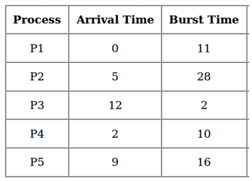

Q1a. Write a menu driven program that implements the following CPU scheduling algorithms for the above scenario.
1. First Come First Serve (FCFS)
2. Shortest Job First (SJF) – Non Premptive
3. Shortest Remaining Time First (SRT) – Premptive SJF
Code:
Implementation of First Come First Serve Algorithm:
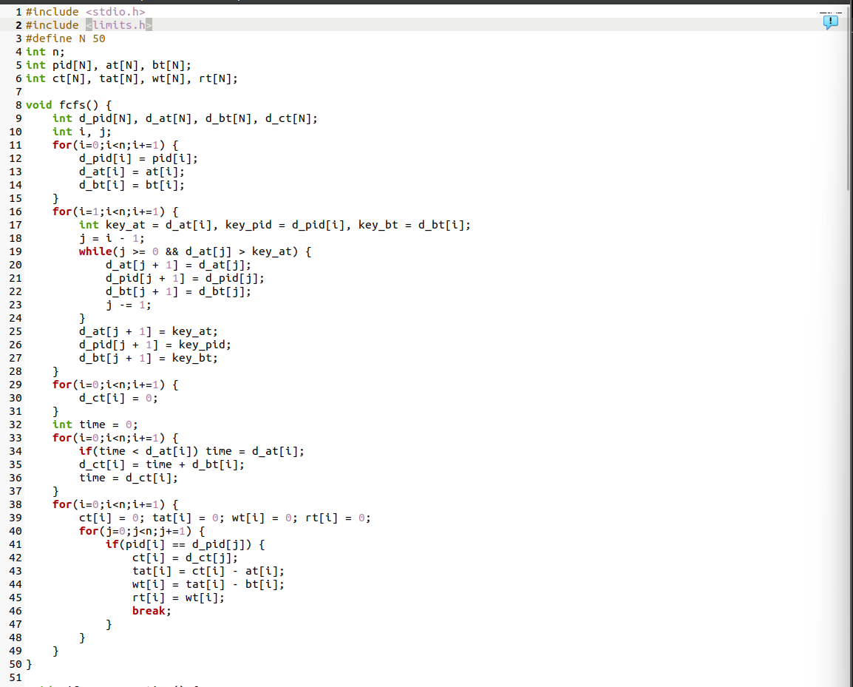
Implementation of Shortest Job First Algorithm:
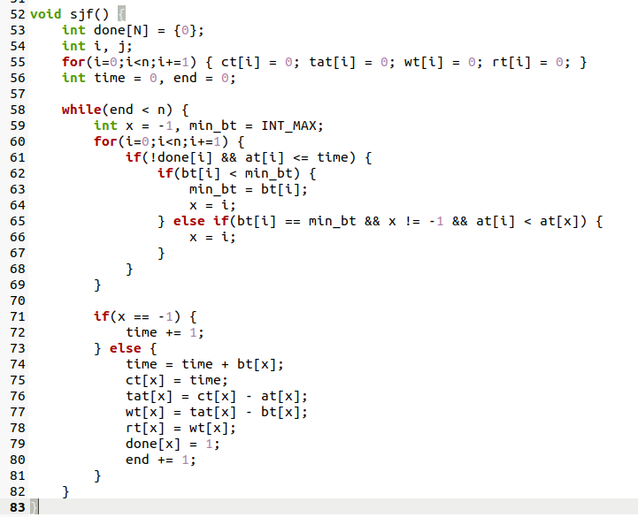

Implementation of Shortest Remaining Time First Algorithm:
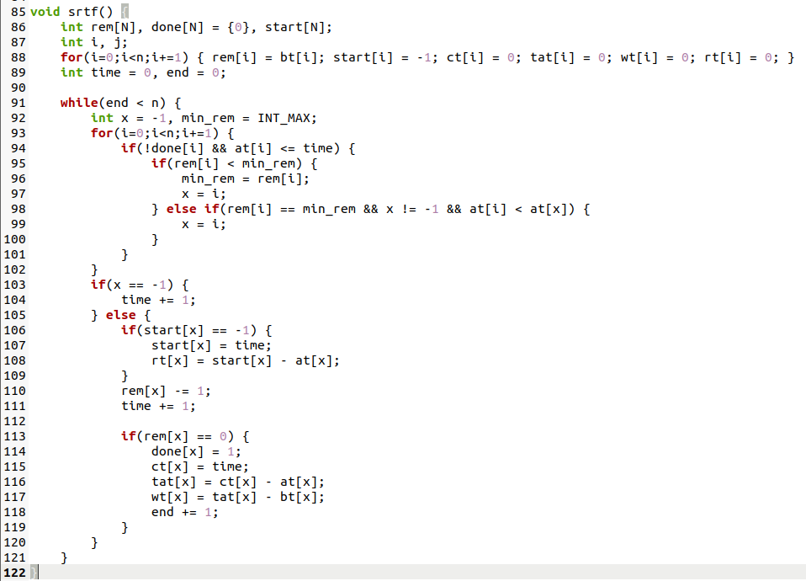

Function to display Process ID, Arrival Time, Burst Time, Completion Time, Turn Around time, Waiting time and Response time as well as Average TAT, Average WT and Average RT.
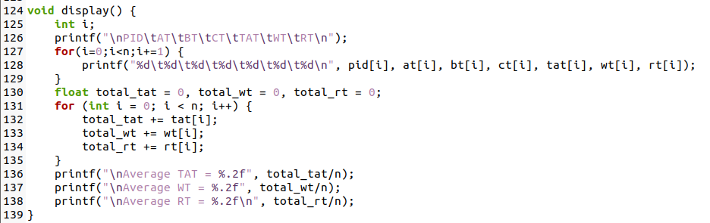
Menu driver code:
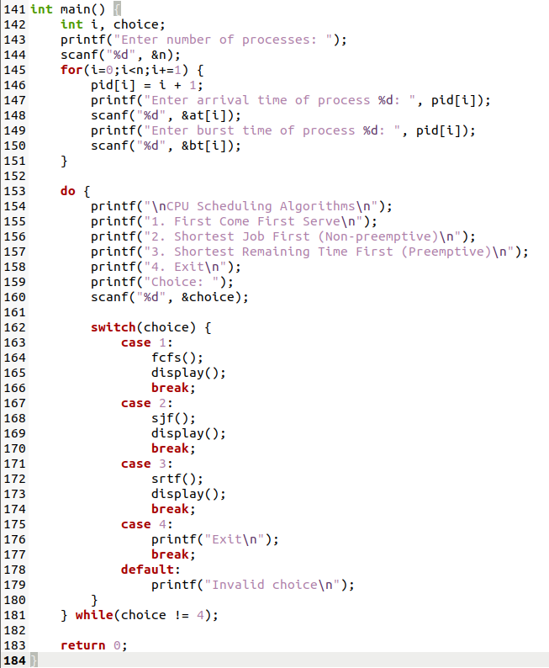

Q1b, Q1c. Make a table to calculate the turnaround time, waiting time and response time of each process. Cross checks the table results with a handmade table and Gantt chart.
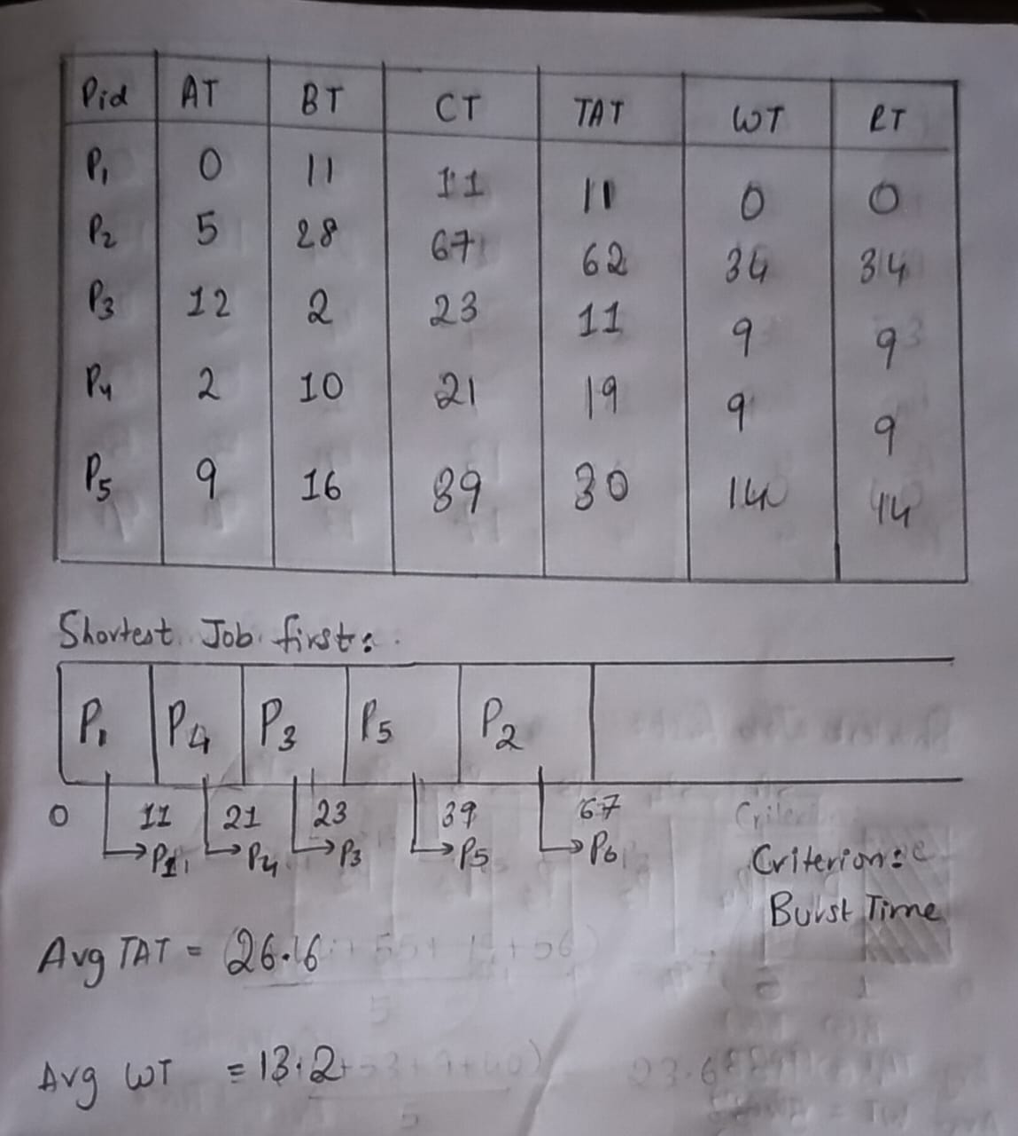
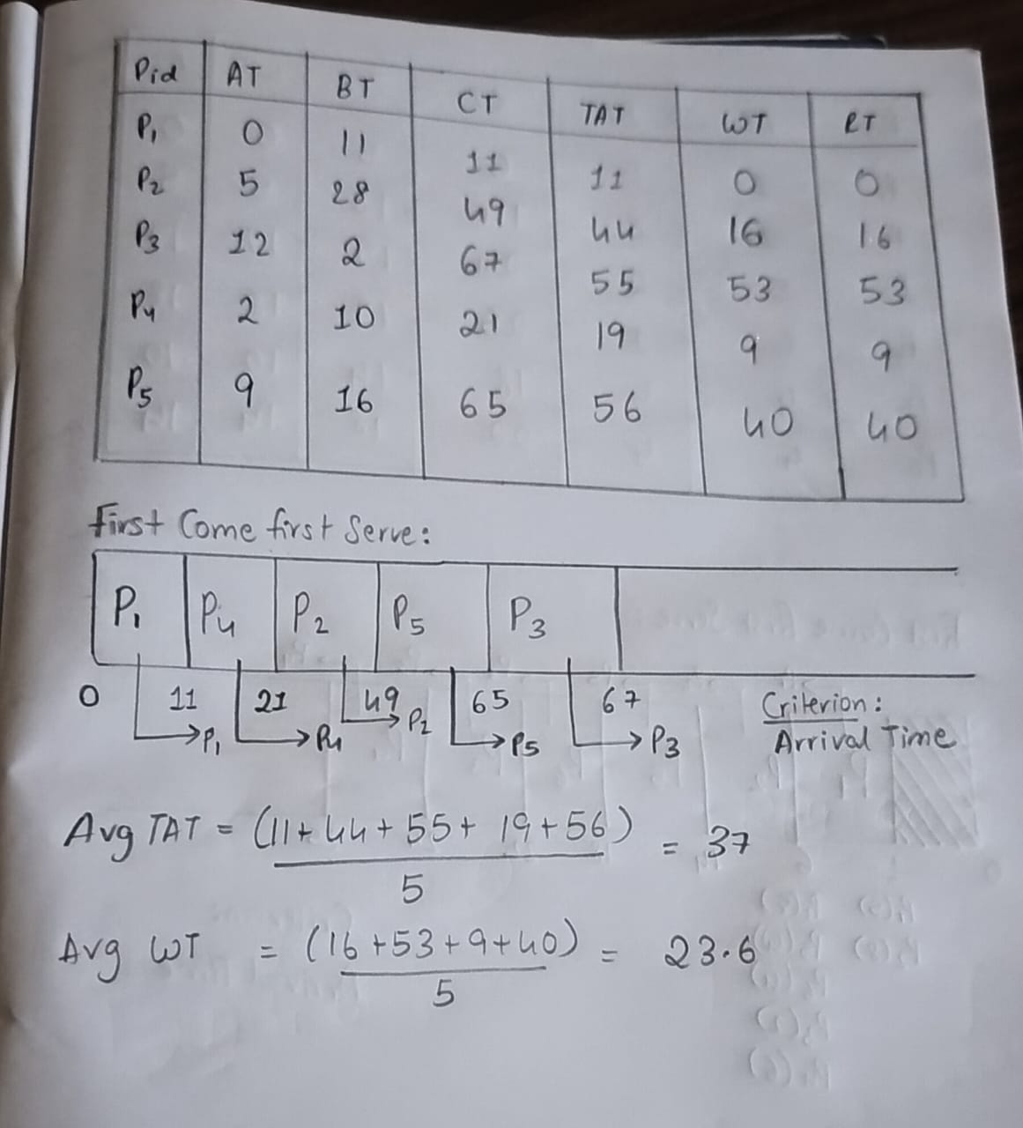
First Come First Serve manual implementation Shortest Job First manual implementation
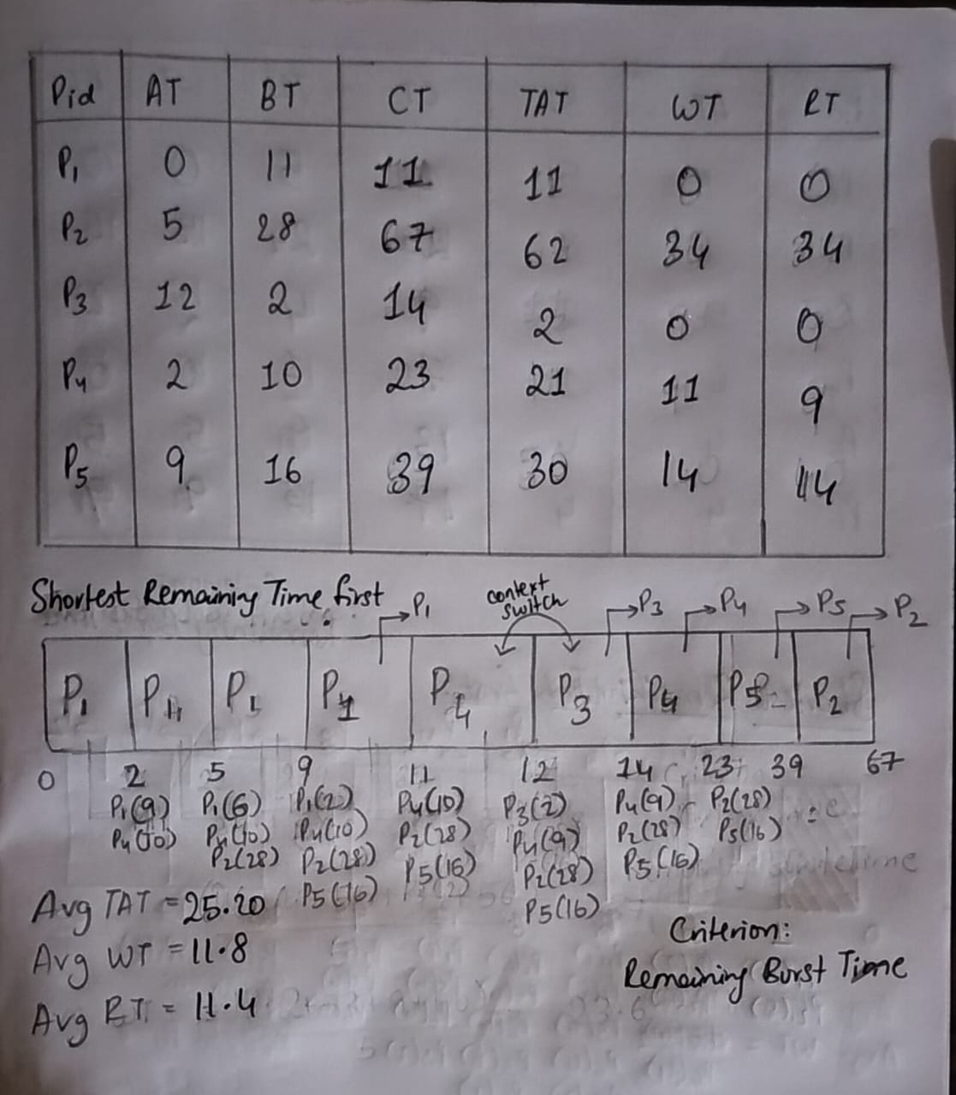
Shortest Remaining Time First manual implementation

Q1d. Find the sequence of process that terminates after complete execution of the job.
The sequence of process completion in FCFS is: P1, P4, P2, P5 and P3
The sequence of process completion in SJF is: P1, P4, P3, P5 and P2
The sequence of process completion in SRTF is: P1, P3, P4, P5 and P2

Q1e. Calculate the average turnaround time and average waiting time for each of the above scenario.
Algorithm | Average Turnaround Time (TAT) | Average Waiting Time (WT) | Average Response Time (RT)
FCFS | 37.0 | 23.6 | 23.6
SJF (Non-preemptive) | 26.6 | 13.2 | 13.2
SRTF (Preemptive SJF) | 25.2 | 11.8 | 11.4

Q1f. Comment on the best algorithm in this scenario.
The recommended algorithm to be used is Shortest Remaining Time First since it has the lowest TAT, WT and RT. SRTF keeps picking the job that can finish early, even if it interrupts the current process thereby reducing waiting for short processes.

Input:
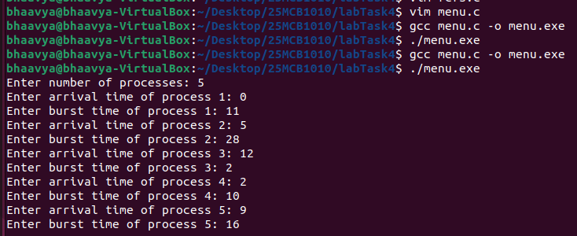
Output:
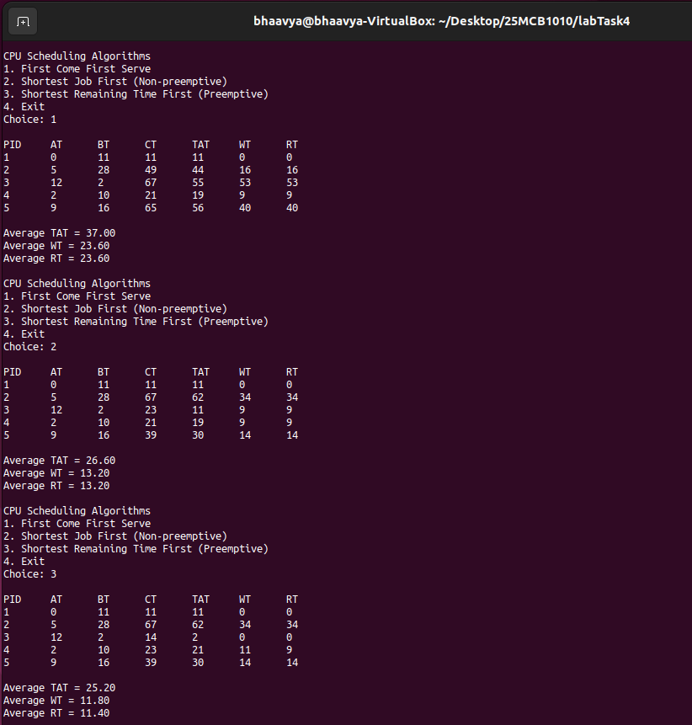

- Consider the following scenario:
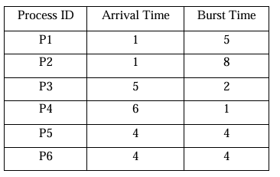
Q2a. Implemented the same code as above.
Q2b, Q2c. Make a table to calculate the turnaround time, waiting time and response time of each process. Cross checks the table results with a handmade table and Gantt chart.
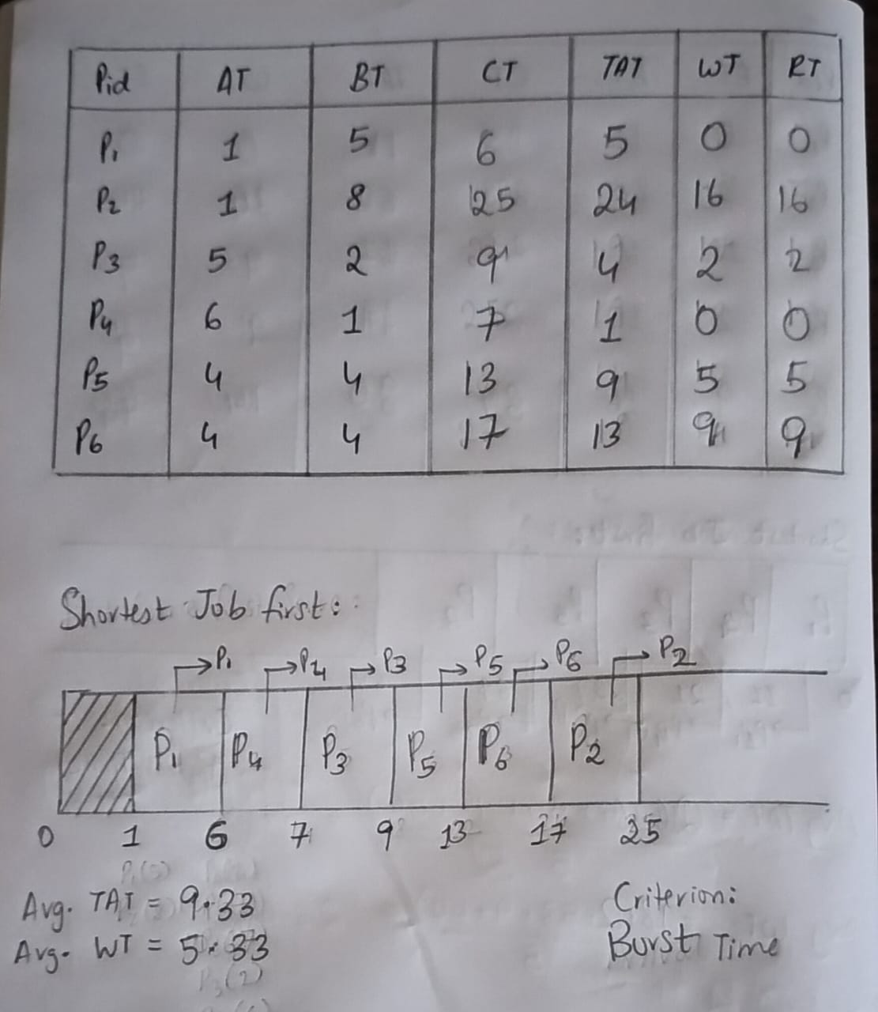
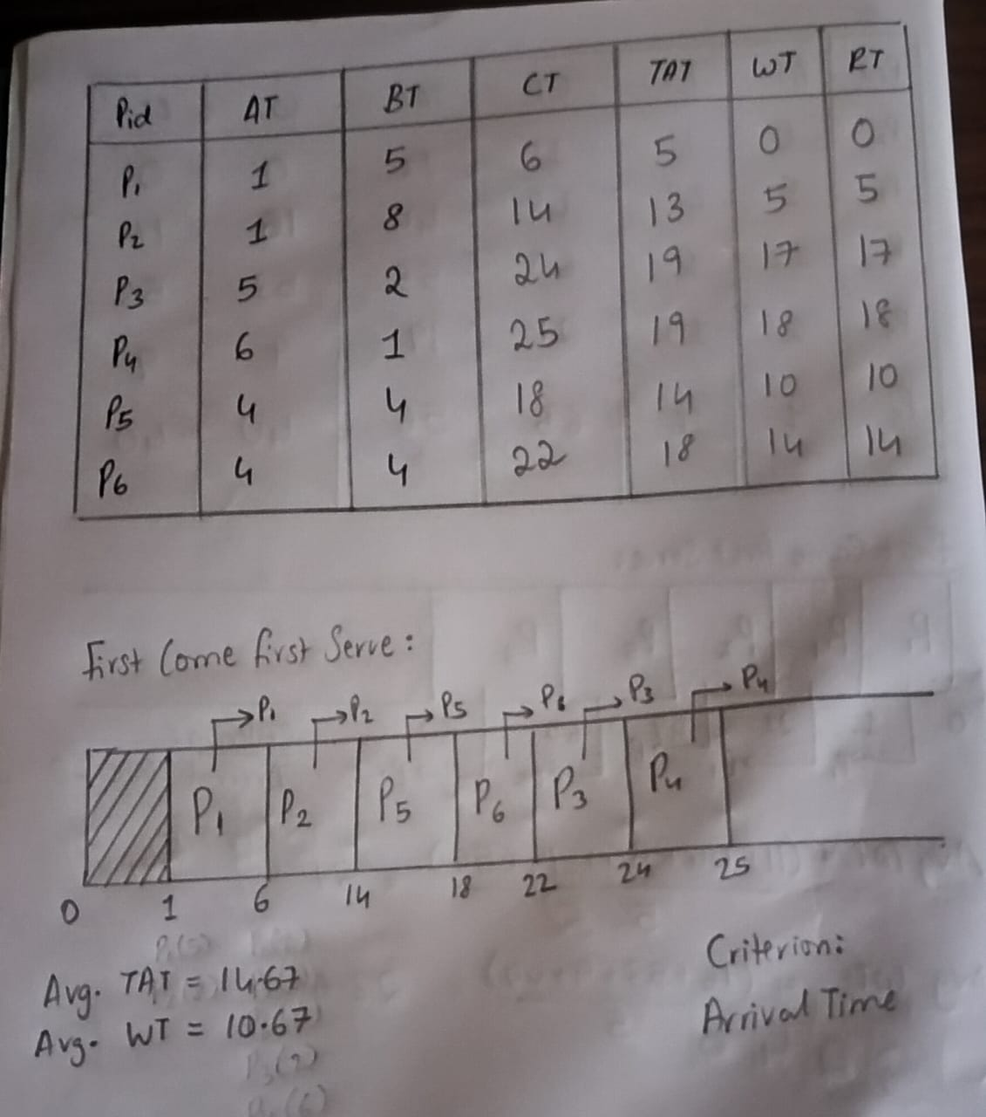
First Come First Serve manual implementation Shortest Job First manual implementation
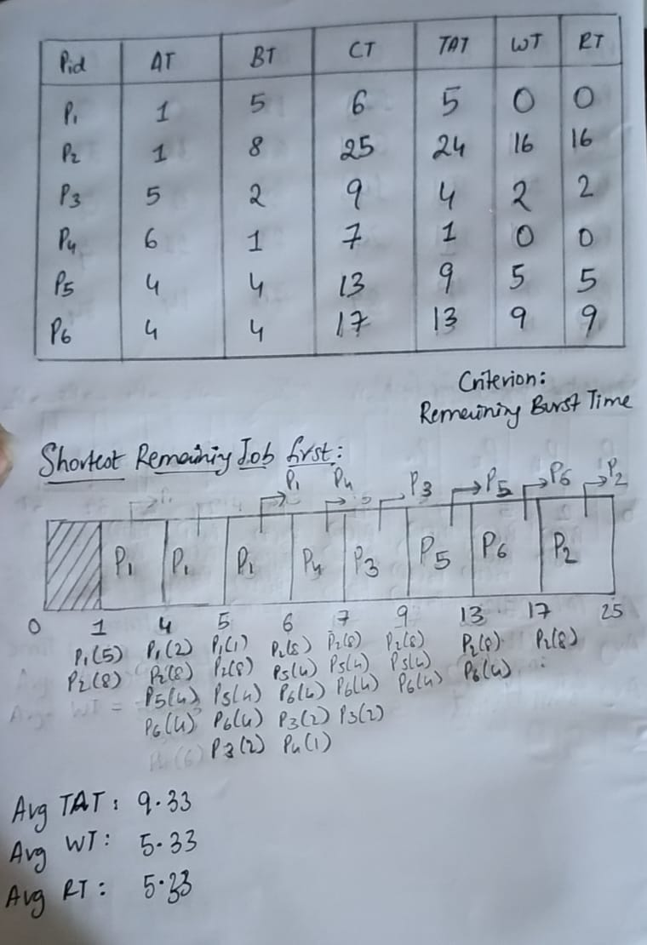
Shortest Remaining Time First manual implementation

Q2d. Find the sequence of process that terminates after complete execution of the job.
The sequence of process completion in FCFS is: P1, P2, P5, P6, P3 and P4
The sequence of process completion in SJF is: P1, P4, P3, P5, P6 and P2
The sequence of process completion in SRTF is: P1, P4, P3, P5, P6 and P2

Q2e. Calculate the average turnaround time and average waiting time for each of the above scenario.
Algorithm | Average Turnaround Time (TAT) | Average Waiting Time (WT) | Average Response Time (RT)
FCFS | 14.67 | 10.67 | 10.67
SJF (Non-preemptive) | 9.33 | 5.33 | 5.33
SRTF (Preemptive SJF) | 9.33 | 5.33 | 5.33

Q2f. Comment on the best algorithm in this scenario.
Table 2 Analysis:
The recommended algorithms to be used are Shortest Job First and Shortest Remaining Time First since they perform equally for TAT, WT, and RT. The processes have arrival times such that pre-emption doesn’t add extra benefit over non-premptive SJF.

Input:
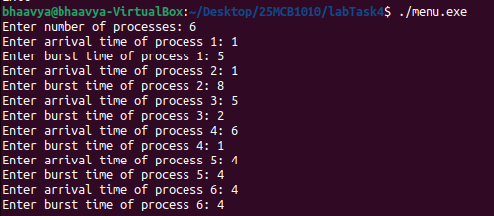
Output:
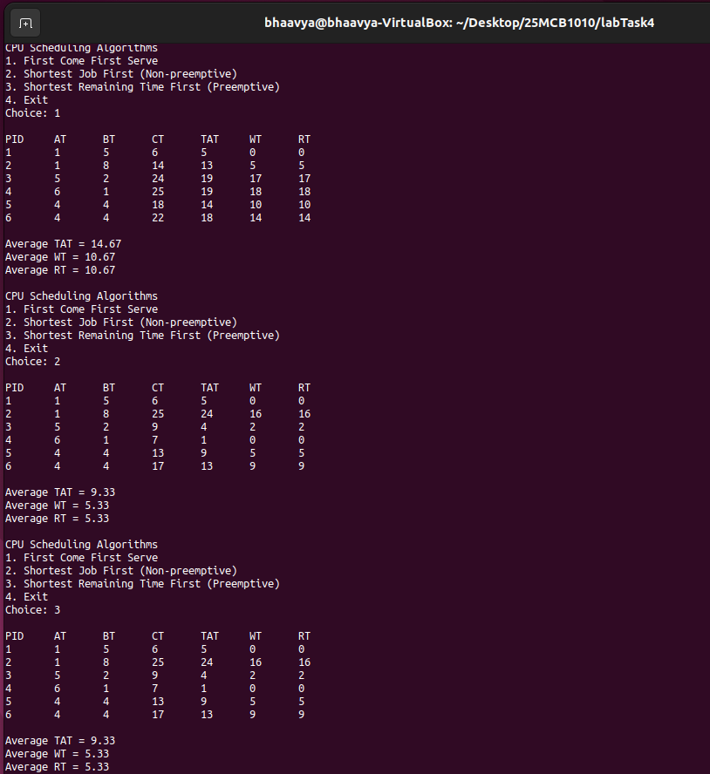
Key Learnings:
- Turnaround Time (TAT): How long a process takes from arrival to completion including (waiting time and execution time)
- Waiting time (WT): How long a process waits in the queue before actually running.
- Response Time (RT): Time from arrival until the process starts running for the first time.
For processes with varying execution times and arrival times, SRTF is preferred. For predictable, short jobs that arrive early, SJF is good. FCFS is simple but slow when short processes get stuck behind long ones.

Submitted By: Patsamatla Bhaavya Ramita, 25MCB1010

