OPERATING SYSTEMS LAB EXPERIMENT – 5
Submitted By: 25MCB1010, Patsamatla Bhaavya Ramita
- Write a menu driven program that implements the following CPU scheduling algorithms for the above scenario.
- Non Premptive Priority Scheduling (0-lowest and 4-highest)
- Premptive Priority Scheduling (0-lowest and 4-highest)
- Round Robin Scheduling (Time Quantum = 3units) (Note: Do not consider Priority)
Driver code:
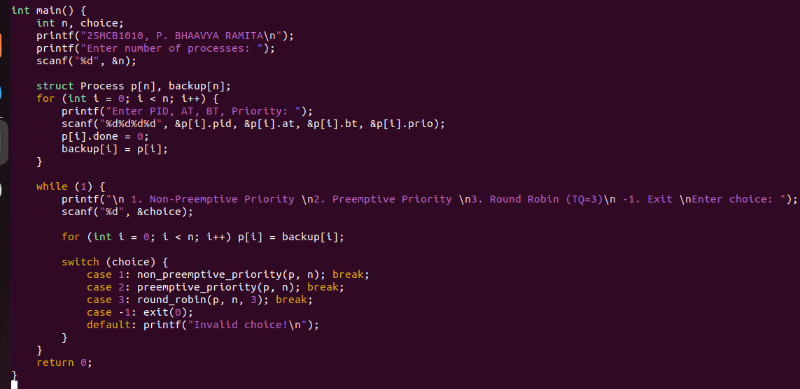
Structure and display function:
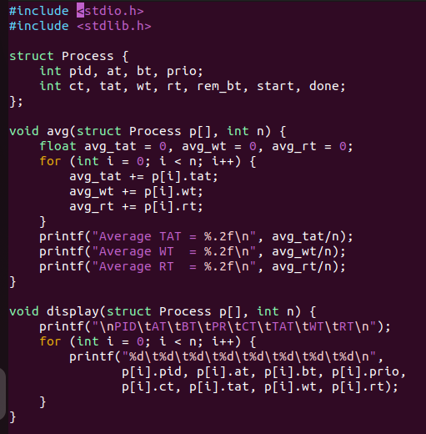
Non-premptive function:
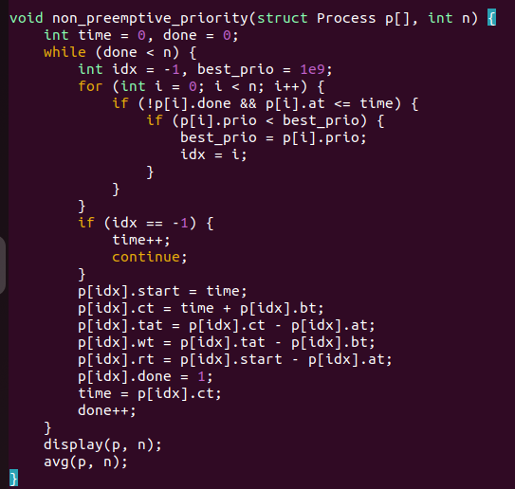
Pre-emptive Priority scheduling:
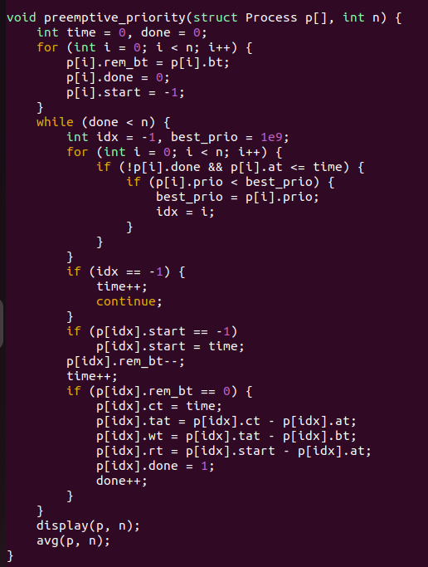
Round Robin scheduling:
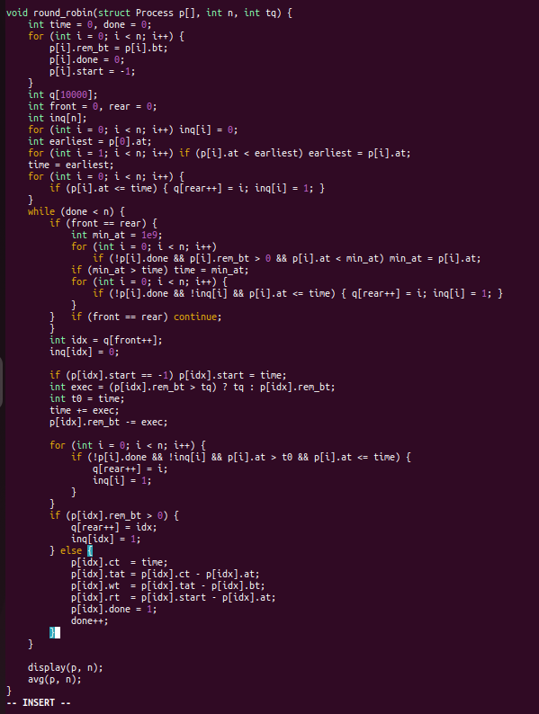

Table 1:
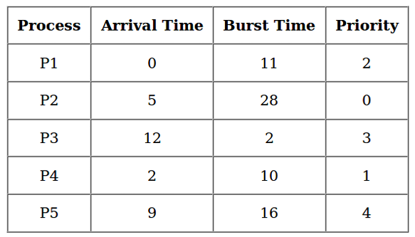
- Make a table to calculate the turnaround time, waiting time and response time of each process.
- Cross check the table results with a handmade table and Gantt chart.

Non-premptive Priority Scheduling:
Code Results:
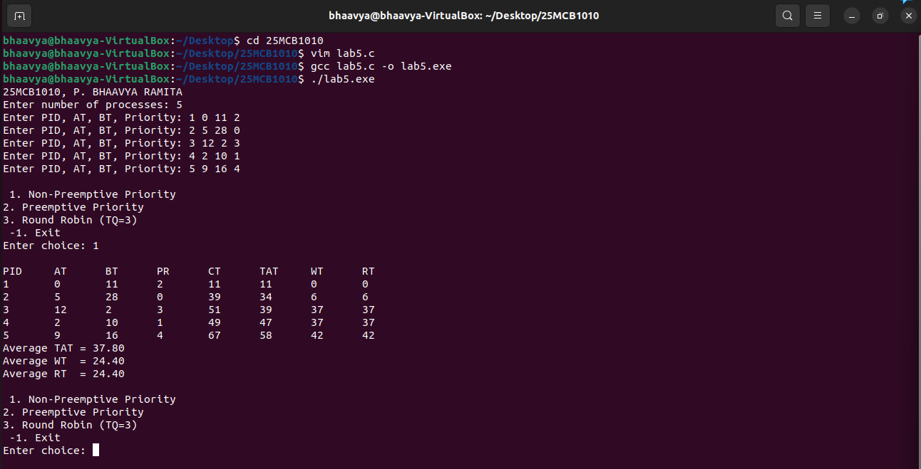

Manual calculation:
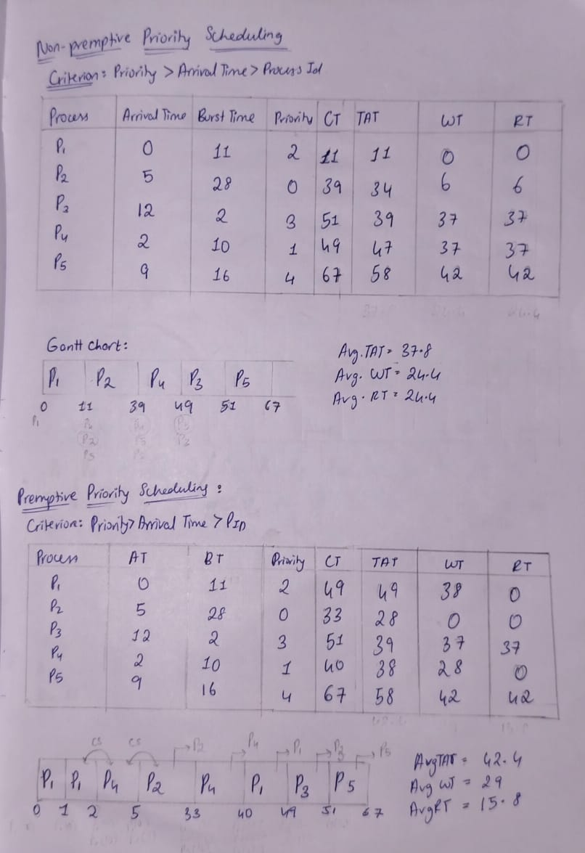
- Find the sequence of process that terminates after complete execution of the job.
P1 -> P2 -> P4 -> P3 -> P5
Premptive Priority scheduling:

Code Results:
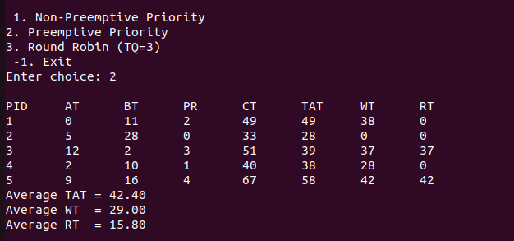

Manual Results:


- Find the sequence of process that terminates after complete execution of the job.
P2 -> P4 -> P1 -> P3 -> P5

Round Robin Scheduling with Time Quantum = 3

Code Results:
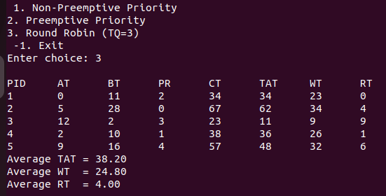

Manual Calculation:
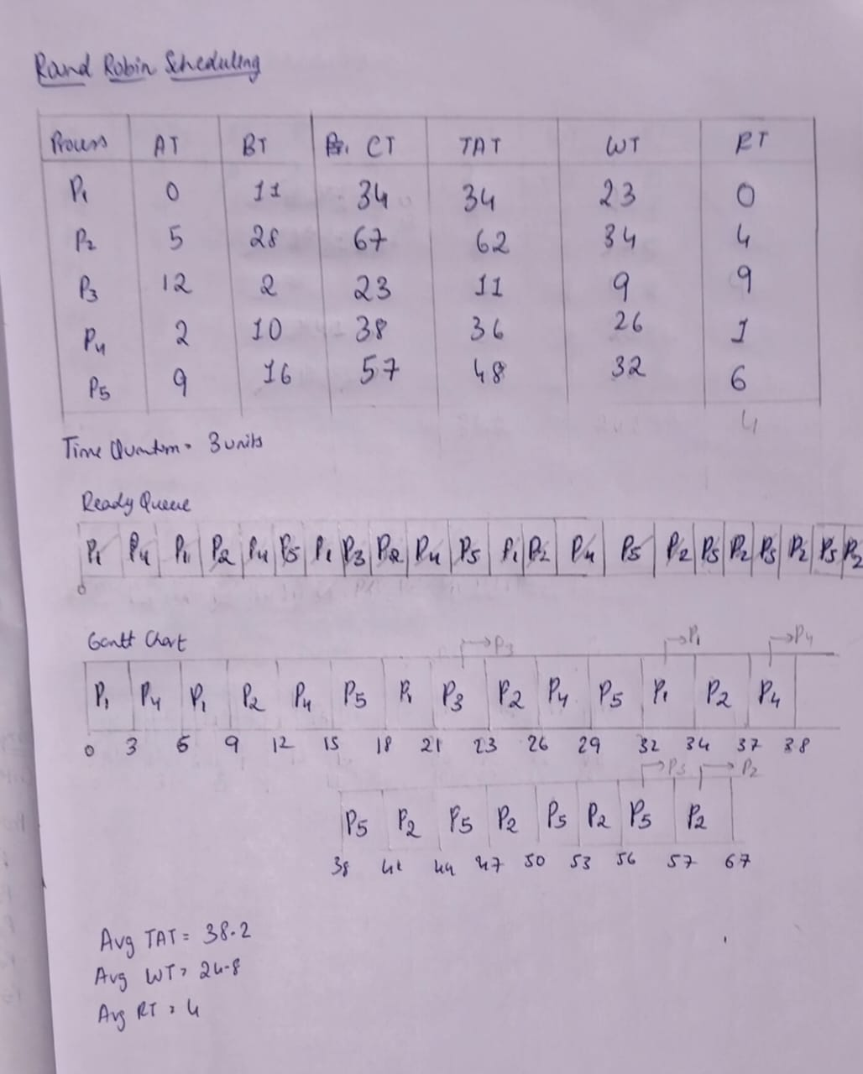
- Find the sequence of process that terminates after complete execution of the job.
P3 -> P1 -> P4 -> P5 -> P2

- Calculate the average turnaround time and average waiting time for each of the above scenario.
Scheduling Algorithm | Average Turnaround Time | Average Waiting Time | Average Response Time
Non-Preemptive Priority | 37.8 | 24.4 | 24.4
Preemptive Priority | 42.4 | 29.0 | 15.8
Round Robin (TQ = 3 units) | 38.2 | 24.8

- Comment the best algorithm for this scenario:
Round Robin has lowest RT = 4.0 but TAT = 38.2 and WT = 24.8. Non-preemptive priority gives TAT = 37.8 and WT = 24.4 but high RT = 24.4. Preemptive priority improves RT = 15.8 but increases TAT = 42.4 and WT = 29.0. Best is preemptive priority as it finishes urgent jobs earlier.

Table 2:
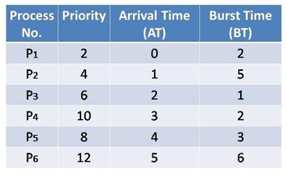

- The implemented driver code is mentioned above
- Make a table to calculate the turnaround time, waiting time and response time of each process.
- Cross check the table results with a handmade table and Gantt chart.

Non-premptive Priority scheduling:
Code results:
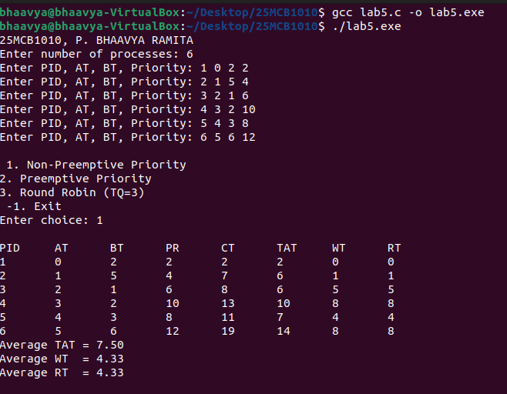

Manual Implementation:
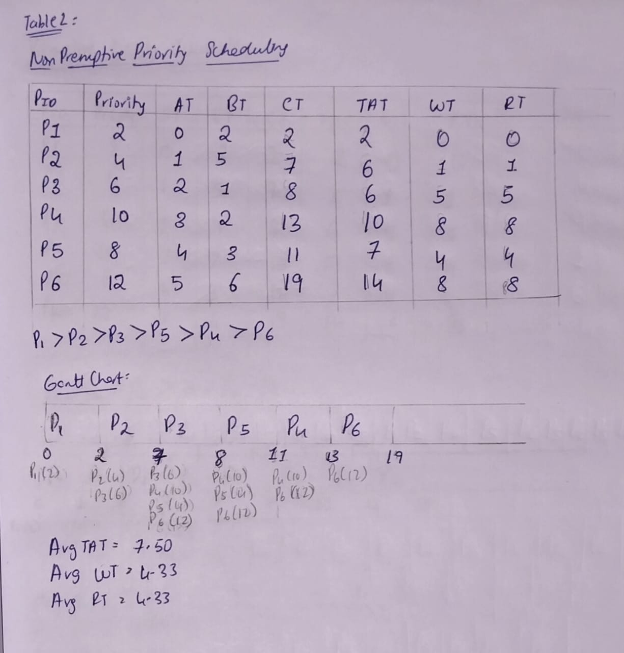
- Find the sequence of process that terminates after complete execution of the job.
P1 -> P2 -> P3 -> P5 -> P4 -> P6
Premptive priority scheduling:
Code results:
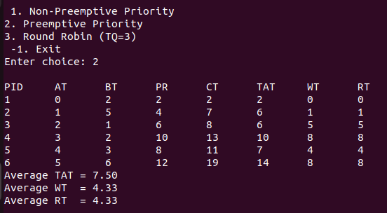

Manual Implementation:
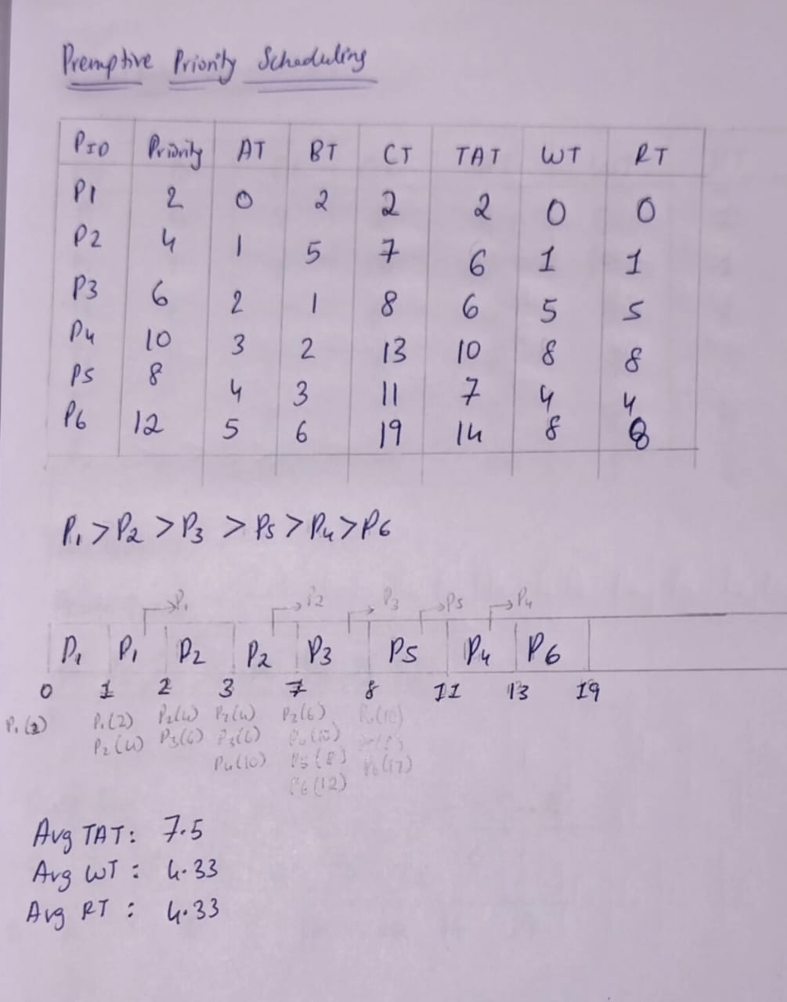
d. Find the sequence of process that terminates after complete execution of the job.
P1 -> P2 -> P3 -> P5 -> P4 -> P6
Round Robin scheduling
Code results:
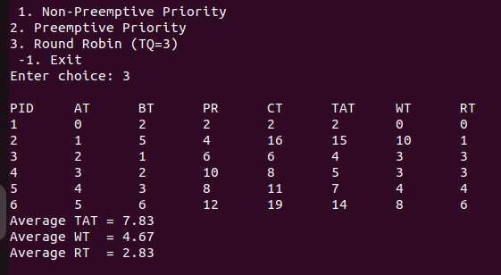

Manual Implementation:
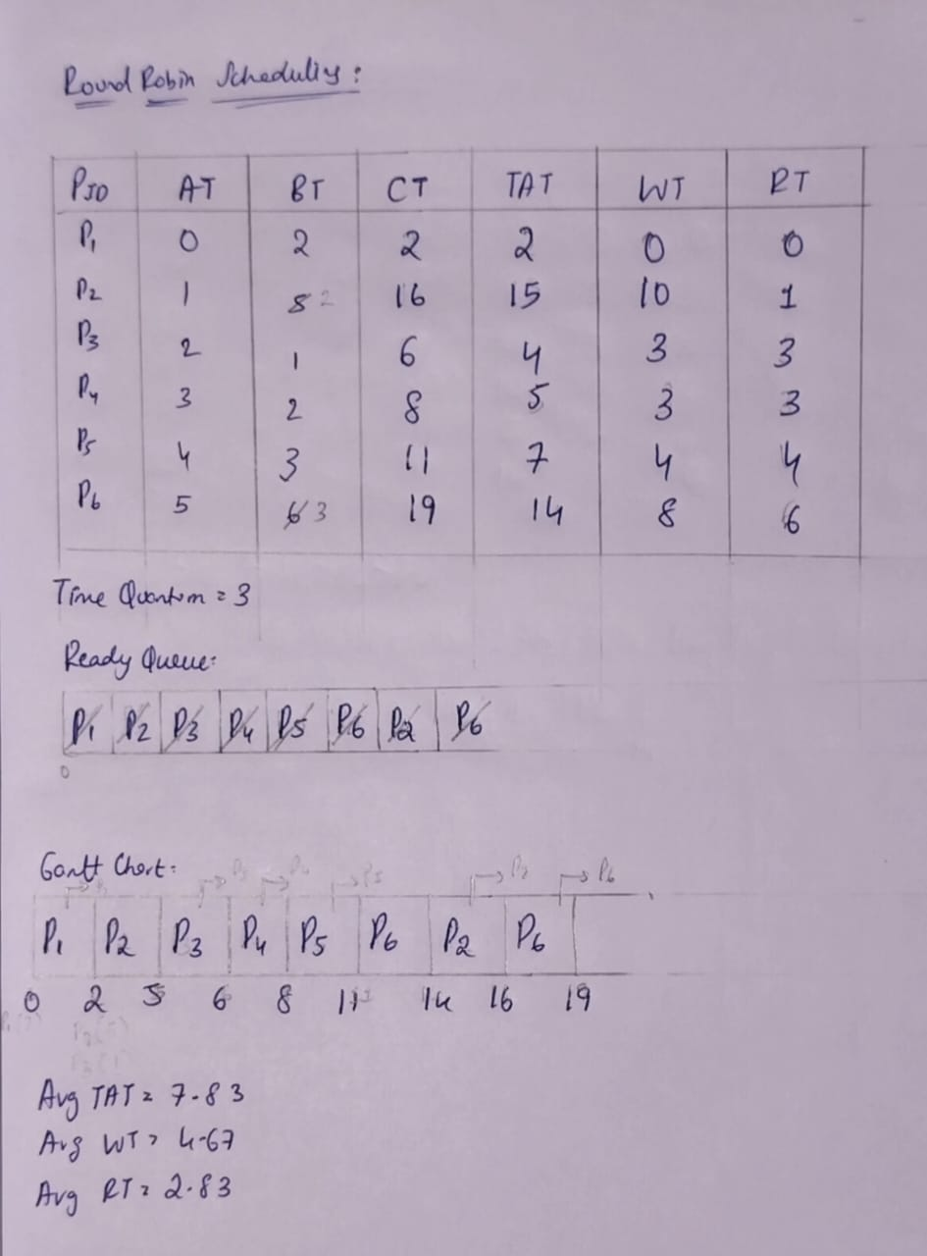

d.Find the sequence of process that terminates after complete execution of the job.
P1 -> P3 -> P4 -> P5 -> P2 -> P6

- Calculate the average turnaround time and average waiting time for each of the above scenario.

Scheduling Algorithm | Average Turnaround Time | Average Waiting Time | Average Response Time
Non-Preemptive Priority | 7.5 | 4.33 | 4.33
Preemptive Priority | 7.5 | 4.33 | 4.33
Round Robin (TQ = 3 units) | 7.83 | 4.67 | 2.83

- Comment the best algorithm for this scenario:
In this case, both preemptive and non-preemptive priority gave the same results, with average TAT = 7.5 and WT and RT = 4.33. Round Robin was slightly higher in TAT (7.83) and WT (4.67) but gave a better RT (2.83) since processes got quicker initial response.

Submitted by: 25MCB1010, P. Bhaavya Ramita

