Operating Systems: Lab 6 – Threads
Submitted By: 25MCB1010, Patsamatla Bhaavya Ramita

TASK – 1: To write C programs for demonstrating creation and manipulation of threads.

Code 1:
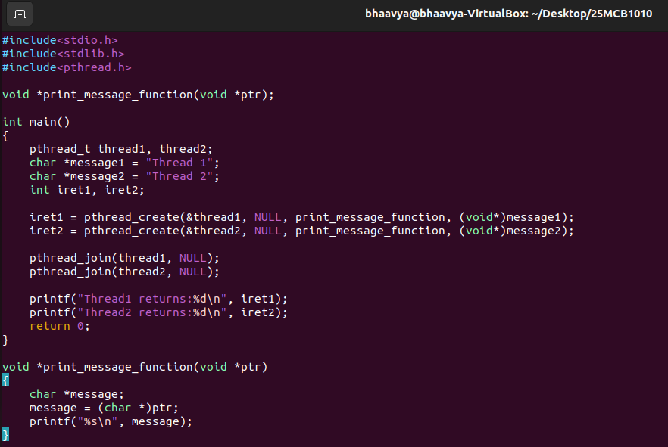
Output:
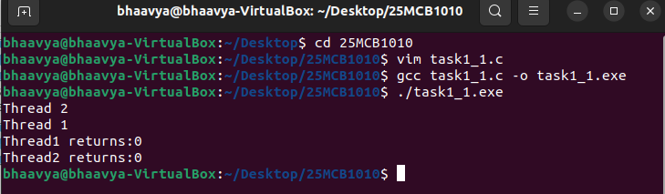

Code 2:
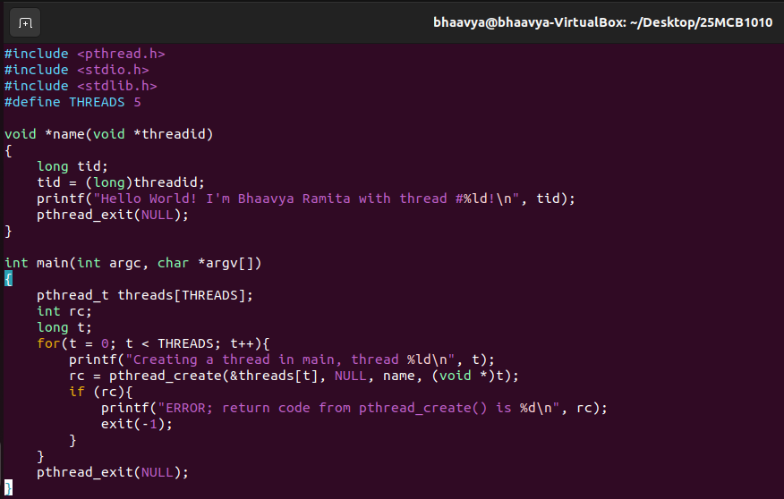
Output:
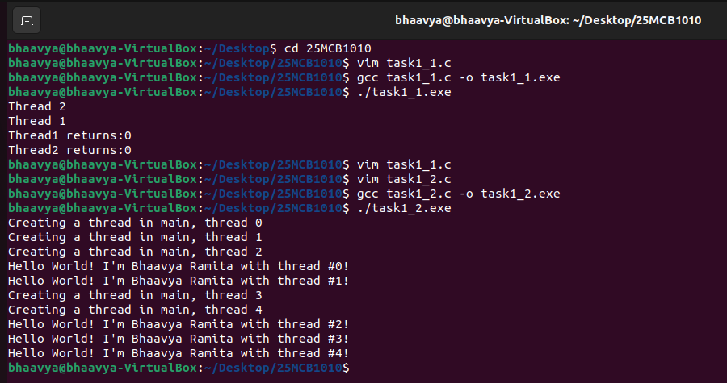

TASK – 2: To write a C program to demonstrate Process Synchronization Problem

Code:

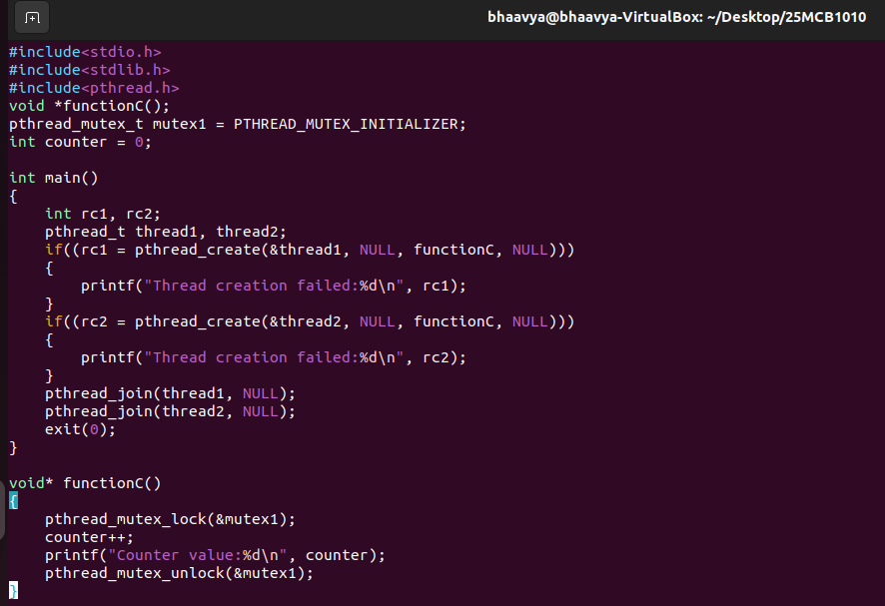

Output:

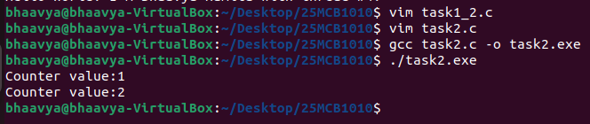

TASK – 3: Write a C program using threads that divides an array into parts and assign each part to a different thread to calculate the partial sum. Finally, combine the results in the main thread.

Code:

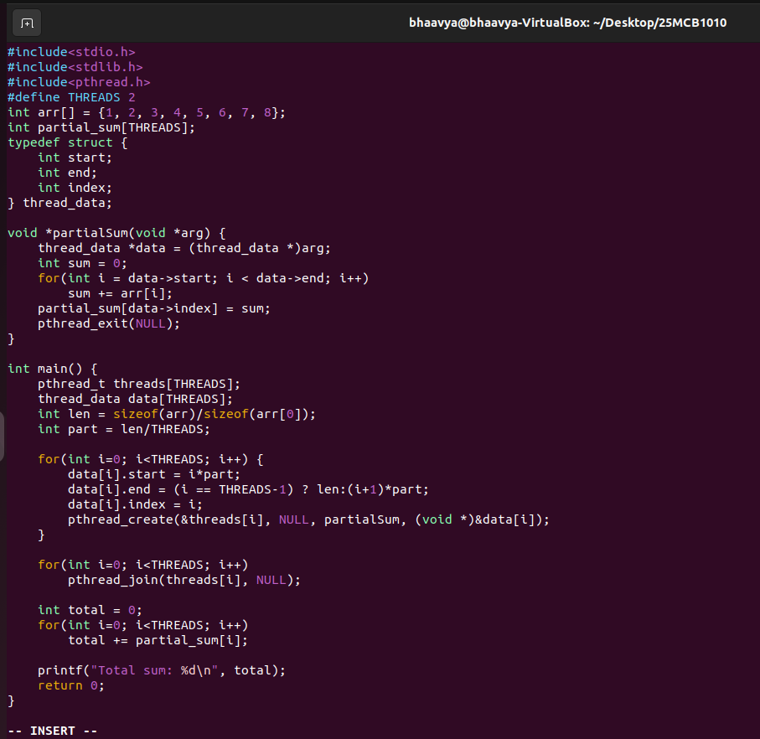

Output:
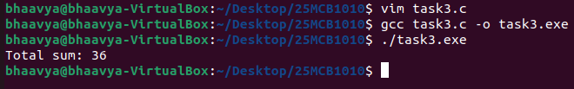

Array is divided into THREADS parts and each thread calculates sum of its part (partial_sum). The main thread calculates the total sum from partial sums. This is used in parallel processing and load division.

TASK – 4: Write a C program using threads that does matrix multiplication where each thread computes one row of the result matrix.

Code:
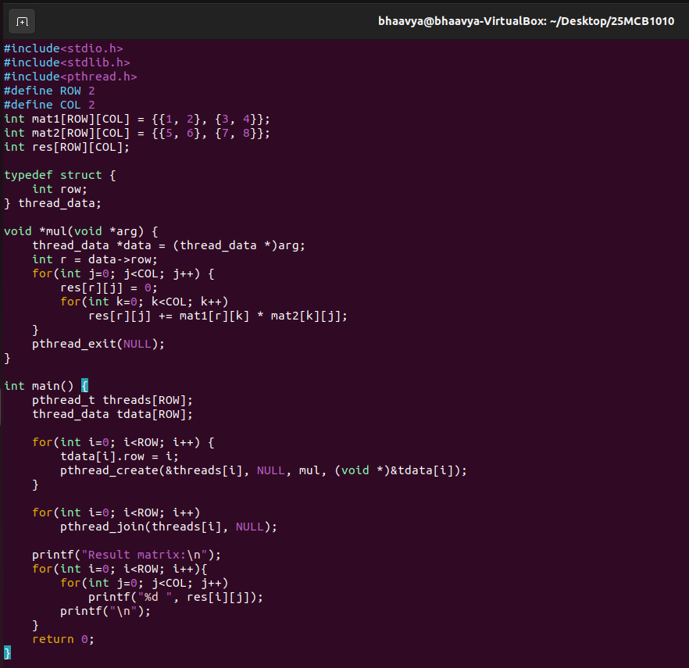
Output:
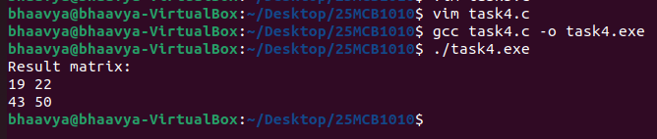
Each thread calculates one row of result matrix. Threads run concurrently to do row-wise multiplication of matA and matB. The main thread collects all rows to output the final matrix (res).
Summary of key learnings:
- pthread_create() is a function used to create a new thread.
Syntax: pthread_create(&thread_id, NULL, function, argument)
- pthread_join() is a function that waits for a thread to finish its execution
Syntax: pthread_join(thread_id, NULL)
- pthread_exit() is a function used to terminate a thread. It returns a value or NULL if not used.
- pthread_mutex_lock() is a function that locks a mutex to enter the critical section. It is sued in process synchronization.
- pthread_mutex_unlock() is a function that unlocks a mutex after leaving the critical section.

Submitted By: 25MCB1010, Patsamatla Bhaavya Ramita
Email: patsamatla.bhaavya2025@vitstudent.ac.in

