OS LabTask 9 - Fixed Size Memory Partitioning
Submitted By: 25MCB1010, Patsamatla Bhaavya Ramita

Aim 1: To implement first fit, best fit and worst fit algorithm for fixed sized memory management algorithm assuming FCFS process scheduling algorithm.
Example 1:
- Enter the number of blocks: 5
- Enter the number of files: 4
- Enter the size of the blocks:
  - Block 1: 100
  - Block 2: 200
  - Block 3: 300
  - Block 4: 400
  - Block 5: 500
- Enter the size of the files:
  - File 1: 135
  - File 2: 313
  - File 3: 112
  - File 4: 562
Manual Implementation for Example 1:
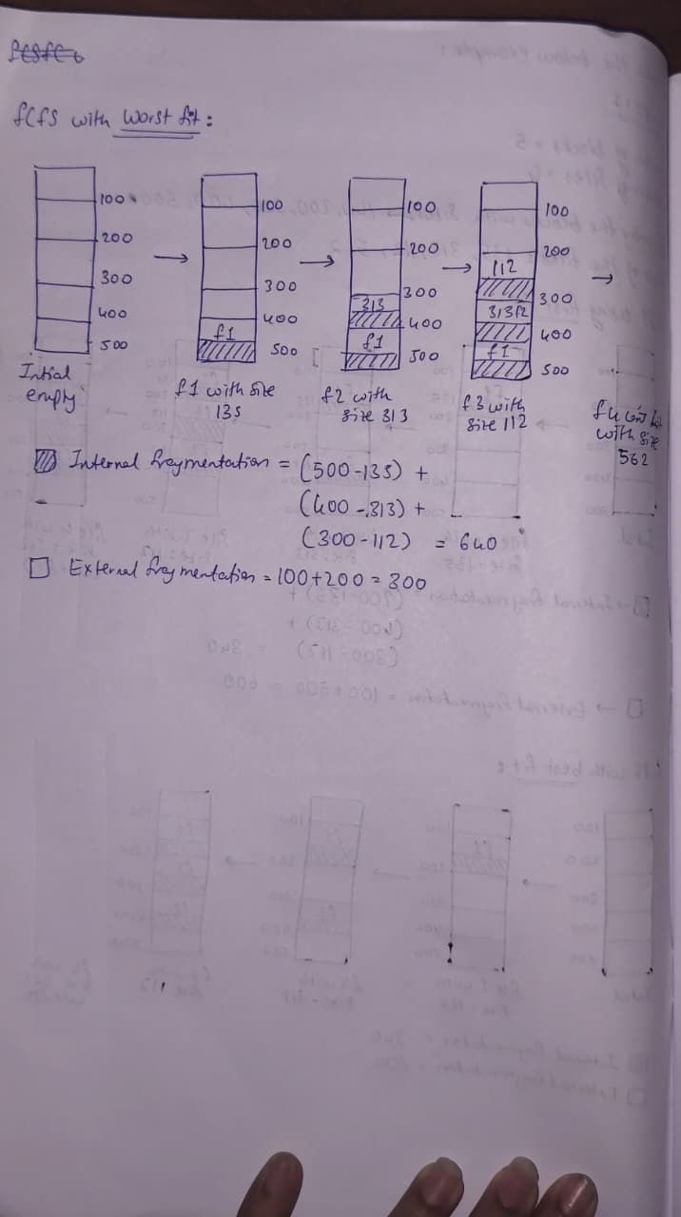
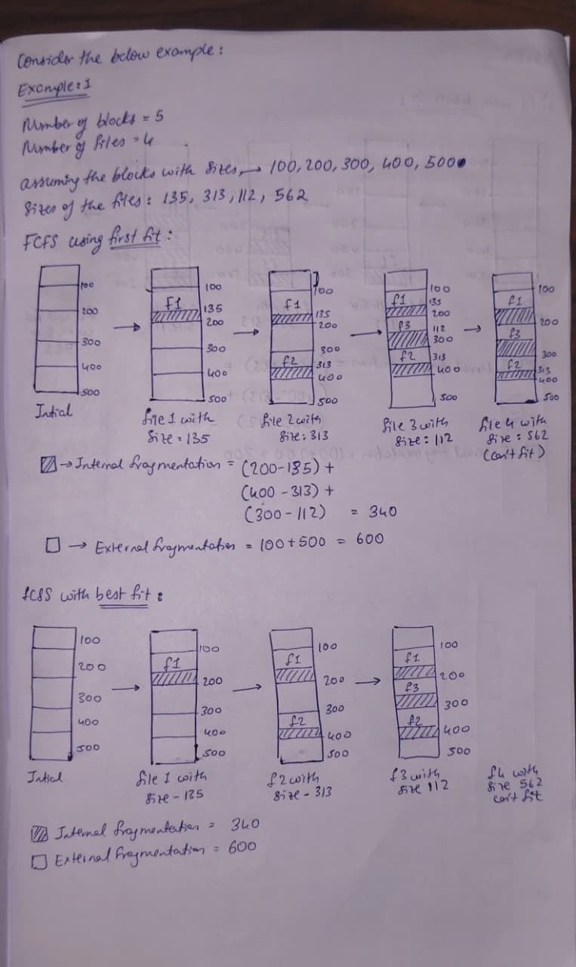
Code implementing Fixed Size Memory Partitioning using FCFS
- First Fit function
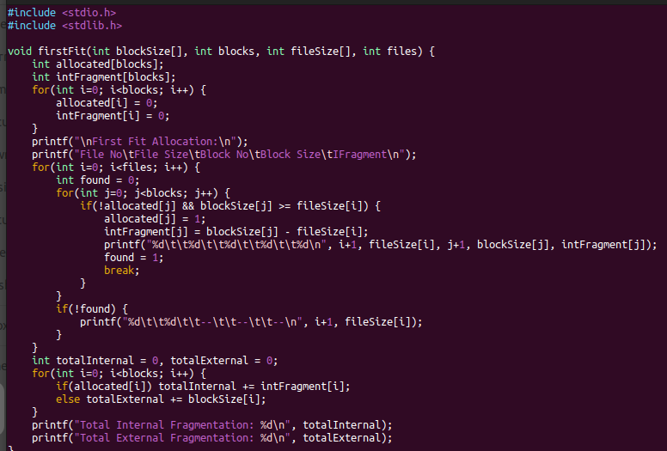
- Best Fit function
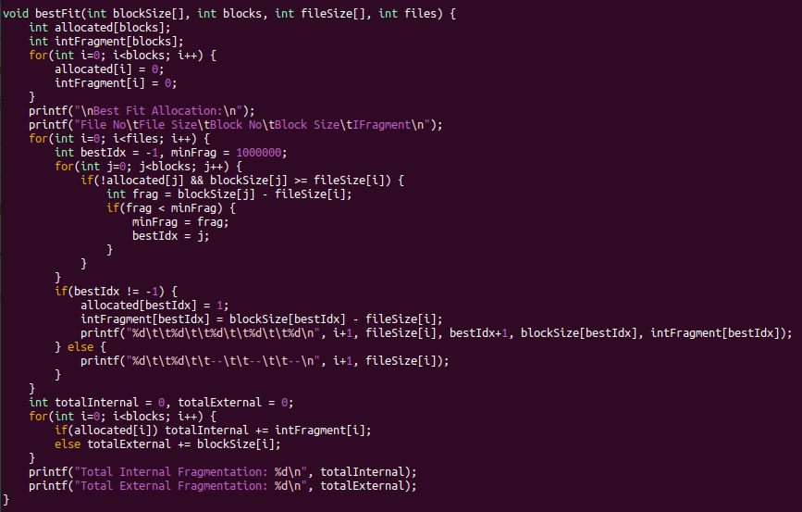

- Worst Fit function
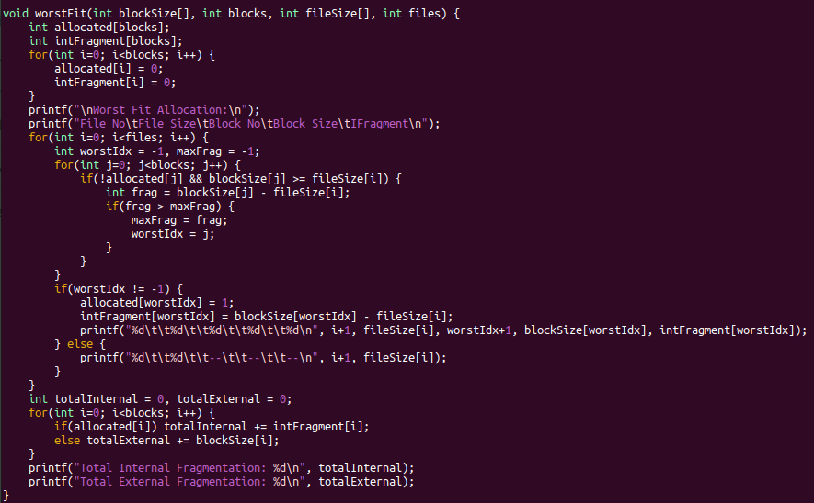

- Driver code
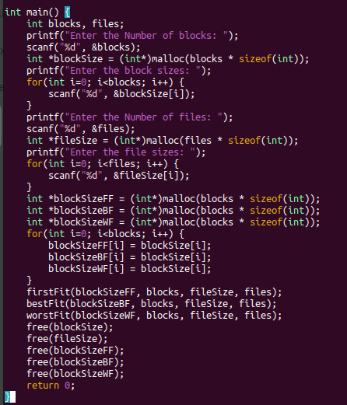

Example 1 Output:
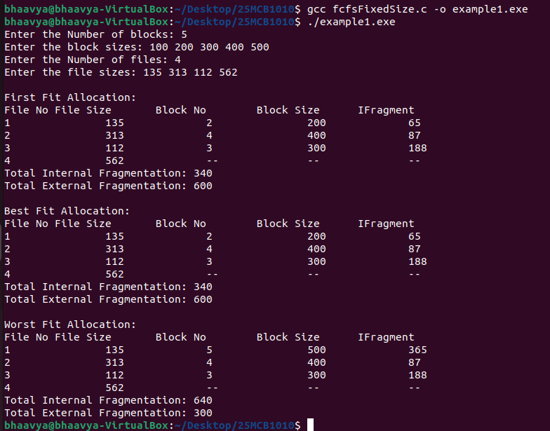

Example 2: Own Scenario
- Enter the number of blocks: 6
- Enter the number of files: 9
- Enter the size of the blocks:
  - Block 1: 128
  - Block 2: 256
  - Block 3: 512
  - Block 4: 1024
  - Block 5: 2048
  - Block 6: 4096
- Enter the size of the files:
  - File 1: 100
  - File 2: 200
  - File 3: 300
  - File 4: 600
  - File 5: 800
  - File 6: 1500
  - File 7: 2500
  - File 8: 3500
  - File 9: 4500

Manual Implementation for Example 2:
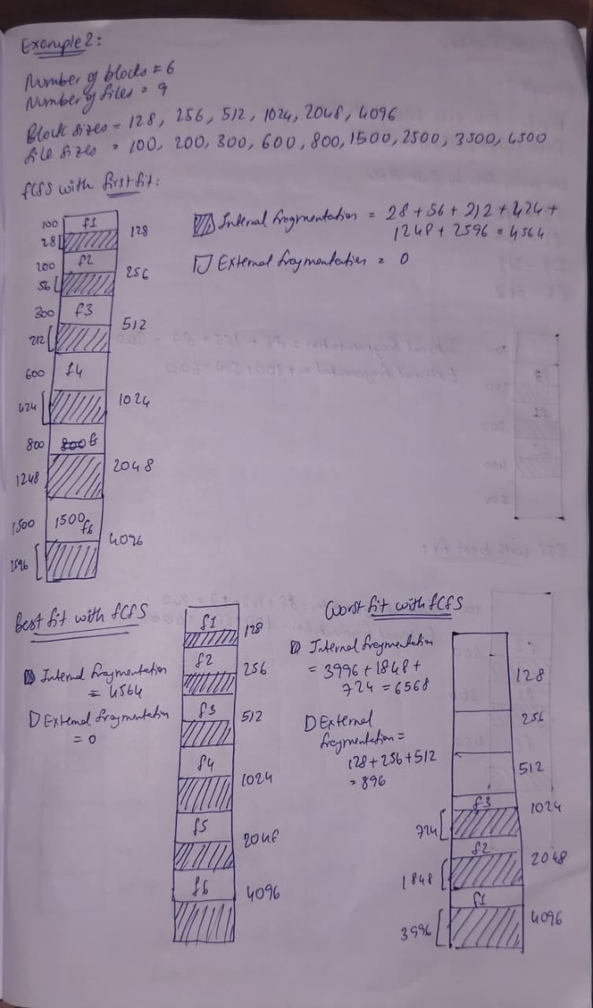
Example 2 Output:
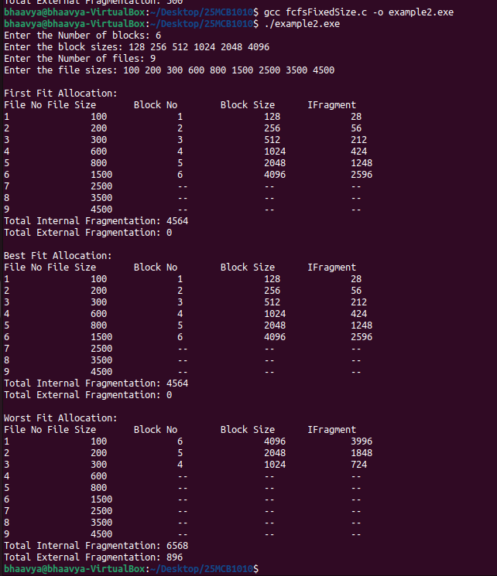

Aim 2: To implement first fit, best fit and worst fit algorithm for fixed sized memory management algorithm assuming SJF process scheduling algorithm. Use the above two scenarios for verification.
Example 1:
- Enter the number of blocks: 5
- Enter the number of files: 4
- Enter the size of the blocks:-
  - Block 1: 100
  - Block 2: 200
  - Block 3: 300
  - Block 4: 400
  - Block 5: 500
- Enter the size of the files:-
  - File 1: 135
  - File 2: 313
  - File 3: 112
  - File 4: 562

Manual Implementation for Example 1:
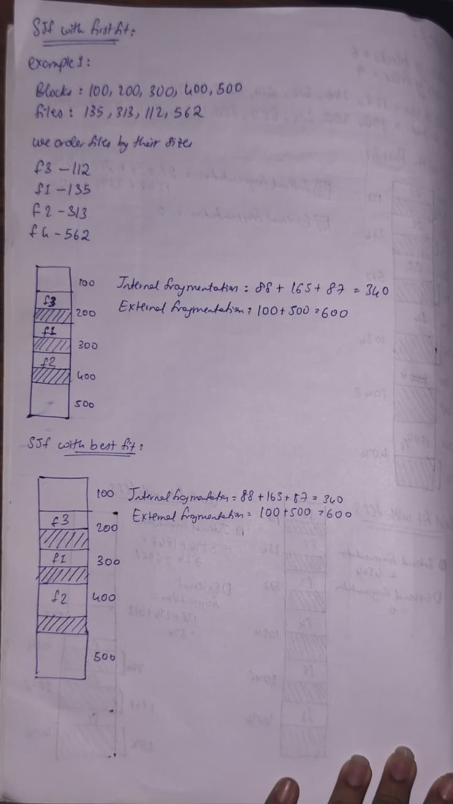
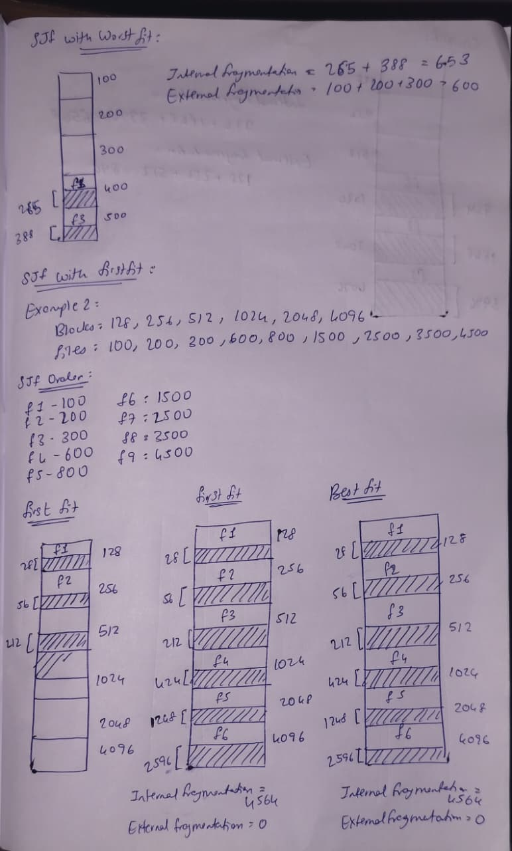

Example 2: Own Scenario
- Enter the number of blocks: 6
- Enter the number of files: 9
- Enter the size of the blocks:
  - Block 1: 128
  - Block 2: 256
  - Block 3: 512
  - Block 4: 1024
  - Block 5: 2048
  - Block 6: 4096
- Enter the size of the files:
  - File 1: 100
  - File 2: 200
  - File 3: 300
  - File 4: 600
  - File 5: 800
  - File 6: 1500
  - File 7: 2500
  - File 8: 3500
  - File 9: 4500

Manual Implementation for Example 2:

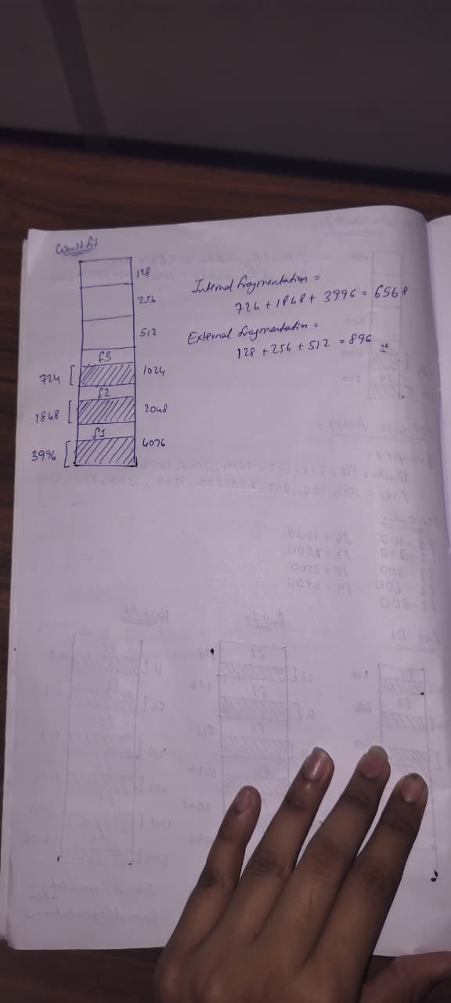


Code implementing Fixed Size Memory Partitioning using SJF
- First fit function
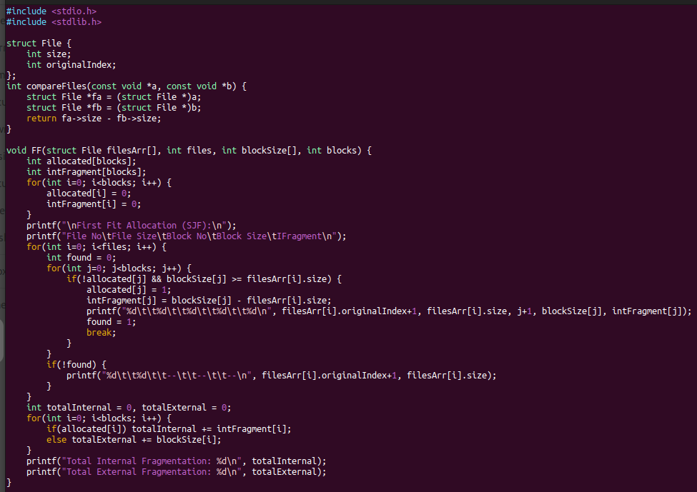
- Best fit function
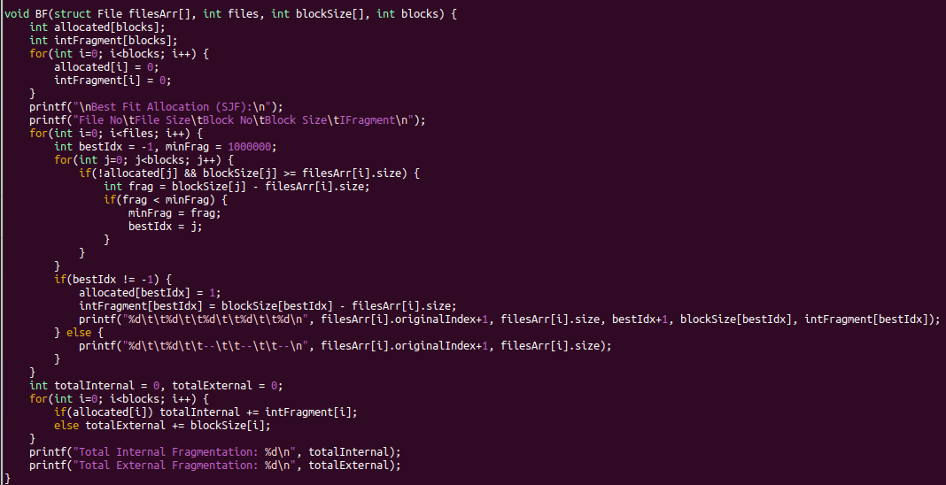
- Worst fit function
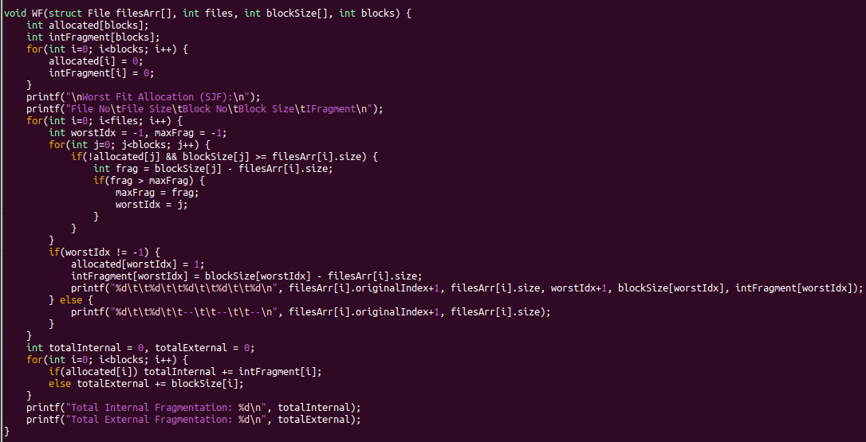
- Driver code
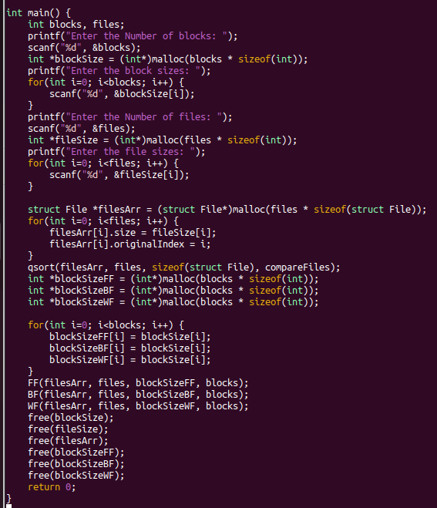

Example 1 Output:
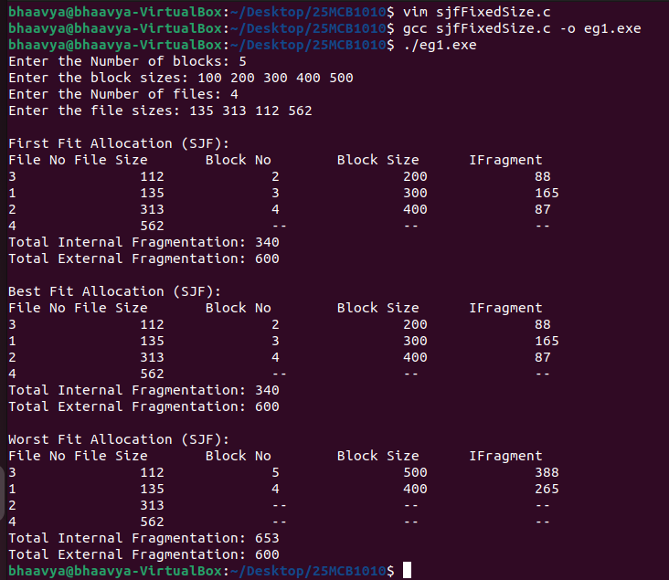
Example 2 Output:
