OS Lab- 2 Assignment: System Calls

- Execute all the fork system call examples discussed in the class and explain the respective outputs.

  - Print in parent process if a number is a divisible by 2 or not and in child process if number is divisible by 3 or not.
Code:
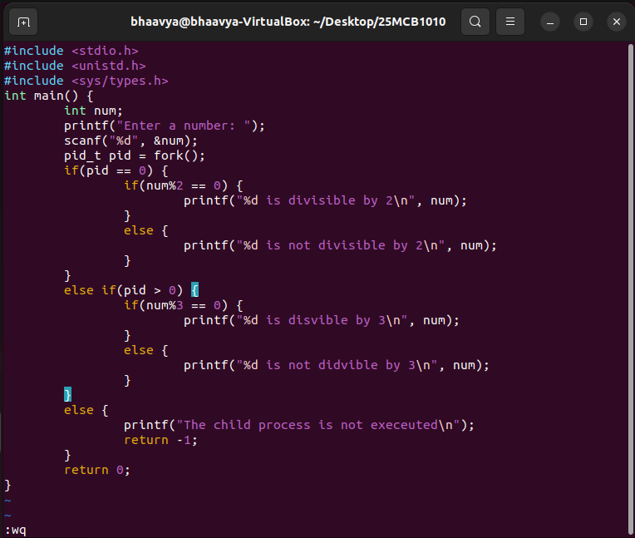

Output:
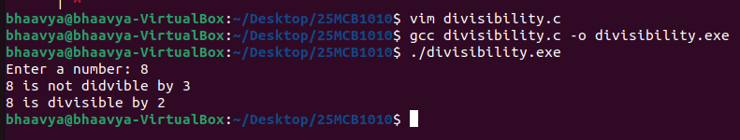

Explanation: fork() is a system call that creates two processes, a parent and child process. Pid represents process id, and if pid > 0 it denotes parent process which performs divisibility by 3 operation. If pid == 0, it denotes child process which checks if number is divisible by 2. Both processes run independently and print their results.

1.2 Check if number is palindrome in parent process and print reverse of number in child.
Code:
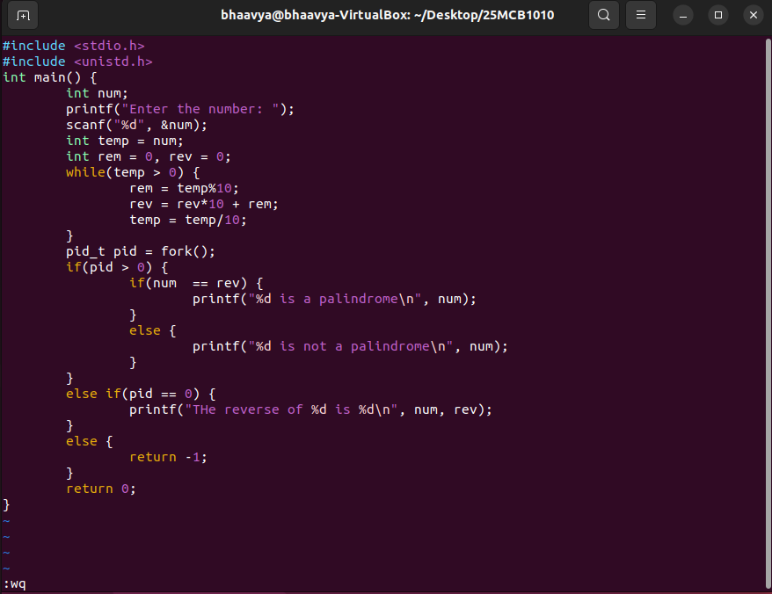

Output:
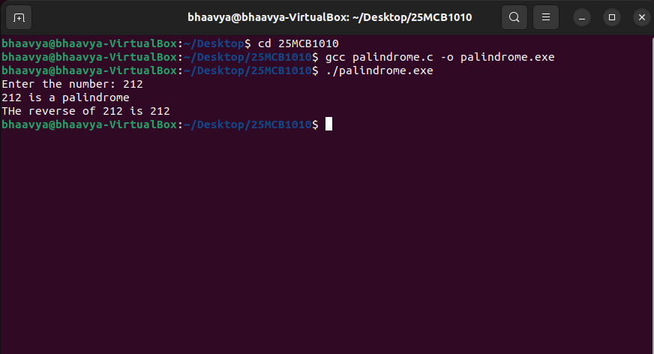
Explanation: fork() splits the process into parent and child. The parent process checks if the number is a palindrome by comparing the original and reversed number. The child process prints the reversed number.
1.3 Problems on Fork() system call
1.3.1 Code: fork() && fork()
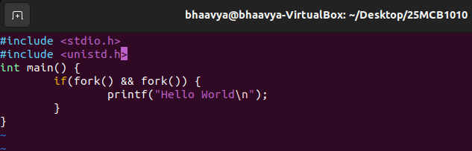

Output: prints Hello World once
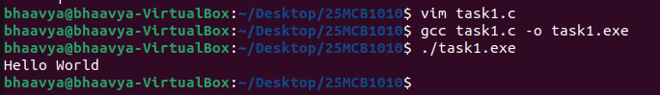

Explanation: 2 fork() calls creates 4 processes but due to AND operation, the print statement executes only in one process when both forks return non-zero (original parent) and other processes skip the block as at least one fork returns 0.

    - Code: fork() || fork()

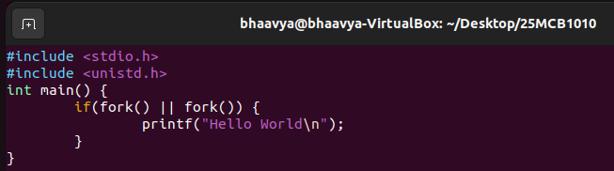

Output: prints Hello World twice
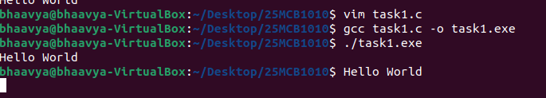
Explanation: 2 fork() calls can create 4 processes, but due to OR operation, the print statement executes in all processes except one where both forks return 0 (child of a child), so it the if condition is true in all but one process, it will print “Hello World” twice.

Illustration of 1.3.1 and 1.3.2 codes:
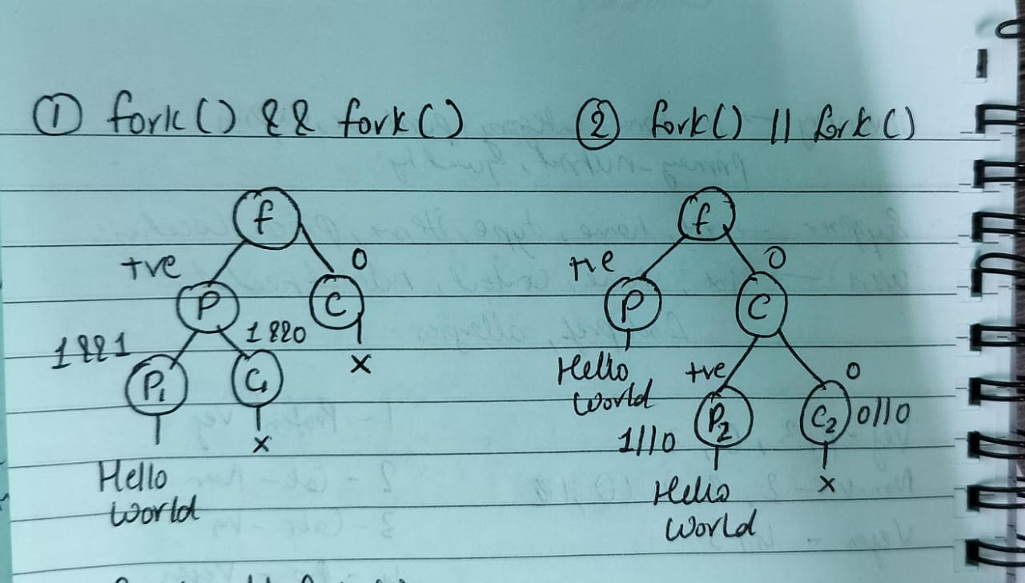

1.3.3 Code: 3 fork() calls

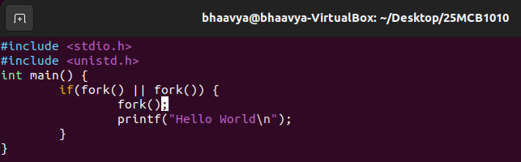

Output: prints Hello World 4 times

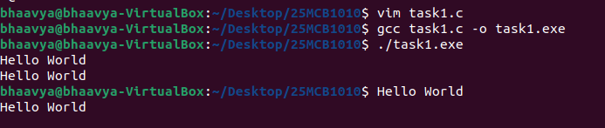

Explanation: 3 fork() calls create up to 8 processes. The if condition is true in all but one process. The processes that enter the block call an another fork() and print. So more processes are created inside the block, printing “Hello World” 4 times.

Illustration:
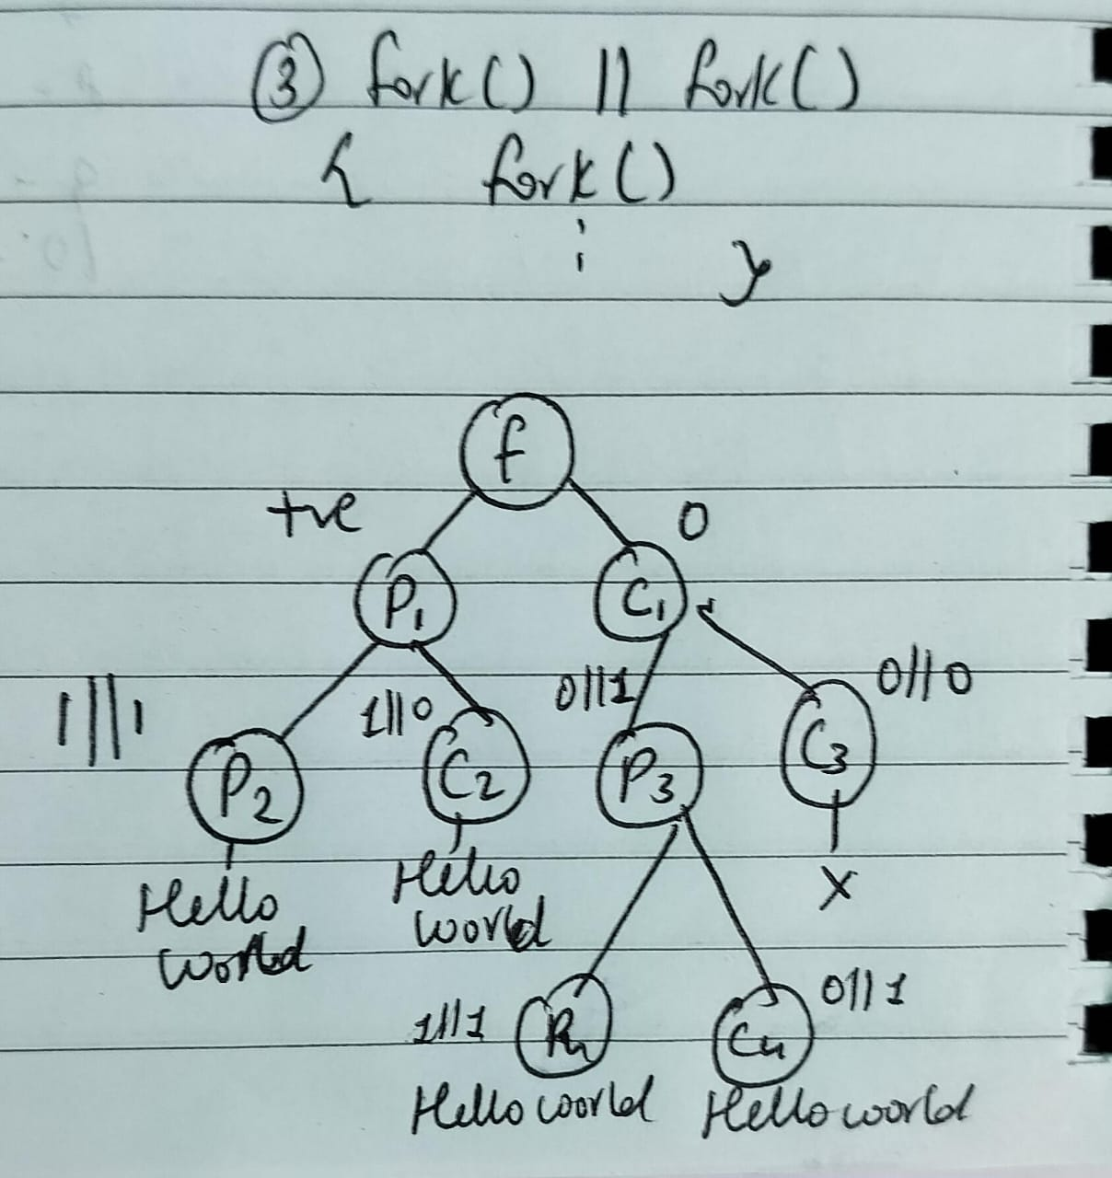

- Write a C program that uses fork system call and prints your parents name if it’s the parent process along with the child process id and parent process id. The same program prints your name if it’s the child process along with the child process id.

Code:
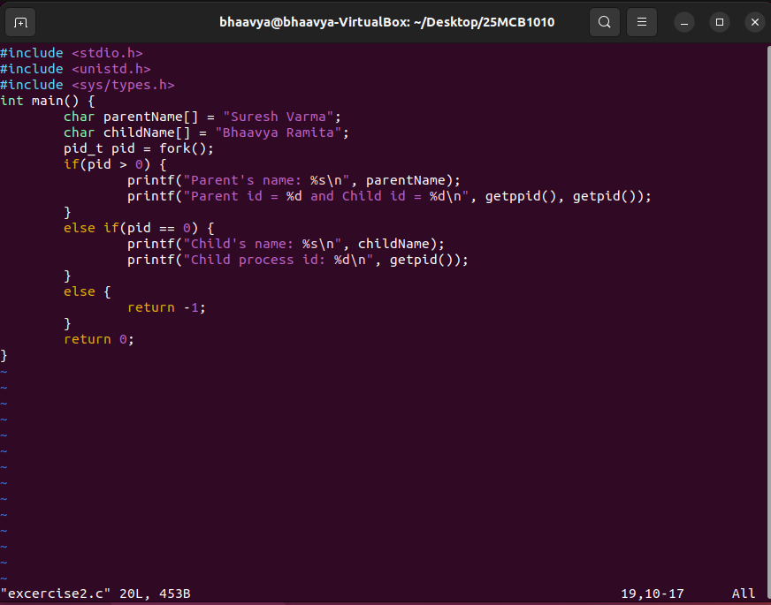

Output:
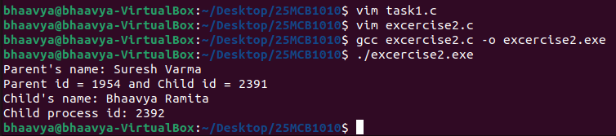

- In Q2 use a system call that makes sure the child process terminates first and then the parent process. Explain the concept of zombie process and orphan process here.
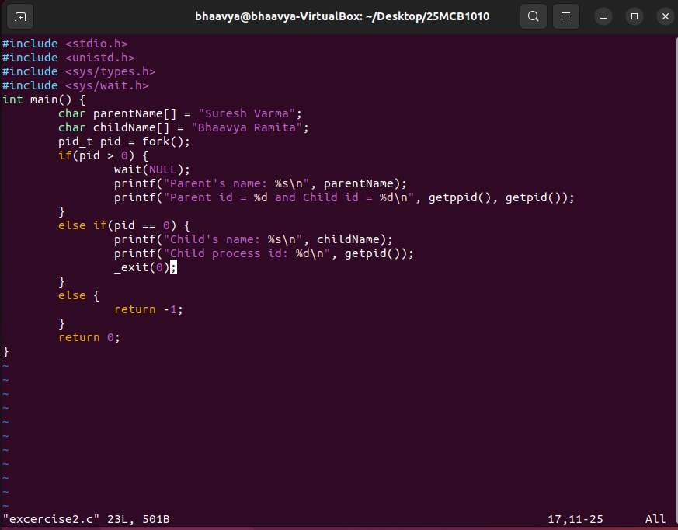

Output:
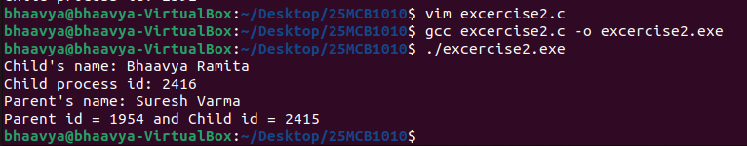

Explanation:
A zombie process is a process that has completed its execution but still remains in the process table because its parent has not yet read its exit status using wait(). Although the process is no longer running, it holds system resources like its PID. Zombies occur as a part of normal process termination but should be cleared to avoid resource leakage.
An orphan process is a child process whose parent terminates before the child finishes execution. In such cases, the orphan is automatically adopted by the init process (PID 1) or a system manager like systemd, which then monitors and cleans it up once it finishes.

- Write a C code that uses “execv” system call to call another C code that prints the sum of two numbers along with your name.
Code: sum.c
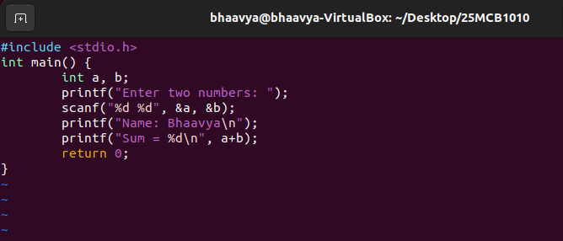

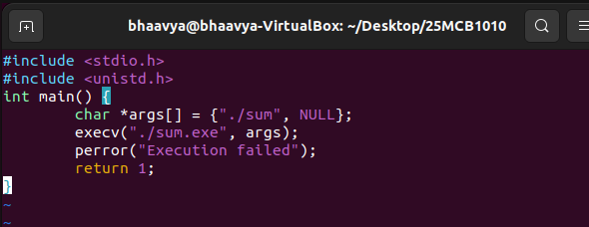
Code: excercise4.c

Output:
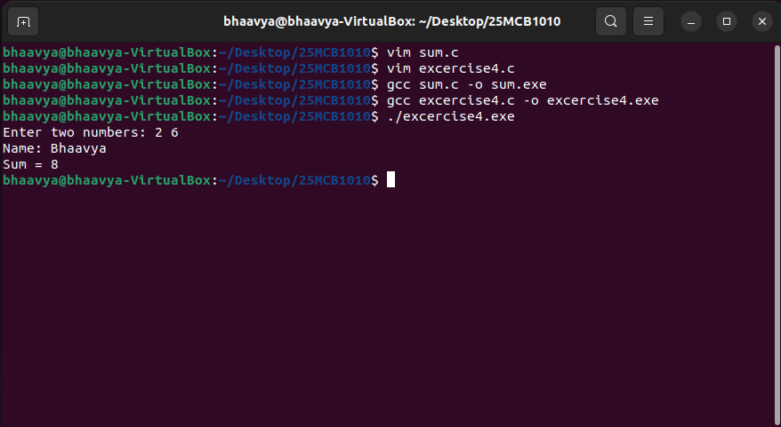

Submitted by: Patsamatla Bhaavya Ramita, 25MCB1010

