Program 1
Write a program to take command line input and check number is odd or even.
Code:
import java.until.*;
Class evenOdd{
Public static void main(String args[]){
Int a;
Scanner s=new Scanner(System.in);
System.out.println(“Enter the number:”);
a=s.nextInt();
if (a%2==0){
System.out.println(“The number “+ a +” is Even.”);
}
else{
System.out.println(“The number “+ a +” is Odd.”);
}
}
}
Output:
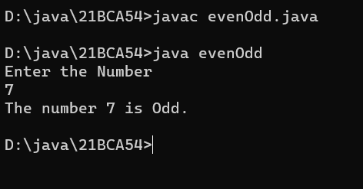

Program 2
Write a program to take command line input and sum of 2 number.

Code:
import java.util.*;
class add{
public static void main(String args[]){
int a,b;
Scanner s=new Scanner (system.in);
System.out.println(“enter the first no:”);
a=S.nextint();
system.out.println(“enter the second no:”);
b=s.nextint();
System.out.println(“the sum of two numbers is :”+(a+b));
}
}
Output:
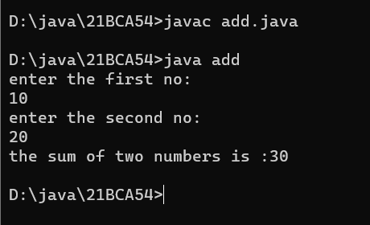

Program 3
Write a program to take command line input and calculate a Simple Interest.

Code:
import java.util.*;
class SimpleIntrest{
public static void main(String args[]){
Scanner s=new Scanner (System.in);
System.out.println(“Enter the Principal balance:”);
p=s.nextInt();
System.out.println(“Enter the Rate of interst:”);
r=s.nextInt();
System.out.println(“Enter the the number of times interest compounds in a year :”);
n=s.nextInt();
double result=((p*r*n)/100);
System.out.println(“The Simple intrest is:”+ result);
}
}

Output:
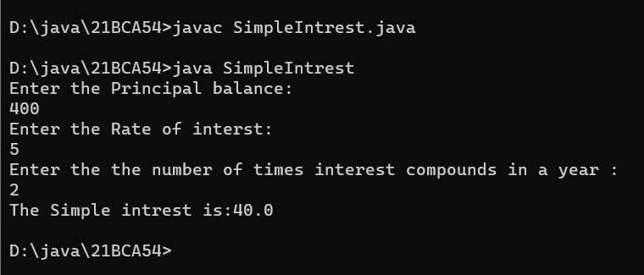

Program 4
Write a Program to take command line input and Check Number is Positive or Negative.
Code:
import java.util.*;
class positiveORnagative{
public static void main(String args[]){
int a;
Scanner s=new Scanner (System.in);
System.out.println(“Enter the no to check the number is positive or negative:”);
n=s.nextInt();
if (a<0){
System.out.println(“The Number is Negative.”);
}
else{
System.out.println(“The Number is Positive.”);
}
}
}
Output:
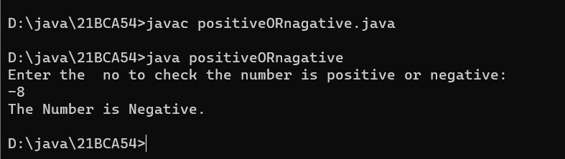

Program 5
Write a Program to take command line input and Check Year is Leap Year or Not.
Code:
import java.util.*;
class leapYear{
public static void main(String args[]){
int year;
Scanner s=new Scanner (System.in);
System.out.println(“Enter the No of days:”);
a=s.nextInt();
if(year % 400==0){
System.out.println(year+” is a Leap Year.”);
}
else if(year % 100==0){
System.out.println(year+” is not a Leap Year.”);
}
else if(year % 4==0){
System.out.println(year+” is a Leap Year.”);
}
else{
System.out.println(year+” is not a Leap Year.”);
}
}
}
Output:
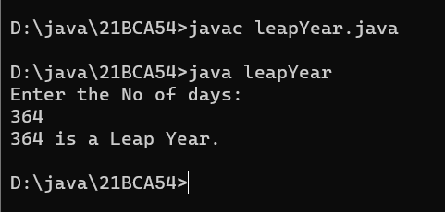

Program 6
Write a program to take command line input and find the Character Is Vowel or Not.
Code:
import java.util.*;
class WovelORnot{
public static void main(String args[]){
Scanner s=new Scanner(System.in);
System.out.println("Enter any character:");
char c;
c=s.next().charAt(0);
if(c=='a'||c=='A'||c=='e'||c=='E'||c=='i'||c=='I'||c=='o'||c=='O'||c=='u'||c=='U'){
System.out.println("The "+c+" is Vovel.");
}
else{
System.out.println("The "+c+" is Vovel.");
}
}
}
Output:
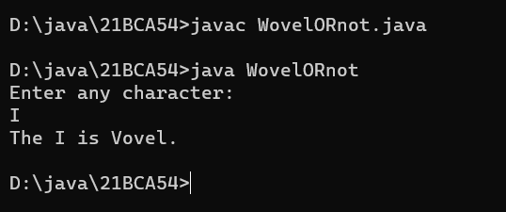

Program 7
Write a program to reverse a given number using while loop.
Code:
import java.util.*;
class reverseWhile{
public static void main(String args[]){
int a,n,b=0;
Scanner s=new Scanner(System.in);
System.out.println(“Enter the Number:”);
a=s.nextInt();
int i=a;
while(a!=0){
N=a%10;
B=b*10+n;
A=a/10;
}
System.out.println(b);
}

}
Output:

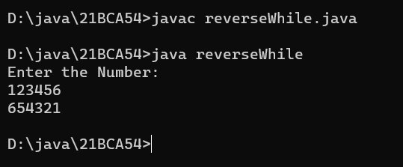

Program 8
Write a program to reverse a given number using for loop.

Code:
import java.util.*;
class reverseFor{

public static void main(String args[]){
int a,n,b=0;
Scanner s=new Scanner(System.in);
System.out.println(“Enter the Number:”);
a=s.nextInt();
for(int i=0;a!=0;i++){
N=a%10;
B=b*10+n;
A=a/10;
}
System.out.println(b);
}
}
Output:
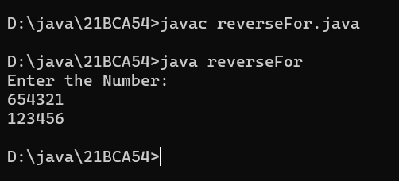

Program 9
Write a program to check number is Armstrong or Not.
Import java.util.*;
class Armstrong{

Public static void main(String args[]){
Scanner s=new Scanner(System.in);
System.out.println(“Enter the Number:”);
A=s.nextInt();
Int r,re=0;

Int o=n;

For(int i=n;i!=0;i++){

R=n % 10;

Re=(r*r*r);

N=(n/10);

}

If(re==n)

System.out.println(o+” is an Armstrong Number.”);

Else

System.out.println(o+” is not an Armstrong Number.”);

}

}

Output:
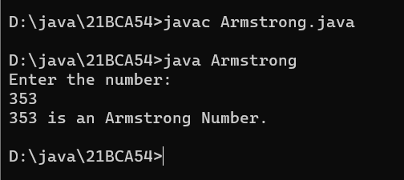

Program 10
Write a to check number is Prime number or not.
Import java.util.*;
Class primeNo{

Public static void main(String args[]){

Int m=0,f=0,a;
Scanner s=new Scanner(System.in);
System.out.println(“Enter the Number:”);

A=s.nextInt();
M=a/2;
If(a==0||a==1){
System.out.println(a+” is not prime number.”);
}

Else{

For(int i=2;i<=m;i++){

If(a%i==0){
System.out.println(a+” is not prime number.”);

F=1;

break;

}

}

If(f==0){

System.out.println(a+” is prime number.”);

}

}

}

}

Output:
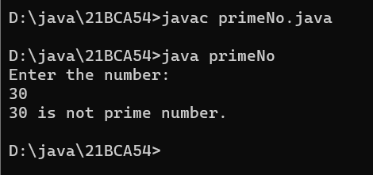

Program 11
Write a program to check given string is Palindrome or not

Code:
import java.util.*;
class PalindromeString{
public static void main(String args[]){
Scanner s=new Scanner(System.in);
String r="";
System.out.println("Enter the String:");
String Name=s.next();
int a=Name.length();
for(int i=(a-1);i>=0;--i){
r=r+Name.charAt(i);
}
if (Name.toLowerCase().equals(r.toLowerCase())){
System.out.println("String is palindrome.");
}
else{
System.out.println("String not is palindrome.");
}
}
}
Output:
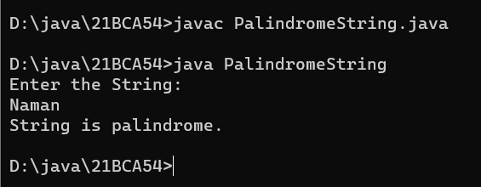

Program 12
Write a program in java to display the pattern like right angle triangle using an asterisk.
*
**
***
****
*****
import java.util.*;
class pattern{
public static void main(String args[]){
int a;
Scanner s=new Scanner(System.in);
System.out.println("Enter number to Print pattern until You want to print:");
a=s.nextInt();

for(int i=0;i<a;i++)
{
for(int j=0;j<i;j++)
{
System.out.print("*");
}
System.out.println();
}

}

}

Output:
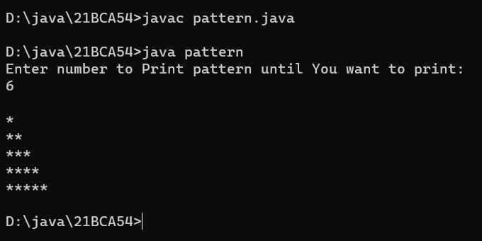

Program 13
Write a program in java to make such a pattern like a pyramid with numbers increased
by 1.
1
2 3
4 5 6
7 8 9 10
import java.util.*;
class NumPattern{
public static void main(String args[]){
int a;
Scanner s=new Scanner(System.in);
System.out.println("Enter number to Print pattern until You want to print:");
a=s.nextInt();
int m=a;
int n=1;
for(int i=0;i<a;i++)
{
for(int j=0;j<m-1;j++)
{
System.out.print(" ");
}
for(int k=1;k<=2*i-1;k+=2){

System.out.print(n+" ");
n++;
}
m--;
System.out.println();
}

}

}

Output:
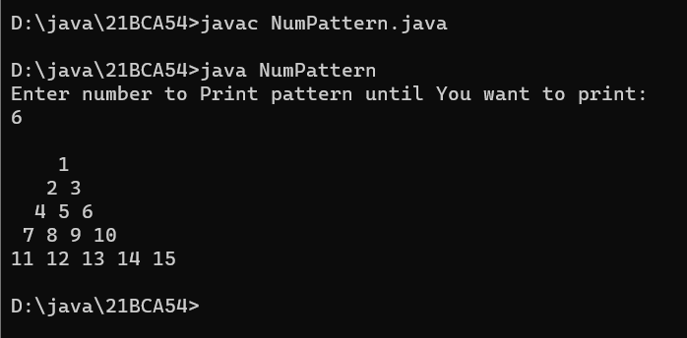

Program 14
Write a C Program to display the pattern using the alphabet.
A B C D E
A B C D
A B C
A B
A
import java.util.*;
class AbcPattern{
public static void main(String args[]){
int a;
Scanner s=new Scanner(System.in);
System.out.println("Enter number to Print pattern until You want to print:");
a=s.nextInt();
for(int i=0;i<a;i++)
{
for(int j=i,p='A';j<a;j++,p++)
{
System.out.print((char)p);
}
System.out.println();
}
}
}

Output:

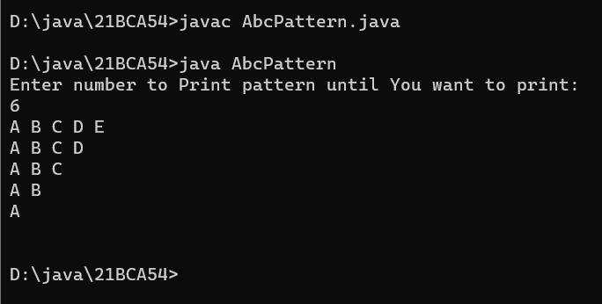

Program 15
Write a program to take command line input and print factorial of given number.
//factriol=4!
Import java.util.*;
class factorial{
public static void main(String args[]){
Scanner s=new Scanner(System.in);
System.out.println(“Enter the Number:”);
int a=s.nextInt();
int c=1;
for(int i=a;i>=1;--i){
c=c*i;
}
System.out.println("The Factorial of is:"+c);
}
}

Output:
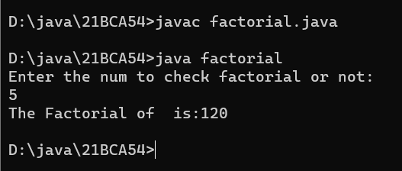

Program 16
Write a program to display Fibonacci series.
class fibonaccisirise{
public static void main(String args[]){
int n,next=0;
s=new Scanner(System.in);
System.out.println(“Enter the Number:”);
n=s.nextInt();
int f=0,s=1;
System.out.println("Fibonacci Series till "+n+" terms:");
for(int i=1;i<=n;++i){
System.out.println(f+",\n ");
next=f+s;
f=s;
s=next;
if(f>n){
break;
}
}
}
}
Output:
