Program 1
Design a class to represent a bank account. Include the following members. (Using Multiple Constructor)Data members: Name of depositor, Account number, Type of account, Balance amount in the account.Methods: To assign initial values, To deposit an amount, To withdraw an amount after checking balance, To display the name and balance.
Code:
import java.util.*;
public class BankAccount {
private String depositorName;
private int accountNumber;
private String accountType;
private double balance;

// Constructor with no arguments
public BankAccount() {
this("", 0, "Savings", 0.0);
}

// Constructor with name and account number arguments
public BankAccount(String name, int accountNumber) {
this(name, accountNumber, "Savings", 0.0);
}

// Constructor with all arguments
public BankAccount(String name, int accountNumber, String accountType, double balance) {
this.depositorName = name;
this.accountNumber = accountNumber;
this.accountType = accountType;
this.balance = balance;
}

// Method to assign initial values
public void setInitialValues(String name, int accountNumber, String accountType, double balance) {
this.depositorName = name;
this.accountNumber = accountNumber;
this.accountType = accountType;
this.balance = balance;
}

// Method to deposit an amount
public void deposit(double amount) {
if(amount > 0) {
balance += amount;
System.out.println("Deposit successful. New balance is " + balance);
} else {
System.out.println("Invalid amount. Please enter a positive amount to deposit.");
}
}

// Method to withdraw an amount after checking balance
public void withdraw(double amount) {
if(amount <= 0) {
System.out.println("Invalid amount. Please enter a positive amount to withdraw.");
} else if(amount > balance) {
System.out.println("Insufficient balance. You can withdraw up to " + balance);
} else {
balance -= amount;
System.out.println("Withdrawal successful. New balance is " + balance);
}
}

// Method to display name and balance
public void display() {
System.out.println("Depositor name: \n" + depositorName);
System.out.println("Account number: \n" + accountNumber);
System.out.println("Account type: \n" + accountType);
System.out.println("Current balance: \n" + balance);
}
public static void main(String args[]){
Scanner s=new Scanner(System.in);
// Create an instance of BankAccount with no arguments
BankAccount account1 = new BankAccount();
// Set values using setInitialValues method
account1.setInitialValues("John Smith", 12345, "Savings",0.0);
// Deposit
System.out.println("Enter the amount That You want to Deposit:");
double depositAmount=s.nextDouble();
account1.deposit(depositAmount);
// Withdraw
System.out.println("Enter the amount That You want to Withdrawr:");
double withdrawAmount=s.nextDouble();
account1.withdraw(withdrawAmount);
// Display account information
}
}

Output:
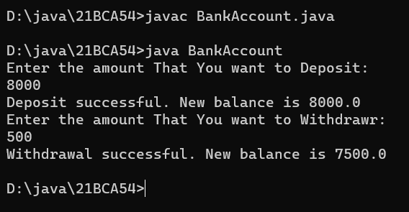

Program 2
Write a program to print Floyd’s triangle where n is command line input.
1
2 3
4 5 6
7 8 9 10
.....
N
Code:
class FloyedTriangle{
public static void main (String args[]){
int no,k=1;

no=Integer.parseInt(args[0]);
for(int i=0;i<no;i++){
for(int j=0;j<i;j++,k++){
System.out.print(k);
}
System.out.println();
}

}
}
Output:
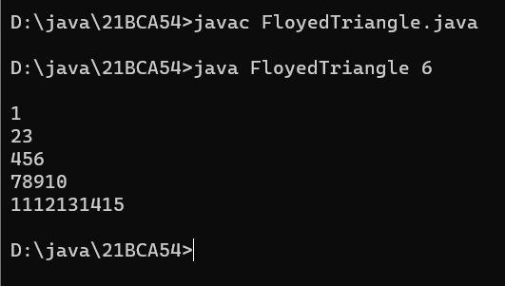

Program 3
Design a class Cricketer having data member name and a number of matches and appropriate member function to set the values. Derived two classes Batsman and Bowler from cricketer class with data member total number of runs and wickets respectively. Batsman class is having method to calculate average wicket. Write a program to create two objects and display information of one batsman and bowler along with average run and wicket.
Code:
class Crickter{
public String name;
public double matchPlayed;
public void setValues(String name,double matchPlayed){
this.name=name;
this.matchPlayed=matchPlayed;
}
}
class Batsman extends Crickter{
public double totalruns;
public double avarageRuns(double totalruns){
this.totalruns=totalruns;
return this.totalruns/matchPlayed;
}

}
class Bowler extends Crickter{
public double wickets;
public double avarageWickets(double wickets){
this.wickets=wickets;
return this.wickets/matchPlayed;
}
}
class main {
public static void main(String args[]){
Batsman bm=new Batsman();
bm.setValues("Virat Kohli",450);
double avgRuns=bm.avarageRuns(7000);
System.out.println("Batsman Information\n");
System.out.println("Batsman Name:"+bm.name);
System.out.println("Batsman Run:"+bm.totalruns);
System.out.println("Batsman Match Played:"+bm.matchPlayed);
System.out.println("Batsman Avg Runs:"+avgRuns);
Bowler br=new Bowler();
br.setValues("Jusprit Bhumraha",300);
double avgWickets=br.avarageWickets(600);
System.out.println("\nBowler Information\n");
System.out.println("Bpwler Name:"+br.name);
System.out.println("Bpwler Wicketcs:"+br.wickets);
System.out.println("Bpwler Match Played:"+br.matchPlayed);
System.out.println("Bpwler Avg Wickets:"+avgWickets);
}
}
Output:
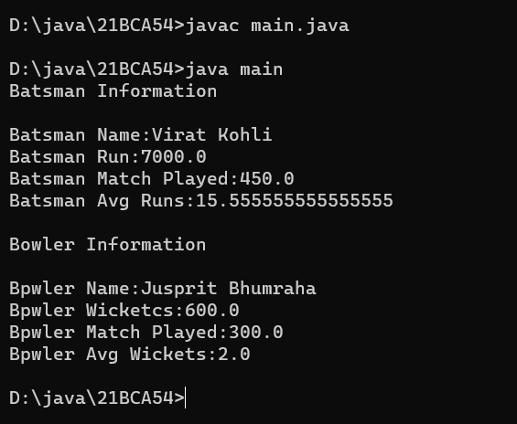
Program 4
Write a program that will accept two strings or two numbers from command line and create overloaded method that add these two numbers or concate two strings.
Code:
class OverloadMethod{
public void display(String s1,String s2){
System.out.println("The Concated String is:"+(s1+s2));
}
public void display(int a,int b){
System.out.println("The Addition of "+a+" and "+b+" is:"+(a+b));
}
public static void main(String args[]){
OverloadMethod o=new OverloadMethod();
o.display("Wellcome to"," Vnsgu Website");
o.display(5,10);

}
}
Output:
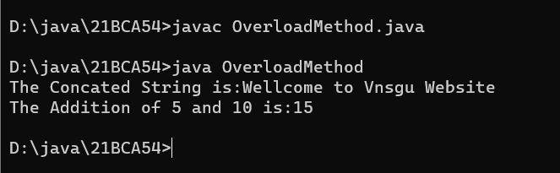

Program 5
Write a program that accept a number from command line and check whether it is palindrome or not.
Code:
class palindromeNumber{
public static void main(String args[]){
int num=Integer.parseInt(args[0]);
int sum=0,r,temp=num;
for(int i=0;num!=0;i++){
r=num%10;
sum=(sum*10)+r;
num=num/10;
}
if(sum==temp){
System.out.println("The "+temp+" is Palindrome.");
}
else
System.out.println("The "+temp+" is not Palindrome.");

}
}
Output:
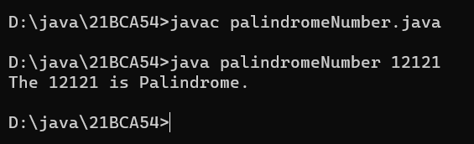

Program 6
Write a program that will accept a string from command line and arrange all the characters in alphabetical order.
E.g. input- computer
output-cemoprtu
Code:
import java.util.Arrays;

public class SetCharAscending{
public static void main(String[] args) {
if (args.length == 0) {
System.out.println("Please provide a string argument.");
return;
}

String input = args[0];
char[] charArray = input.toCharArray();
Arrays.sort(charArray);
String sorted = new String(charArray);

System.out.println("Input: " + input);
System.out.println("Output: " + sorted);
}
}
Output:
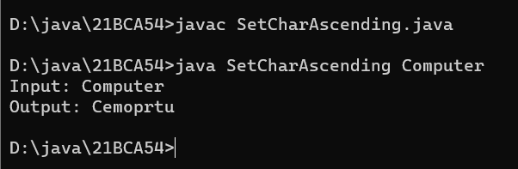

Program 7
Write a program to create interface Area. Create three classes called rectangle, triangle and square calculate areas respectively.
Code:
interface Area{
public void Calculatearea();
}
class rectangle implements Area{
float x,y;
public rectangle(float x,float y){
this.x=x;
this.y=y;
}
public void Calculatearea(){
System.out.println("The Area of Rectangle is:"+(this.x*this.y));
}
}
class triangle implements Area{
float x,y;
public triangle(float x,float y){
this.x=x;
this.y=y;
}
public void Calculatearea(){
System.out.println("The Area of Triangle is:"+((this.x*this.y)/2));

}
}
class square implements Area{
float x;
public square(float x){
this.x=x;
}
public void Calculatearea(){
System.out.println("The Area of Square is:"+(this.x*this.x));
}
}
class CalculateArea{
public static void main(String args[]){
//hare hight=20 and width=40
rectangle re=new rectangle(20,40);
re.Calculatearea();
//hare base=20 and hight=40
triangle tr=new triangle(20,40);
tr.Calculatearea();
//hare hight=40
square sq=new square(40);
sq.Calculatearea();
}
}

Output:
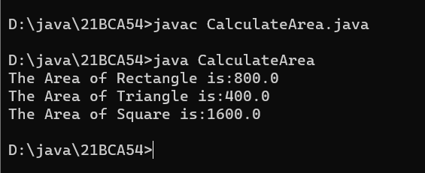

Program 8
Write a program that will accept a number from command line and raise a user defined
exception if the number consists of odd number of digits.
Code:
class OddException extends Exception{
OddException(String str){
System.out.println(str);
}
}
class ExceptionHandaling{
public static void main(String args[]){
int a=Integer.parseInt(args[0]);
try{
if(a%2==0){
System.out.println("The "+a+" is Even.");
}
else{
throw new OddException("Number Consist Odd Value.");
}

}
catch(OddException e){
System.out.println(e);;
}

}
}
Output:

Program 9
Write a java application which accepts 10 names of student and their age. Sort names and age in descending order. (Using Array)
Code:
import java.util.*;
class StudentDetail{
public static void main(String args[]){
// String[] StdName=new String[10];
// int[] age=new int[10];
String StdName[]={"Yash","Divyang","Kaushik","Ajay","Kamlesh","Shivraj","Abhay","Chetan","Vivek","Brijesh"};
int age[]={18,18,18,18,19,19,19,19,18,18};
int n=9;
String temp;
for (int i=0; i<=n;i++) {
for (int j=i+1;j<=n;j++){
// to compare one string with other strings
if (StdName[i].compareTo(StdName[j]) > 0) {
// swapping
temp = StdName[i];
StdName[i] = StdName[j];
StdName[j] = temp;
}
}
}
for(int i=0;i<=n;i++){
for(int j=i+1;j<=n;j++){
//to set the age in descnding order
int temp1;
if(age[i]>age[j]){
temp1=age[i];
age[i]=age[j];
age[j]=temp1;
}
}
}
System.out.println("Names & Age in descnding order.");
System.out.println("Names\t\t\tAge");
System.out.println("==================== \t====================");
for (int i = n; i >=0; i--) {
System.out.println(StdName[i]+"\t\t\t"+age[i]);
}

}
}Output:
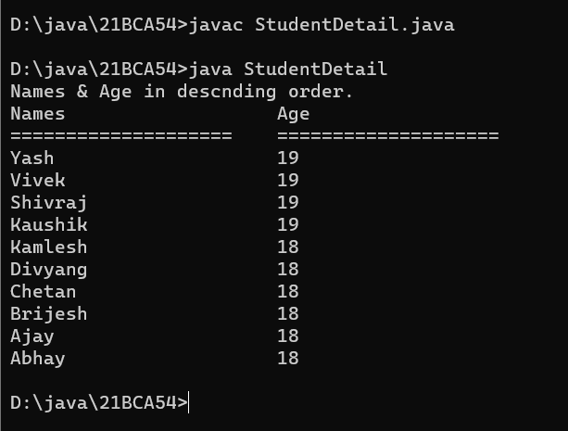

Program 10
Design a class MyString having a data member of type String and add member functions to achieve following task. (i) Reverse string (ii) String in Titlecase. (iii) Extract N-characters from
right-end of the string Write a menu driven program to call these methods of MyString class. The program should not terminate abruptly.
Code:
import java.util.*;

public class MyString {
private String str;

public MyString(String str) {
this.str = str;
}

public String reverse() {
return new StringBuilder(str).reverse().toString();
}

public String toTitleCase() {
StringBuilder result = new StringBuilder(str.length());
String[] words = str.split("\\s");

for (String word : words) {
if (!word.isEmpty()) {
result.append(Character.toUpperCase(word.charAt(0)));
result.append(word.substring(1).toLowerCase());
}

result.append(" ");
}

return result.toString().trim();
}

public String extractNFromRight(int n) {
if (n >= str.length()) {
return str;
}

return str.substring(str.length() - n);
}

public static void main(String[] args) {
Scanner scanner = new Scanner(System.in);

System.out.print("Enter a string: ");
String str = scanner.nextLine();
MyString myString = new MyString(str);
char ch;
do {
System.out.println();
System.out.println("Menu:");
System.out.println("1. Reverse string");
System.out.println("2. String in Titlecase");
System.out.println("3. Extract N-characters from right-end of the string");
System.out.println("4. Exit");
System.out.print("Enter your choice: ");

int choice = scanner.nextInt();
scanner.nextLine();

switch (choice) {
case 1:
System.out.println("Reversed string: " + myString.reverse());
break;
case 2:
System.out.println("Titlecased string: " + myString.toTitleCase());
break;
case 3:
System.out.print("Enter N: ");
int n = scanner.nextInt();
scanner.nextLine();
System.out.println("Extracted " + n + " characters from right: " + myString.extractNFromRight(n));
break;
case 4:
System.out.println("Exiting...");
System.exit(0);
break;
default:
System.out.println("Invalid choice. Try again.");
}
System.out.println("Do you want to continue?(press=y)");
ch=scanner.next().charAt(0);
}while(ch=='y');
}
}

Output:
