project part:-2

PART A : Detail study and analysis of Requirements elicitation

1. The project scope for a personalized news aggregator includes the following steps:-

The scope of this personalized news aggregator project in detail:

1. User registration and login:
   * Users will be able to create an account by providing basic information such as their name, email address, and password.
   * A confirmation email will be sent to the user's email address to verify their account.
   * Users will be able to log in to their account using their email address and password.
   * Forgotten password functionality will be provided, allowing users to reset their password using their registered email address.
2. News source and topic selection:
   * Users will be able to select and follow their preferred news sources and topics.
   * The news aggregator will have a list of popular news sources and topics that users can choose from.
   * Users will also have the option to add custom news sources or topics.
   * The news aggregator will provide an interface for users to manage their followed sources and topics, allowing them to add or remove sources and topics as desired.
3. News aggregator:
   * The articles will be filtered and categorized based on topics, making it easier for users to find articles related to their interests.
   * The news aggregator will be updated regularly to ensure that users receive the latest articles from their followed sources.
4. Personalized news feed:
   * The news aggregator will generate a customized news feed for each user, based on their preferred sources and topics.
   * The personalized news feed will be updated in real-time as new articles are published.
   * The news feed will display articles in a paginated format, with the option to view more articles or load previous articles.
5. Article search:
   * The news aggregator will provide a search functionality that allows users to search for specific articles based on keywords, sources, or topics.
   * The search results will be ranked based on relevance and date, with the most relevant articles appearing at the top of the results list.
6. Article recommendations:
   * The news aggregator will suggest articles based on user interests.
   * The recommended articles will be displayed in a separate section of the news feed or on a separate page.
7. Device compatibility:
   * The news aggregator will be designed to be accessible and user-friendly on mobile devices and Desktop Computers
   * The mobile version of the news aggregator will have a responsive design, adapting to the size and orientation of the device's screen.
   * The mobile version will include all the functionality available in the desktop version, including source and topic selection, personalized news feed, article search, and article recommendations.
8. Data privacy and security:
   * User data will be encrypted in transit and at rest to prevent unauthorized access or theft.
   * The news aggregator will have a privacy policy that clearly explains how user data is collected, used, and protected.
9. Analytics and reporting:
   * The news aggregator will have an analytics and reporting system that provides insights into user behavior and engagement.
   * The analytics and reporting system will provide data on user engagement, such as the average time spent reading articles, the most popular sources and topics, and the most viewed articles.
   * The analytics and reporting system will allow the news aggregator to make data-driven decisions on how to improve the user experience.
10. User feedback and support:

* The news aggregator will have a feedback mechanism that allows users to provide feedback, report bugs, or request new features.
* The news aggregator will have a support team that will respond to user feedback and resolve any issues that arise.
* The support team will also be responsible for monitoring the news aggregator for any technical problems or security issues, and taking the necessary steps to resolve them.

1. Integration with social media:

* The news aggregator will have the option to integrate with social media platforms, such as Facebook and Twitter.
* Users will be able to share articles from their news feed on their social media profiles.
* The news aggregator will also have the option to post updates on the user's behalf, such as the latest articles from their followed sources.

1. Content moderation:

* The news aggregator will have a content moderation system that ensures that articles are appropriate and meet the news aggregator's standards for quality and accuracy.
* The content moderation system will be responsible for reviewing articles before they are included in the news feed.
* The content moderation system will also monitor user feedback and take action if any articles are reported as inappropriate or inaccurate.

1. Ad management:

* The news aggregator will have the option to display ads to users.
* The ad management system will allow the news aggregator to target ads to specific user segments, based on their interests and behavior.
* The ad management system will also provide reporting and analytics on ad performance and

1. Technical infrastructure:

* The news aggregator will be built using a scalable and reliable technical infrastructure.
* The technical infrastructure will be designed to handle high traffic and ensure that the news aggregator is always available to users.
* The technical infrastructure will include a combination of cloud-based servers, databases, and caching systems, optimized for performance and reliability.

1. Some Appropriate techniques are used for a personalized news aggregator are as follow:-
2. Web scraping: To collect articles from various news sources and to keep the news feed up-to-date, web scraping techniques can be used to extract the content from the sources' websites.

2. Natural Language Processing (NLP): NLP techniques can be used to analyze and categorize the articles based on their content, including topics, sentiment, and key entities. This information can be used to personalize the news feed for each user based on their interests.

3. Machine Learning: Machine learning algorithms can be used to recommend articles to users based on their reading history and interests. This can help users discover new content that is relevant to their interests.

4. Data storage and retrieval: Relational databases such as MySQL, databases such as MongoDB can be used to store and retrieve the articles and user information.

5. Server-side programming: To build the web-based application, server-side programming languages such as PHP, Python can be used.

6. Client-side programming: To build the user interface and handle user interactions, client-side programming languages such as HTML, CSS, and JavaScript can be used.

7. Content Delivery Network : To ensure fast delivery of the news feed to users globally, It can be used to distribute the content across multiple servers in different locations.

1. Search Engine Optimization : To improve the visibility of the news aggregator in search engines and attract more users, This techniques can be used. This can include optimizing the website's content and structure, creating meta descriptions and keywords, and building backlinks from other websites.
2. Security: To ensure the security of user data, the news aggregator can use various security techniques, for encryption, secure password storage, and regular security audits.
3. Performance optimization: To ensure that the news aggregator is fast and responsive, various performance optimization techniques can be used, including caching, and compressing images.

The Important thing is that how the functional and User interface requirements works.

# Functional Requirements:

1. User registration and login: Users should be able to create an account and log in to access their personalized news feed.
2. News feed: Users should be able to view a personalized news feed based on their interests, which can be updated in real-time.
3. Notification system: Users should be able to receive notifications when new articles are published on topics they are interested in.
4. Multi-language support: The news aggregator should be able to display articles in multiple languages, allowing users to select their preferred language.

# Non-functional Requirements:

1. Performance: The news aggregator should have a fast response time and be able to handle high traffic.
2. Scalability: The news aggregator should be able to scale to accommodate growth in the number of users and articles.
3. Security: The news aggregator should protect user data and prevent unauthorized access to sensitive information.

The User-Interface requirements

* 1. Intuitive navigation: The news aggregator should have a clear and intuitive navigation system, allowing users to easily access different sections of the website.
  2. Responsive design: The news aggregator should have a responsive design, adapting to different screen sizes and devices.
  3. Clear visual hierarchy: The news aggregator should have a clear visual hierarchy, making it easy for users to scan and find information.
  4. Consistent style: The news aggregator should have a consistent visual style and branding, providing a seamless user experience.
  5. Easy-to-read font: The news aggregator should use an easy-to-read font that is appropriate for the target audience and device.
  6. High-quality images: The news aggregator should display high-quality images, including images for articles and user avatars.
  7. Loading speed: The news aggregator should load quickly, even on slow internet connections.

1. Use Cases at level 0 and level 1 :-

# Level 0 Use Cases:

1. Login/Registration: A user can create an account or log in to an existing account to access personalized news.
2. View News Feed: A user can view a news feed of articles based on their interests and news sources.
3. Follow/Unfollow News Sources: A user can follow or unfollow news sources to receive articles from that source.
4. Search for Articles: A user can search for articles based on keywords or topics.
5. View Article Details: A user can view the details of an article, including its title, author, source, and content.
6. Rate Articles: A user can rate articles based on their relevance and quality.

# Level 1 Use Cases:

* 1. Edit Profile: A user can edit their profile, including their interests and news sources.
  2. View Archive: A user can view an archive of previously published articles.
  3. Manage Advertisements: The system can display advertisements, with options for controlling the placement and frequency of ads.
  4. View User Ratings: A user can view ratings of articles by other users.

1. The Pre and Post conditions for all use cases considering business rules, assumptions and challenges of the system are as follows:-
2. Login/Registration:
3. Pre-condition: The user must have a valid email address and password to log in, or they must provide these details to create a new account. The system must have a secure and reliable authentication mechanism to protect user data.
4. Post-condition: The user is successfully logged in to the personalized news aggregator and can access their news feed and other features. The user's data is protected and stored securely by the system.
5. View News Feed:
6. Pre-condition: The user must be logged in to the personalized news aggregator. The system must have up-to-date information on the user's interests and news sources.
7. Post-condition: The user can view a news feed of articles based on their interests and news sources. The news feed is regularly updated with fresh articles and information.
8. Follow/Unfollow News Sources:
9. Pre-condition: The user must be logged in to the personalized news aggregator. The system must have a reliable and up-to-date database of news sources.
10. Post-condition: The user has successfully followed or unfollowed a news source, and will receive articles from that source in their news feed. The system updates the user's news feed in real-time as new articles become available.
11. Search for Articles:
12. Pre-condition: The user must be logged in to the personalized news aggregator. The system must have a fast and efficient search mechanism to retrieve articles based on keywords or topics.
13. Post-condition: The user can view a list of articles based on their search keywords or topics. The search results are ranked based on relevancy and quality.
14. View Article Details:
15. Pre-condition: The user must be logged in to the personalized news aggregator. The system must have accurate and up-to-date information on each article.
16. Post-condition: The user can view the details of an article, including its title, author, source, and content. The user can also rate the article based on its relevance and quality.

PART B : Document the Requirements Elicitation process using modelling approach.

1. Use Case Diagram:-

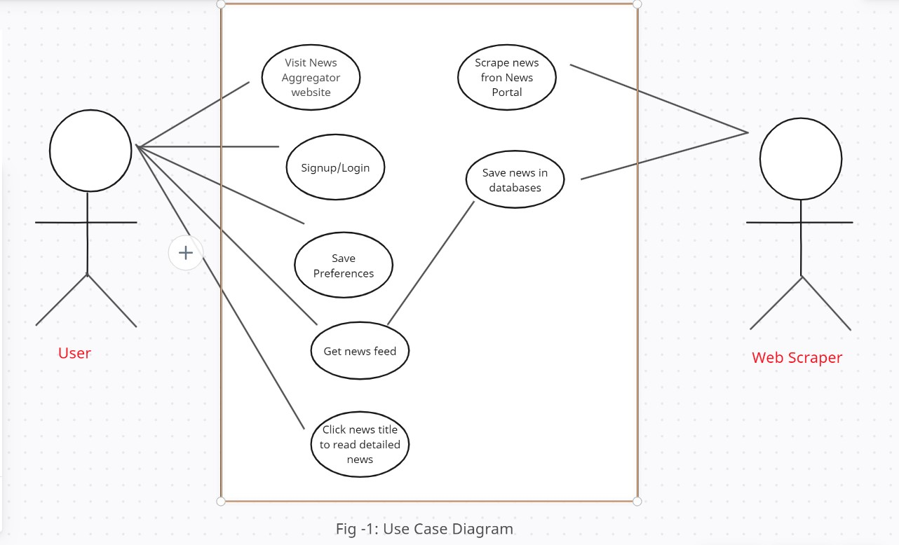

* + 1. Define Use Cases at Level 0 and Level 1

1. Level 0 use cases provide a high-level view of the functionality offered by the system, and are typically described using natural language. Level 0 use cases are used to define the overall scope of the system and to provide a high-level view of the system's functionality
2. Level 1 use cases provide a more detailed view of the functionality offered by the system, and are typically described using a more structured format. Level 1 use cases are used to specify the steps involved in carrying out a particular use case, and to provide a more detailed view of the system's functionality
   * 1. The Data-Driven approach is applied in this Project like an framework which provides group-buying aggregation service and it will offers a new opportunity for personalized services and recommendation and advertisement.
3. Class Diagram:-
4. For Level 1 Use cases the classes, attributes and methods includes:-
5. User Class:

Attributes:- -id :int

-username : string

-password : string

-date() : Date

Methods: sign up, login, logout, subscribe to news source, subscribe to topic, view subscribed sources/topics

+login() : void

1. News Source Class:

Attributes: name, URL, description.

-reporter : string

-sub_category : string

-reporter_id : int

Methods: add news source, update news source, delete news source.

+add : void()

+delete : void()

+update : void()

1. Article Class:

Attributes: headline, author, date published, content, news source

Methods: add article, update article, delete articles.

1. Class Diagram

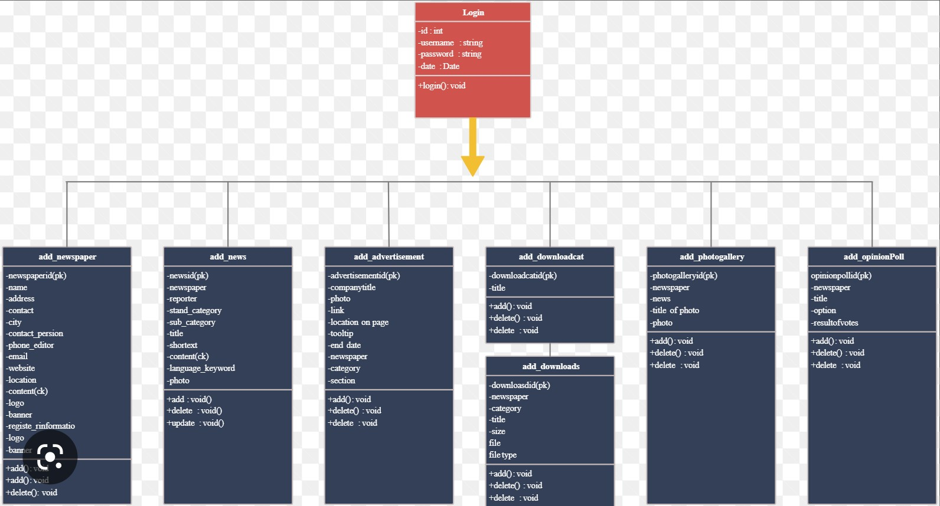

1. Public and Private properties of attributes and methods are as follows:-

User Class

private: username

private: password

private: email

private: list of subscribed news sources

private: list of subscribed topics

public: sign up()

public: login()

public: logout()

public: subscribe to news source()

public: subscribe to topic()

public: view subscribed sources/topics()

public: view articles from subscribed sources/topics()

News Source Class

private: name

private: URL

private: description

public: add news source()

public: update news source()

public: delete news source()

1. Sequence Diagram

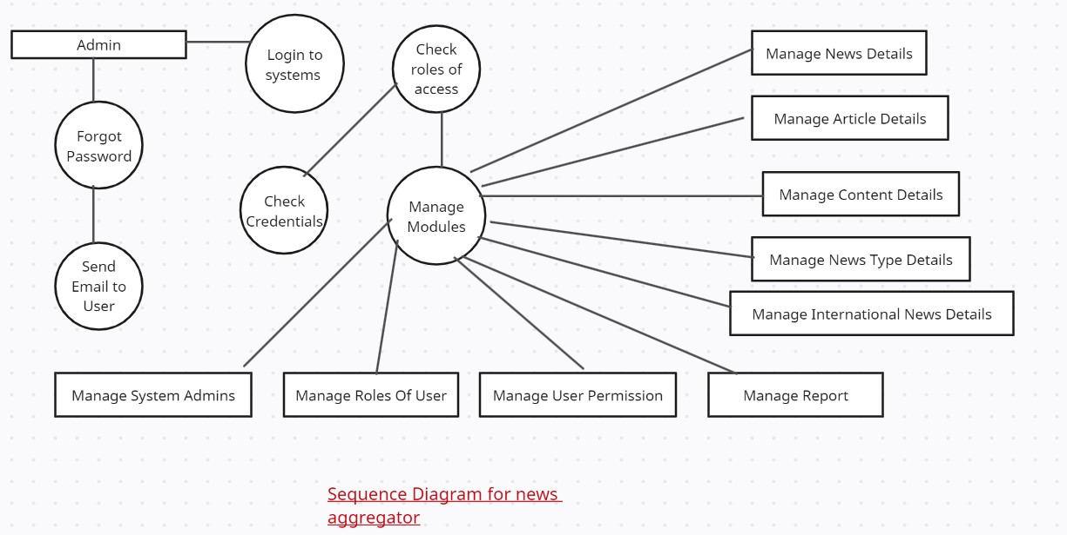

# Team Name :- Error 404

Member 1:- Rakshit Somkuwar(21BCS122)

Member 2:- Sankalp Chiprikar(21BCS027)