**1. Negative soil moisture-precipitation feedback in dry and wet regions**

This paper investigated global patterns using satellite and ground observations. The output are summarized as follows:

* Negative feedback dominates in dry and wet regions, primarily due to evapotranspiration limits—either by moisture in arid zones or by energy in humid ones—revealing nonlinear mechanisms across climates.
* Positive Soil Moisture-Precipitation feedback is predominant over land, non-negligible negative feedback occurs in dry and wet regions.
* Physically, negative SM-P feedback depends on the Soil Moisture-Precipitation correlation.
* In dry regions, evapotranspiration change is soil moisture limited, while in wet regions, evapotranspiration change is energy limited.

**2. The Continental-Scale Soil Moisture–Precipitation Feedback in Europe with Parameterized and Explicit Convection**

This research used convection-resolving simulations to study soil moisture–precipitation feedback across Europe.

* Explicit convection shows stronger and more realistic feedback compared to parameterized models. Especially in convective-heavy regions like Central and Eastern Europe.
* Wet soils may enhance convection by providing more evaporation (moisture recycling). But under some conditions, dry soils may promote convection via surface heating and instability.
* Feedbacks vary by season and region—they are stronger in summer and in transitional climate zones—and feedback 'hotspots' align with regions where land–atmosphere coupling is strongest.

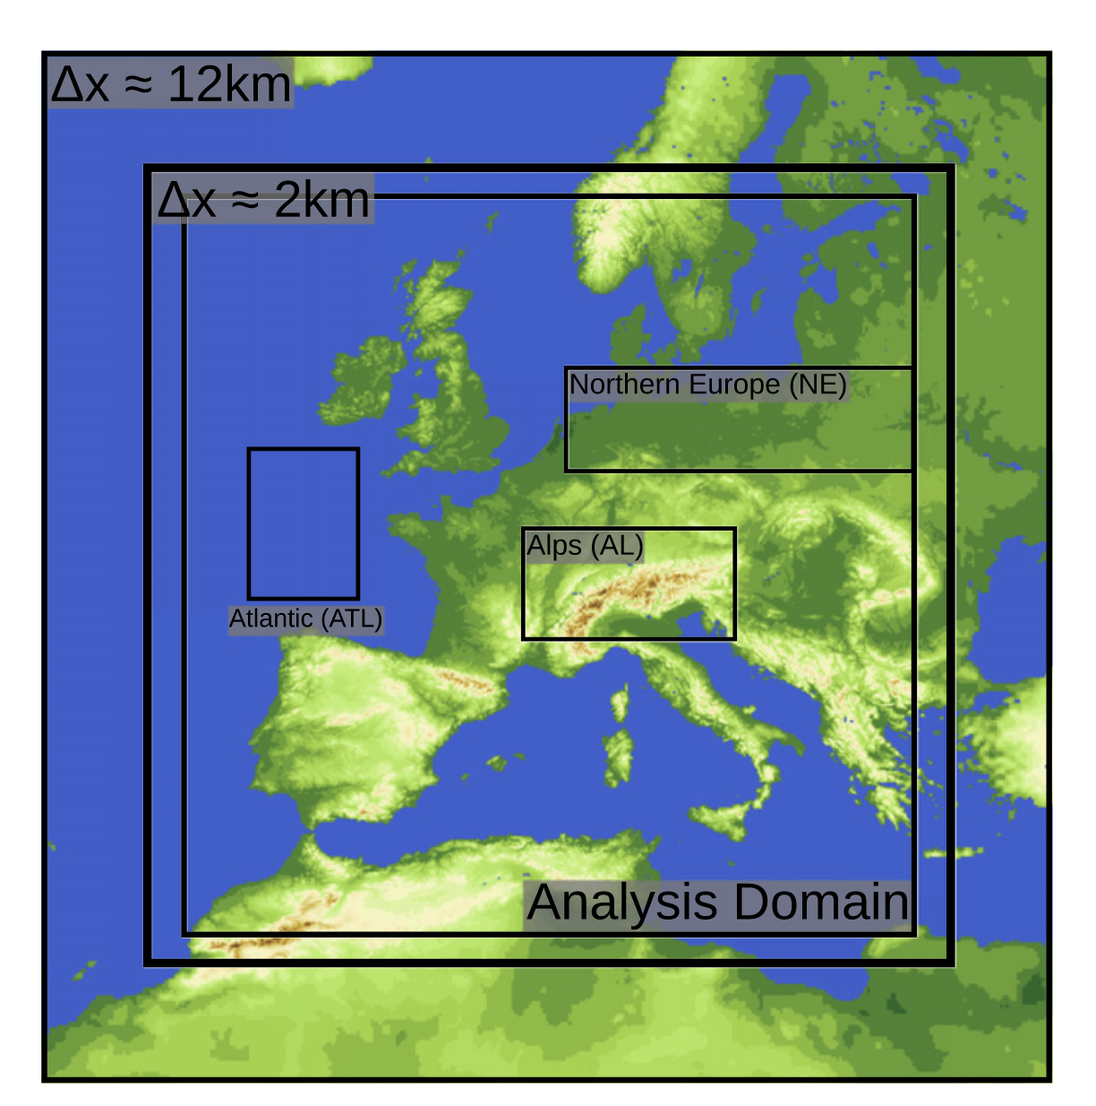

**3. Is the soil moisture precipitation feedback enhanced by heterogeneity and dry soils? A comparative study**

This research investigates how **soil moisture heterogeneity** (variations in soil moisture across different areas) and **dry soil conditions** influence the feedback loop between soil moisture and precipitation. The study aims to determine whether these factors enhance or suppress the likelihood of precipitation events.

* **Enhanced Feedback in Heterogeneous and Dry Conditions:**The study found that regions with more heterogeneous and drier soils exhibited a stronger soil moisture–precipitation feedback. This means that in such conditions, the land surface has a more significant influence on triggering precipitation events.
* **Mesoscale Circulations:** In areas with sharp contrasts in soil moisture, differential heating can lead to the development of mesoscale circulations. These circulations can enhance convective activity, leading to increased precipitation.
* **Regional Differences**: The spatial variability of soil moisture is more important for surface-atmosphere interactions than the actual soil moisture content. This means that the areas with the highest precipitation amounts did not match the areas with the highest soil moisture gradients. Accordingly, the impact of soil moisture heterogeneity on precipitation was more pronounced in West Africa compared to Southern Germany. This suggests that the climatic and land surface characteristics of a region play a crucial role in determining the strength of the feedback.

|  |  |
| --- | --- |
| (a) Ammer region | (b) Sissili region |
|  |  |

**4. Identification of Soil Moisture–Precipitation Feedback Based on Temporal Information Partitioning Networks**

This research introduces a novel approach to quantify the feedback between soil moisture and precipitation using Temporal Information Partitioning Networks (TIPNets). Unlike traditional methods that often rely on model-based simulations, TIPNets utilize information theory to analyze observational data, aiming to provide a more direct and potentially less biased understanding of land-atmosphere interactions. The following outputs are considered:

* **Seasonal Feedback Dynamics**: The analysis reveals that the soil moisture–precipitation feedback is most pronounced during late spring to mid-summer (May to mid-July). During this period, soil moisture anomalies have a more substantial influence on subsequent precipitation events.
* **Bidirectional Interactions**: The study identifies a bidirectional feedback mechanism, with soil moisture affecting precipitation and vice versa. However, the strength and lag times of these interactions vary seasonally.
* **Land Use Influence**: Areas dominated by wooded grasslands show a higher propensity for positive feedback mechanisms, indicating that certain land cover types may enhance the coupling between soil moisture and precipitation.
* **Spatial Variability**: Regions in south-central Illinois exhibit stronger feedback signals, suggesting that local land cover and soil properties may modulate the intensity of land-atmosphere interactions.

**5. Influence of lower-tropospheric moisture on local soil moisture–precipitation feedback over the US Southern Great Plains**

This study investigates how **lower-tropospheric (LT) humidity,** particularly in the 2–4 km altitude range above the planetary boundary layer (PBL), affects the **soil moisture–precipitation (SM–P) feedback** during the warm season (May–September) in the U.S. Southern Great Plains (SGP). Traditionally, research on land–atmosphere coupling (LAC) has focused on near-surface and PBL processes, often overlooking the role of LT humidity. The main findings of this research are summarized below:

* **Critical Role of LT Humidity Under Dry Conditions**: The study found that anomalously high LT humidity is essential for initiating afternoon precipitation events (APEs) when the soil is dry. This moisture in the LT enhances convective buoyancy, facilitating precipitation that wouldn't occur based solely on surface conditions.
* **Limitations of Traditional LAC Indices:** Commonly used indices like the Convective Triggering Potential (CTP) and Low-Level Humidity Index (HI<sub>Low</sub>) do not account for LT humidity. As a result, they may fail to predict precipitation events under dry soil conditions where LT humidity plays a pivotal role.
* **Sufficiency of Boundary Layer Moisture in Wet Conditions:** In contrast, under wet soil conditions, the boundary layer moisture alone is often sufficient to generate the necessary buoyancy for precipitation, making the influence of LT humidity less critical.

**6. Soil Moisture‐Cloud‐Precipitation Feedback in the Lower Atmosphere From Functional Decomposition of Satellite Observations**

This research investigates how variations in topsoil moisture influence cloud formation and precipitation processes in the lower atmosphere. The study focuses on the central United States, a region known for its significant land-atmosphere interactions.

* **Variable Feedback Strength:** The study found that the influence of soil moisture on cloud formation and precipitation varies with cloud height and time lag. This indicates that the feedback mechanisms are complex and depend on multiple factors.
* **Modeling Implications:** The findings highlight the importance of incorporating detailed land surface information into weather and climate models to improve the accuracy of precipitation forecasts.
* **Spatial Variability:** There is significant spatial variability in the soil moisture–cloud–precipitation feedback across the central U.S., suggesting that local land surface conditions play a crucial role in atmospheric processes.

**References:**

**[1]** Yang, L., Sun, G., Zhi, L., & Zhao, J. (2018). Negative soil moisture-precipitation feedback in dry and wet regions. *Scientific reports*, *8*(1), 4026.

[**https://www.nature.com/articles/s41598-018-22394-7**](https://www.nature.com/articles/s41598-018-22394-7)

**[2]** Leutwyler, D., Imamovic, A., & Schär, C. (2021). The continental-scale soil moisture–precipitation feedback in Europe with parameterized and explicit convection. Journal of Climate, 34(13), 5303-5320.

[**https://journals.ametsoc.org/view/journals/clim/34/13/JCLI-D-20-0415.1.xml**](https://journals.ametsoc.org/view/journals/clim/34/13/JCLI-D-20-0415.1.xml)

**[3]** Graf, M., Arnault, J., Fersch, B., & Kunstmann, H. (2021). Is the soil moisture precipitation feedback enhanced by heterogeneity and dry soils? A comparative study. Hydrological Processes, 35(9), e14332.

[**https://onlinelibrary.wiley.com/doi/full/10.1002/hyp.14332**](https://onlinelibrary.wiley.com/doi/full/10.1002/hyp.14332)

**[4]** Lou, W., Liu, P., Cheng, L., & Li, Z. (2022). Identification of soil moisture–precipitation feedback based on temporal information partitioning networks. JAWRA Journal of the American Water Resources Association, 58(6), 1199-1215. <https://onlinelibrary.wiley.com/doi/full/10.1111/1752-1688.12978>

**[5]** Wang, G., Fu, R., Zhuang, Y., Dirmeyer, P. A., Santanello, J. A., Wang, G., ... & McColl, K. (2024). Influence of lower-tropospheric moisture on local soil moisture–precipitation feedback over the US Southern Great Plains. Atmospheric Chemistry and Physics, 24(6), 3857-3868.

[**https://acp.copernicus.org/articles/24/3857/2024/**](https://acp.copernicus.org/articles/24/3857/2024/)

**[6]** Gao, Y., Guilloteau, C., Foufoula‐Georgiou, E., Xu, C., Sun, X., & Vrugt, J. A. (2024). Soil moisture‐cloud‐precipitation feedback in the lower atmosphere from functional decomposition of satellite observations. Geophysical Research Letters, 51(22), e2024GL110347.

<https://agupubs.onlinelibrary.wiley.com/doi/full/10.1029/2024GL110347>