**DOMAIN: CLOUD APPLICATION DEVELOPMENT**

**PROJECT NAME: Personal Blogs on IBM Cloud Static Web Apps**

**PHASE 4**

In this part you will continue building your project.

Continue building the travel blog by setting up the IBM Cloud Static Web App and deploying the website. Sign up for an IBM Cloud account.

Create a new Static Web App and follow the prompts to set up the repository, build pipeline, and deployment options.

Choose a static site generator like Jekyll or Hugo to make it easy to update and manage the blog content.

This would involve converting your HTML content into template files that can be easily updated.

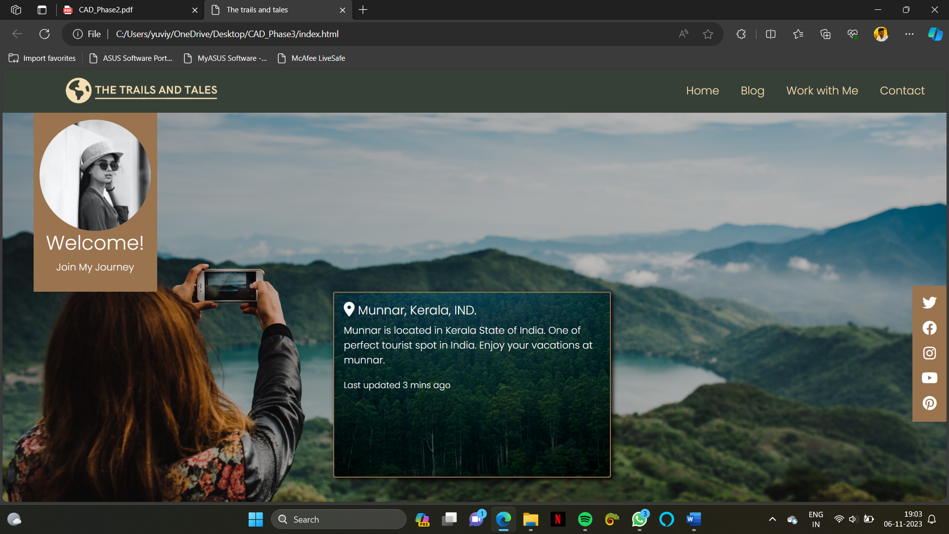

**HTML CODE:**

<!DOCTYPE *html*>

<html *lang*="en">

<head>

    <meta *charset*="UTF-8">

    <meta *name*="viewport" *content*="width=device-width, initial-scale=1.0">

    <title>The trails and tales</title>

    <link *href*="https://cdn.jsdelivr.net/npm/bootstrap@5.3.2/dist/css/bootstrap.min.css" *rel*="stylesheet"

*integrity*="sha384-T3c6CoIi6uLrA9TneNEoa7RxnatzjcDSCmG1MXxSR1GAsXEV/Dwwykc2MPK8M2HN" *crossorigin*="anonymous">

    <link *rel*="stylesheet" *href*="./style.css">

      <link *rel*="stylesheet" *href*="https://cdnjs.cloudflare.com/ajax/libs/font-awesome/6.4.2/css/all.min.css"

*integrity*="sha512-z3gLpd7yknf1YoNbCzqRKc4qyor8gaKU1qmn+CShxbuBusANI9QpRohGBreCFkKxLhei6S9CQXFEbbKuqLg0DA=="

*crossorigin*="anonymous" *referrerpolicy*="no-referrer" />

</head>

<body>

    <div *class*="super_main">

        <div *class*="Nav-Bar">

            <div *class*="HamBurger">

                <span *class*="Nav-Bar-Line"></span>

                <span *class*="Nav-Bar-Line"></span>

                <span *class*="Nav-Bar-Line"></span>

            </div>

            <div *class*="Nav-logo-div">

                <img *class*="logo_1" *src*="./images/logo.png" *class*="Nav-logo" *alt*="Logo" />

            </div>

            <ul *class*="Nav-ul">

                <li *class*="Nav-li" *id*="0">

                    <a *href*="./index.html" *class*="Nav-a">Home</a>

                </li>

                <li *class*="Nav-li" *id*="1">

                    <a *href*="./blog.html" *class*="Nav-a">Blog</a>

                </li>

                <li *class*="Nav-li" *id*="3">

                    <a *href*="./work.html" *class*="Nav-a">Work with Me</a>

                </li>

                <li *class*="Nav-li" *id*="4">

                    <a *href*="./contact.html" *class*="Nav-a">Contact</a>

                </li>

            </ul>

        </div>

        </header>

        <div *class*="profile">

            <img *class*="profile_pic" *src*="./images/profile-pic.jpg" *alt*="profile" *draggable*="false">

            <h2 *class*="Welcome">Welcome!</h2>

            <p *class*="Journey">Join My Journey</p>

        </div>

        <div *class*="social">

            <i *class*="fa-brands fa-twitter"></i>

            <i *class*="fa-brands fa-facebook"></i>

            <i *class*="fa-brands fa-instagram"></i>

            <i *class*="fa-brands fa-youtube"></i>

            <i *class*="fa-brands fa-pinterest"></i>

        </div>

        <div *class*="card text-bg-dark" *id*="munnar_card">

            <img *src*="./images/munnar-kerala.jpg" *class*="card-img" *alt*="munnar-kerala">

            <div *class*="card-img-overlay">

              <h5 *class*="card-title"><i *class*="fa-solid fa-location-dot"></i> Munnar, Kerala, IND.</h5>

              <p *class*="card-text">Munnar is located in Kerala State of India. One of perfect tourist spot in India. Enjoy your vacations at munnar.</p>

              <p *class*="card-text"><small>Last updated 3 mins ago</small></p>

            </div>

          </div>

    </div> *<!-- main div -->*

    <script *src*="./nav.js"></script>

    <script *src*="https://cdn.jsdelivr.net/npm/bootstrap@5.3.2/dist/js/bootstrap.bundle.min.js"

*integrity*="sha384-C6RzsynM9kWDrMNeT87bh95OGNyZPhcTNXj1NW7RuBCsyN/o0jlpcV8Qyq46cDfL"

*crossorigin*="anonymous"></script>

</body>

</html>

<!DOCTYPE *html*>

<html *lang*="en">

<head>

    <meta *charset*="UTF-8">

    <meta *name*="viewport" *content*="width=device-width, initial-scale=1.0">

    <title>contact me</title>

    <link *href*="https://cdn.jsdelivr.net/npm/bootstrap@5.3.2/dist/css/bootstrap.min.css" *rel*="stylesheet"

*integrity*="sha384-T3c6CoIi6uLrA9TneNEoa7RxnatzjcDSCmG1MXxSR1GAsXEV/Dwwykc2MPK8M2HN" *crossorigin*="anonymous">

    <link *rel*="stylesheet" *href*="./styles/contact.css">

    <link *rel*="stylesheet" *href*="https://cdnjs.cloudflare.com/ajax/libs/font-awesome/6.4.2/css/all.min.css"

*integrity*="sha512-z3gLpd7yknf1YoNbCzqRKc4qyor8gaKU1qmn+CShxbuBusANI9QpRohGBreCFkKxLhei6S9CQXFEbbKuqLg0DA=="

*crossorigin*="anonymous" *referrerpolicy*="no-referrer" />

</head>

<body>

    <body>

        <div *class*="video_background">

        </div>

        <div *class*="super_main">

            <div *class*="Nav-Bar">

                <div *class*="HamBurger">

                    <span *class*="Nav-Bar-Line"></span>

                    <span *class*="Nav-Bar-Line"></span>

                    <span *class*="Nav-Bar-Line"></span>

                </div>

                <div *class*="Nav-logo-div">

                    <img *class*="logo_1" *src*="./images/logo.png" *class*="Nav-logo" *alt*="Logo" />

                </div>

                <ul *class*="Nav-ul">

                    <li *class*="Nav-li" *id*="0">

                        <a *href*="./index.html" *class*="Nav-a">Home</a>

                    </li>

                    <li *class*="Nav-li" *id*="1">

                        <a *href*="./blog.html" *class*="Nav-a">Blog</a>

                    </li>

                    <li *class*="Nav-li" *id*="3">

                        <a *href*="./work.html" *class*="Nav-a">Work with Me</a>

                    </li>

                    <li *class*="Nav-li" *id*="4">

                        <a *href*="./contact.html" *class*="Nav-a">Contact</a>

                    </li>

                </ul>

            </div>

            </header>

            <div *class*="background-div">

                <video *autoplay* *muted* *loop* *id*="video-bg">

                    <source *src*="./Videos/contact-bg.mp4" *type*="video/mp4">

                </video>

                <div *class*="container" *id*="send_msg">

                    <h3>Contact Me</h3>

                    <p>thetrailsandtales.com | +91 9159600804</p>

                    <div *class*="row">

                        <div *class*="col-6">

                            <label *for*="1">First Name</label>

                            <input *type*="text" *id*="1">

                        </div>

                        <div *class*="col-6">

                            <label *for*="2">Last Name</label>

                            <input *type*="text" *id*="2">

                        </div>

                    </div>

                    <div *class*="row">

                        <div *class*="col-6">

                            <label *for*="3">Email</label><br>

                            <input *type*="text" *id*="3">

                        </div>

                        <div *class*="col-6">

                            <label *for*="4">Phone</label><br>

                            <input *type*="text" *id*="4">

                        </div>

                    </div>

                    <div *class*="row">

                        <div *class*="col-12">

                            <label *for*="5">Message</label><br>

                            <textarea *id*="5" *cols*="30" *rows*="5" *class*="txt_area"></textarea>

                        </div>

                        <div *class*="col-12">

                            <button *class*="submit">Send Message</button>

                        </div>

                    </div>

                </div>

                <div *class*="social">

                    <i *class*="fa-brands fa-twitter"></i>

                    <i *class*="fa-brands fa-facebook"></i>

                    <i *class*="fa-brands fa-instagram"></i>

                    <i *class*="fa-brands fa-youtube"></i>

                    <i *class*="fa-brands fa-pinterest"></i>

                </div>

            </div>

        </div>

        <script *src*="./nav.js"></script>

        <script *src*="https://cdn.jsdelivr.net/npm/bootstrap@5.3.2/dist/js/bootstrap.bundle.min.js"

*integrity*="sha384-C6RzsynM9kWDrMNeT87bh95OGNyZPhcTNXj1NW7RuBCsyN/o0jlpcV8Qyq46cDfL"

*crossorigin*="anonymous"></script>

    </body>

</html>

**CSS CODE:**

*@import* url('https://fonts.googleapis.com/css2?family=Poppins:ital,wght@0,100;0,300;1,400&display=swap');

* {

    box-sizing: border-box;

    margin: 0;

    padding: 0;

    font-family: poppins;

    z-index: 1111;

}

*.Nav-Bar* {

    width: 100*%*;

    height: 70*px*;

    background-color: #364037;

    z-index: 1111;

}

*.Nav-logo-div* {

    float: left;

    display: flex;

    justify-content: center;

    align-items: center;

    width: 300*px*;

    height: 70*px*;

}

*.Nav-logo* {

    display: inline-block;

    width: 120*px* *!important*;

}

*.Nav-ul* {

    float: right;

    margin-right: 20*px*;

    font-family: var(*--poppins*);

    font-size: 18*px*;

    margin-top: 0;

}

*.Nav-li* {

    list-style: none;

    display: inline-block;

    line-height: 70*px*;

    margin: 0 5*px*;

    font-family: var(*--poppins*);

    font-size: 18*px*;

    font-weight: 400;

}

*.Nav-a* {

    text-decoration: none;

    color: wheat;

    font-size: 18*px*;

    padding: 5*px* 10*px*;

}

*.HamBurger* {

    display: none;

    float: left;

    margin-top: 20*px*;

    margin-left: 20*px*;

    cursor: pointer;

}

*.Nav-Bar-Line* {

    display: block;

    width: 25*px*;

    height: 3*px*;

    margin: 5*px* auto;

    background-color: wheat;

    ;

}

*@media* (max-width:995*px*) {

*.Nav-a* {

        text-decoration: none;

        color: wheat;

        font-size: 16*px*;

        padding: 5*px* 5*px*;

    }

*.Nav-li* {

        list-style: none;

        display: inline-block;

        line-height: 70*px*;

        margin: 0 3*px*;

        font-size: 16*px*;

        font-weight: 400;

    }

*.Nav-logo-div* {

        float: left;

        width: 150*px*;

*/* height: 70px; */*

        display: flex;

        justify-content: center;

        align-items: center;

    }

*.Nav-logo* {

        display: inline-block;

        width: 10*px*;

    }

}

*@media* (max-width:768*px*) {

*.h-tags* {

        font-size: 24*px*;

        font-weight: 600;

        font-family: var(*--poppins*);

    }

*.Nav-logo-div* {

        display: flex;

        justify-content: center;

        align-items: center;

        float: left;

*/* width: 350px; */*

        height: 70*px*;

    }

*.Nav-logo* {

        display: inline;

        width: 250*px*;

    }

*.HamBurger* {

        display: block;

    }

*.HamBurger.Active* *.Nav-Bar-Line:nth-child*(2) {

        opacity: 0;

    }

*.HamBurger.Active* *.Nav-Bar-Line:nth-child*(1) {

        transform: translateY(8*px*) rotate(45*deg*);

    }

*.HamBurger.Active* *.Nav-Bar-Line:nth-child*(3) {

        transform: translateY(-8*px*) rotate(-45*deg*);

    }

*.Nav-ul* {

        position: fixed;

        width: 100*%*;

        height: 100*vh*;

        margin-top: 0;

        margin-bottom: 0;

        background-color: black;

        top: 70*px*;

        left: -100*%*;

        text-align: center;

        transition: all .5*s*;

    }

*.Nav-li* {

        list-style: none;

        display: block;

        line-height: 30*px*;

        margin: 50*px* 0;

        padding: 0;

        font-family: var(*--poppins*);

        font-size: 18*px*;

        font-weight: 400;

    }

*.Nav-a* {

        text-decoration: none;

        color: (0, 102, 228);

        font-size: 24*px*;

        padding: 5*px* 10*px*;

    }

*.Nav-ul*,

*.Nav-a:hover* {

        color: var(*--secondary-color*);

        font-size: 24*px*;

    }

*.Nav-ul.Active* {

        position: fixed;

        z-index: 11111;

        width: 100*%*;

        height: 100*vh*;

        background-color: #364037;

        color: var(*--secondary-color*);

        top: 70*px*;

        left: 0;

        text-align: center;

        transition: all .5*s*;

    }

}

*/* =============================================== */*

*.logo_1* {

    width: 250*px*;

    margin-left: 150*px*;

    border: none;

}

*/* ================= main-1 ========================== */*

*.super_main* {

    height: 100*vh*;

    width: 100*%*;

    background-image: linear-gradient(*to* right, rgba(0, 0, 0, 0.2), rgba(0, 0, 0, 0.2)), url(./images/bg_img.jpg);

    background-position: center;

    background-size: cover;

    background-repeat: no-repeat;

}

*/* ====================================================== */*

*.profile* {

    background-color: #9A734F;

    color: white;

    width: 200*px*;

    height: 290*px*;

    margin-left: 50*px*;

    display: flex;

    flex-direction: column;

    align-items: center;

    justify-content: center;

    z-index: 000;

}

*.profile_pic* {

    width: 180*px*;

    border-radius: 50*%*;

}

*/* ============================================== */*

*.social*{

    background-color: #9A734F;

    color: white;

    width: 55*px*;

    height: 220*px*;

    display: flex;

    flex-direction: column;

    align-items: center;

    justify-content: space-evenly;

    position: fixed;

    top: 350*px*;

    right: 0;

}

i{

    font-size: 23*px*;

    color: white;

}

*/* ================================================ */*

*#munnar_card*{

    width: 450*px*;

    margin-left: 35*%*;

    border-radius: 3*px*;

    border: solid 2*px*  #9A734F;

    color: wheat;

    box-shadow: 3*px* 3*px* 7*px* black;

    transition: all 0.3*s*;

    cursor: pointer;

}

*#munnar_card:hover*{

    border:solid 2*px* wheat ;

}

*#munnar_card:active*{

    opacity: 0.7;

}

**WEBSITE LINK HOSTED ON IBM CLOUD:**

**LINK:** [**https://the.trails.and.tales.s3-web.che01.cloud-object-storage.appdomain.cloud**](https://the.trails.and.tales.s3-web.che01.cloud-object-storage.appdomain.cloud)

[**Click to open website**](https://the.trails.and.tales.s3-web.che01.cloud-object-storage.appdomain.cloud)

|  |  |  |  |  |
| --- | --- | --- | --- | --- |
| **S.No** | **Name** | **Degree** | **Email Address** | **Naan Mudhalvan Id** |
| 1. | S. Yuvaraj | BE | yuviyuvarajkpr@gmail.com | au820321104060 |
| 2. | S. Surya | BE | suryavirat065@gmail.com | au820321104051 |
| 3. | S. Vengatesh | BE | vengadeshshanmugavel@gmail.com | au820321104054 |
| 4. | U. Shriram | BE | shriram68427@gmail.com | au820321104043 |