1. 创建数据库

create datebases pleasing_growth;

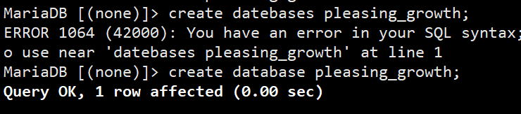

1. 进入数据库

use pleasing_growth;

1. 创建表

创建用户表

create table User(uid int primary key,uname varchar(10) unique,uimage varchar(40),usex char(4),utel varchar(20),upass varchar(20),ustatus bool);

创建文章表

create table Article (aid int PRIMARY KEY,atitle varchar(40),acontent varchar(10000),astatus bool,atran int ,agood int,atime varchar(20) ,uid int, FOREIGN KEY (uid) REFERENCES User(uid));

创建文章和栏目表

create table Article_Lanmu (aid int,acol varchar(10));

创建说说表

create table Say(sid int primary key,stitle varchar(40),scontent varchar(10000),sstatus bool,stran int ,sgood int ,stime varchar(20), uid int);

创建关注用户表

create table Follow_User(uid int,upid int);

创建评论表

reate table Comment(cid int primary key,ccontent varchar(1000),ctime varchar(20),cstatus bool,cgood int ,uid int ,FOREIGN KEY (uid) REFERENCES User(uid));

创建意见反馈表

create table Back(rid int,rcontent varchar(1000),rtime varchar(20),rstatus bool,rtel int,uid int,FOREIGN KEY (uid) REFERENCES User(uid));

创建相册表

create table Photo_Album(xid int primary key,xname varchar(1000),xtime varchar(20),xstatus bool,xcount int,xlocal varchar(100),uid int,FOREIGN KEY (uid) REFERENCES User(uid));

创建照片表

create table Photo(pid int primary key,pname varchar(100),ptime varchar(20),pstatus bool,ptype varchar(10) ,plocal varchar(100),xid int,FOREIGN KEY (xid) REFERENCES Photo_Album(xid));

创建视频表

create table Video(vid int primary key,vname varchar(1000),vtime varchar(20),vstatus bool,vtype varchar(10),vlocal varchar(100),uid int,FOREIGN KEY (uid) REFERENCES User(uid));

创建成长树表

create table Tree(tid int primary key,tcount int,ttime varchar(20),tstatus bool ,uid int ,FOREIGN KEY (uid) REFERENCES User(uid));

创建果实表

create table Fruit(fid int,fname varchar(100),ftime varchar(20),fstatus bool,tid int,FOREIGN KEY (tid) REFERENCES Tree(tid));

