Data Visualization Project - Team Technerds

1. Project Overview
This project aims to analyze and visually explore factors influencing loan repayment behavior for a finance company operating in urban regions. The goal is to help the company better identify trustworthy applicants, reduce defaults, and strengthen the credit evaluation process.
The analysis is conducted using three datasets:
- application_data.csv – Client-level information recorded during loan application.
- previous_application.csv – History of earlier applications and their approval outcomes.
- columns_description.csv – Metadata dictionary explaining all variables.
The final outcomes include structured EDA, feature engineering, insights, and a foundation for an interactive dashboard.

Data Exploration, Cleaning & Initial Insights

1. Business Understanding

Business Goal
The primary objective is to minimize financial losses from loan defaults while maximizing the approval of creditworthy applicants. By analyzing historical loan application data, we aim to identify key indicators of default risk. This will enable the credit team to refine their approval criteria, implement risk-based pricing, or flag high-risk applications for manual review.

Key Analysis Questions
- What are the defining characteristics of applicants who default versus those who repay? (Demographics, Income, Employment)
- How does financial stability (Income, Credit Amount, Annuity) correlate with default risk?
- Are there specific loan types or contract terms associated with higher default rates?
- How does previous loan history influence current application performance?
- What data quality issues (missing values, outliers) need to be addressed before modeling?

2. Data Structure & Quality Assessment

Dataset Overview
- Application Data: Contains client-level information for current loan applications.
  - Shape: (307,511 rows, 122 columns)
  - Target Variable: TARGET (1 = Default, 0 = Repaid)
- 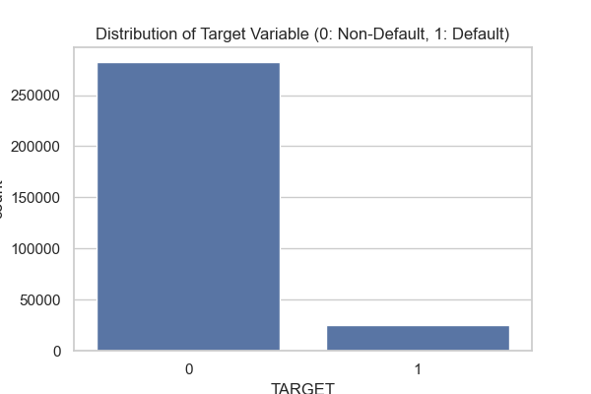
- Previous Application Data: History of previous loans for the same clients.
  - Shape: (1,670,214 rows, 37 columns)
- Column Descriptions: Metadata explaining the features.

Data Quality Issues
- Missing Values:
  - Significant missing data in several columns. Top missing columns include housing-related information (e.g., COMMONAREA_AVG, NONLIVINGAPARTMENTS_AVG) and external source scores.
  - Action: We will need to decide on imputation strategies (median, mode, or creating a "missing" category) or drop columns with excessive missingness (>50%) if they lack predictive power.
- 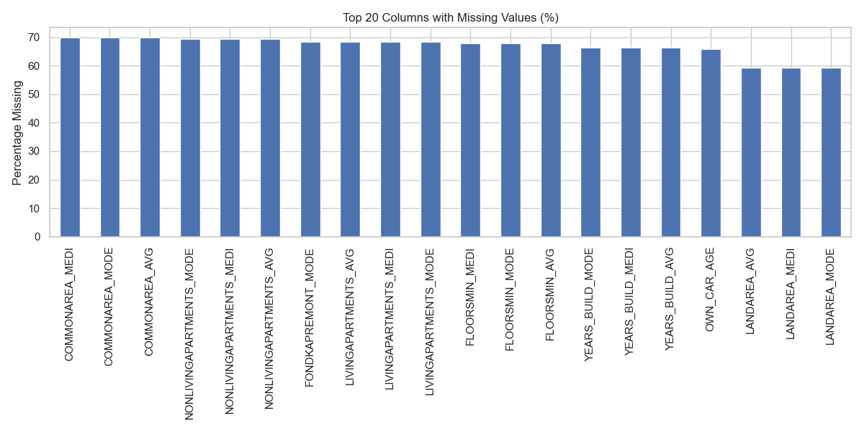
- Outliers:
  - Income: AMT_INCOME_TOTAL shows extreme outliers (e.g., max value is likely an error or a very high-net-worth individual). These will need capping or log-transformation.
- 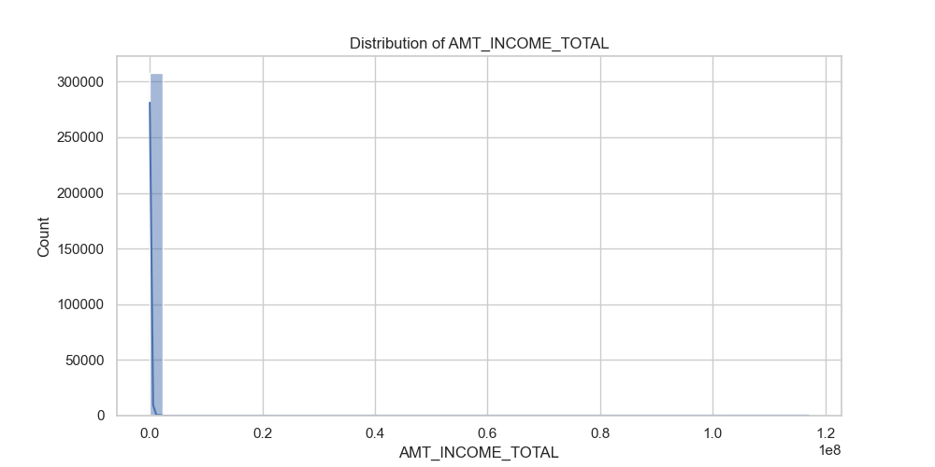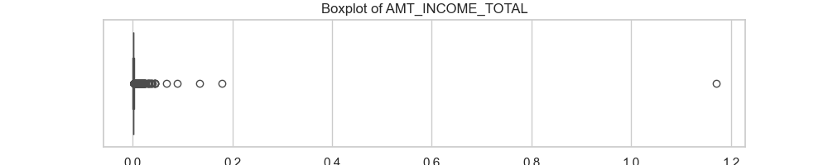
  - Days Employed: There are anomalous values (e.g., 365243) which likely represent a placeholder for "unemployed" or "pensioner". This needs to be cleaned.

3. Initial Exploratory Insights

Borrower Profiles & Default Proportions
- Target Distribution: The vast majority of loans are repaid. The 8% default rate is the critical minority we need to characterize.
- Contract Type:
  - Cash Loans: Make up the majority of applications.
  - Revolving Loans: Have a lower volume but potentially different risk profile.
- 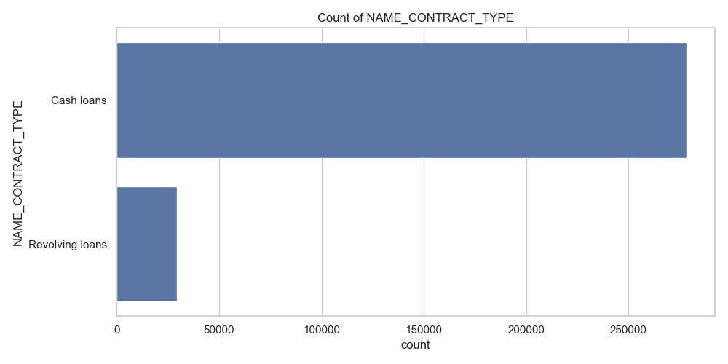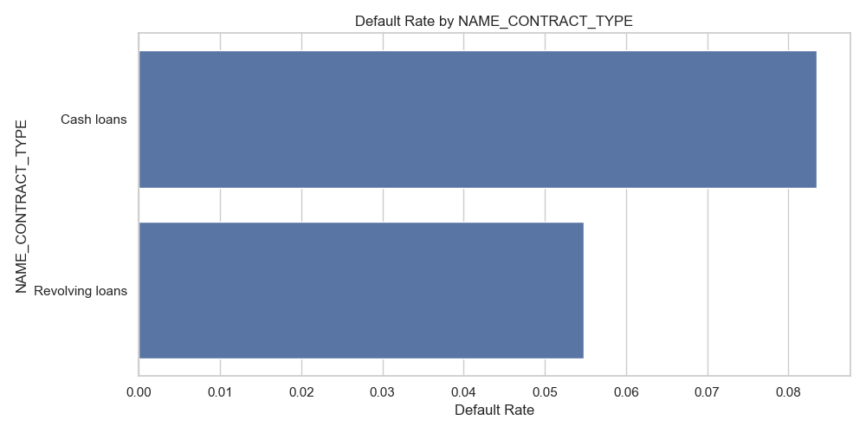
- Gender:
  - Females tend to apply more frequently than males.
  - Insight: Initial checks suggest males might have a slightly higher default rate (to be confirmed with statistical tests).
- 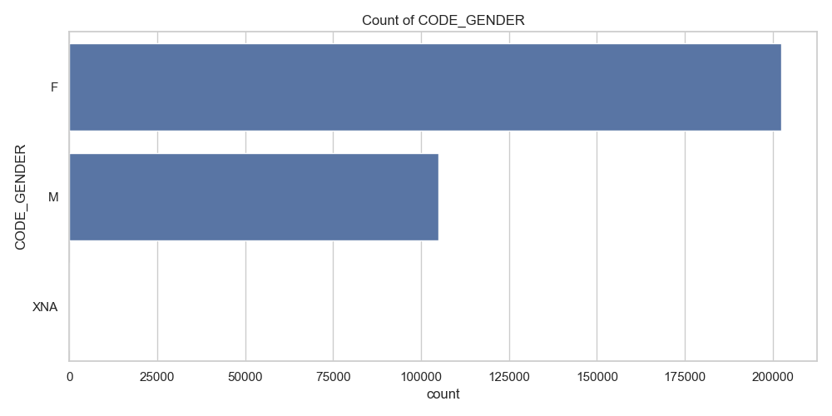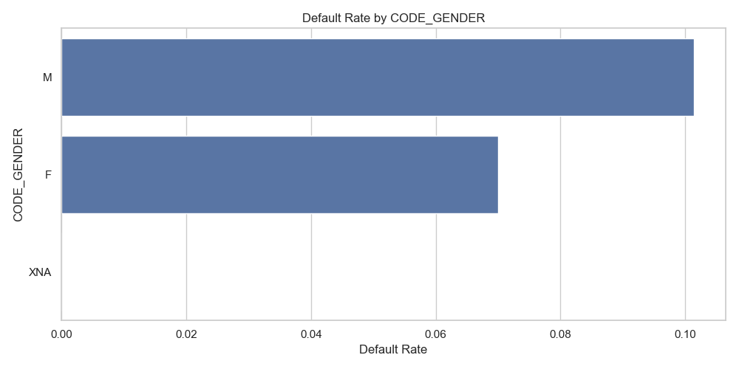
- Education:
  - Applicants with "Secondary / secondary special" education are the most common.
  - Insight: Higher education levels generally correlate with lower default rates.
- 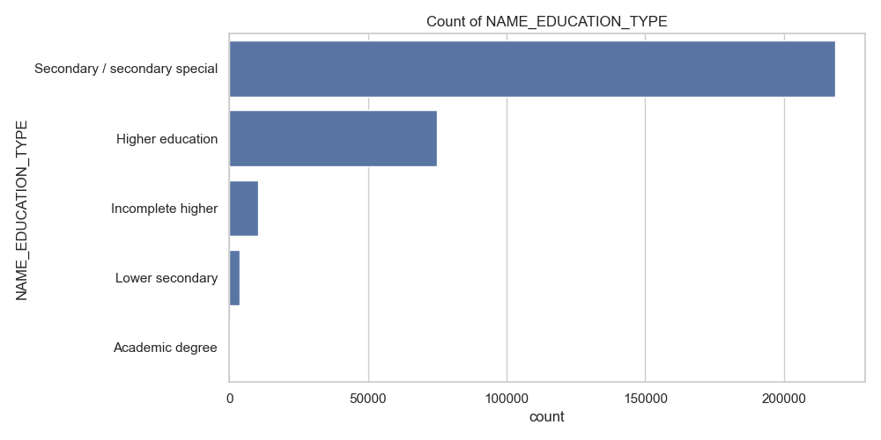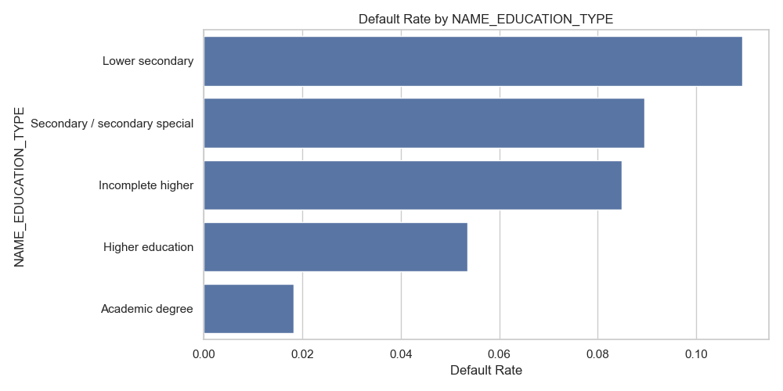
- Financials:
  - Credit Amount: Distribution is right-skewed. Most loans are for smaller amounts, but there is a long tail of high-value loans.
  - Income: Highly skewed. Most applicants have low to medium income.
- 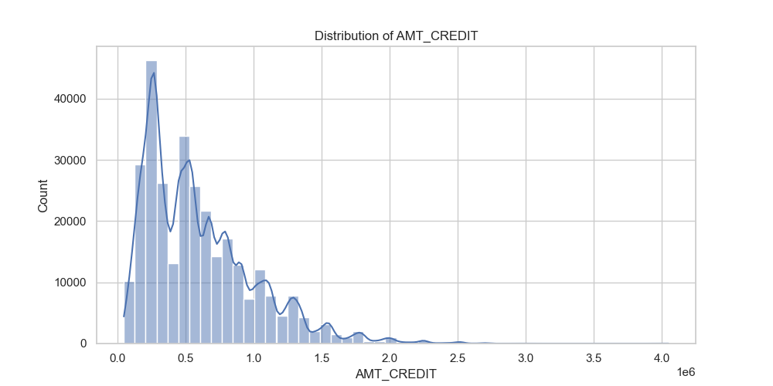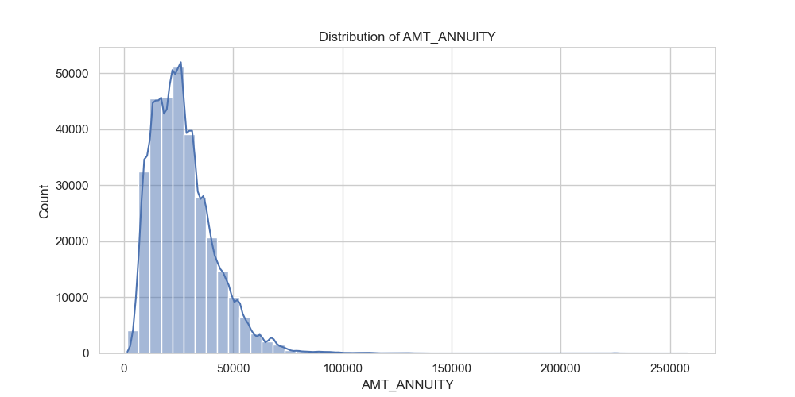

Initial Observations Summary
The data holds strong potential for predictive modeling but requires significant cleaning. The class imbalance is a major factor to consider. Key risk drivers appear to be education level, gender, and potentially the type of loan contract. The EXT_SOURCE variables (external credit scores) are likely to be strong predictors and should be prioritized despite missing values.

Feature Engineering

Overview
This feature engineering process was applied to the application_data.csv and previous_application.csv datasets. The objective was to transform initially cleaned data into a concise, interpretable set of features that effectively capture borrower profiles, loan characteristics, and historical repayment behavior.
The process included domain-driven transformations, ratio calculations, time conversions, and careful aggregation of historical records. The resulting final dataset contains 307,511 observations and 68 columns, with no missing values and a preserved default rate of 8.073%. This engineered dataset is optimized for exploratory analysis, risk segmentation, and interactive visualization in Power BI.

1. Feature Engineering on Application Data
The engineered application_data dataset was reduced from 122 to approximately 52 columns through targeted transformations and selections. Key engineered features include:
- AGE_AT_LOAN: Age of the applicant in years at the time of loan application (derived from |DAYS_BIRTH| / 365.25). Provides an intuitive demographic variable for segmentation and correlation analysis with repayment behaviour.
- JOB_AGE_AT_LOAN: Years employed at the current job (derived from |DAYS_EMPLOYED| / 365.25, with anomalies flagged). Captures employment stability, a strong indicator of repayment capacity.
- REG_AGE_AT_LOAN, ID_PUBLISH_AGE_AT_LOAN, PHONE_AGE_AT_LOAN: Years since registration, ID update, and phone change, respectively. Reflect potential life changes or data freshness relevant to risk assessment.
- INCOME_TO_CREDIT_RATIO: Total income divided by loan credit amount. Measures the applicant's ability to service the requested credit.
- ANNUITY_TO_INCOME_RATIO: Monthly annuity divided by total income. Indicates monthly repayment burden relative to income.
- CREDIT_TERM_MONTHS: Estimated loan term in months (AMT_CREDIT / AMT_ANNUITY). Summarises loan duration for comparative analysis.
- INCOME_PER_FAMILY_MEMBER: Income divided by family size (including applicant). Adjusts income for household dependencies.
- HAS_CHILDREN: Binary indicator of presence of children. Enables direct segmentation by family structure.
- HAS_CAR_AND_REALTY: Binary indicator of owning both a car and real estate. Serves as a proxy for overall asset ownership and financial stability.
- AVG_APARTMENTS_BUILDING: Mean of normalised building information features (e.g., apartment size, basement area). Consolidates multiple related housing metrics into a single interpretable score.
- EXT_SCORES_AVG: Average of the three external data source scores (EXT_SOURCE_1, 2, 3). Provides a robust composite external risk signal.
- TOTAL_DOCS_SUBMITTED: Sum of document submission flags (FLAG_DOCUMENT_3 to 21). Quantifies completeness of application documentation.
Irrelevant or redundant columns (e.g., individual contact flags) were removed to reduce dimensionality while retaining predictive and explanatory power.
The processed file was saved as application_data.csv in data/processed/Feature-Engineered/.

2. Feature Engineering on Previous Application Data
Historical records from previous_application.csv (originally >1.6 million rows) were aggregated to the customer level (SK_ID_CURR), resulting in 16 derived features per applicant. Only columns with strong behavioural signals were retained prior to aggregation.
Key engineered features include:
- PREV_TOTAL_APPS: Total number of previous applications. Indicates application frequency and potential credit-seeking behaviour.
- PREV_APPROVED_COUNT and PREV_APPROVAL_RATE: Count and proportion of previously approved applications. Higher approval rates suggest consistent creditworthiness.
- PREV_REFUSED_COUNT and PREV_REFUSAL_RATE: Count and proportion of previously refused applications. Elevated refusal rates signal elevated historical risk.
- PREV_AVG_LOAN_AMT, PREV_TOTAL_LOAN_AMT, PREV_MAX_LOAN_AMT: Average, cumulative, and maximum credit amounts from past approved loans. Reflect historical borrowing scale and exposure.
- PREV_AVG_OVERASK: Average difference between requested and granted amounts (AMT_APPLICATION – AMT_CREDIT). Positive values indicate tendency to over-request, potentially reflecting optimism or financial strain.
- PREV_AVG_DOWNPAYMENT_PCT: Average down payment as a percentage of granted credit. Higher values demonstrate greater upfront commitment and financial capacity.
- PREV_MOST_RECENT_APP_YEARS and PREV_AVG_YEARS_AGO: Years since the most recent and average previous application (derived from |DAYS_DECISION| / 365.25). Capture recency and overall activity timeline.
- PREV_AVG_LOAN_TERM_MONTHS: Average contractual loan term in months. Indicates preference for short- or long-term financing.
- PREV_PCT_CONSUMER_LOANS: Proportion of past loans classified as consumer loans. Distinguishes consumption-driven borrowing patterns.
- PREV_PCT_WITH_INSURANCE: Proportion of past loans with optional insurance taken. May reflect risk awareness or financial prudence.
Applicants with no previous applications received zero values across all features, preserving the full cohort size.
The processed file was saved as previous_application.csv in data/processed/Feature-Engineered/.

3. Final Dataset Assembly
The engineered application and previous-application datasets were merged on SK_ID_CURR using a left join. Remaining missing values in previous-application features were imputed with zeros (no history) and, where necessary, medians for numerical columns and modes for categorical columns.
The final dataset comprises 307,511 rows and 68 columns, maintaining the original target distribution (default rate 8.073%) and containing no missing values.
The dataset was exported as final_dataset.csv in data/final_dataset/ for direct use in Power BI dashboard development and presentation materials.
This engineered dataset provides a clean, compact, and domain-aligned foundation for identifying risk patterns, segmenting borrower profiles, and constructing the required interactive risk dashboard.

Deep Analysis, Feature Validation & Risk Attribution
This document presents a highly detailed, deep exploratory and validation analysis performed on the finalized dataset. The purpose is intentionally not model optimization, but deep explainability and risk understanding — clearly articulating why applicants default, which financial, behavioral, and demographic signals matter most, how these signals interact, and how each analytical finding directly translates into actionable credit policy and business decisions.

1. Final Dataset Overview
Dataset Location
data/final_dataset/final_dataset.csv
Granularity
- One row represents one loan application
- One-to-one mapping with unique applicant ID (SK_ID_CURR)
Target Variable
- TARGET = 1 → Client defaulted
- TARGET = 0 → Client fully repaid or Not defaulted
Why this matters All downstream analysis, modeling, and dashboards rely on this dataset as the single source of truth. Ensuring clarity at this stage prevents data leakage and misinterpretation later.

2. Feature Landscape & Grouping
To improve interpretability and avoid analytical bias, features are logically grouped before analysis.

2.1 Numerical Features
Numerical features represent continuous risk signals related to affordability, stability, and credit behavior. Examples include:
- AGE_AT_LOAN – borrower maturity and life-stage stability
- CREDIT_INCOME_RATIO – repayment burden relative to income
- ANNUITY_INCOME_RATIO – monthly cash-flow stress
- EXT_SOURCE_MEAN – external credit bureau assessment
- PREV_REFUSAL_RATE – historical rejection behavior
Analytical Focus:
- Distribution shape (skewness, concentration)
- Outlier behavior
- Relationship with default probability

2.2 Categorical Features
Categorical features capture structural and demographic context. Examples include:
- CODE_GENDER
- NAME_CONTRACT_TYPE
- EDU_SIMPLIFIED
- ORGANIZATION_TYPE
Analytical Focus:
- Frequency imbalance
- Category-level default concentration
- Statistical dependency with TARGET

3. Data Quality & Target Structure

3.1 Target Distribution

What this plot shows:
- A strong class imbalance with defaults forming a small minority
Why this matters:
- Accuracy alone is misleading
- Requires stratified sampling, ROC-AUC, and class weighting
- Reflects real-world credit portfolios

4. Univariate Analysis: Understanding Individual Signals
Univariate analysis focuses on isolating each feature independently to understand its natural distribution, stability, and inherent risk signal before considering interactions. This step is critical in credit risk because misleading distributions or extreme skewness can silently distort downstream models if not properly understood.
Univariate analysis helps answer: What does a typical applicant look like?

4.1 Numerical Feature Distributions
Each numerical feature is analyzed using two complementary visualizations to capture both central tendency and extreme behavior: For each numerical feature:
- Histogram + KDE → overall distribution and skewness
- Boxplot → outliers and variability
Typical Observations:
- Income and loan amounts are heavily right-skewed
- Ratio features show tighter, more informative distributions
- Extreme values exist but are economically plausible
Why this matters:
- Guides transformations (log, capping)
- Prevents models from overfitting noise
Plots saved as:
{feature}_histogram.png
{feature}_boxplot.png

4.2 Categorical Feature Distributions
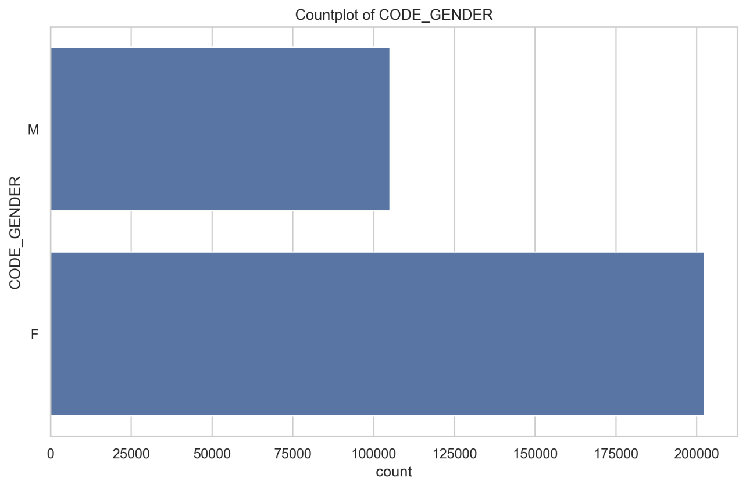
What this plot shows:
- Relative frequency of each category
Key Insight:
- Some categories dominate volume but not necessarily risk
- Rare categories can carry disproportionate default rates
Business Relevance: Volume ≠ Risk. Credit decisions must consider both.

5. Bivariate Analysis: Features vs Default
This section explains how each feature behaves differently for defaulters vs non-defaulters.

5.1 Numerical Features vs TARGET
This analysis compares how numerical feature values differ between defaulters and non-defaulters, helping determine whether a variable merely describes customers or truly differentiates risk outcomes.
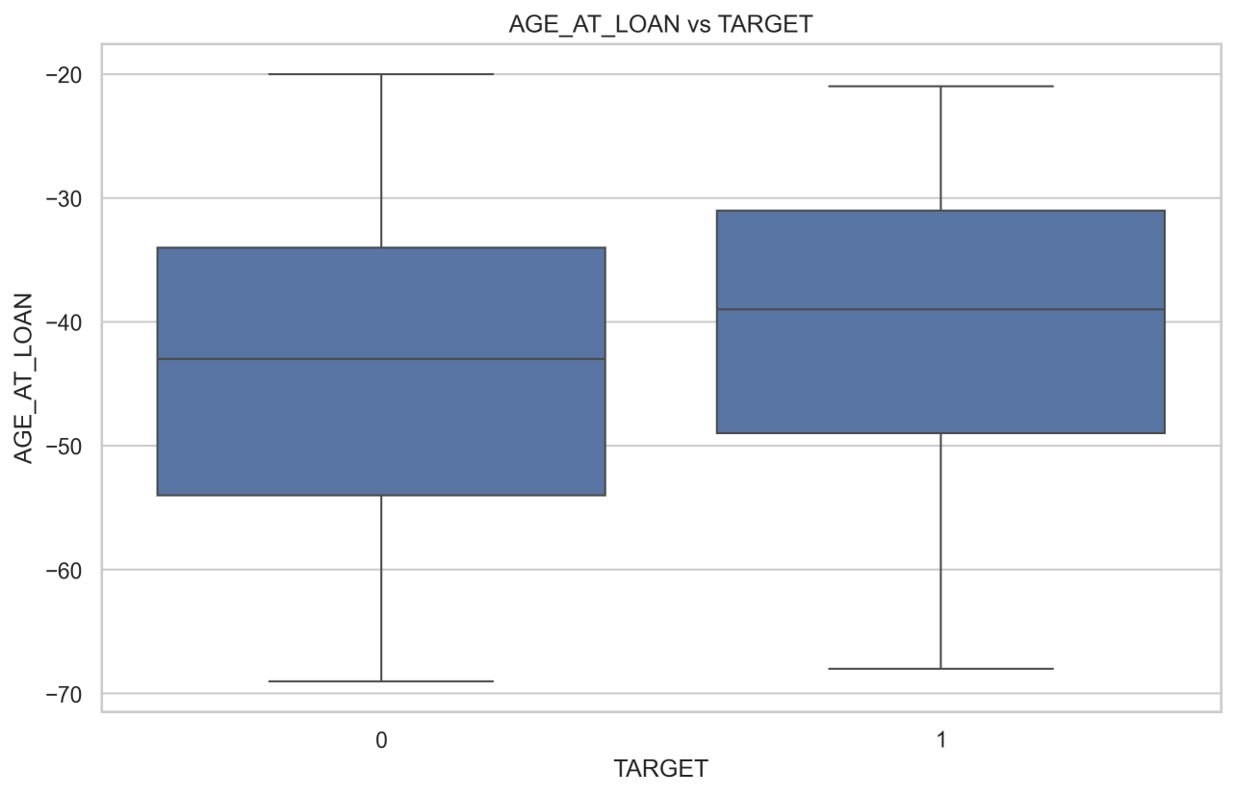
What this plot shows:
- Distribution of borrower age across default outcomes
Insight:
- Younger applicants show higher default concentration
- Risk decreases with age up to a stability plateau
Business Interpretation: Age acts as a proxy for income stability and credit maturity.

5.2 Categorical Features vs TARGET
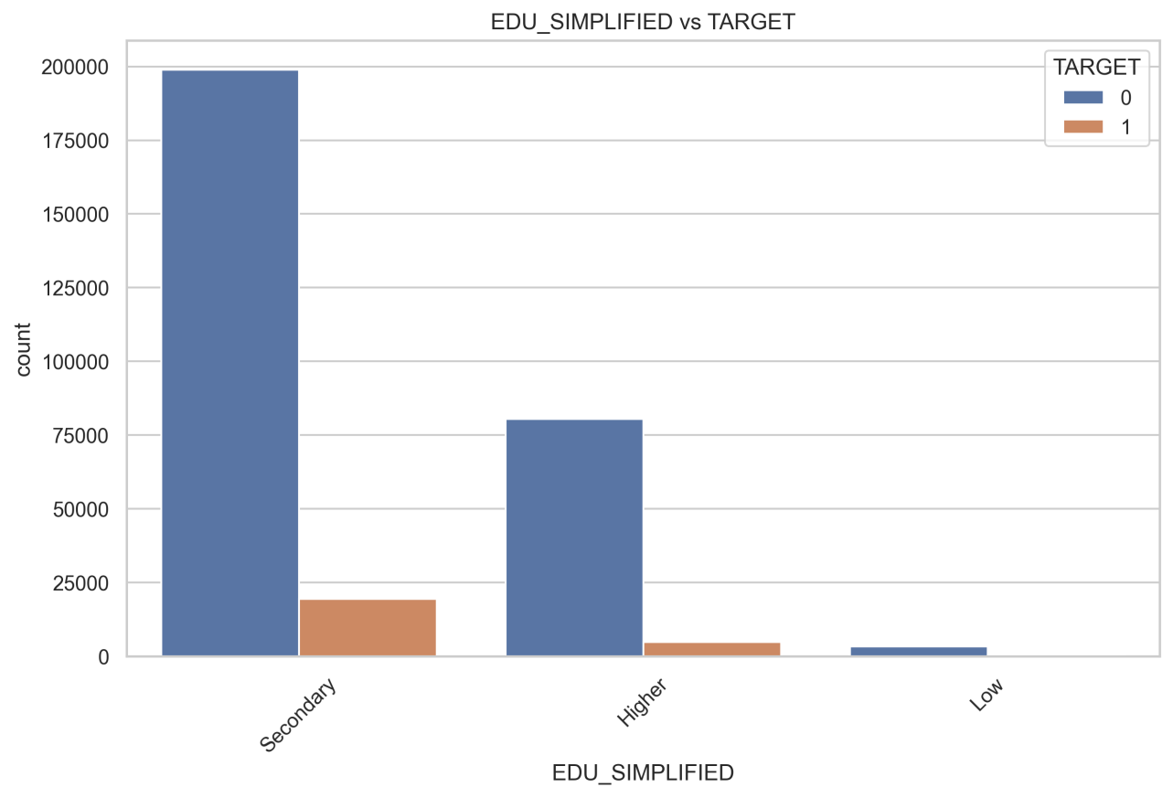
What this plot shows:
- Default proportion within each education category
Statistical Validation:
- Chi-square tests confirm dependency
- Observed differences are statistically meaningful
Business Interpretation: Education level indirectly reflects earning stability and employment quality.

6. Correlation Analysis

6.1 Full Correlation Heatmap
Correlation analysis is used here strictly as a diagnostic tool, not as a feature selection mechanism. In credit risk, strong linear correlations are rare; therefore, weak correlations do not imply irrelevance.
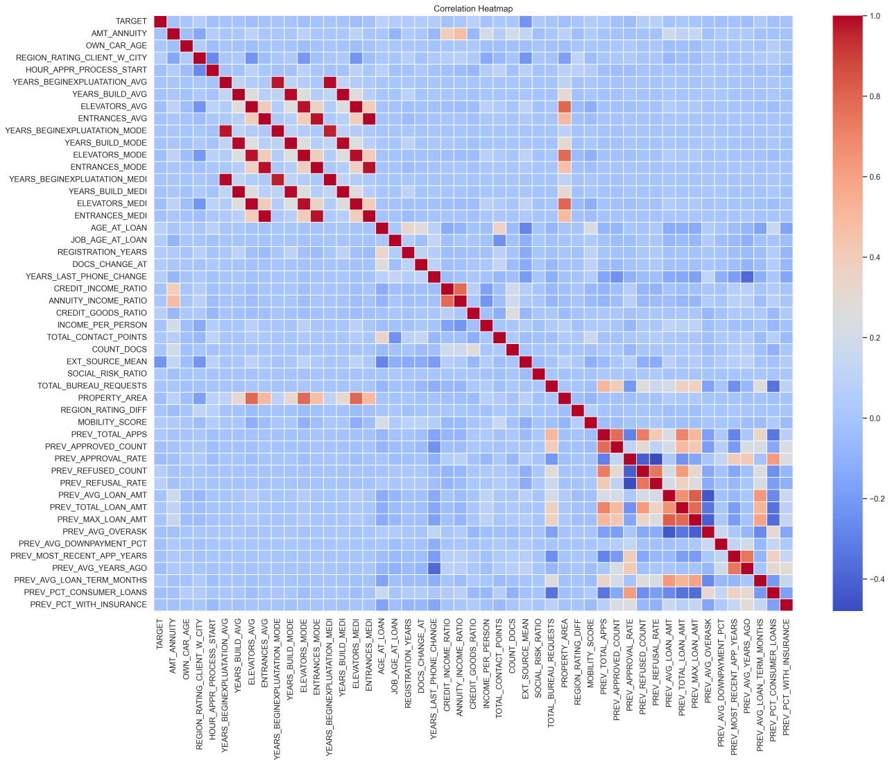
What this shows:
- Linear relationships between all numerical variables
Key Observation:
- Weak linear correlations are expected in credit risk
- Risk is driven by non-linear interactions

6.2 Correlation with TARGET
Risk-Increasing Signals:
- PREV_REFUSAL_RATE
- CREDIT_GOODS_RATIO
- AGE_AT_LOAN
Protective Signals:
- External credit scores
- Income-normalized ratios

6.3 Focused Correlation Heatmap
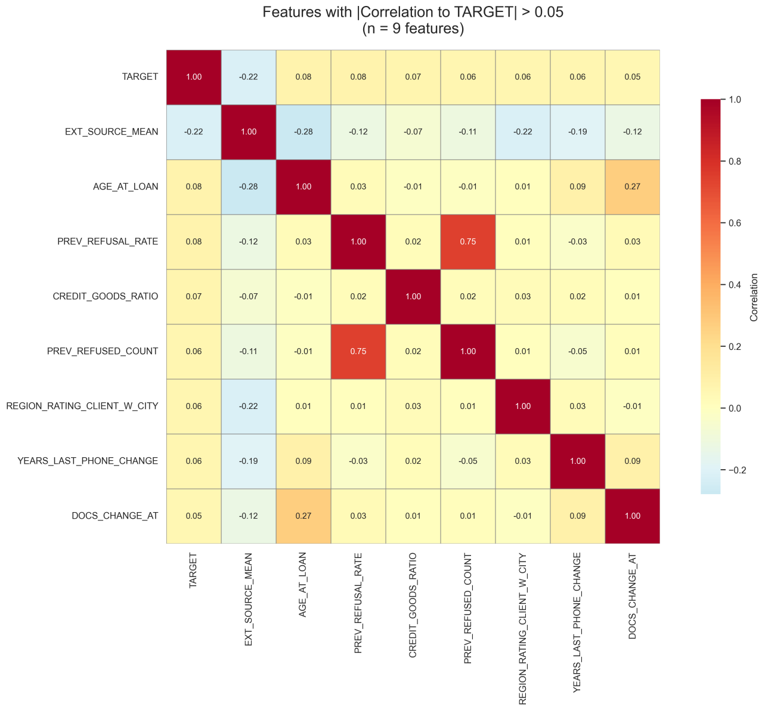
Insight: Only a limited subset shows linear signal — engineered features matter most.

7. Multivariate Analysis

7.1 Average Default Rate by Category
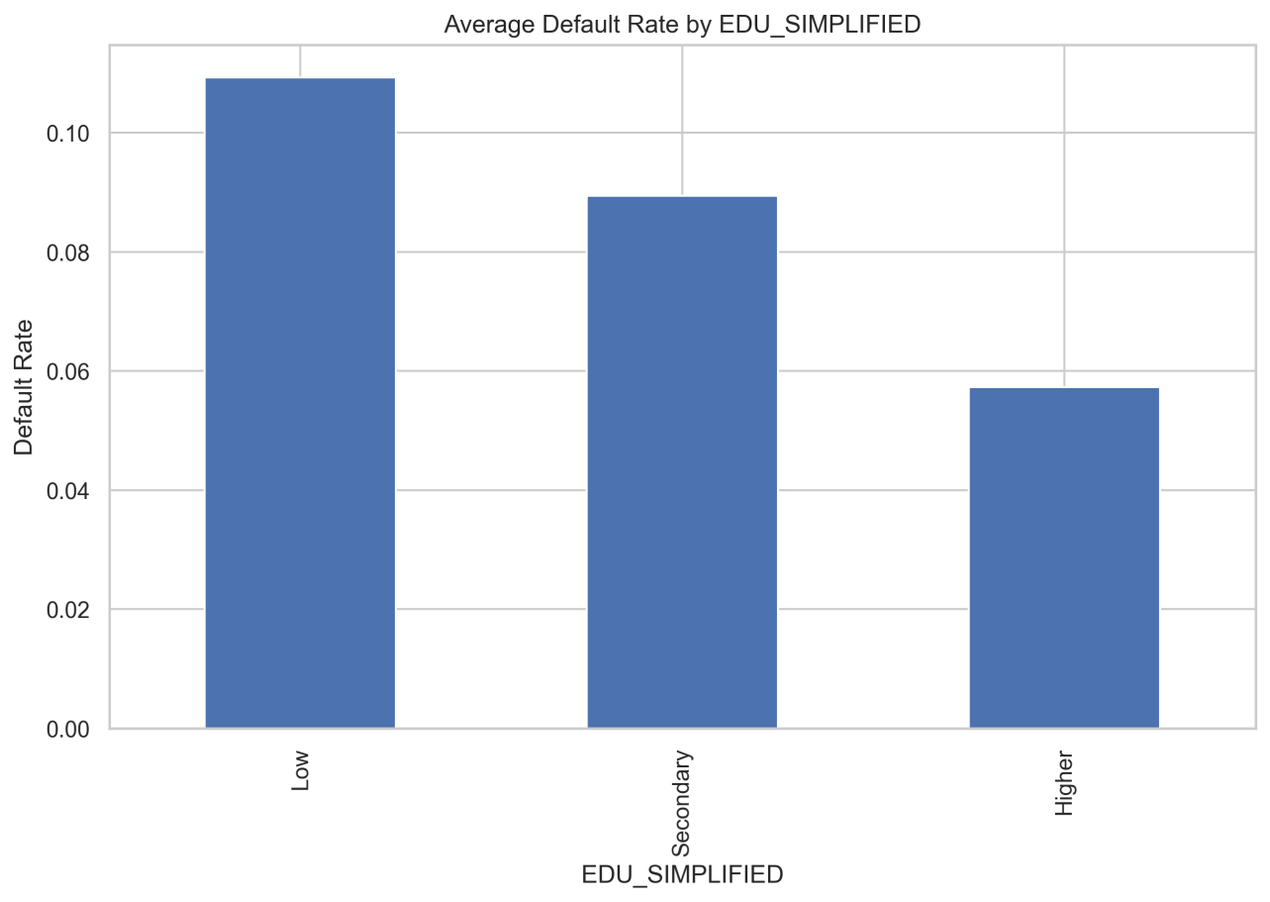
What this shows:
- Risk varies significantly within categories
Why it matters:
- Supports segmentation-based policy rules

7.2 Numerical Binning & Risk Trend
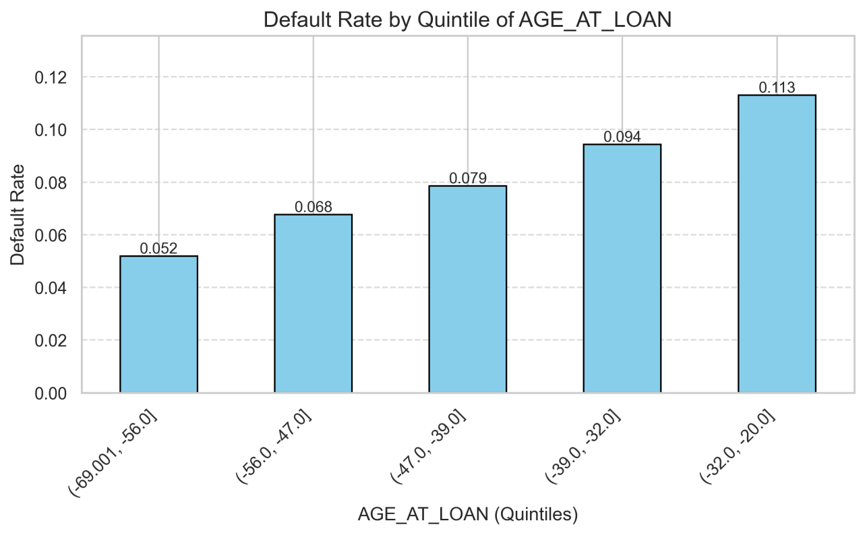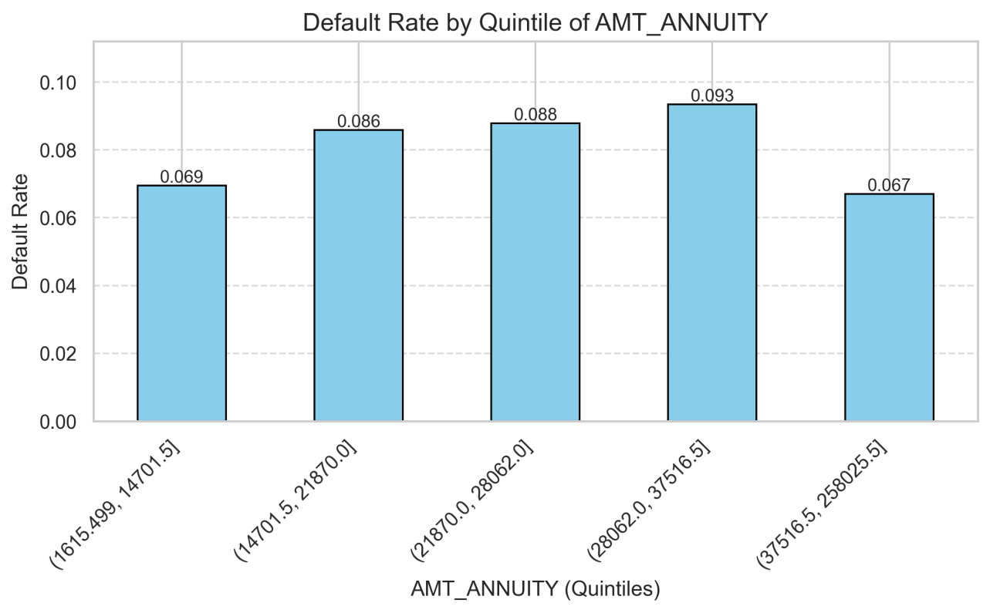
Insight:
- Clear monotonic increase in default
- Validates ratio-based feature engineering

7.3 Interaction Analysis
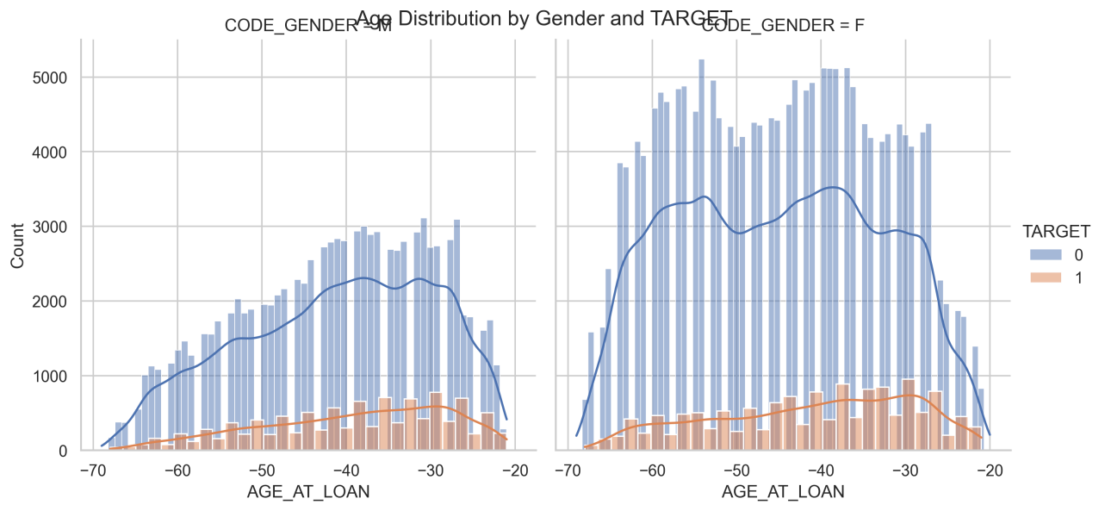
What this reveals:
- Gender alone is weak
- Gender within age bands modifies risk
Modeling Implication: Supports interaction-aware models.

8. Outlier Analysis (IQR Method)
Approach:
- Applied IQR on numerical variables only
- IDs and target excluded
Findings:
- Outliers concentrated in income and loan size
- Represent real but high-risk applicants
Action: Outliers retained but handled via robust modeling.

9. Feature Importance Validation (Random Forest)
This section validates all exploratory findings using a tree-based, non-linear ensemble model, ensuring that insights derived from EDA are not purely visual but hold predictive value in a supervised learning context.
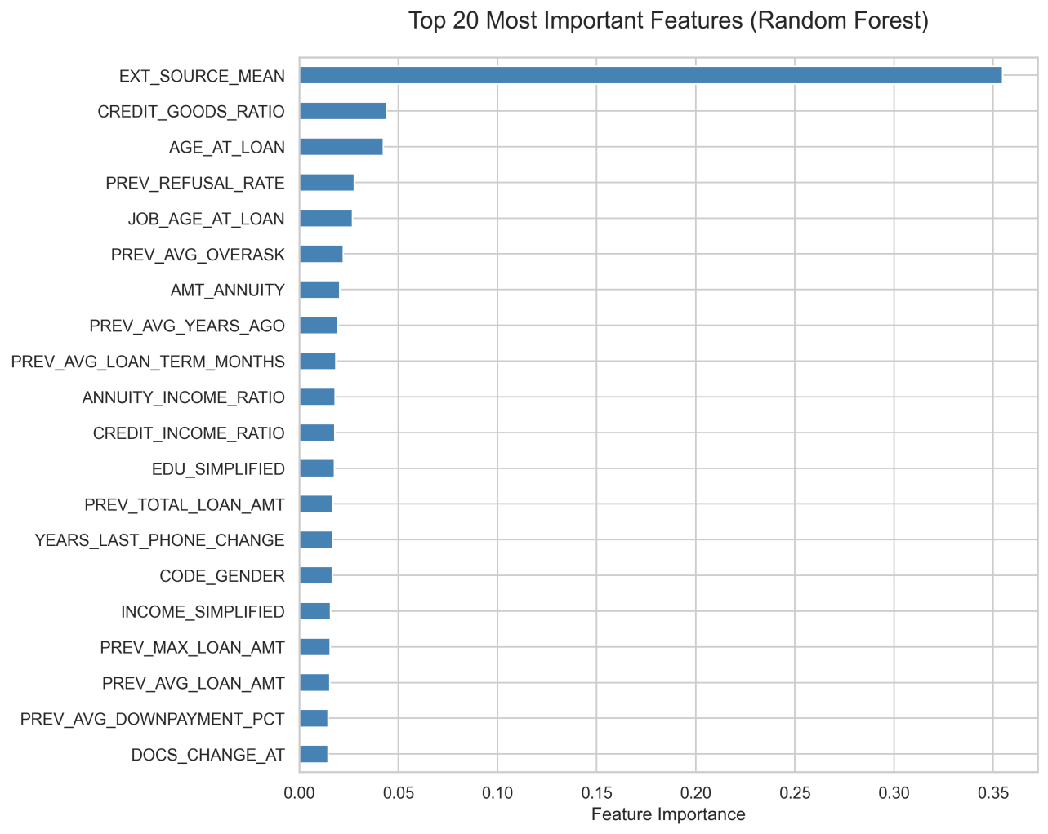
Purpose:
- Validate EDA insights using a non-linear model
Top Drivers Identified:
- EXT_SOURCE_MEAN
- CREDIT_GOODS_RATIO
- AGE_AT_LOAN
- PREV_REFUSAL_RATE
- ANNUITY_INCOME_RATIO
Model Performance:
- ROC-AUC: 0.7549
Interpretation: Strong discrimination for baseline risk validation.

10. Risk Scoring & BI Readiness
Each application enriched with:
- RISK_PROBA – predicted default probability
- RISK_SCORE – scaled 0–1000 risk score
Output File
data/final_dataset/FINAL_DATASET_FOR_WITH_RISK_SCORE.csv
Business Value:
- Plug-and-play Power BI integration
- Enables thresholding, segmentation, and monitoring

Power BI Dashboard

1. Overview Page
The Overview Page serves as the executive summary for the credit risk analysis, providing a high-level snapshot of the loan portfolio's health, applicant demographics, and key risk indicators. It is designed to allow stakeholders to quickly gauge the magnitude of applications, identify the volume of "at-risk" loans, and filter data by key demographics.
Overview Dashboard 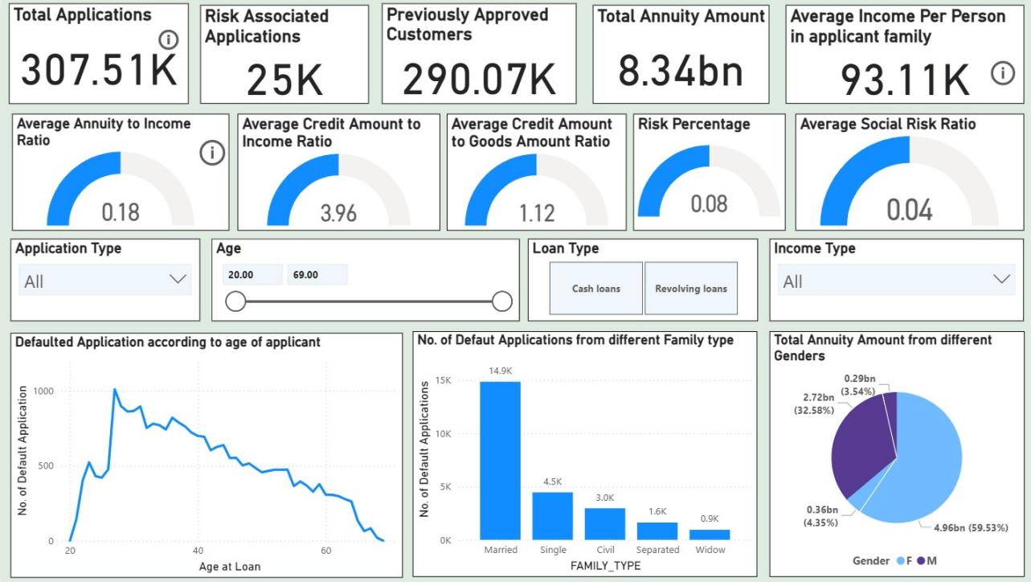

Key Performance Indicators (KPIs)
The top section highlights critical aggregate metrics:
- Total Applications: 307.51K total loan requests processed.
- Risk Associated Applications: 25K applications flagged as defaults (approx. 8% of total).
- Previously Approved Customers: 290.07K applicants with a history of prior approvals.
- Financial Scope: A total annuity exposure of 8.34bn, with an average per-capita family income of 93.11K.

Financial & Risk Ratios (Gauge Indicators)
The second row visualizes critical financial health ratios that determine affordability and risk:
- Average Annuity to Income Ratio (0.18): On average, applicants spend 18% of their income on loan repayment, indicating a generally healthy affordability level.
- Credit to Income Ratio (3.96): The average loan size is nearly 4x the applicant's income.
- Risk Percentage (0.08): Confirms the overall portfolio default rate is steady at 8%.

Interactive Filters
The dashboard empowers users to slice the data dynamically using:
- Age Slider: Filters data for applicants aged 20 to 69.
- Loan Type: Toggles between Cash Loans and Revolving Loans.
- Demographic Dropdowns: Allows filtering by Application Type and Income Type.

Visual Insights & Breakdowns
- Default Trend by Age (Line Chart):
  - Chart: "Defaulted Application according to age of applicant"
  - Insight: There is a distinct spike in defaults among younger applicants (peaking around late 20s to early 30s). As applicants age beyond 40, the number of defaults steadily declines, corroborating the EDA finding that older applicants generally display higher credit stability.
- Defaults by Family Status (Bar Chart):
  - Chart: "No. of Default Applications from different Family type"
  - Insight: Married applicants comprise the largest volume of defaults (14.9K), followed by Single (4.5K). Note: While the volume is high for married individuals, this is likely driven by the fact that they make up the majority of the applicant pool.
- Annuity Distribution by Gender (Pie Chart):
  - Chart: "Total Annuity Amount from different Genders"
  - Insight: Females account for the majority of the total annuity amount (59.53% or 4.96bn), compared to Males (32.58% or 2.72bn). This aligns with the observation that females apply for loans more frequently than males.

2. Previous Applications Distribution Dashboard
This dashboard page shifts focus from the current applicant profile to their historical banking behavior. By analyzing the 1.4 million previous application records, this view helps the credit team understand the relationship between a customer's past loyalty (frequency of borrowing) and their current risk profile.
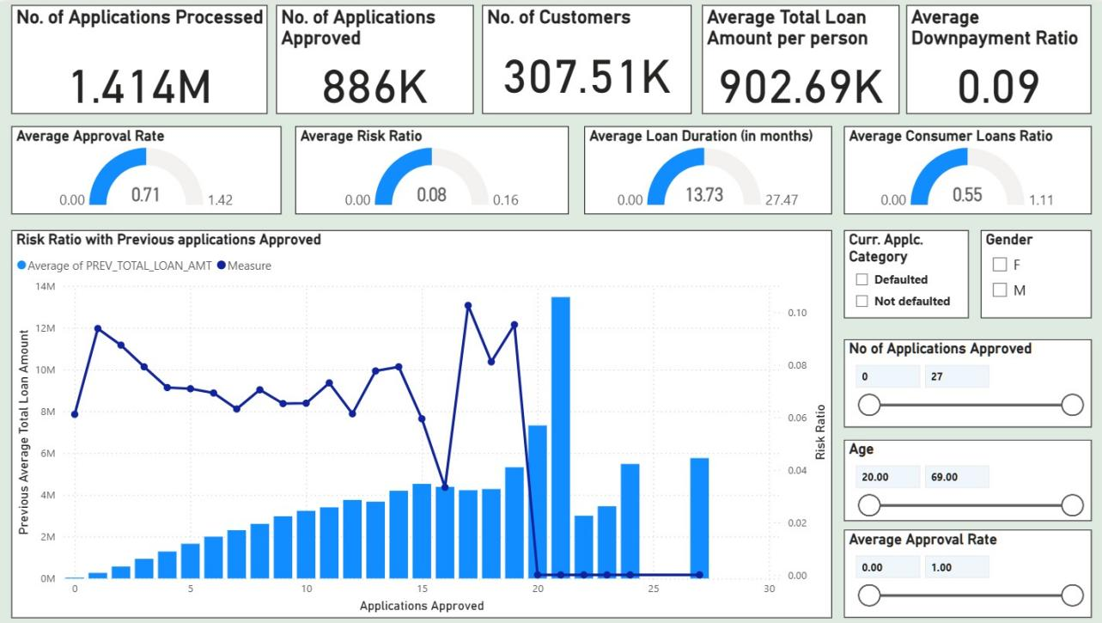

Historical Volume & Operational Metrics (KPIs)
The top header provides a summary of the operational scale and historical credit funnel:
- Processing Volume: 1.414M previous applications have been processed in total.
- Approval Volume: 886K of these applications were approved, indicating a historically active lending environment.
- Customer Base: These applications map back to 307.51K unique customers.
- Financial Average: The average total loan amount per person historically stands at 902.69K, with an average downpayment ratio of 0.09 (9%).

Behavioral Ratios (Gauge Indicators)
The second row visualizes the efficiency and nature of past lending:
- Average Approval Rate (0.71): Approximately 71% of past applications were approved, suggesting a moderately lenient historical approval policy.
- Average Risk Ratio (0.08): Consistent with the main overview, the historical risk ratio hovers at 8%.
- Average Loan Duration (13.73 months): Most historical loans were short-term, averaging just over 1 year.
- Consumer Loans Ratio (0.55): Over half (55%) of past lending activity was driven by consumer loans rather than cash loans.

Key Visual Insight: The "Loyalty vs. Risk" Curve
Chart: Risk Ratio with Previous Applications Approved This combination chart is the centerpiece of the historical analysis, plotting "Applications Approved" (X-axis) against "Total Loan Amount" (Bars) and "Risk Ratio" (Line).
- Loan Amount Trend (Bars): There is a clear positive correlation between approval frequency and loan size. Customers with more approved applications (moving right on the X-axis) consistently secure higher total loan amounts, peaking near the 20-approval mark.
- Risk Trend (Line): The risk ratio (dark blue line) remains relatively stable between 6% and 8% for customers with 1–15 past approvals. However, it shows volatility and a sharp decline for "super-borrowers" (20+ approvals), potentially indicating that highly frequent borrowers are either very safe or represent a distinct outlier segment.

Interactive Filters
This page allows for deep-diving into specific risk cohorts using:
- Current Application Category: Toggle between Defaulted and Not Defaulted to see if past history differs for current defaulters.
- Approval Frequency Slider: Filter for customers with a specific range of past approvals (e.g., 0 to 27).
- Demographics: Filters for Gender and Age allow for segmentation of historical trends.

3. Current Applications Distribution Dashboard
This dashboard page focuses on the sociodemographic profile of the current applicant pool. Unlike the risk-centric views, this page is descriptive, helping the business understand who is applying for loans. It analyzes the distribution of applicants across gender, family status, asset ownership, and employment sectors.
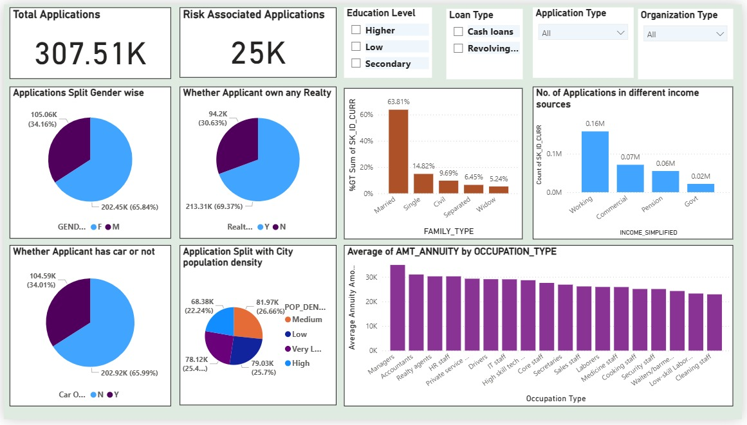

Key Portfolio Volume
- Total Applications: 307.51K unique applications are profiled here.
- Risk Context: Of these, 25K are flagged as risk-associated, keeping the consistent 8% baseline visible for reference.

1. Gender & Asset Ownership
These visualizations highlight the gender imbalance and asset liquidity of the portfolio:
- Gender Split: The portfolio is predominantly female. Female applicants account for 65.84% (202.45K) of the volume, while males account for 34.16% (105.06K).
- Real Estate: A significant majority, 69.37% (213.31K), own their own home or realty, suggesting a base level of asset stability for most applicants.
- Vehicle Ownership: In contrast to housing, car ownership is lower. 65.99% of applicants do not own a car, which may correlate with the high volume of applications from lower-to-middle income segments.

2. Family & Social Structure
- Family Status: Married individuals form the overwhelming majority of applicants, representing 63.81% of the total. Single applicants follow at 14.82%, with Civil Marriage (9.69%), Separated, and Widows making up the remainder.
- Income Source: The "Working" class (blue collar/general workforce) submits the highest volume of applications (~0.16M), followed by "Commercial" associates (~0.07M) and Pensioners (~0.06M).

3. Economic & Geographic Distribution
- City Population Density: The application volume is remarkably balanced across different living environments. High, Medium, Low, and Very Low population density regions each contribute roughly 25% of the total volume, indicating the lender has a consistent market penetration across both urban and rural settings.
- Annuity by Occupation: This bar chart reveals financial capacity by job type. Managers and Accountants carry the highest average annuity amounts (indicating larger loans and higher repayment capacity), while Low-skill Laborers and Cleaning Staff have the lowest average annuities.

4. Risk Drivers & Sensitivity Analysis Dashboard
This dashboard page offers a granular "deep dive" into the current loan application pool. Unlike the high-level Overview, this view is designed for sensitivity analysis, allowing analysts to adjust specific financial levers (like annuity values or job tenure) to see how they impact risk profiles.
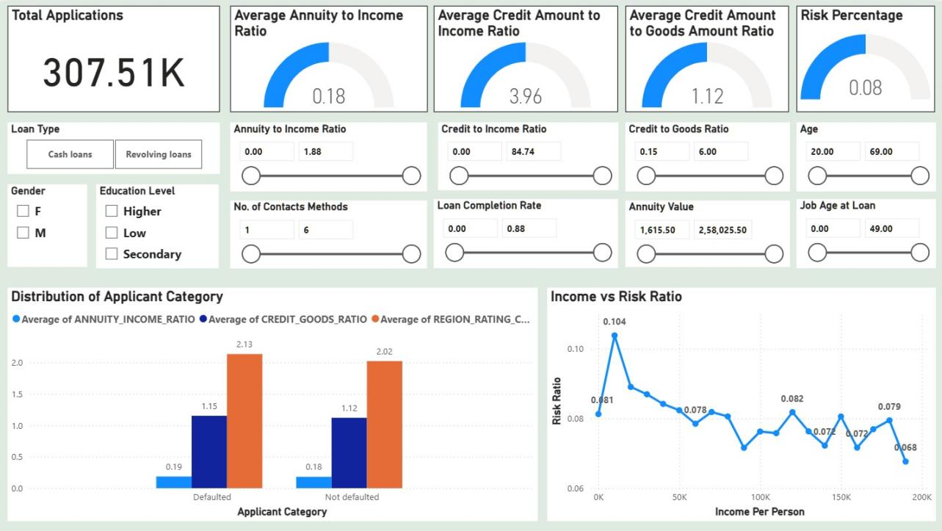

Key Financial Ratios & KPIs
The top section reiterates core portfolio metrics with a specific focus on collateral and affordability ratios:
- Total Applications: 307.51K active files under review.
- Credit to Goods Ratio (1.12): This gauge is unique to this page. A ratio greater than 1.0 suggests that, on average, applicants are borrowing slightly more than the value of the goods they are purchasing (potentially for insurance or fees), which can be a risk signal.
- Affordability Metrics: The Annuity to Income Ratio (0.18) and Credit to Income Ratio (3.96) remain visible to monitor baseline affordability.

Advanced Filtering & Sensitivity Controls
This page features the most extensive set of filters, enabling "What-If" analysis:
- Demographic Segmentation: Checkboxes for Gender (M/F) and Education Level (Higher, Low, Secondary).
- Risk Sliders: Users can filter the entire dashboard by specific continuous ranges, such as:
  - Job Age at Loan: To isolate new employees vs. stable veterans.
  - Loan Completion Rate: To filter based on historical repayment progress.
  - No. of Contacts: To analyze if applicants providing more contact methods are more reliable.

Visual Insights: Risk Drivers
- Distribution of Applicant Category (Defaulter vs. Non-Defaulter)
  - Chart: Grouped bar chart comparing key averages for Defaulted vs Not Defaulted applicants.
  - Insight:
    - Region Rating (Orange Bar): Defaulters have a noticeably higher average Region Rating (2.13) compared to non-defaulters (2.02), suggesting that location/regional economic health is a predictive factor.
    - Credit-to-Goods (Dark Blue Bar): Defaulters also show a slightly higher gap between credit received and goods value (1.15 vs 1.12), indicating they may be financing more "extras" or have less downpayment coverage.
- Income vs. Risk Ratio
  - Chart: Line chart plotting Risk Ratio against Income Per Person.
  - Insight: There is a visible inverse relationship between income and risk.
    - Highest Risk: The risk peaks at 10.4% for the lowest income bracket (near 0–20K).
    - Lowest Risk: As income rises to 200K, the risk drops significantly to 6.8%.
    - Volatility: The curve is not perfectly smooth; there is a notable "bump" in risk around the 150K income mark (8.2%), suggesting that higher income does not always guarantee lower risk—perhaps due to higher leverage in that segment.

Conclusion
This data visualization project has successfully transformed complex loan application datasets into clear, actionable insights through systematic data cleaning, feature engineering, and in-depth exploratory analysis. The project identifies key behavioral and financial indicators linked to loan default—such as external credit scores, repayment burden ratios, age-related stability, previous refusal rates, and historical application patterns. These insights will guide the finance company in improving its credit evaluation model and risk screening process.
The final engineered and risk-enriched dataset provides a robust, clean foundation for the upcoming interactive Power BI dashboard. This dashboard will enable stakeholders to dynamically explore borrower profiles, segment risk across demographic and financial dimensions, monitor default patterns, and simulate the impact of policy changes in real time. By emphasizing visual storytelling and interpretability, the project bridges raw data with practical business decision-making, supporting faster and more informed credit assessments while reducing potential default losses.
Next steps involve building the interactive Power BI dashboard and preparing a final presentation summarizing key insights for stakeholders.
For a detailed view of the code, notebooks, processed datasets, and visualization outputs, the complete project repository is available on GitHub:
https://github.com/21f1001520/technerds.git

Technical Setup Instructions
To set up and run this Data Visualization Project, follow these steps to ensure a smooth execution. This guide assumes you have Python installed on your system (version 3.8 or higher recommended) and access to a Jupyter Notebook environment.

1. Clone the Repository
Clone the project repository from GitHub to your local machine:
git clone https://github.com/21f1001520/technerds.git
cd technerds
This will download the project structure, including folders like build, charts, data, output, src, week_1, week_2, week_3, and files such as LICENSE, pyproject.toml, README.md, and uv.lock.

2. Install Required Libraries
Install all the necessary libraries prior to running the code. These are based on the imports used in the project. Run the following command in your terminal or command prompt:
pip install pandas numpy regex math pathlib seaborn matplotlib plotly scikit-learn scipy
The key libraries include:
- pandas for data manipulation
- numpy for numerical computations
- re for regular expressions (standard library)
- math for mathematical functions (standard library)
- pathlib for file path handling (standard library)
- seaborn and matplotlib for static visualizations
- plotly.express for interactive plots
- sklearn.preprocessing.LabelEncoder for encoding categorical variables
- scipy.stats for statistical tests
- sklearn.model_selection.train_test_split for splitting datasets
- sklearn.ensemble.RandomForestClassifier for modeling
- sklearn.metrics.roc_auc_score for evaluation
- warnings to suppress warnings (standard library)
Additionally, set visualization styles in your code if needed:
import warnings
warnings.filterwarnings('ignore')
sns.set(style="whitegrid")
plt.rcParams['figure.figsize'] = (10, 6)

3. Set Up Directory Structure
Before running the notebook, create the required data directories to store raw, processed, and final datasets. Navigate to the project root and run the following commands (or create them manually):
mkdir data
cd data
mkdir raw_dataset
mkdir final_dataset
mkdir processed
cd processed
mkdir Feature-Engineered
mkdir initially_cleaned_dataset
cd .../..
This will result in the following structure under data/:
- raw_dataset/ (for original datasets like application_data.csv, previous_application.csv, columns_description.csv)
- final_dataset/ (for the assembled final dataset like final_dataset.csv)
- processed/
  - Feature-Engineered/ (for engineered files like application_data.csv and previous_application.csv)
  - initially_cleaned_dataset/ (for initial cleaning outputs)
Place your raw datasets (e.g., application_data.csv, previous_application.csv, columns_description.csv) into data/raw_dataset/ before proceeding.

4. Run the Notebook Step by Step
The main code for data exploration, cleaning, feature engineering, analysis, and visualization is in src/code.ipynb. To run it:
- Launch Jupyter Notebook:
- jupyter notebook
- Or use JupyterLab:
- jupyter lab
- Open src/code.ipynb in your browser.
- Execute the cells step by step:
  - Initial Setup Cells: Import libraries and set configurations (e.g., warnings, visualization styles).
  - Data Loading Cells: Load datasets from data/raw_dataset/ using pandas (e.g., pd.read_csv('data/raw_dataset/application_data.csv')).
  - Data Cleaning Cells: Handle missing values, outliers, and anomalies (e.g., capping income, fixing DAYS_EMPLOYED).
  - Exploratory Data Analysis (EDA) Cells: Generate distributions, boxplots, and insights using seaborn, matplotlib, and plotly (e.g., target distribution, contract type counts).
  - Feature Engineering Cells: Create new features like ratios (INCOME_TO_CREDIT_RATIO), binaries (HAS_CHILDREN), and aggregates; save to data/processed/Feature-Engineered/.
  - Merging and Final Assembly Cells: Merge datasets, impute remaining misses, and export to data/final_dataset/final_dataset.csv.
  - Deep Analysis Cells: Perform univariate, bivariate, multivariate analysis; correlation heatmaps; outlier detection; feature importance with RandomForestClassifier; risk scoring.
  - Visualization Cells: Generate plots and save them to output/ or charts/Analysis/ (e.g., histograms, countplots, default rate by quintiles).
- Run each cell sequentially, checking outputs for errors. The notebook assumes the directory structure is set up as described. If issues arise (e.g., file not found), verify paths and dataset placement.
After running, the processed files, final dataset, and visualizations will be generated in the respective folders. This sets the foundation for the Power BI dashboard.

Contact Us
For questions, collaborations, or further details, please reach out our Team Technerds members:
- Name: Shib Kumar Saraf
- Email: 21f1001520@ds.study.iitm.ac.in
- Name: Suraaj Jain
- Email: 22f3002242@ds.study.iitm.ac.in
- Name: Supreeth Rao
- Email: 21f1002726@ds.study.iitm.ac.in
- Name: Kanishk Kumar
- Email: 22f1000386@ds.study.iitm.ac.in

