Happyland Life in Manila
Happyland is in Tondo, Manila. Families live here under difficult, often extremely difficult, conditions. We want to look more closely and portray the people and their surroundings with respect.
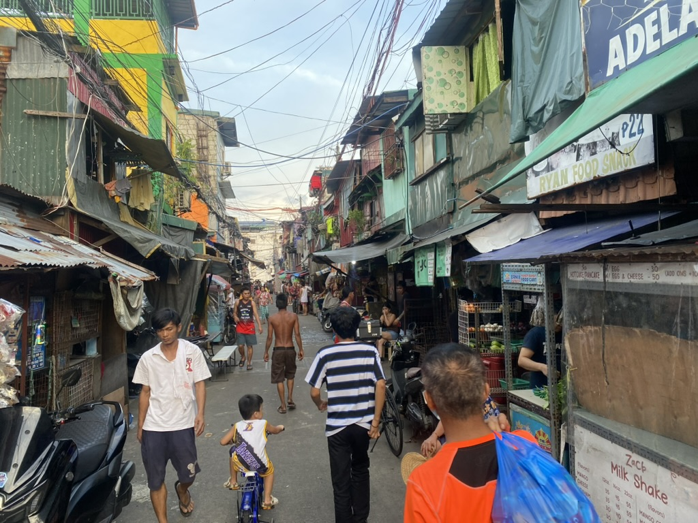
Happyland’s main street, lined with homes and small shops. Photograph by Father Severin.

Daily life waste and recycling
For some families, collecting and sorting recyclable materials provides an income. Waste around their homes also makes daily life harder. At times, the smell can be overwhelming.
One extreme example is the collection of discarded chicken bones with varying amounts of meat still attached. These are cooked again and sold as “pagpag”. I, Father Severin, a moderator, have witnessed this several times myself.
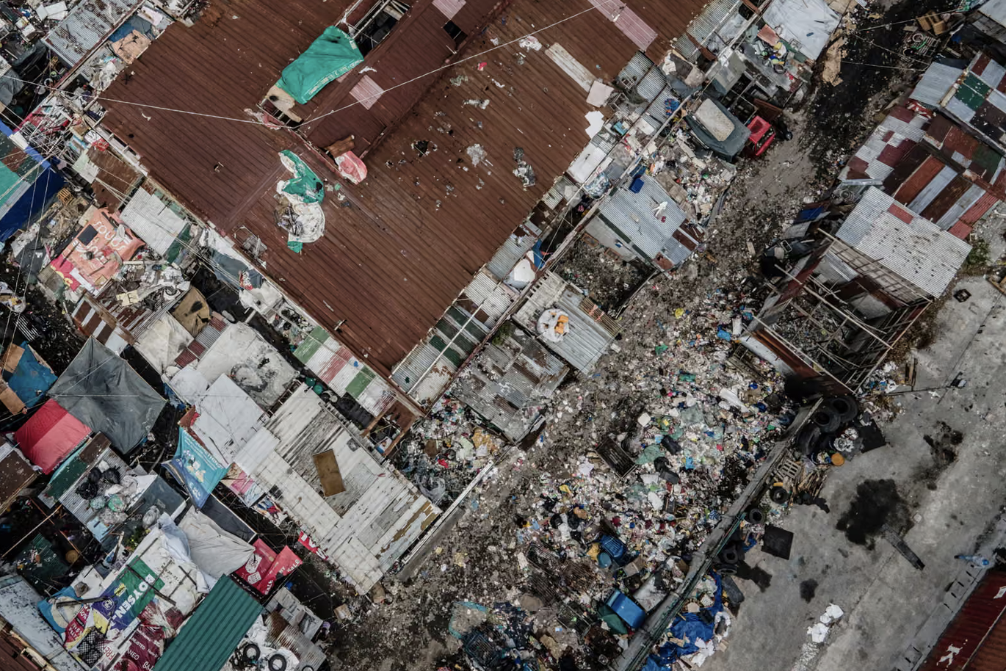
A view from above of closely packed buildings and narrow lanes.

Life in the neighbourhood
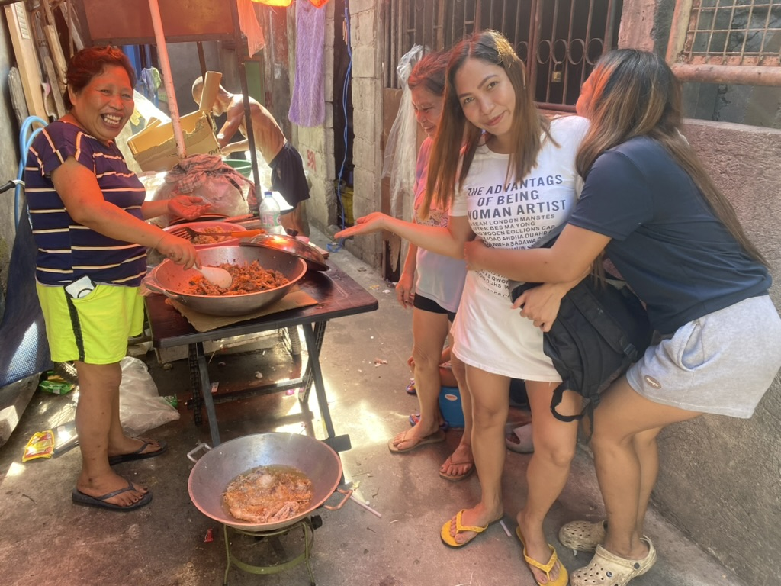
Pagpag
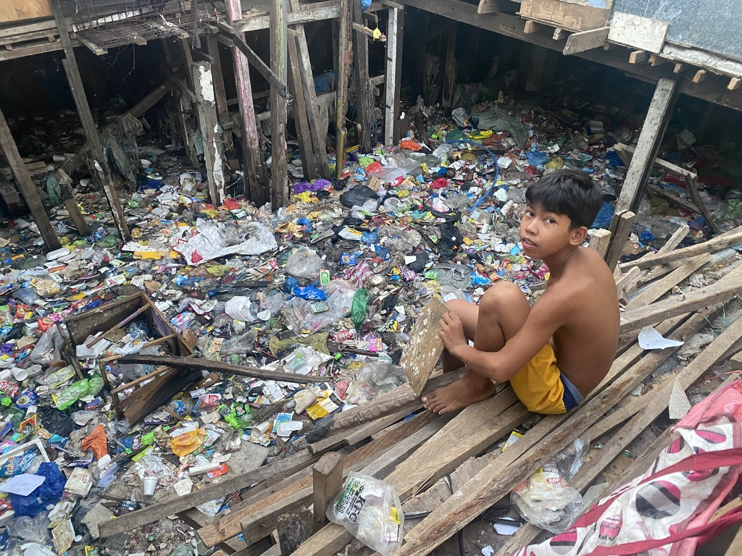
Discarded materials have accumulated beside and beneath the buildings.

People and their homes
The informal settlements of Tondo are among the poorest areas of Manila. The small rooms people live in often serve as a kitchen, bedroom and living space all at once. People often wash in the street, scooping water from a bucket and pouring it over themselves.
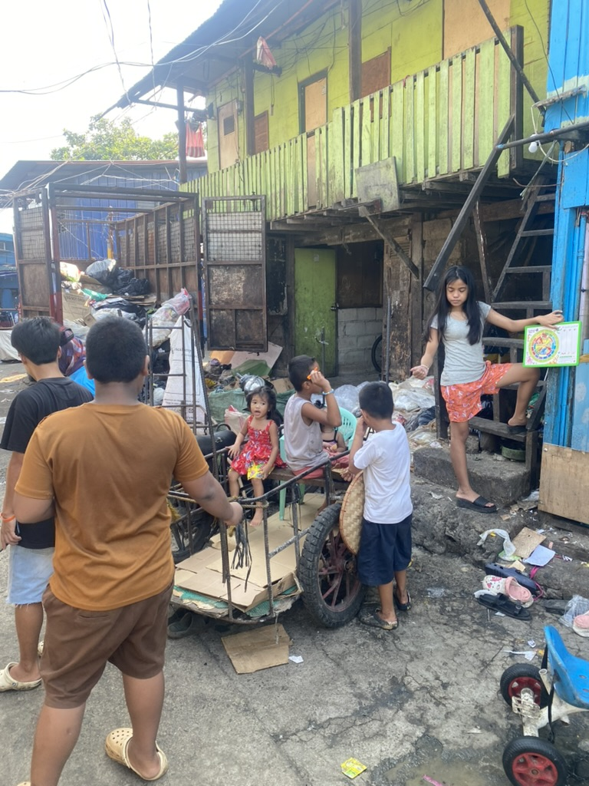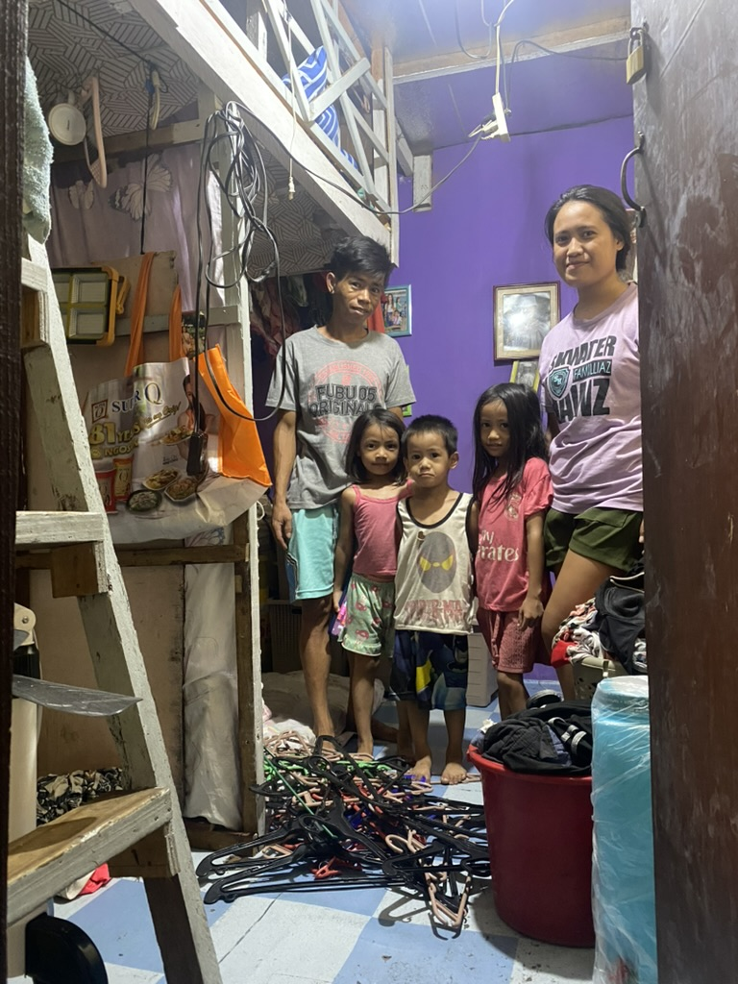
Left: Neighbours gather in a lane between homes. Right: An adult and children stand in the entrance to a compact home.

Shared spaces and narrow lanes
The paths are often in very poor condition and very dirty.
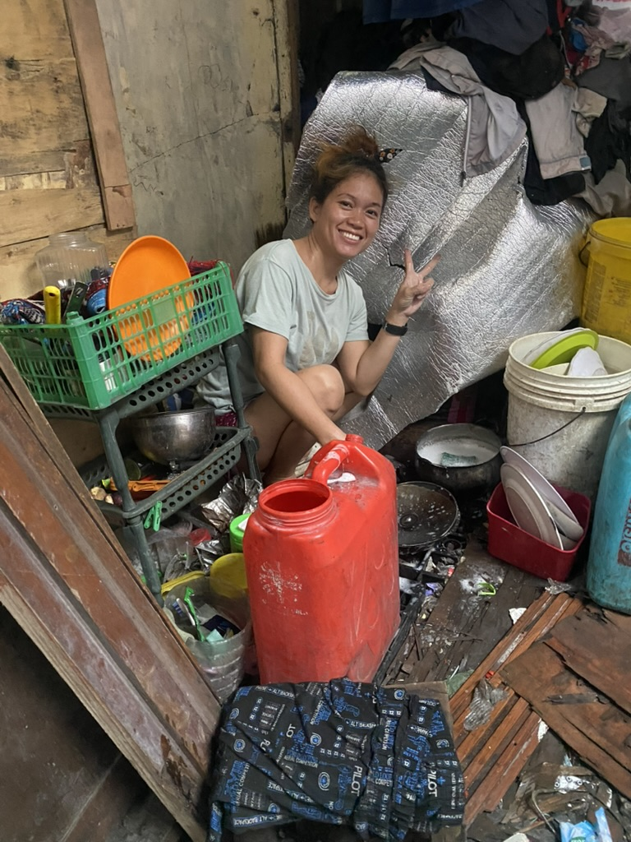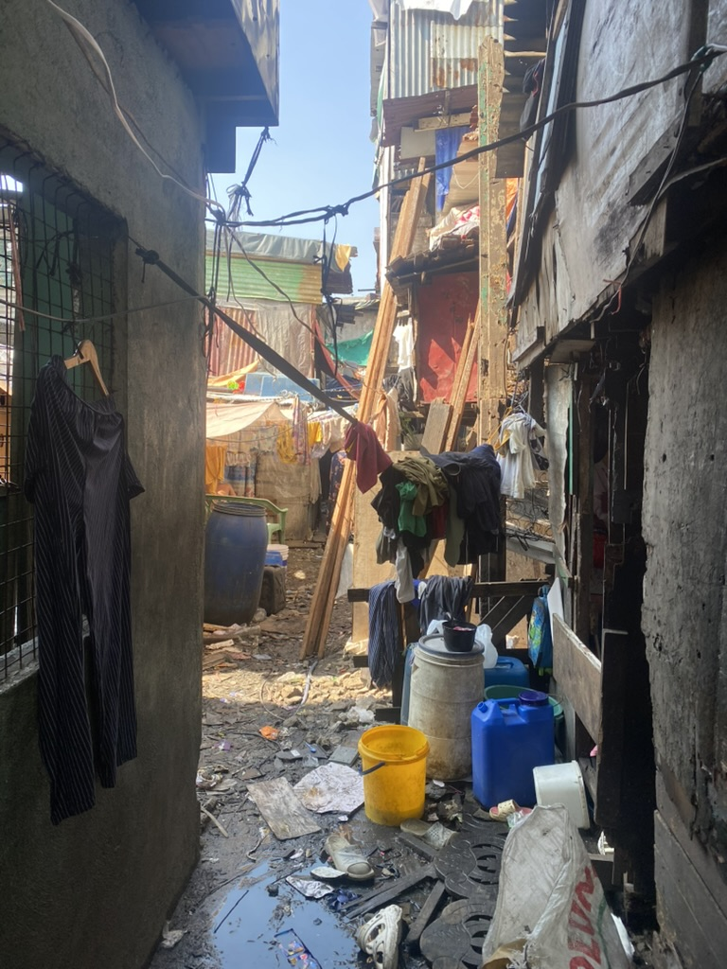
Left: Cooking utensils, water containers and household supplies share a small space. Right: A narrow passage between homes, with uneven ground and scattered waste.

Editorial fields for completion

21.gifts on the ground
This section remains hidden on the website until the local collaboration has been verified and the text approved.
Local partner or contact: [To be completed]
Role of 21.gifts: [To be completed]
Approved text: [To be completed]
Optional photo 3: [To be completed]
Caption: [To be completed]
Alternative text: [To be completed]

What donations make possible
This section remains hidden until the specific use of donations has been documented and approved.
Specific use: [To be completed]
Supporting evidence or contact person: [To be completed]
Approved text: [To be completed]
Optional photo 4: [To be completed]
Caption: [To be completed]
Alternative text: [To be completed]

Approval
Name and date: [To be completed]
Notes on image rights and consent: [To be completed]

