**7. Demonstrate ZeroR technique on Iris dataset (by using necessary pre-processing technique(s)) and share your observations.**

**ZeroR Algorithm:**

* ZeroR is the simplest classification method which relies on the target and ignores all predictors.
* ZeroR classifier simply predicts the majority category (class).
* Although there is no predictability power in ZeroR, it is useful for determining a baseline performance as a benchmark for other classification methods.
* ZeroR is only useful for determining a baseline performance for other classification methods.

**Steps:**

1. Open your WEKA Explorer and click on explorer.



1. In explorer, go to preprocess and then click on open file and load the iris dataset into WEKA which is present in C:/programfiles/WEKA 3.8.6/data/iris.

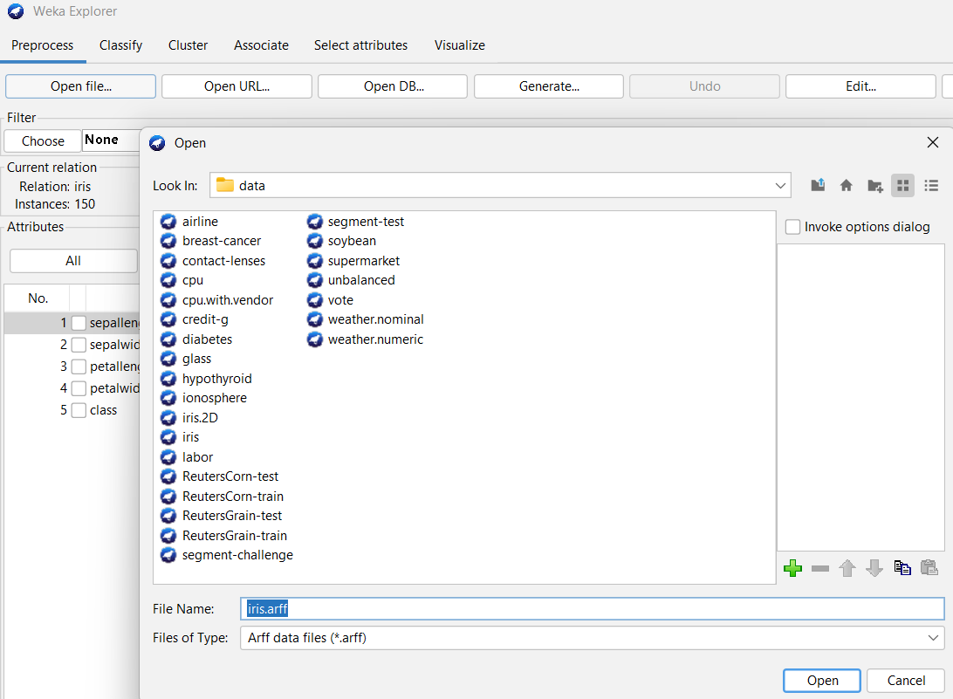

1. And then go to classify. As ZeroR algorithm is the default algorithm, Set the dataset as a training dataset.

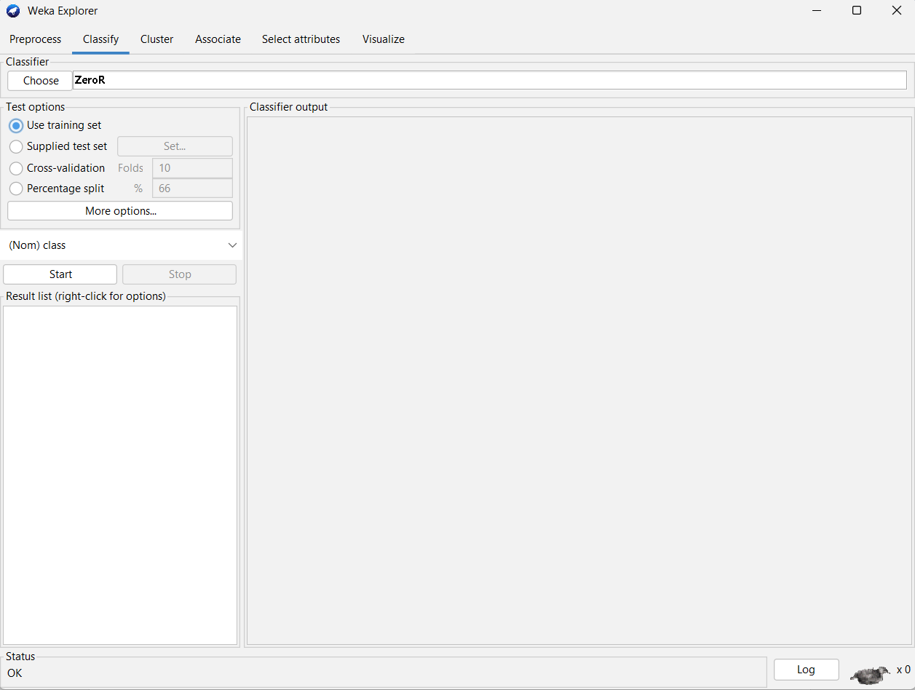

4) Click on start and view the results.

