**Installation of XAMPP**

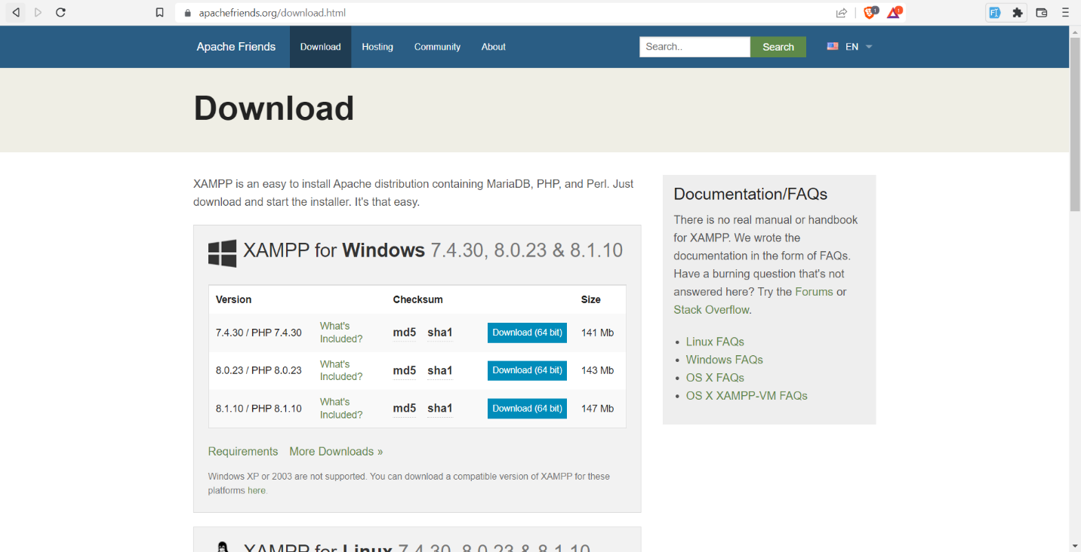Go to <https://www.apachefriends.org/download.html> and choose the version with the latest PHP version. After the installation of XAMPP, open and start the APACHE and MySQL.

**Create your Database**

Open your preferred browser and type **localhost/phpMyAdmin** and click **New**.

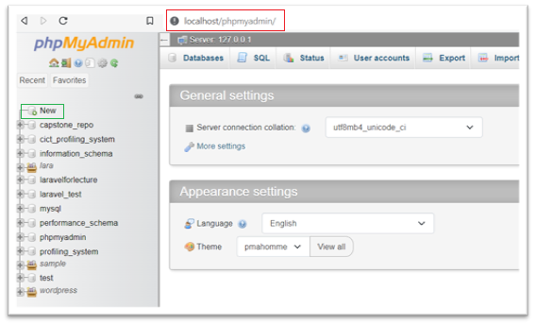

Enter your database name and click **CREATE**. Your project’s name is usually the name of your datatabase.

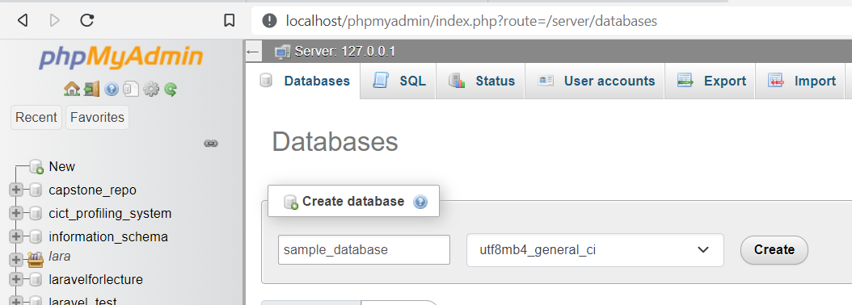

Input your table name. In this example, the table name is **users**. Keep in mind that table name must be in plural form. The number of columns depends on the data that you are going to save.

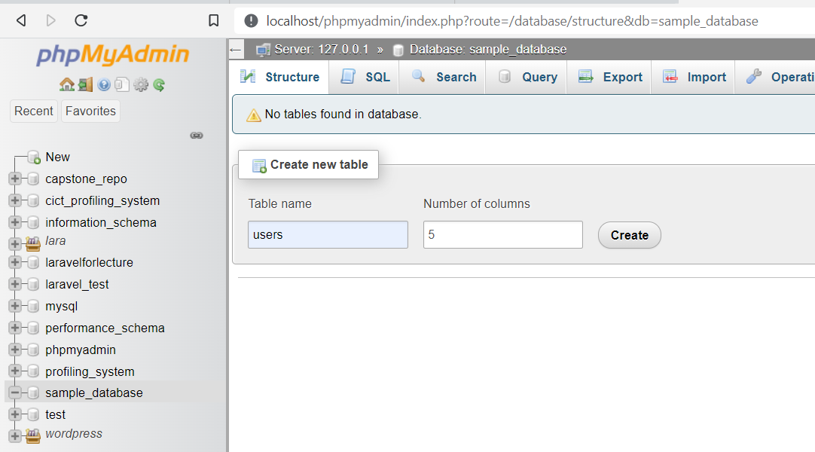

Input the data that you want to save, every table must have a primary key **id** that must be auto incremented (A_I). You can always add other column if your previous inputted number of columns lacks. After you’re done setting up your table, scroll down and hit the **SAVE** button.

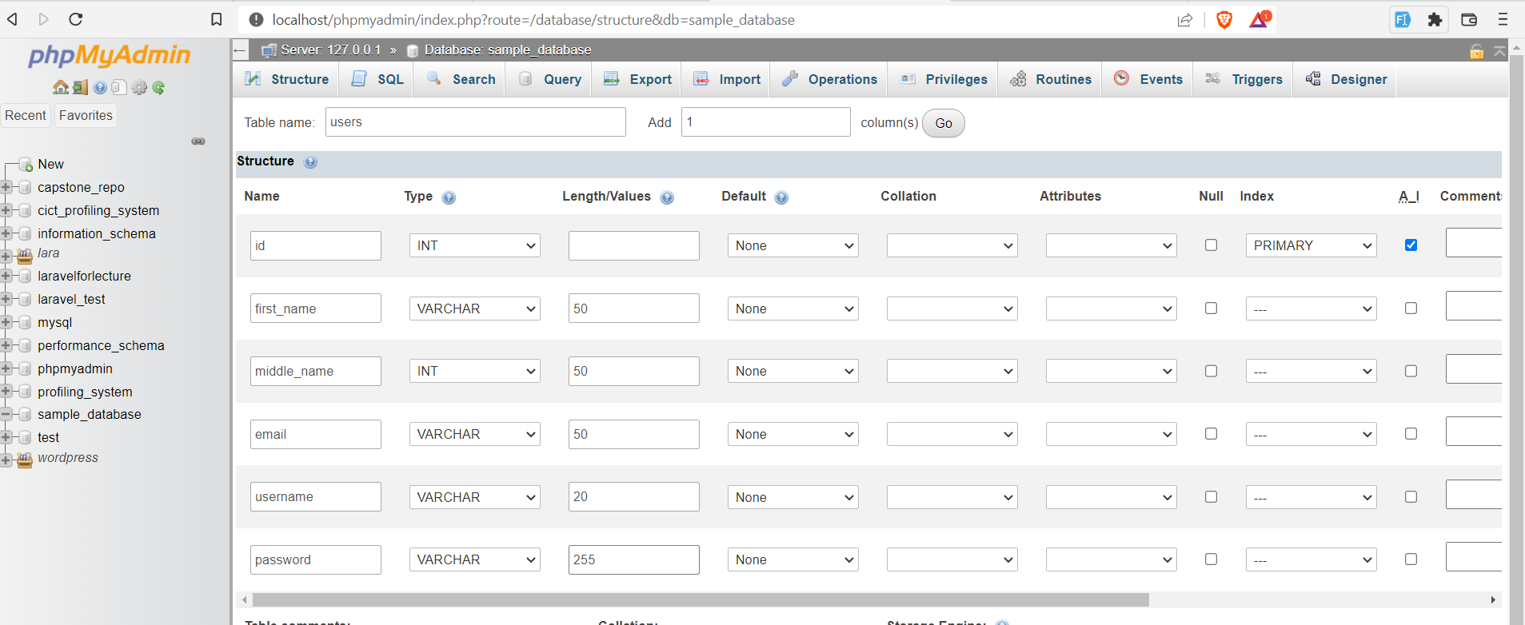

You must have an overview of your fields inside the table after saving.

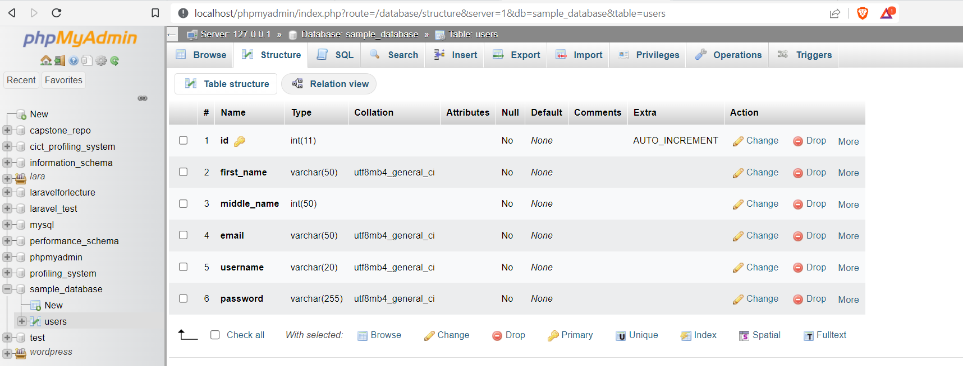

**Setting up your projects file**

In your windows explorer. Go to **C:\xampp\htdocs**. Inside the htdocs folder, create a folder. If you already have a project, your can copy it inside of your created folder. In this example, I will use **ajax-demo**.

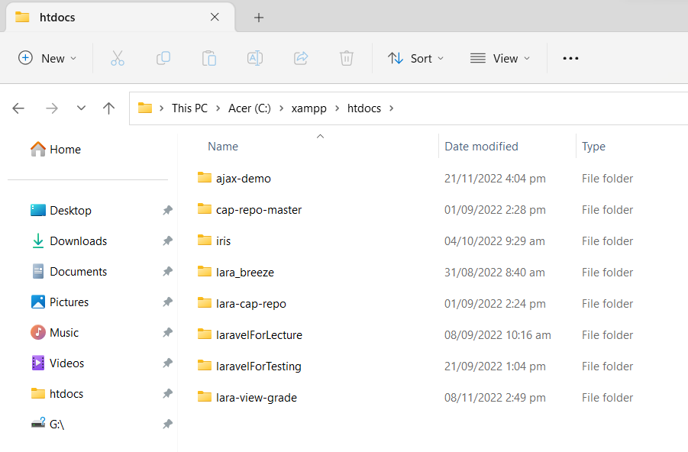

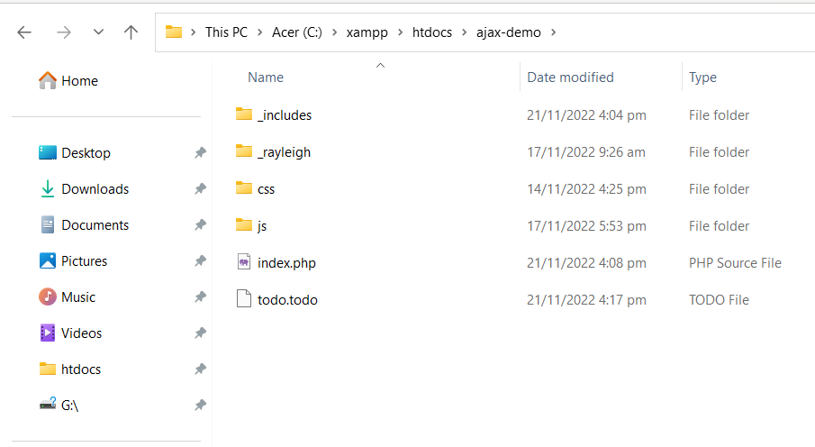Inside of your created folder. Create a folder and name it as _includes, css, js, and 1 folder for your database connection file. In this example, I used _rayleigh folder.

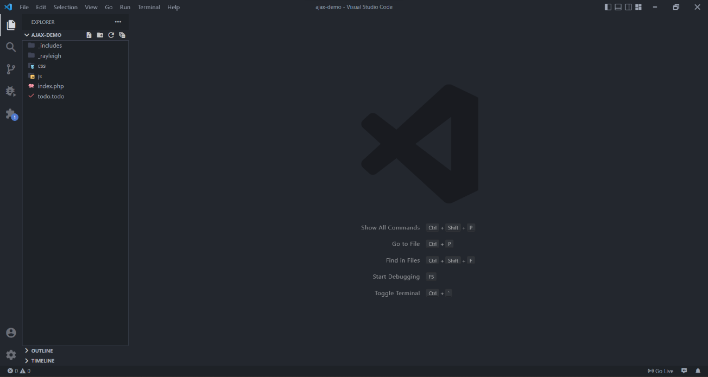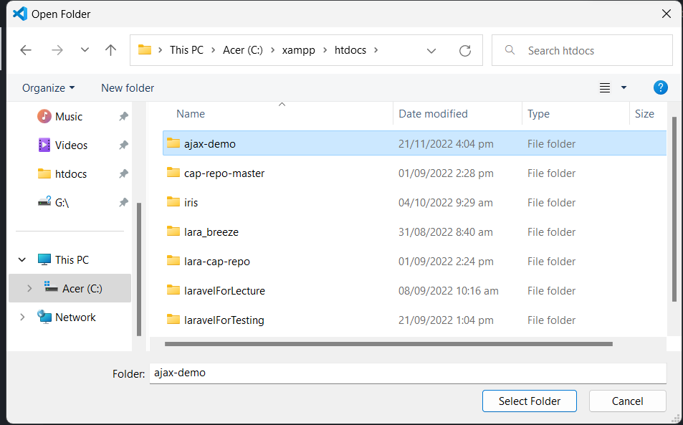Now, open your VS Code and locate our projects folder. **Click File > Open Folder** and go to **C:\xampp\htdocs** then select your project.

Inside of your database folder create a php file that will handle the connection of our project. In this example, my database folder is **_rayleigh** and my database connection php file is **rayleigh.php**

Inside of your connection file (**rayleigh.php**), copy the code below. Make sure to change the $database into your database name. In this example I will use the profiling_system database.

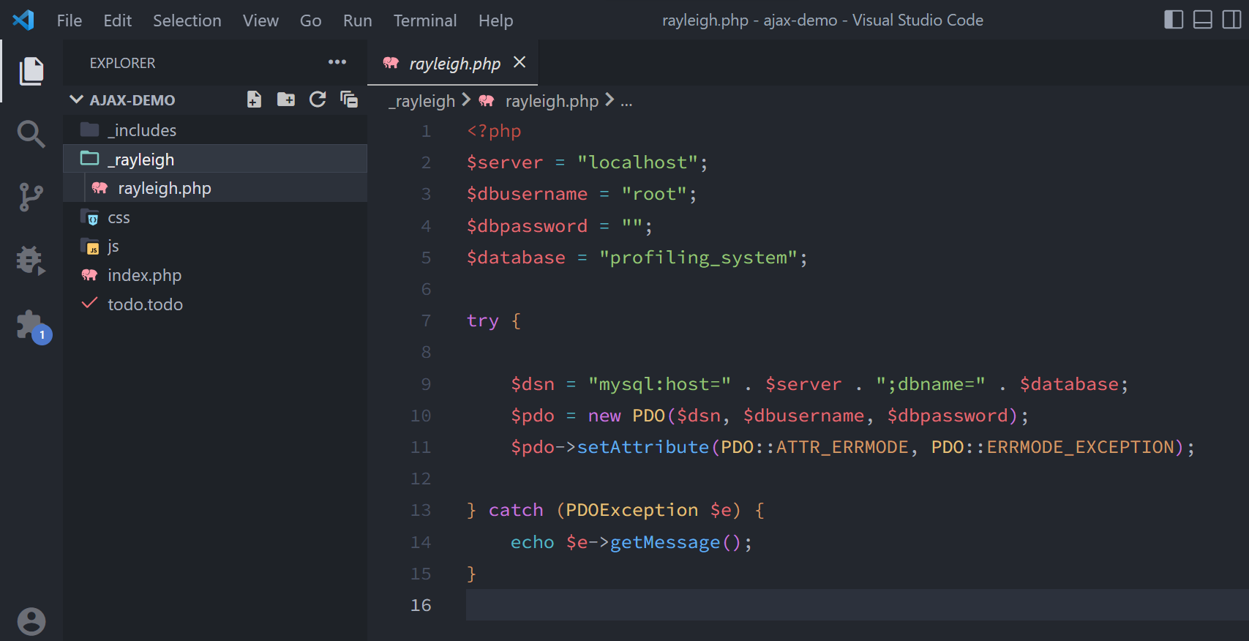

Now, inside of your _includes folder, create a php file that will handle the AJAX process. I will name my php file as the process.inc.php

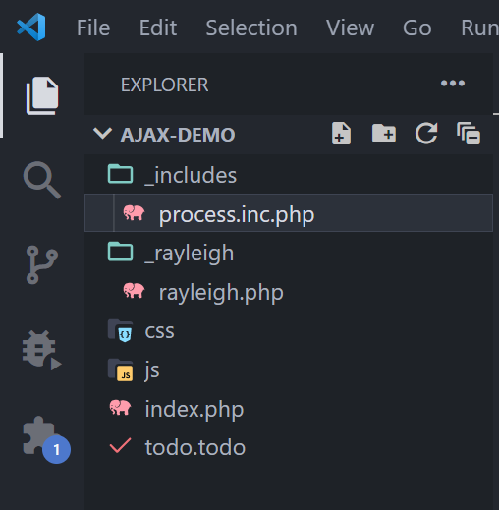

Now let us set up our view(UI). Depends on you, you can have your own design. In this example, I will use the index.php file as my view. Don’t forget to put IDs in your input fields and be sure to have the jquery connected in your page.

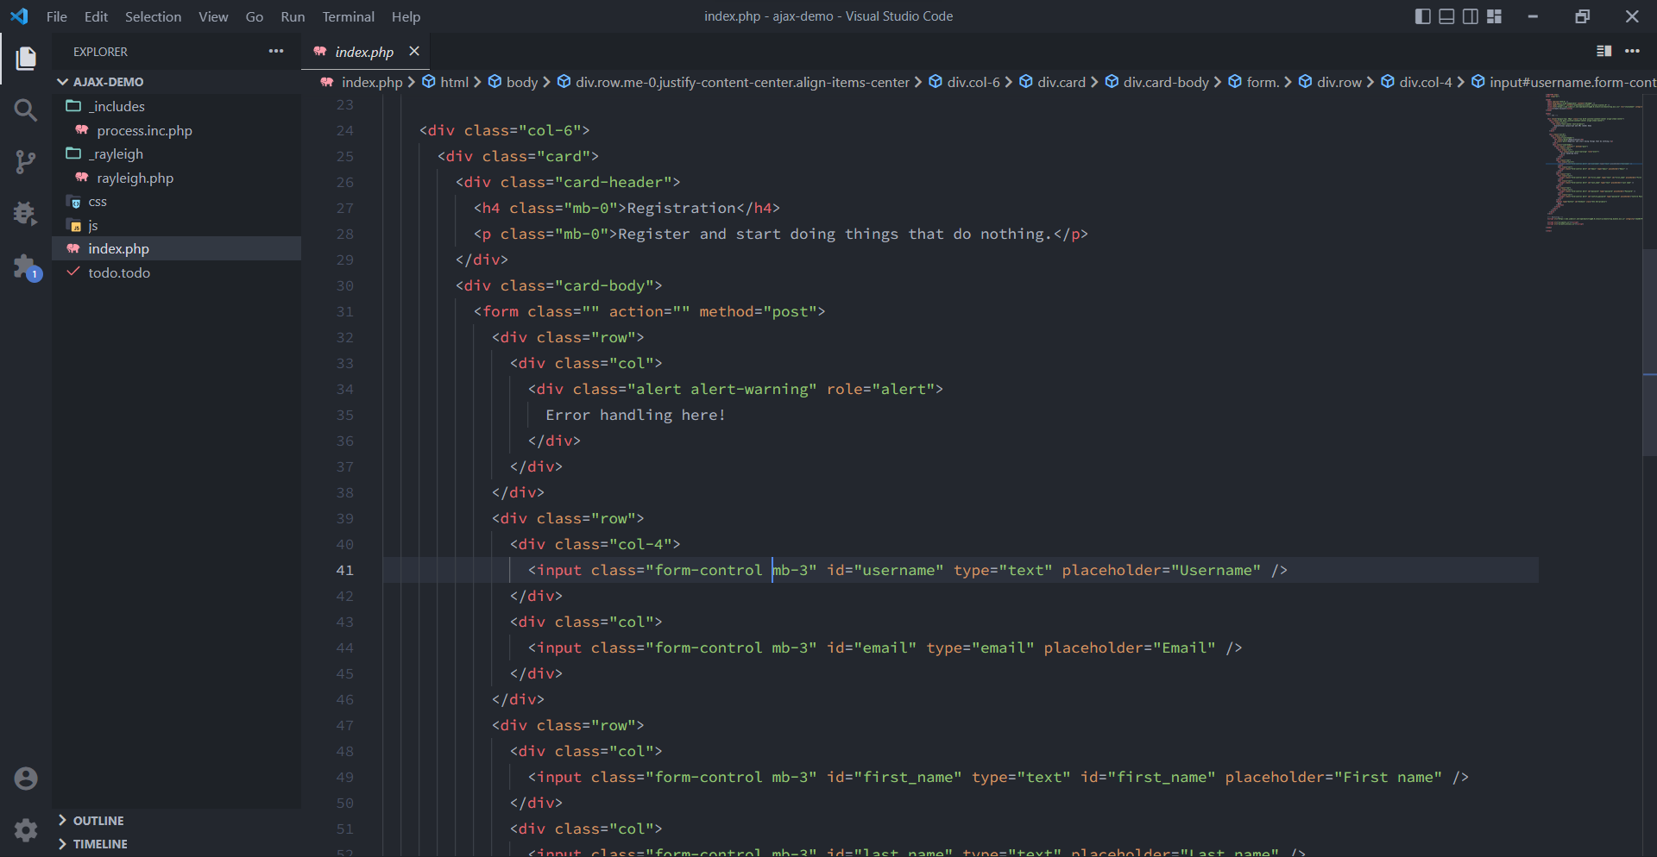

Inside your js folder, create a js file that will handle our JS scripts. Make sure to connect this file in your view(UI) under the jquery library. In this example, I will use **auth.process.js**

