CS Pulse — Technical Deep Dive
Tech-lead onboarding · implementation internals
Doc #3 of three. Where User Perspective (#1) shows what customers see and Vision/Architecture (#2) shows what the system promises, THIS doc shows how the code actually delivers it. File paths + line numbers throughout — open the editor alongside this doc and trace as you read.
Audience: tech lead who has read docs #1 and #2 and now wants to ramp on the codebase. By the end you should be able to (a) trace a Wizard D calibration end-to-end, (b) explain the GLMM math to an AI-DD reviewer, (c) modify a context-graph invariant without breaking the audit, (d) add a new MCP tool with proper auth + cost tracking, and (e) write a verify_*.py script for a new persona-facing surface.
All references match the deployed image as of late May 2026 (main HEAD eaec74db8).

1. The Stack — One-Page Map
Component | Implementation
Backend HTTP API | Flask (Python 3.11), entry point app_v3_minimal.py. ~9 blueprints registered: executive_dashboard_api, outcome_roi_api, ask_ai_endpoint, predictor_api, customer_playbook_api, signal_engine ingest_api, admin_api, integration_api, action_interface_api, plus RAG variants.
Database | PostgreSQL (cs_pulse). All ORM models in kpi-dashboard/backend/models.py. Migrations via Alembic; auto-run at container bootstrap.
Frontend | React 18 + TypeScript + Tailwind. Entry point src/App.tsx → CSPlatform.tsx mounts persona dashboards by route.
Vector store | Qdrant (signal semantic search). Optional — falls back to keyword matching if QDRANT_URL not set.
MCP server | FastMCP-style decorators (@mcp.tool) across kpi-dashboard/backend/mcp_server/cs_pulse_*.py. ~52 tools. JSON-RPC streamable-HTTP over /mcp endpoint.
LLM provider | Anthropic Claude (primary). OpenAI selectable per tenant via llm_provider config. Cost tracked in LLMUsageLog table via record_usage() — every call site must invoke.
Container | Docker. Image cspulse-platform built on amd64. docker-compose.cspulse.yml for local stack. Hot-reload on React only; Flask requires restart.
Deploy | EC2 single-instance today. Two deploy scripts: deploy-ec2-git-pull.sh (primary, ~5–10 min, always matches main HEAD) and rehydrate-ec2-ecr.sh (~1–2 min, ECR tag based, honors PLATFORM_TAG).

1.1 Request lifecycle (one API call end-to-end)
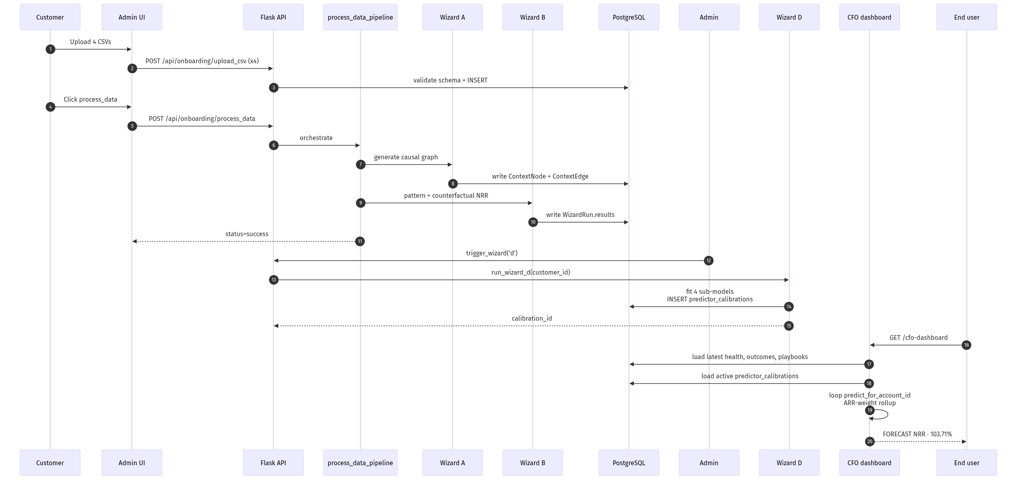
Figure 1 — End-to-end request lifecycle. Top: customer upload of 4 CSVs → process_data → Wizard A/B fire automatically. Middle: admin runs trigger_wizard('d') to fit the per-tenant GLMM. Bottom: end user hits the CFO dashboard, handler ARR-weights per-account predictor v3 forecasts into the FORECAST NRR tile.
Walking the lifecycle in detail. For an Ask AI call from Claude.ai resolving to get_account_nrr_forecast:
- Claude.ai sends JSON-RPC POST to https://d2oqfugrb2ltg9.cloudfront.net/mcp?api_key=csp_server_... (Bearer header also works).
- CloudFront → EC2 origin (3.94.106.197) → cspulse-platform Docker container :80.
- Nginx (in-container) routes /mcp → Flask /mcp endpoint.
- MCP server validates the Bearer token via validate_server_key() against MCP_SERVER_API_KEY env var. EMPTY env = 'Invalid or revoked API key' regardless of token (§3.10 footgun).
- Tool resolver in mcp_server/cs_pulse_predictor.py routes the call to get_account_nrr_forecast(customer_id, account_id, horizon).
- Tool body calls predictor.inference.predict_for_account_id() which loads the active PredictorCalibration rows (4 sub-models per customer × vertical × profile) and runs inference.
- LLMUsageLog row written via record_usage() if any LLM call happened inside (none for this pure-inference tool).
- JSON-RPC response back through CloudFront to Claude.ai.

2. The Four Wizards
Wizards are the predictive-AI backbone. A through D, each owning a distinct concern. The biggest tech-lead mistake is treating them as a uniform 'AI pipeline' — they're four DIFFERENT models with different runtime contracts.

2.1 Wizard A — Causal-graph generation
- Purpose: build the per-account causal graph (ContextNode + ContextEdge) from raw uploaded signals + KPI deltas.
- Entry point: wizards/wizard_a_*.py invoked by process_data_pipeline.py.
- Runtime: auto-fires as part of process_data. Customer doesn't trigger explicitly.
- Output: ContextEdges with edge_type (CAUSED_BY / INDICATES / LED_TO / etc.), polarity, weight, revenue_impact. The 'natural arc' classification (crisis_recovery, champion_loss, etc.) lives on Account.arc_type, also written by Wizard A.
- Validation: 11 graph invariants (per session memory context_graph_invariants.md), 3 layers — prod WARN, pytest CI, audit CLI. Polarity invariants are the most-watched: a positive signal can't cause a negative-revenue-impact OUTCOME.

2.2 Wizard B — Pattern + counterfactual analysis
- Purpose: pattern-match historical journeys against canonical arcs (silent_churn, expansion_champion, etc.). Compute counterfactual NRR — 'what would NRR have been if CS Pulse had been running through this period?'
- Entry point: wizards/wizard_b_pattern_db.py → run_wizard_b(customer_id). Wraps verticals/_template/journey/wizard_b/wizard_b_pattern_analyzer.py.
- Runtime: auto-fires as part of process_data.
- Output (stored in portfolio_nrr_forecast field): without_cs_pulse_nrr_pct, with_cs_pulse_nrr_pct, with_interventions_nrr_pct, cs_pulse_delta_pct, cs_pulse_arr_protected, cs_pulse_accounts_saved, T+30/60/90 trajectory.
- CRITICAL FOR DEMOS: Wizard B's NRR figures are FORWARD-projected, NOT historical (despite the panel header 'PAST — Three Lenses' implying past-looking). The 88.49 / 109.26 / 88.09 numbers are forward simulations using arc-pattern signature × ARR-weighted projection. Lens A (90.21% historical) uses gross outcome math on uploaded events — DIFFERENT denominator AND different time direction. Don't try to reconcile by subtraction; the panel disambiguates inline (PR #43 + PR #44 fix).
- Architecture decision (legitimate but confusing): Wizard B's 88.09% 'natural-arc baseline' is from a cross-customer pattern set, NOT this tenant's actual history. By design — counterfactual modeling needs an out-of-sample baseline. The 0.4pp lift (with-CS minus without-CS in Wizard B's world) is the legitimate attributable lift.

2.3 Wizard C — KPI weight calibration
- Purpose: per-customer KPI weights are dynamic, not hardcoded. Wizard C correlates historical KPI values against HealthScore-derived success/fail labels, then re-derives kpi_weights_L1 and pillar_weights_L2.
- Entry point: wizards/wizard_c_weight_calibrator_db.py.
- Runtime: NOT auto-fired by process_data. Explicit-only via trigger_wizard('c') MCP tool OR admin endpoint. Policy rationale (per policy_wizard_c_decoupled_from_process_data.md): correlation needs stable signal, weight churn breaks WeightCalibrationHistory audit trail. Right cadence is outcome-count threshold (≥10 new closed outcomes) OR monthly cron — NOT per-process_data.
- Important caveat: the ≥10-outcomes auto-trigger is POLICY-STATED but NOT CODE-ENFORCED today. Treat as admin-trigger-only until base dev confirms the threshold is wired. Documented in FDE Playbook §7.3.
- Output: writes to CustomerConfig.dc2s_pillar_weights (L2) and dc2s_kpi_weights (L1). Audit trail in WeightCalibrationHistory.
- Roadmap (Tier 2): a second 'edge-aware' weight column that consumes count_trustworthy_causal_edges() — surfacing context graph quality into the calibration. Triggers: ≥3 customers with ≥30 LLM-enriched edges + AI-DD probe. See backlog_wizard_c_edge_aware_weights.md.

2.4 Wizard D — Predictor recalibration (the GLMM)
Wizard D is the most consequential model in CS Pulse — it powers the forward NRR forecast that anchors the CFO + CRO demos. Worth understanding deeply.
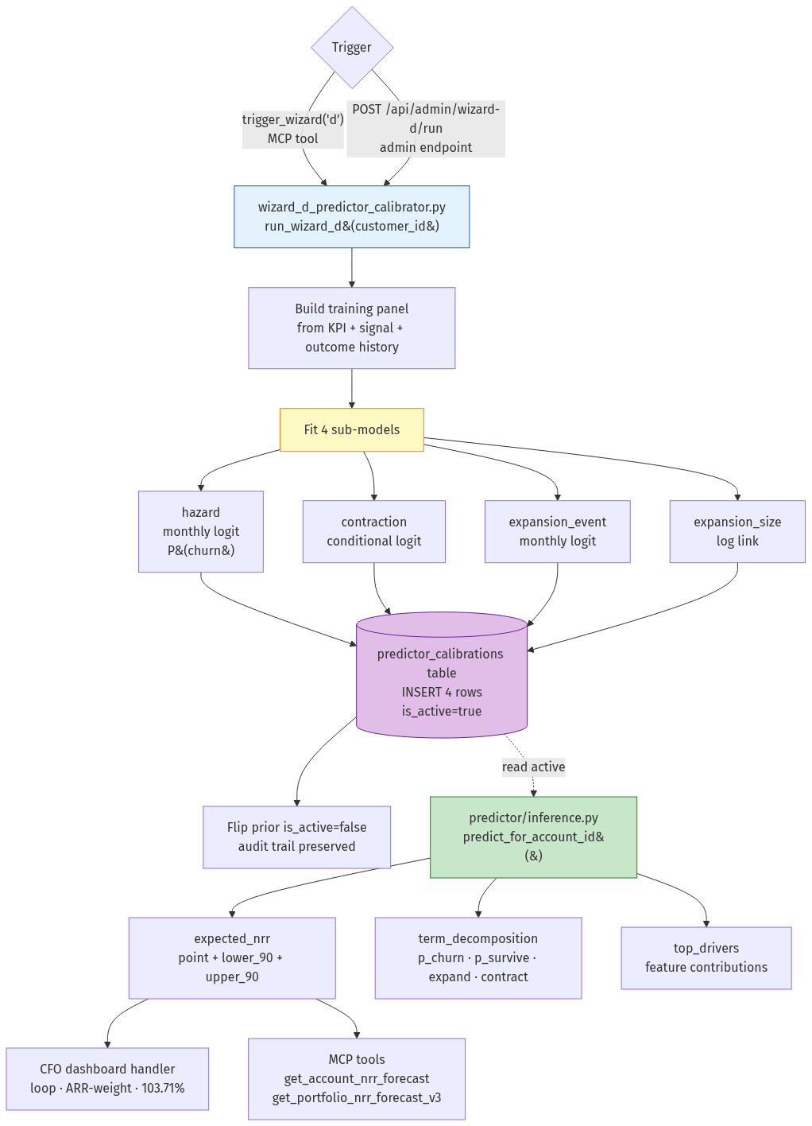
Figure 2 — Wizard D calibration + inference flow. Top: trigger (MCP or admin endpoint) → run_wizard_d builds training panel → fits 4 sub-models (hazard, contraction, expansion_event, expansion_size). Middle: INSERTs to predictor_calibrations, flips prior is_active=false (audit trail). Bottom: predictor/inference.py reads active rows at request time; output surfaces on CFO rollup (103.71% ARR-weighted for cust 334) and MCP tools.

Entry point + storage
- Entry: wizards/wizard_d_predictor_calibrator.py → run_wizard_d(customer_id). Admin trigger: POST /api/admin/wizard-d/run (admin_api.py:1057). MCP trigger: trigger_wizard('d').
- Output stored in DB table predictor_calibrations (models.py:1862 — PredictorCalibration class).
- Schema: calibration_id (unique) + customer_id (nullable) + vertical + saas_profile + sub_model + fit_type + coefficients (JSON) + prior_used (JSON) + metrics (JSON) + panel_summary (JSON) + is_active + fit_completed_at.
- One row per (customer × vertical × profile × sub_model) at any active moment. Wizard D never UPDATEs; INSERTs new + flips prior is_active to False (audit trail preserved).
- 4 sub-models per tenant (A6 architecture decision):
  - hazard — monthly logit, P(account churns in this month)
  - contraction — conditional logit, P(contraction event | account survives)
  - expansion_event — monthly logit, P(any expansion event)
  - expansion_size — log link, E[size | expansion event occurred]
- fit_type: cdi_seed (cross-customer prior, cold start) → tenant_glmm (frequentist hierarchical, default Phase 1) → tenant_bayes (Bayesian hierarchical, Phase 2, gated on data + hire).

The GLMM (Generalized Linear Mixed Model)
Why GLMM and not plain regression? Because the NRR outcomes aren't normally distributed. Churn is binary (0/1), expansion size is continuous-but-skewed. A plain linear regression doesn't respect those bounds; GLM's link functions (logit, log) map them onto a well-behaved linear scale.
Why 'mixed'? Because the model needs BOTH fixed effects (parameters that apply across all tenants — e.g. 'high health-score lowers churn probability') AND random effects (per-tenant intercepts that capture this customer's specific baseline). The 'mixed' part is what lets cross-customer patterns and tenant-specific idiosyncrasies coexist in one model without overfitting.
Why not deep learning? GLMM coefficients are INTERPRETABLE. When a CFO asks 'why is account X forecasted at 107%?', Wizard D names the features (health, expansion signals, signal count, ARR bucket) and how much each contributed. A neural net can't do that natively. For auditor-defensibility, interpretability matters more than marginal accuracy.

Inference path
- predictor/inference.py — predict_for_account_id(customer_id, account_id, horizon). Loads active PredictorCalibration rows for (customer × vertical × profile × *). Runs the 4 sub-models per account.
- Returns expected_nrr.{point, lower_90, upper_90} + term_decomposition (p_churn, p_survive, e_contract, e_expand) + top_drivers (feature contributions) + expansion_outlook (P(event), expected_size, ARR_lift) + calibration_id (provenance).
- Portfolio rollup: NO standalone HTTP route. Happens inline in executive_dashboard_api.py:1353–1395 (cfo_dashboard handler loops predict_for_account_id over every account, ARR-weights, returns as predictor_v3_portfolio_nrr block).

Per-account HTTP route + MCP tools
- HTTP: GET /api/predictor/account/<int:account_id>/nrr-forecast (predictor_api.py:71).
- MCP get_account_nrr_forecast(customer_id, account_id, horizon) — cs_pulse_predictor.py:48
- MCP get_portfolio_nrr_forecast_v3(customer_id, horizon) — line 126
- MCP get_top_expansion_opportunities_v3(customer_id, horizon, limit) — line 278
- MCP get_top_at_risk_accounts_v3(customer_id, horizon, limit) — line 355

Live data sample (cust 334 today)
arr_weighted_nrr_pct: 103.71
simple_avg_nrr_pct: 88.78
active_account_count: 25
calibration_id: wizard_d_7824d7c1f4c8__saas_enterprise__expansion_size
calibrated_at: 2026-05-12T18:01:31

Confidence intervals — what they mean + what's pending
Each account returns expected_nrr.lower_90 and upper_90. The 90% CI is a frequentist interval — formally 'if we re-ran the calibration many times, the true NRR would fall inside this range in ~90% of those runs.' For the demo audience, use the colloquial: 'in 9 out of 10 cases the realized NRR lands inside this band.'
What's still placeholder (Phase 1 task #4 pending): the CI WIDTH today is a placeholder, not from a fully calibrated bootstrap. Tagged via ci_method: placeholder_uncalibrated on every v3 response. The point estimate IS calibrated; only the bounds aren't yet. AI-DD reviewers WILL catch this — the honest answer is 'point uses the calibrated GLMM; width is conservative until bootstrap CIs land.' CRO-3 / CRO-4 / CRO-8 / CFO-10 stay partial-credit until Phase 1 task #4 ships.

3. Context Graph (the causal layer)
Every revenue-relevant fact in CS Pulse — a signal arriving, a decision made, an outcome realized — lands in the context graph. Two tables, ContextNode and ContextEdge, with eleven invariants enforced in CI.

3.1 Schema
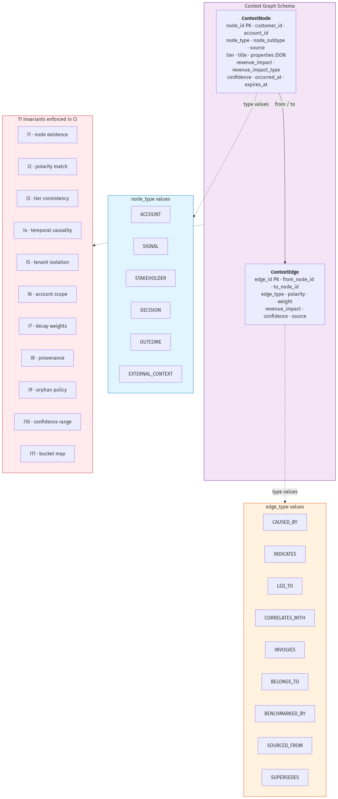
Figure 3 — Context Graph schema. Two tables (ContextNode + ContextEdge) with 6 node_type values and 9 edge_type values, validated by 11 CI-enforced invariants. Polarity invariants (I2) are the most-watched — a positive signal cannot cause a negative-revenue OUTCOME.

ContextNode (models.py:719)
- node_id (PK), customer_id, account_id — tenant + account isolation
- node_type — ACCOUNT / SIGNAL / STAKEHOLDER / DECISION / OUTCOME / EXTERNAL_CONTEXT
- node_subtype — finer-grained (e.g. SIGNAL.nps_decline, DECISION.playbook, OUTCOME.churn_lost)
- source — 'customer' (CSV upload) or 'system' (Wizard A / signal_analyst / urgent_scanner)
- tier — 1 (permanent) / 2 (decaying with TTL) / 3 (ephemeral)
- title, properties (JSON), revenue_impact (Numeric 15,2), revenue_impact_type (at_risk / protected / expansion / lost), confidence (0–1)
- source_platform (sfdc / hubspot / intercom / csv_import), source_event_id (dedup key)
- occurred_at, expires_at (NULL for tier 1), weight_decay

ContextEdge (models.py:798)
- edge_id (PK), from_node_id + to_node_id (CASCADE delete)
- edge_type — CAUSED_BY / INDICATES / LED_TO / CORRELATES_WITH / INVOLVES / BELONGS_TO / BENCHMARKED_BY / SOURCED_FROM / SUPERSEDES
- polarity, weight, revenue_impact, confidence
- source — 'customer' / 'wizard_a' / 'wizard_b_pattern' / 'llm_enrichment' / 'signal_analyst'

3.2 The eleven invariants
Per context_graph_invariants.md. Validators run in three places: prod WARN (logs but doesn't block), pytest CI (blocks merges), audit CLI (one-shot baseline diff). Any new invariant must ship with paired clean+dirty tests — meta-test enforces this.
- I1 — node existence: edges reference nodes that exist
- I2 — polarity match: edge polarity matches node revenue_impact_type
- I3 — tier consistency: tier-1 nodes can't have edges from tier-3 nodes
- I4 — temporal causality: CAUSED_BY edges require from_node.occurred_at < to_node.occurred_at
- I5 — tenant isolation: nodes + edges share customer_id
- I6 — account scope: account_id matches across connected nodes for account-scoped subgraphs
- I7 — decay weights: weight_decay ∈ [0, 1]
- I8 — provenance: every system-source node has a non-null source_event_id
- I9 — orphan policy: tier-1 nodes can't be orphaned (no incoming or outgoing edges)
- I10 — confidence range: confidence ∈ [0, 1] on edges + nodes
- I11 — bucket map: revenue_impact_type subtype matches polarity classification
Baseline on cust 384/385: ~280 violations each. I11 dominates but is trivially fixable; I1/I8/I10 are audit-indefensible (high-priority cleanup); I2 reveals template edge generators producing polarity-mismatched edges (systemic, not per-tenant). Tech lead heuristic: NEW invariant should NEVER ship without a paired migration that clears the existing baseline OR an explicit grandfather entry.

3.3 Query helpers
utils/context_graph.py provides: get_nodes(customer_id, filters), get_edges, traverse_2hop, upsert_node (handles dedup via source_platform + source_event_id), add_edge, get_revenue_at_risk (aggregates revenue_impact where revenue_impact_type='at_risk').
Aggregation helper aggregate_revenue_across_accounts is the engine behind the 'Confirmed Revenue at Risk' tile on both CRO and CFO dashboards. Same function call, two surfaces — the Flask + MCP duplication-drift audit (PR #37) catches cases where this aggregation drifts between dashboards.

4. Signal Engine (three channels)
Qualitative signals are the leading-indicator layer (per Vision/Architecture §1.1). Three ingest paths into the same destination — ContextNode rows with node_type='SIGNAL'.
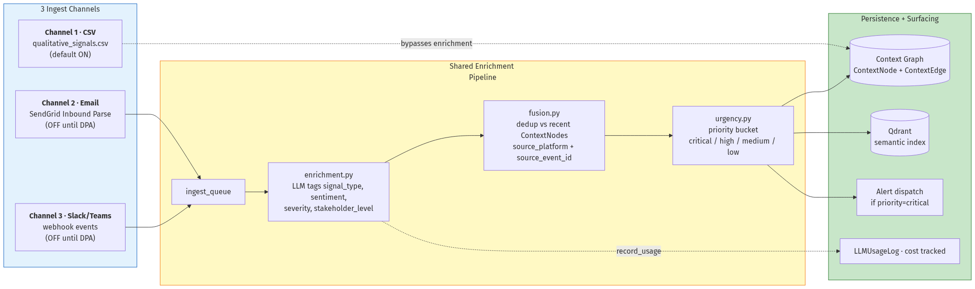
Figure 4 — Signal engine three-channel pipeline. Channel 1 (CSV) bypasses enrichment; Channels 2+3 (live email/Slack) go through the shared LLM-enrichment + fusion + urgency pipeline. All three converge on the context graph + Qdrant index. CSV is default-ON, live channels are OFF until DPA signed (per playbook §2.4).

4.1 Channel 1 — CSV upload (default)
- File: qualitative_signals.csv or enhanced_qualitative_signals.csv (both accepted)
- Loader: cs_pulse_onboarding.py via process_data → context graph upsert
- Default state: ON for every new tenant. Signals land directly during process_data.

4.2 Channel 2 — Live email forwarding
- File: signal_engine/email_receiver.py
- Source: SendGrid Inbound Parse hits an HTTP endpoint when emails arrive at a customer-specific forwarding address.
- Pipeline: email → enrichment.py (LLM tags signal_type + sentiment) → fusion.py (dedup against existing context nodes) → urgency.py (priority classification) → context graph insert + alert dispatch.
- Default state: OFF per tenant until DPA signed.

4.3 Channel 3 — Live Slack/Teams webhooks
- File: signal_engine/slack_events.py
- Source: Slack/Teams event webhook → ingest_api.py route.
- Same enrichment/fusion/urgency pipeline as email.
- Default state: OFF per tenant until DPA signed + Slack workspace integration approved.

4.4 The enrichment pipeline
Shared across channels 2+3 (channel 1 bypasses since CSVs come pre-classified):
- Raw event arrives → ingest_api.py → ingest_queue.
- Worker picks up event → enrichment.py — LLM call to tag signal_type, sentiment, severity, stakeholder_level. Logged via record_usage().
- Worker passes to fusion.py — dedup against recent context nodes (source_platform + source_event_id + time-window heuristic).
- Worker passes to urgency.py — assigns priority bucket (critical / high / medium / low) based on signal_type + sentiment + account health.
- Worker writes to ContextNode + (optionally) ContextEdge → fires alert if priority='critical'.
- Worker calls SignalVectorStore.index_signal() (if QDRANT_URL set) → Qdrant index updated for semantic search.

4.5 Hard rules
- DO NOT edit enrichment.py, fusion.py, urgency.py, collision.py in a customer overlay. These are the shared signal-processing pipeline. Bespoke rules go to base-dev.
- Auto-fix policy for unknown signal subtypes (policy_taxonomy_runtime_auto_fix.md): polarity subtypes silent LLM auto-classify; revenue-bucket subtypes quarantine + human review. Customers never edit the taxonomy directly; they pick via CDI DNA templates.

5. Outcome ROI Engine
Three lenses of CS ROI proof: historical (what closed), forward (Power-of-1 projection), bridge (continuity narrative). The CFO dashboard reads from this engine; the Outcome ROI dashboard renders all three in one view.
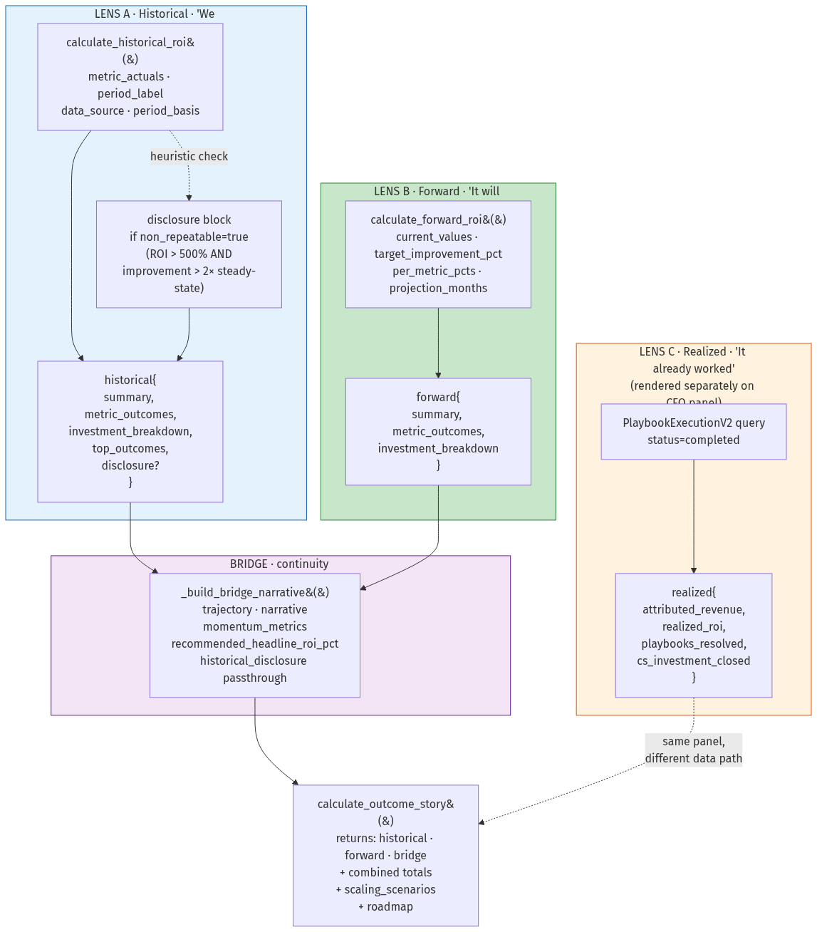
Figure 5 — Outcome ROI 3-lens architecture. Lens A (Historical) goes through the disclosure heuristic which fires the auditor caveat when ROI > 500% AND avg improvement > 2× forward steady-state. Bridge ties historical + forward + steers the reader to the credible headline number. Lens C (Realized) is rendered on the same CFO panel but takes a different data path — bottom-up sum of PlaybookExecutionV2.revenue_protected.

5.1 The OutcomeROIResult dataclass (outcome_roi_engine.py:380+)
- view_type — 'historical' or 'forward'
- period_label — 'Last 6 Months' or backend-rewritten 'Last 6 Months (since onboarding — includes one-time gains)' when disclosure fires
- summary — total_investment, total_impact, revenue_protected, revenue_expanded, cost_savings, roi_pct, payback_months, improvement_pct_avg
- metric_outcomes — per-metric drill: baseline_value, current_value, improvement_pct, dollar_impact, revenue/savings_portion, linked_kpis, linked_playbooks
- disclosure (PR #20) — populated when historical view surfaces non-repeatable one-time gains. Shape: { non_repeatable, period_basis, headline, detail, recommended_label }

5.2 The disclosure heuristic (the auditor caveat trigger)
_build_historical_disclosure (outcome_roi_engine.py:612). The disclosure fires when both conditions hold:
- ROI > 500% (well above steady-state CS ROI, which sits in 200–500% per Bain/TSIA benchmarks)
- AVG historical improvement > 2× forward_steady_state_pct (or > 2.0pp absolute when forward signal absent)
When triggered: period_label gets rewritten with the 'since onboarding' suffix, bridge.recommended_headline_roi_pct steers the reader to forward steady-state, an amber disclosure block renders on the PROVEN panel (PR #40 UI). Cust 334 example: 7,652% historical → triggered; 7,652% with improvement_pct=1 forward target (lift threshold 2.0); SUPPRESSED at improvement_pct=4 (threshold 8.0).

5.3 Stable-window baseline (Option A — opt-in)
_extract_historical_actuals supports skip_unstable_months kwarg. When set to N (e.g. 3), the loader drops the earliest N distinct months per KPI before computing baseline — anchors past the typical onboarding ramp / synthetic-decline phase. Exposed via ?stable=N query param on /api/outcome-roi/historical AND via ROI_HISTORICAL_SKIP_UNSTABLE_MONTHS env var on the MCP tool.
Default 0 preserves legacy behavior. Use when a buyer demands strict trailing-window proof. Provenance recorded as data_source='..._stable_skip3' and historical_period_basis='stable_window'.

5.4 The bridge
Bridges historical → forward with a narrative. bridge.trajectory ('accelerating' / 'sustaining'), bridge.narrative (auto-built string), bridge.momentum_metrics (per-metric historical_dollars + forward_dollars). When historical disclosure fires, bridge.recommended_headline_roi_pct = forward steady-state — explicit steer for the auditor to anchor on the credible number.

6. MCP Server

6.1 Anatomy
- Tools live in kpi-dashboard/backend/mcp_server/cs_pulse_*.py. Each tool is a Python function decorated with @mcp.tool with a docstring + typed signature.
- Tool count: ~52 today. NOT auto-generated — count by greping for @mcp.tool before quoting.
- Transport: JSON-RPC streamable-HTTP over /mcp. Both query-param (?api_key=) and Bearer-header forms work.
- Auth: validate_server_key() checks MCP_SERVER_API_KEY env var. EMPTY env = all keys rejected — see §3.10 footgun in FDE Playbook.
- Per-account auth: _require_account_auth + _validate_account_ownership for tools that take account_id. Prevents cross-tenant leakage if a valid customer key tries an account from a different tenant.

6.2 Adding a new MCP tool (base-dev only)
- Pick the right file: cs_pulse_predictor.py for forecast tools, cs_pulse_revenue.py for revenue/ROI tools, cs_pulse_onboarding.py for customer ops, etc.
- Decorate with @mcp.tool. Write a TIGHTLY-SCOPED docstring — the Ask AI router uses this to decide when to call the tool. Vague docstrings → wrong-tool calls.
- Add typed args with sensible defaults. customer_id is always required as the first positional arg (convention from PR #18 onwards).
- Add per-account auth if relevant: _validate_account_ownership(customer_id, account_id).
- Add a paired Flask route IF the dashboard needs it. WARNING: this triggers the Flask+MCP duplication-drift audit (PR #37) — sibling functions across layers must match in signature, response keys, and helper routing.
- If the tool makes an LLM call, ensure record_usage() is called. Grep-verify; do NOT trust assumed-tracked.
- Add a persona-grader fixture if any persona will ask a question that should route here.

6.3 Ask AI vs MCP — two consumption surfaces
Same tool catalog, two entry points. Ask AI (in-product floating portal) routes through ask_ai_endpoint.py which uses TOOL_DEFINITIONS in ask_ai_tools.py — a curated subset of MCP tools. Claude.ai connects directly to the MCP HTTP endpoint and sees all ~52 tools.
Risk: drift between the two surfaces. Apr 26 incident — had to manually wire get_csm_scorecard / get_csm_ranking / get_team_capacity / get_portfolio_revenue_breakdown into Ask AI even though all 4 had been in MCP for weeks. Roadmap (backlog_auto_derive_ask_ai_tools_from_mcp.md): auto-derive Ask AI TOOL_DEFINITIONS from the @mcp.tool registry. ~1.5–2 days. Trigger: next time a 4th–5th tool surfaces this drift.

7. Database Schema (key tables)
Highlights only. Full schema in kpi-dashboard/backend/models.py.
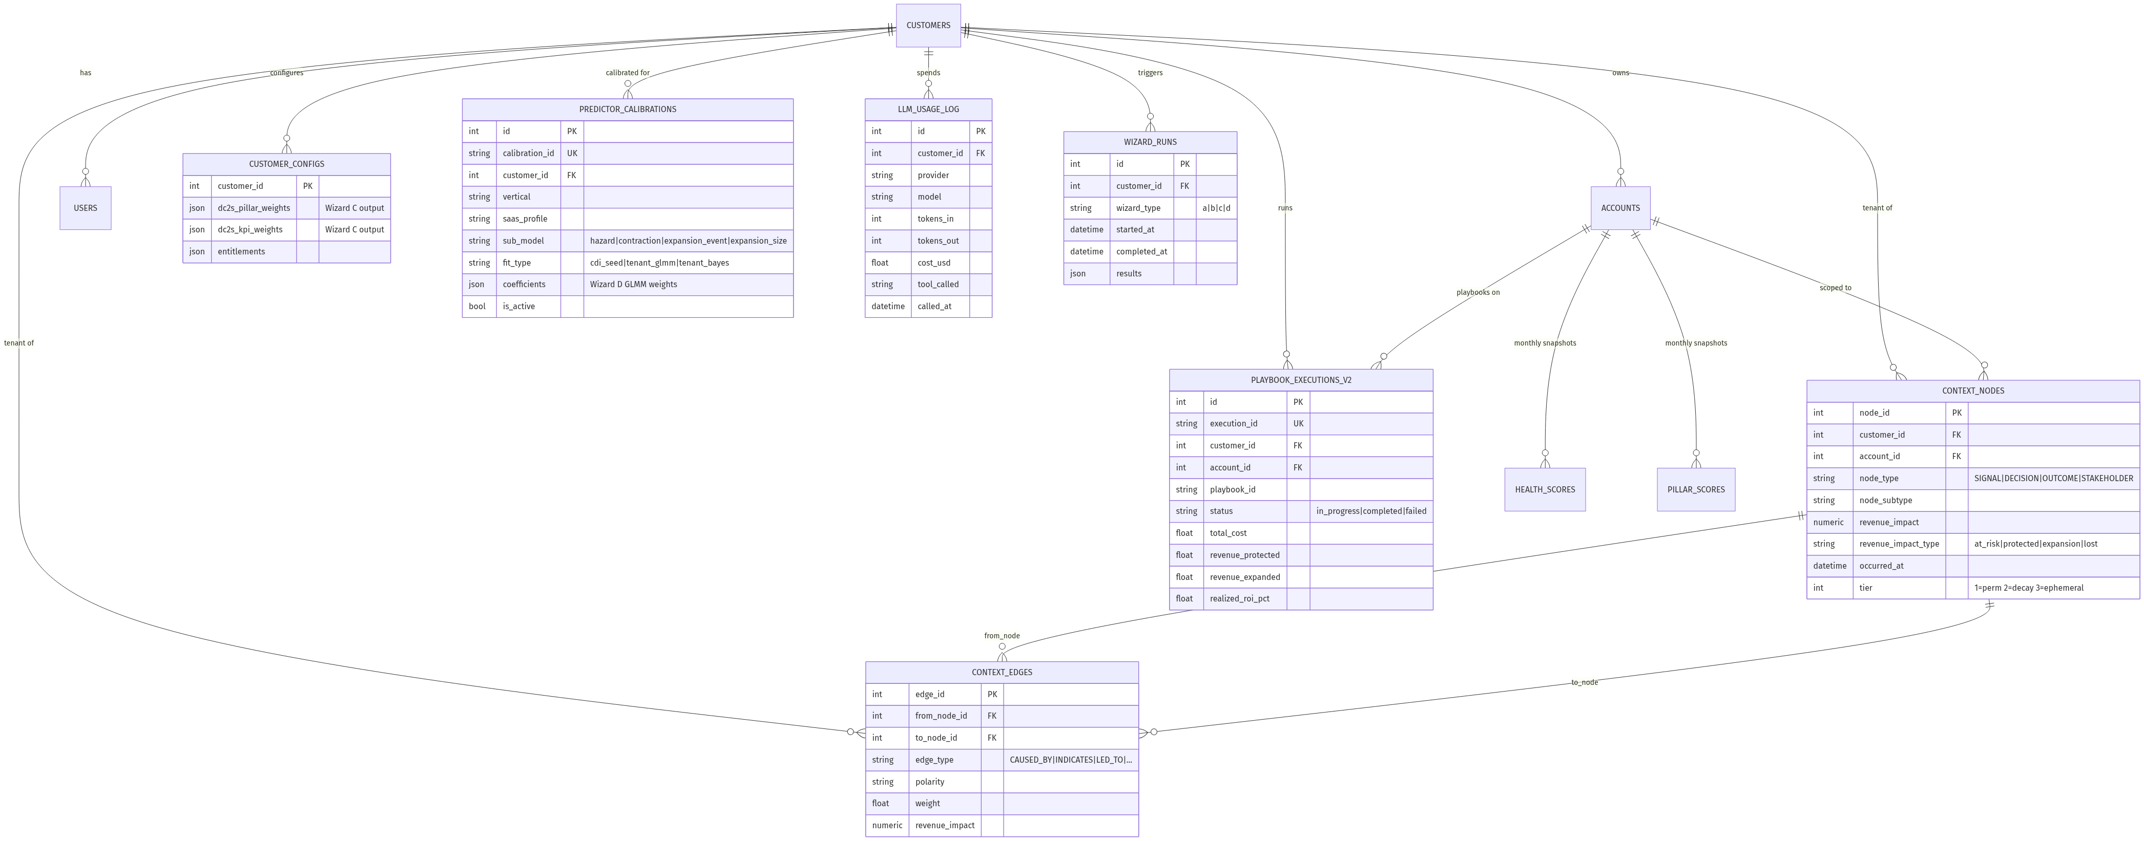
Figure 6 — ER diagram of the key tables. Customers is the root; everything fans out tenant-isolated. Note PREDICTOR_CALIBRATIONS (Wizard D output, 4 sub-models per active tenant), CONTEXT_NODES + CONTEXT_EDGES (the causal layer with self-referential edges via from/to_node_id), and LLM_USAGE_LOG (every LLM call tracked for cost attribution + governance audit).
Table | Purpose
customers | One row per tenant. Customer_id (int) + uuid. vertical, profile_metadata (JSON), tier.
accounts | Per-tenant accounts. account_id (PK), customer_id (FK), account_name, revenue, account_status, industry, vertical, region, external_account_id, profile_metadata (JSON — includes assigned_csm), uuid, customer_uuid, arc_type/arc_phase/arc_confidence (Wizard A output).
health_scores | Monthly health score snapshots. account_id, measurement_month, health_score, status, contributing_pillars (JSON), kpi_only_score, trend.
pillar_scores + kpi_scores | Pillar and KPI breakdowns per account-month.
context_nodes | The graph node table. See §3.1 for schema. Indexed on account+type, customer+type, occurred_at, tier+expires_at, source_platform+source_event_id.
context_edges | The graph edge table. See §3.1.
playbook_executions_v2 | Realized ROI Tracker. execution_id, customer_id, account_id, playbook_id, status (in_progress / completed / failed / cancelled), phase (stabilize / rebuild / secure), csm_hours, total_cost, health_at_trigger, health_at_close, revenue_protected, revenue_expanded, realized_roi_pct, projected_roi_pct, roi_variance_pct, action_log (JSON), skill_output (JSON), executive_briefing (text).
predictor_calibrations | Wizard D output. See §2.4. 4 sub-models × is_active=true rows per active (customer × vertical × profile).
customer_playbooks | Per-tenant playbook customizations via /api/playbooks/library.
weight_calibration_history | Wizard C audit trail.
roi_snapshots | Audit trail of ROI calculations.
llm_usage_log | EVERY LLM call. provider, model, tokens_in/out, cost_usd, tool_called, customer_id (for attribution). Required for cost dashboard + governance.
wizard_runs | Audit trail per wizard invocation. wizard_type, customer_id, started_at, completed_at, status, results (JSON).
users | Auth subjects. user_id, customer_id, email, password_hash, role, allowed_account_ids (JSON, per-CSM scoping), magic_link_token + magic_link_expires_at.
customer_configs | Per-tenant config: dc2s_pillar_weights + dc2s_kpi_weights (Wizard C output), feature toggles, entitlements.

8. End-to-End Data Flow
One representative slice — what happens between a customer uploading their 4 CSVs and a CFO seeing the FORECAST NRR tile.
- Customer uploads 4 CSVs via admin UI OR MCP upload_csv. Files land in verticals/customer{N}-{vertical}/data/.
- Customer (or admin) calls process_data. cs_pulse_onboarding._process_data_impl orchestrates: validate schemas → insert accounts → insert KPI measurements → insert qualitative signals → insert outcomes → fire Wizard A → fire Wizard B → (optionally) Qdrant indexing → mark complete.
- Wizard A walks each account's signals + KPI deltas → emits ContextNodes (DECISION + OUTCOME) and ContextEdges (CAUSED_BY, INDICATES). Account arc_type, arc_phase, arc_confidence written back.
- Wizard B reads Wizard A output → pattern-matches against canonical arcs → builds portfolio_nrr_forecast (without_cs / with_cs / with_interventions, ARR-weighted across active accounts) → stored as WizardRun.results.
- Admin runs trigger_wizard('d'). Wizard D fits 4 sub-models on the tenant's panel data + prior. INSERTs 4 PredictorCalibration rows, flips prior is_active=False.
- CFO loads /cfo-dashboard. Handler queries: latest health, pillar scores, OUTCOME nodes (for Lens A), Wizard B output (for Lens B), PlaybookExecutionV2 (for Lens C), predictor_calibrations (for FORECAST NRR tile).
- Handler loops predict_for_account_id over every account → loads active PredictorCalibration rows → runs 4 sub-models → aggregates ARR-weighted → returns as predictor_v3_portfolio_nrr block.
- React renders all blocks. FORECAST NRR — NEXT 12MO tile shows arr_weighted_nrr_pct (e.g. 103.71% for cust 334). User clicks the (i) tooltip → calibration_id + calibrated_at.

9. LLM Cost Tracking + Governance
Every LLM call is a financial transaction. The discipline is: every call site invokes record_usage() with provider, model, tokens, cost_usd, tool_called, customer_id. Per-customer cost attribution lives in the llm_usage_log table; the platform dashboard rolls it up.

9.1 record_usage discipline
- Helper: utils/llm_budget_controller.record_usage(...). Also can_call() for pre-flight budget check.
- Wrap every Anthropic / OpenAI SDK call. The wrapper around the SDK call should be the ONLY place that talks to the provider; bare provider calls bypass tracking.
- Apr 20 incident: 6 production callers bypassed record_usage. $0.45 of real spend invisible. After the audit: grep-verified every call site has a matching record_usage call before considering a PR done.

9.2 Governance framework
Per project_governance_layer_apr20.md, CS Pulse shipped 7 governance docs in April: AI_GOVERNANCE_FRAMEWORK + MODEL_INVENTORY (15 models) + CHANGE_MANAGEMENT + AUDIT_TRAIL_REQUIREMENTS + DRIFT_MONITORING + GOVERNANCE_ROADMAP + SOC2/RBAC v1.1.
Key principles:
- Model card per LLM-backed feature — declared in MODEL_INVENTORY. Tier 1/2/3 by risk.
- Known limitations are CRs (change requests), not documentation. Apr 20 incident: MOD-004 limitation got logged not CR'd; surfaced in buyer AI-DD next day.
- MOD-002 approval gate + MOD-007 prompt register + MOD-008 admin UI form the fast-unblock path for 9 of 15 models. MOD-003 (renewal probability) + MOD-012 stay hard-blocked until Phase 1 controls land.

10. Testing Architecture
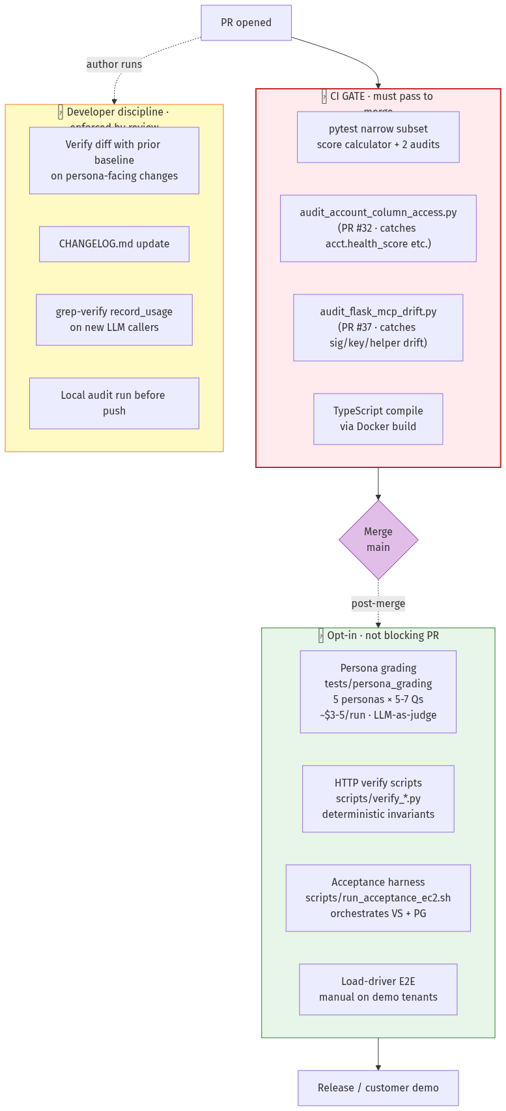
Figure 7 — Testing architecture. Red = CI gates (must pass to merge — narrow pytest subset + 2 audits + TypeScript compile). Green = opt-in post-merge or pre-release (persona grading, verify scripts, acceptance harness, load-driver E2E). Yellow = developer discipline enforced by code review (verify-diff, CHANGELOG, record_usage grep, local audit run).

10.1 What CI runs as a gate
- Narrow pytest subset — score calculator, account-column ORM audit (PR #32), Flask + MCP duplication-drift audit (PR #37).
- Frontend TypeScript compile (catches type drift pytest misses).
- Account-column audit: AST-walks every Account attribute access against the actual ORM column list. Drained 9 latent violations on first run.
- Flask + MCP drift audit: pairs Flask handlers with MCP sibling tools via name + URL stem + manual alias map. Catches signature_drift, response_key_drift, helper_drift. 0 NEW violations on the last 5 main commits.

10.2 What CI does NOT run automatically (opt-in)
- Persona grading (tests/persona_grading) — costs $3–5 per run. Opt in via PERSONA_GRADING_ENABLED=1 pytest flag, or run manually before tagging a release.
- HTTP verify scripts (scripts/verify_*.py) — run post-rehydrate, not at PR time. Acceptance harness scripts/run_acceptance_ec2.sh orchestrates.
- Load-driver E2E — full lifecycle test, manual on demo tenants.

10.3 Persona grading framework
- Location: kpi-dashboard/backend/tests/persona_grading/
- Five fixtures: ceo.py (5 Qs), cfo.py (6), cro.py (6), csm.py (6), vpcs.py (7). ~30 total.
- Each Question has: question text, must_cite list (facts that must appear), must_call_tools list, tone_check, anti_hallucination list.
- Grader (grader.py) is a Claude Sonnet call role-playing as a 15-year-veteran of the persona (5-yr for CSM). Returns letter grade A–F + numeric (~4.0 scale) + rationale.
- Invocation: python3 -m tests.persona_grading.runner --customer N --output PATH. Flags: --personas (subset), --shots (default 1, use 3 for calibration confidence), --model (default claude-sonnet-4-20250514).

10.4 Verify scripts (deterministic gate)
- Primary: scripts/verify_executive_phases_ec2.py with --suite all|cfo|cro|vpcs|cfo-phase1. Env-driven, reads scripts/.env.acceptance.
- Per-PR scripts kept for surgical re-runs: verify_cfo_phases_ec2.py, verify_cro_phases_ec2.py, verify_vpcs_phases_ec2.py, verify_cfo_phase1_ec2.py.
- Pattern for new persona-facing PRs: extend scripts/ec2_acceptance/checks.py with new invariants + add a new --suite name in the primary script. Do NOT add another standalone verify_*.py — the per-PR pattern predates the env-driven runner.

10.5 Acceptance harness
- scripts/run_acceptance_ec2.sh + scripts/.env.acceptance(.example) + scripts/ec2_acceptance/{config,http_client,checks}.py.
- Two stages: (1) HTTP suites via verify_executive_phases_ec2.py, (2) optional persona grading via docker exec into the platform container.
- Knobs: ACCEPTANCE_CUSTOMER_ID, ACCEPTANCE_SUITE, ACCEPTANCE_RUN_PERSONA, ACCEPTANCE_PERSONAS, ACCEPTANCE_PERSONA_SHOTS, ACCEPTANCE_MIN_GRADE_NUMERIC (gate, e.g. 3.7 for A-), ACCEPTANCE_SEED_VPCS, CSPULSE_CONTAINER.
- Exit non-zero on any HTTP failure or below-gate grade — wire into post-rehydrate runbooks.

11. Engineering Principles (the discipline layer)
Restated from Vision/Architecture §8 for technical completeness — these have caught real bugs. Internalize before opening your first PR.

11.1 Verify model schema before writing queries
Always run Model.__table__.columns.keys() OR read the model definition. NEVER guess column names. Cost of violation: 30+ minute phantom-bug hunts.

11.2 Revert fixes built on a wrong diagnosis
Don't keep dead code as a 'safety net.' Git revert immediately when the diagnosis turns out wrong.

11.3 Account-column drift audit (CI-enforced)
acct.health_score → HealthScore-join, acct.assigned_csm → profile_metadata.assigned_csm, acct.name → account_name, etc. See FDE Playbook §3.11.

11.4 Flask + MCP duplication-drift audit (CI-enforced)
Sibling functions across layers must match in signature, response keys, helper routing. 3 real instances caught in May 2026 (B-1, PR #30, PR #33).

11.5 Shift-left validation
Upload validates schema; ingest validates FK + temporal; wizards assume clean data. Don't punt validation downstream.

11.6 LLM call sites proven tracked
record_usage() is non-negotiable. Grep-verify before merging any LLM caller.

11.7 Governance limitations spawn CRs
Model-card limitations are pending change requests, not documentation. Treat as actionable backlog.

11.8 Intuitive file naming
File names communicate purpose without opening. build_panel.py not panel.py.

11.9 Cold-start sanity after every rebuild
5-minute end-to-end probe (register new tenant, exercise every MCP tool, walk all 5 dashboards) AFTER every rehydrate. Two proof points (Apr 5, May 17) where this caught silent bugs.

11.10 Prefer branches over worktrees
Per feedback_worktree.md — worktrees cause edit-loss and merge friction. Use branches for routine work. Worktrees are a tool for agent-isolated parallel work, not the default.

12. First Practical Exercises
You've now read all three onboarding docs. Three exercises in order — each takes 30–90 min and gives you closed-loop intuition.

Exercise 1 — Trace a Wizard D calibration end-to-end (~60 min)
- Open wizards/wizard_d_predictor_calibrator.py. Read run_wizard_d. Identify which DB tables it reads (panel data) and writes (predictor_calibrations + WizardRun.results).
- Open predictor/inference.py. Read predict_for_account_id. Identify which PredictorCalibration rows it loads and how it composes the 4 sub-models.
- Open executive_dashboard_api.py:1352–1395. Read the cfo_dashboard handler's Predictor v3 block — how it loops predict_for_account_id and ARR-weights.
- Hit live: curl /api/executive/cfo-dashboard for cust 334 and find the predictor_v3_portfolio_nrr block. Confirm arr_weighted_nrr_pct matches what the CFO tile renders.
- Open CFODashboard.tsx. Find where predictor_v3_portfolio_nrr is rendered (FORECAST NRR — NEXT 12MO tile). Trace from JSON to pixels.

Exercise 2 — Run scripts/run_acceptance_ec2.sh + the persona grader (~45 min, ~$3–5 cost)
- Copy scripts/.env.acceptance.example → scripts/.env.acceptance. Fill in CS_PULSE_BASE_URL=http://3.94.106.197 + creds + ANTHROPIC_API_KEY.
- Run ./scripts/run_acceptance_ec2.sh (HTTP-only, no LLM cost). Confirm exit 0. Read scripts/datasets/<timestamp>.json — that's the deterministic verify output.
- Run ACCEPTANCE_RUN_PERSONA=1 ACCEPTANCE_PERSONAS=cfo ACCEPTANCE_PERSONA_SHOTS=3 ./scripts/run_acceptance_ec2.sh. Costs ~$1–2 for one persona × 3 shots.
- Open the grader output JSON. Read the rationale + specific_concerns fields per question. That's the closed-loop quality signal.

Exercise 3 — Add a new MCP tool + paired persona-grader question (~90 min)
- Pick a small surface — e.g. get_arc_breakdown(customer_id) that returns per-arc-type ARR aggregations. Don't ship anything substantive; this is for ramp-up.
- Add @mcp.tool to cs_pulse_admin.py (or another appropriate file). Tightly-scoped docstring. customer_id as first arg.
- Add a Flask route IF it'd be dashboard-visible (skip for this exercise).
- Add a fixture entry to tests/persona_grading/fixtures/csm.py with a question that should route here. must_call_tools should include 'get_arc_breakdown'.
- Run the grader with --personas csm --shots 1 against cust 334. Confirm the AI routes through your new tool.
- Open a PR. Watch the Flask + MCP drift audit + Account-column audit on CI. Get a green build before merging.
─── End of Document 3 (Technical Deep Dive) ───
You've finished the three-doc onboarding kit. Open a Slack thread with the team for questions; the FDE Playbook (gtm-decks/fde-kt/) is the operational companion when you start working with customers.

