CS Pulse — User Perspective Lifecycle Guide
Tech-lead onboarding · what the customer experiences end-to-end
This is the FIRST of three knowledge-transfer documents for an incoming CS Pulse tech lead. It walks the platform from the customer's seat — what they upload during onboarding, what they see on each persona's dashboard, how they interact with Ask AI, and how the experience shifts as the deployment matures from pre-deploy to active.
Companion docs (read in order): (2) CSPulse_Vision_Architecture_Guide.docx — vision, roadmap, system architecture, admin operations. (3) CSPulse_Technical_Deep_Dive.docx — implementation internals, the four wizards, GLMM math, context graph, signal engine. Read THIS one first to understand what we're delivering; read those next to understand HOW we deliver it.
All file paths in this doc are relative to the repo root. All API responses + behaviours described match the deployed image as of late May 2026 (commit eaec74db8 — Wizard B three-state labeling fix on the CRO Forward NRR tile).

1. The Customer Lifecycle
CS Pulse models every customer through four phases. The phase isn't cosmetic — it actually drives what tiles render, what numbers populate, and what story we tell the buyer. As a tech lead you'll hear 'cold-start' and 'pre-deploy' and 'mature tenant' in conversations; this section gives you the working vocabulary.

1.1 The four customer phases
Phase | What it means | What's visible to the buyer
PRE-DEPLOY | Customer has been provisioned in CS Pulse but has not yet uploaded outcomes / run any playbooks. No closed-loop data exists. | Lens A (historical outcomes) shows empty state. Lens B (Wizard B counterfactual) may render if Wizard A has run on uploaded KPI + signal data, otherwise empty. Lens C (realized attribution) is empty by design. Predictor v3 forecast tile may render with wide CIs.
ONBOARDING (0–3mo) | First three months. Some KPI history, some signals, a few playbook executions resolving but no statistically meaningful closed-loop ROI yet. | Lens A + Lens B populated. Lens C is sparse — "first proof points" framing. CSM cockpit is fully usable; CFO dashboard shows leading indicators only.
ACTIVE (3–12mo) | Steady-state. Playbook executions accumulating, attribution working, Wizard D calibrated to this tenant's GLMM. | All three lenses populated. Row C is the primary CFO story. Forecast NRR + realized NRR both render with narrowed CIs.
MATURE (12mo+) | Full audit trail across all three lenses. CDI (Community Domain Intelligence) inputs may apply if 5+ peer customers exist in the vertical. | All three lenses fully populated. Long-term attribution decomposition surfaces. Trajectory tiles show 6+ months of history. Calibration audit trail available for AI-DD reviews.
The CFO dashboard's PHASE BADGE (visible at the top right of the Three Lenses panel) is the FDE's tell of where you are. If a customer is in PRE-DEPLOY and Lens C is empty, that's not a bug — it's the design. Setting customer expectations to match the phase is half the job during the first month.

1.2 What's the same across phases
- All five persona dashboards (CRO / CFO / CEO / VP CS / CSM) render from day one. Tiles show empty states with explanatory copy when their data isn't ready.
- Ask AI works from day one for any tool whose data is present. Try it on a fresh tenant — the experience is 'I can answer the questions you've given me data for; I can't fabricate the rest' (anti-hallucination is a hard rule in the persona grader).
- Context graph populates from day one — every uploaded signal becomes a ContextNode; every causal inference (Wizard A) adds ContextEdges.
- MCP server is live from day one — Claude.ai can connect even before the customer's first persona-eval.

1.3 What changes as phases advance
- ROI tiles transition from PROJECTED (Power-of-1 benchmarks) → REALIZED (PlaybookExecutionV2 sums). The CFO Three-Lenses panel makes this transition visible: Lens C populates when playbooks close.
- Wizard D recalibration moves the tenant off the CDI-seed prior and onto a tenant-specific GLMM. The calibration_id changes from a vertical-level seed to a per-tenant fit.
- Persona grader expectations rise. A new tenant grading B- on CSM (cold-start data limitations) might grade A- once 90+ days of playbook executions accumulate.
- Forecast CIs narrow. Wider CIs on day one shrink as Wizard D refits on more tenant-specific data.

2. Onboarding — From Discovery to First Sanity
Customer onboarding is the FDE's job, but the tech lead needs to understand the flow because it's where 80% of customer-facing bugs are caught. There's exactly one supported path — the canonical 4-CSV upload. Any other pattern is base-dev approval territory.

2.1 Pre-flight — Discovery workbook
Before any data hits the platform, the FDE runs five 30-minute discovery interviews using CSPulse_FDE_Discovery.xlsx (lives in gtm-decks/fde-kt/). One stakeholder per persona at the customer side. The workbook captures: top 5 KPIs, pillar-weight preferences, signal sources, success outcomes, current process pain. The Consolidation tab rolls all five into a config-export view that maps directly into create_customer.
Why the tech lead should care: this is where customer-side mismatches surface BEFORE upload. If the discovery says 'they don't track NPS' and Wizard A then complains about a missing nps_decline signal subtype, that's a configuration problem traceable to the workbook, not a code problem.

2.2 Provisioning
Use the admin UI's onboarding wizard, or the MCP create_customer tool if scripting. Two first-class verticals today:
- dc2_s — data-center hardware vertical. KPIs: deployment velocity, operational stability, AI workload performance, channel/partner health, expansion readiness.
- saas_premium — SaaS B2B vertical. KPIs: product adoption, engagement, sentiment, partner, revenue.
Other industry labels (healthcare, financial services, etc.) flow as account firmographic data — they're NOT separate vertical modules. If a customer asks 'do you have a healthcare vertical?' the honest answer is 'we have CS-Pulse infrastructure that's vertical-aware via JSON catalogs; healthcare-specific KPIs would be a base-dev request to add as a third first-class vertical.'
KPI tier choice: Starter 9 (B+ for cost-conscious tenants), Predictive 11 (A-, the default), Full 43 (A+ for mature CS teams that already track everything).

2.3 The 4-CSV upload
This is the only onboarding pattern we support by default. Customer prepares four CSVs from their source systems (CRM, KPI dashboards, signal channels):
File | What it contains
account_details.csv (preferred) or accounts.csv | Account records — name, products, champion contacts, contract details, firmographic data. Loader prefers account_details.csv when both are present.
kpi_measurements.csv | Monthly KPI time-series. Schema validated at upload — wrong unit, wrong type, out-of-range values are rejected with explicit error messages.
enhanced_qualitative_signals.csv (preferred) or qualitative_signals.csv | Signal feed — NPS scores, escalations, champion changes, executive feedback events. The enhanced_ variant carries additional columns; the loader accepts either.
outcomes.csv | CRM renewal / churn / expansion history (typically a Salesforce export). This is what populates Lens A on the CFO Three-Lenses panel.
Upload via the admin UI or the MCP upload_csv tool. After all four are uploaded, the customer (or admin) calls process_data. This kicks off the pipeline: schema validation → DB inserts → Wizard A (causal graph) → Wizard B (counterfactual NRR) → Qdrant signal indexing (if QDRANT_URL is set). Wizards C and D do NOT auto-fire — they're explicit admin triggers (see §3 in the Technical Deep Dive doc).

2.4 First sanity check
After process_data, the FDE runs scripts/run_acceptance_ec2.sh as a deterministic gate. It hits CFO + CRO + VPCS HTTP suites against the live host and asserts known invariants. Common first-day issues:
- Revenue Protected = $0 on Lens C: post-load attribution didn't run. Trigger via the admin endpoint.
- NRR forecast 0% or stuck at the prior tenant's value: Wizard D wasn't refit. Run trigger_wizard('d') manually.
- Ask AI returns "I don't know" to dashboard questions: the relevant MCP tool wasn't wired into the customer's enabled set. Check entitlements.
- Dashboard tile shows context-graph $ but CRO and CFO numbers don't match: this is the PR #38 parity regression — re-run scripts/verify_cfo_phase1_ec2.py to localize.

2.5 First persona-eval
Once §2.4 is green, run the persona grader for all 5 personas at --shots 3. Expect at least one persona to grade below the customer's bar on day one — usually CSM (no closed-loop revenue attribution yet) or CFO (no realized defensive ROI until playbooks resolve). The discovery workbook answers are the calibration starting point — adjust weights in bootstrap_weights_config.json, re-run, repeat. Target: all 5 personas at the customer's bar (typically B+ or higher) within the first week.
This is the closed-loop calibration mechanism. The grader's specific_concerns field names exactly what's missing — usually a weight or a signal-channel issue, not code.

3. The Five Personas — Dashboard Tour
CS Pulse ships five persona-specific dashboards. Each is its own React component with its own data-fetch path. A buyer working from any one persona should be able to answer the questions that matter to THEIR role without leaving the dashboard. As a tech lead you'll touch all five within your first month — this section is the map.

3.1 CRO — Revenue Intelligence (the headline persona)
Route: /cro-dashboard. Component: CRODashboard.tsx. Audience: head of revenue, head of CS, CRO at a $50M–$5B ARR B2B SaaS.
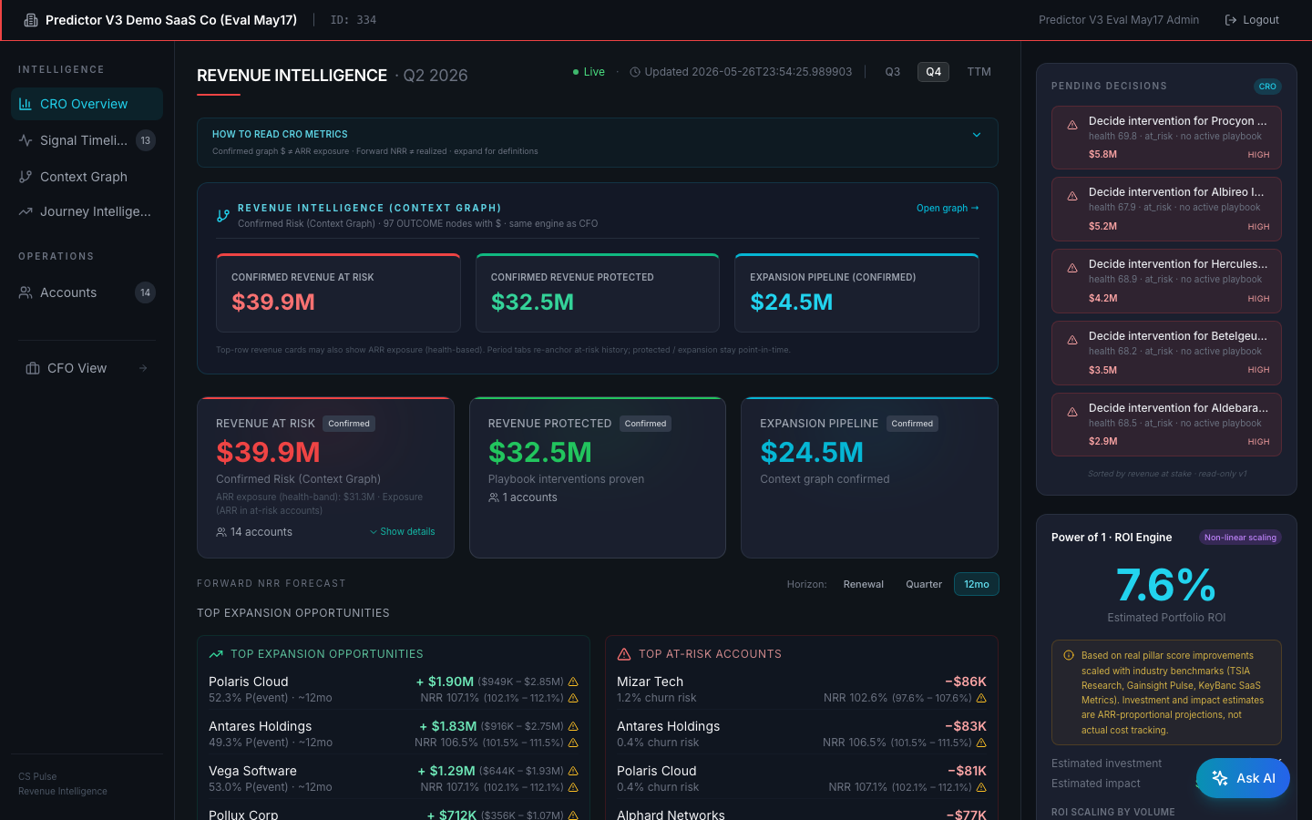
CRO dashboard — top-of-fold on cust 334 (live screenshot, late May 2026)
On the screenshot above, look at:
1. Top header — 'REVENUE INTELLIGENCE · Q2 2026' with the Q3/Q4/TTM tab selector to the right. Tab switching is a pure UI transform on cached data (no new API call fires).
2. 'HOW TO READ CRO METRICS' — collapsed expandable metric guide (added by commit 904184fed, the Phases 0–5 honesty work).
3. 'REVENUE INTELLIGENCE (CONTEXT GRAPH)' strip — Confirmed Revenue at Risk $39.9M / Protected $32.5M / Expansion Pipeline $24.5M. Each tile sourced from context-graph OUTCOME nodes (evidence-weighted), with 'View 8 sample outcomes →' drill-down per tile.
4. Below the strip: legacy main tiles (REVENUE AT RISK / REVENUE PROTECTED / EXPANSION PIPELINE), each with a 'Confirmed' badge after the honesty rework.
5. 'TOP EXPANSION OPPORTUNITIES' + 'TOP AT-RISK ACCOUNTS' panels — these populate from the Predictor v3 (Wizard D-calibrated) per-account forecasts, ranked by ARR impact. CI bands hover inline.
6. Right sidebar: 'Pending Decisions' panel (PR #39) — 5 exec-altitude items awaiting CRO sign-off, sorted by revenue at stake. Below it: 'Power of 1 · ROI Engine' tile showing portfolio ROI (7.6%).

Top-of-fold layout
- REVENUE INTELLIGENCE header with period selector (Q3 / Q4 / TTM tabs — PR #38 + commit 904184fed). Tab switching is a pure UI transform on cached data; no new API call fires per tab change (only a cro_period_change analytics event).
- HOW TO READ CRO METRICS — expandable metric guide added by 904184fed.
- REVENUE INTELLIGENCE (CONTEXT GRAPH) strip — 'Confirmed Risk · 97 OUTCOME nodes with $ · same engine as CFO Overview.' Three confirmed-revenue tiles: Confirmed Revenue at Risk, Confirmed Revenue Protected, Expansion Pipeline (Confirmed).
- REVENUE AT RISK / REVENUE PROTECTED / EXPANSION PIPELINE — the legacy main tiles, each with a Confirmed badge after the 0–5 honesty rework.

Mid-fold — Predictor v3 tile
<PredictorV3Tile> renders below the fold. It shows Top Expansion Opportunities + Top At-Risk Accounts with per-account 90% CI bands from Wizard D. Sample rows from cust 334: Polaris Cloud (+$1.52M expansion, 41.9% P(event), 12mo horizon), Antares Holdings (+$1.46M, 39.2%), etc. Hover the warning icon to see calibration_id provenance.

Right-sidebar — Forward NRR tile
Three-state truthful labeling (PR #44, May 22): Natural-arc baseline (88.09%) → Today with CS Pulse (88.49%) → If interventions succeed (109.26%). All three are Wizard B outputs. The leftmost is what NRR would be without any CS Pulse intervention; the middle is current state; the rightmost is upside if all recommended interventions succeed. This replaces an earlier 2-column layout that mislabeled the with-CS value as 'Without CS Pulse.'
The Pending Decisions Queue (PR #39, May 17) sits above Power of 1 in the right sidebar — 5 items awaiting CRO decision, sorted by revenue at stake, headlines framed account-altitude ('Decide intervention for X').

Below-fold — Trajectory + Waterfall
- NRR Trajectory · all accounts — T+30 / T+60 / T+90 projection with a 5% churn floor on every account. Different from the Forward NRR tile (at-risk only, no floor) — same data, different attribution windows.
- Revenue Waterfall — per-account exposure → expected loss → residual risk → attributed save, with playbook cost + projected ROI per row.

3.2 CFO — Investment Intelligence (the auditor persona)
Route: /cfo-dashboard. Component: CFODashboard.tsx. Audience: CFO, head of FP&A, board-prep finance partner.
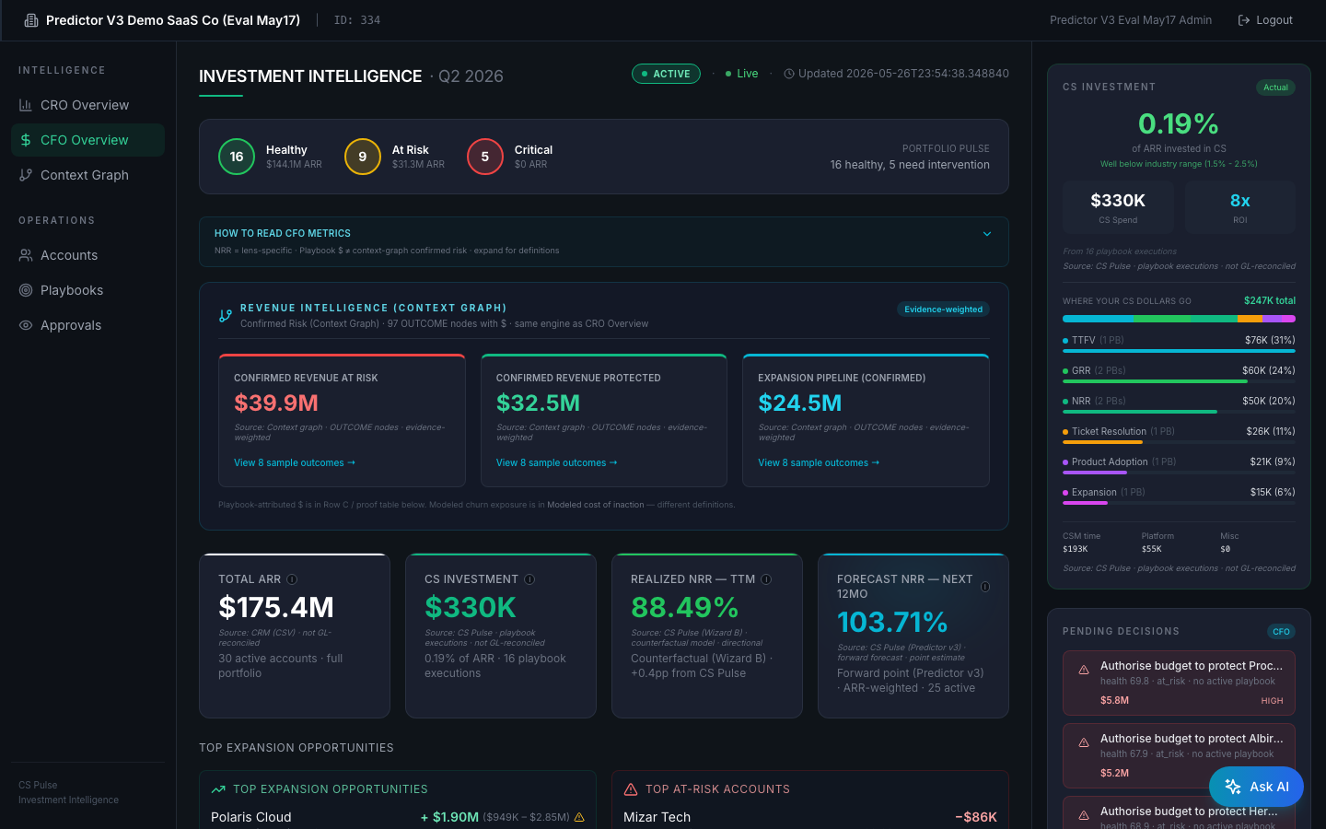
CFO dashboard — top-of-fold on cust 334 (live screenshot)
Key elements:
1. Header: 'INVESTMENT INTELLIGENCE · Q2 2026' with Portfolio Pulse (16 Healthy / 9 At Risk / 5 Critical for cust 334).
2. 'REVENUE INTELLIGENCE (CONTEXT GRAPH)' strip — same engine as CRO (evidence-weighted), proves the two persona dashboards reconcile. PR #38 Phase 1 audit pins this parity.
3. Confirmed Revenue at Risk $39.9M / Protected $32.5M / Expansion Pipeline $24.5M tiles, each with 'View 8 sample outcomes →' drill-downs into the actual context-graph OUTCOME nodes (audit trail).
4. Four-tile row: TOTAL ARR / CS INVESTMENT / REALIZED NRR — TTM (Wizard B counterfactual, 88.49% with Confirmed badge) / FORECAST NRR — NEXT 12MO (Predictor v3 — Wizard D-calibrated, 103.71%).
5. Below the fold (not visible in screenshot): the 'PAST — THREE LENSES' panel — Lens A (Historical, uploaded outcomes), Lens B (Counterfactual, Wizard B), Lens C (Realized, PlaybookExecutionV2 sums). The CFO's signature surface, fixed by PR #43 + #44 for label clarity.
6. Right sidebar: 'Pending Decisions' panel (CFO framing — 'Authorise budget to protect X' instead of CRO's 'Decide intervention for X'). Same 5 items, persona-aware sorting by $ spend.

Top-of-fold
- INVESTMENT INTELLIGENCE header + Portfolio Pulse summary (16 Healthy / 9 At Risk / 5 Critical for cust 334).
- HOW TO READ CFO METRICS — expandable, added by PR #38 Phase 0–2 honesty work.
- REVENUE INTELLIGENCE (CONTEXT GRAPH) strip — same engine as CRO, evidence-weighted. Confirmed Revenue at Risk ($39.9M for cust 334), Protected ($32.5M), Expansion ($24.5M). 'View 8 sample outcomes →' links into the OUTCOME nodes for audit.
- 4-tile row — Total ARR / CS Investment / Realized NRR — TTM (Wizard B counterfactual) / Forecast NRR — Next 12mo (Predictor v3, Wizard D-calibrated).

PAST — THREE LENSES (the auditor's panel)
Below the fold sits the signature CFO surface — three rows answering the same question through three lenses:
- Lens A — Historical Performance (Pre-CS-Pulse). Uploaded OUTCOME data. Historical NRR TTM, ARR churned/expanded/contracted, with raw event counts. Sources from outcomes.csv via context graph OUTCOME nodes — not GL-reconciled.
- Lens B — Counterfactual (Wizard B). 'What would NRR have been if CS Pulse had been running through this period?' Subtitle ends with 'not directly comparable to Lens A's gross-outcome NRR' (PR #43). Four tiles: Hypothetical NRR (88.49%, vs 88.1% natural-arc baseline), Counterfactual NRR Lift (+0.4pp, ≈$701K), ARR Protected (Saved Accounts) ($17M, NOT the NRR-lift dollars), Accounts Could've Been Saved (3).
- Lens C — Realized — Actual CS Pulse Attribution. Bottom-up sum of PlaybookExecutionV2.revenue_protected across closed playbooks. Attributed Revenue, Realized ROI, Playbooks Resolved, CS Investment Closed. Drill-down via Playbook ROI Proof table below.

Modeled Cost of Inaction
Below Lens C — projection of revenue impact if no CS Pulse intervention. Health-weighted churn probability × account ARR. The Modeled Cost of Inaction is DISTINCT from Confirmed Revenue at Risk: the latter is evidence-weighted (only ARR with explicit OUTCOME-node backing); the former is a model-derived churn projection.

Outcome ROI dashboard (linked from CFO)
Route: /outcome-roi. Component: OutcomeROIDashboard.tsx. Renders historical (PROVEN) vs forward (PROJECTED) panels side by side. After PR #40 the PROVEN panel includes an amber disclosure block when the 6-month ROI reflects non-repeatable one-time gains (heuristic: ROI > 500% AND avg improvement > 2× forward steady-state). The disclosure: 'Includes one-time onboarding gains' with detail explaining the buyer should treat the forward projection as the repeatable number.

3.3 CEO — Executive Scorecard
Route: /ceo (also /saas-dashboard/ceo). Component: CEODashboard.tsx. Audience: CEO at the customer (or PE-portfolio CEO at the parent level if portfolio mode is on).
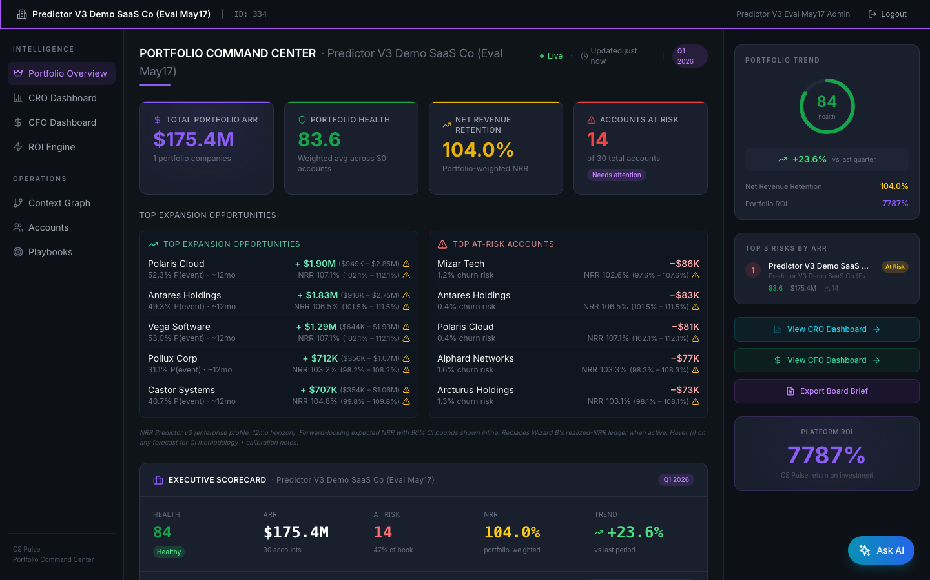
CEO dashboard — 'PORTFOLIO COMMAND CENTER' on cust 334 (single-tenant mode)
Key elements:
1. 'PORTFOLIO COMMAND CENTER' header — when only one customer exists under a portfolio_id (single-tenant mode for cust 334), shows the Executive Scorecard alternative added by PR #31.
2. 4-tile top row: TOTAL PORTFOLIO ARR $175.4M / AVG HEALTH 83.6 / NET REVENUE RETENTION 104.0% / ACCOUNTS AT RISK 14. The NRR number is the Wizard D-calibrated forecast (Predictor v3, ARR-weighted, 12mo horizon).
3. TOP EXPANSION OPPORTUNITIES + TOP AT-RISK ACCOUNTS panels — same Wizard D data as the CRO surface, framed for board-altitude consumption.
4. Right side: Portfolio Health gauge (84) + Predictor v3 ROI tile (7,887% — note this is the historical ROI which the disclosure heuristic flags as non-repeatable; see Outcome ROI doc §5).
5. Below: Executive Scorecard table with per-tile summary metrics.

Layout
- Single-tenant mode (when only one customer exists under a portfolio_id) — Executive Scorecard headline with portfolio NRR, total ARR, account-status breakdown.
- Portfolio mode (PE-fund deployment with multiple customers under one portfolio_id) — Company Comparison Table with portfolio rollup. cust 334 today is single-tenant so this surface collapses; PR #31 (May 17) shipped the Executive Scorecard alternative for that case.
- Top 3 Strategic Moves tile (PR #31) — Conservative / Recommended / Stretch scenarios derived from Power-of-1 scaling. The CEO altitude of the action queue.
- Quarter selector with live computation (was hardcoded 'Q1 2026' until 904184fed).

3.4 VP CS — Operations Intelligence
Route: /vpcs (also /saas-dashboard/vpcs). Component: VPCSDashboard.tsx. Audience: VP of Customer Success — the operational counterpart to the CFO.
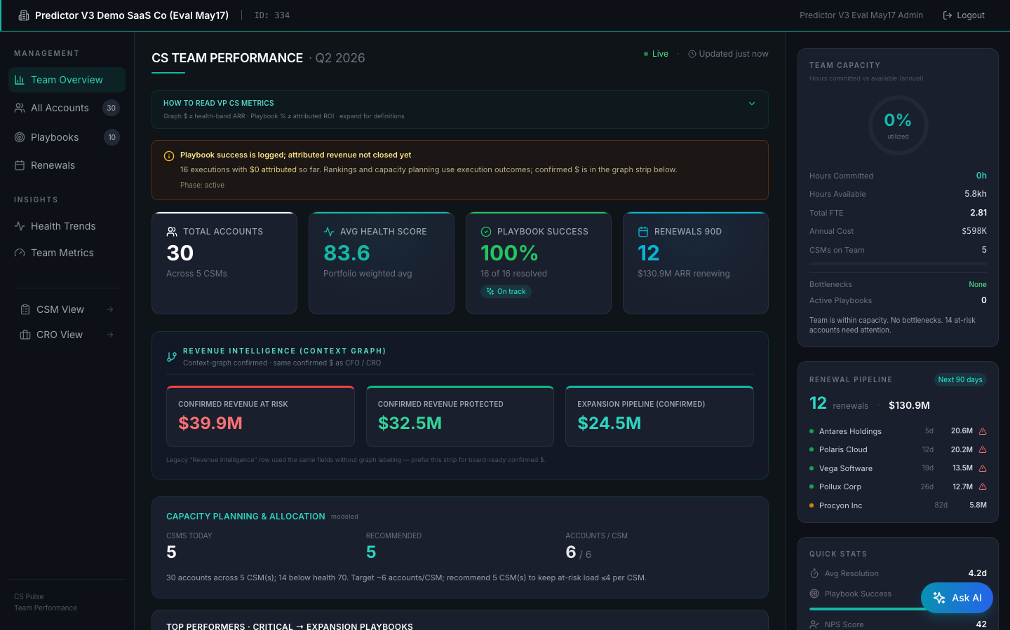
VPCS dashboard — top-of-fold on cust 334
Key elements:
1. TEAM CAPACITY tile (came online via PR #30 + commit fed7d7834) — hours-based utilization with resource_pool / utilization_pct / bottlenecks / recommendation. Replaced earlier account-count-derived fallback gauge.
2. Per-CSM Scorecards — accounts_rescued / accounts_lost / health_delta / playbook_success_rate. Counts are auditable via explicit lifecycle definitions (critical→healthy = rescue, healthy→critical = lost).
3. Top Performers panel — CSM ranking with composite score.
4. Renewal Pipeline widget (90-day window) — pulls renewal_date + forecast_category from CRM data.
5. Right sidebar typically shows playbook recommendations summary at the team level (vs CSM-cockpit per-account drill).
- Team Capacity gauge — hours-based utilization (resource_pool / utilization_pct / bottlenecks / recommendation). Came online via PR #30 (May 17) — earlier the tile fell back to a client-side account-count derived gauge.
- CSM Scorecards — per-CSM accounts_rescued / accounts_lost / health_delta / playbook_success_rate. Counts ARE auditable: critical→healthy = rescue, healthy→critical = lost; explicit lifecycle definitions.
- Per-CSM ranking with composite score.
- Top Performers panel (PR fed7d7834, May 22).
- Renewal Pipeline widget — accounts with renewal_date < 90 days, with days_until + forecast_category from CRM data.

3.5 CSM — Daily Cockpit
Route: /saas-dashboard/csm. Component: CSMCockpit.tsx. Audience: individual CSM. This is the most-used surface in the product — designed for a 2-minute morning briefing.
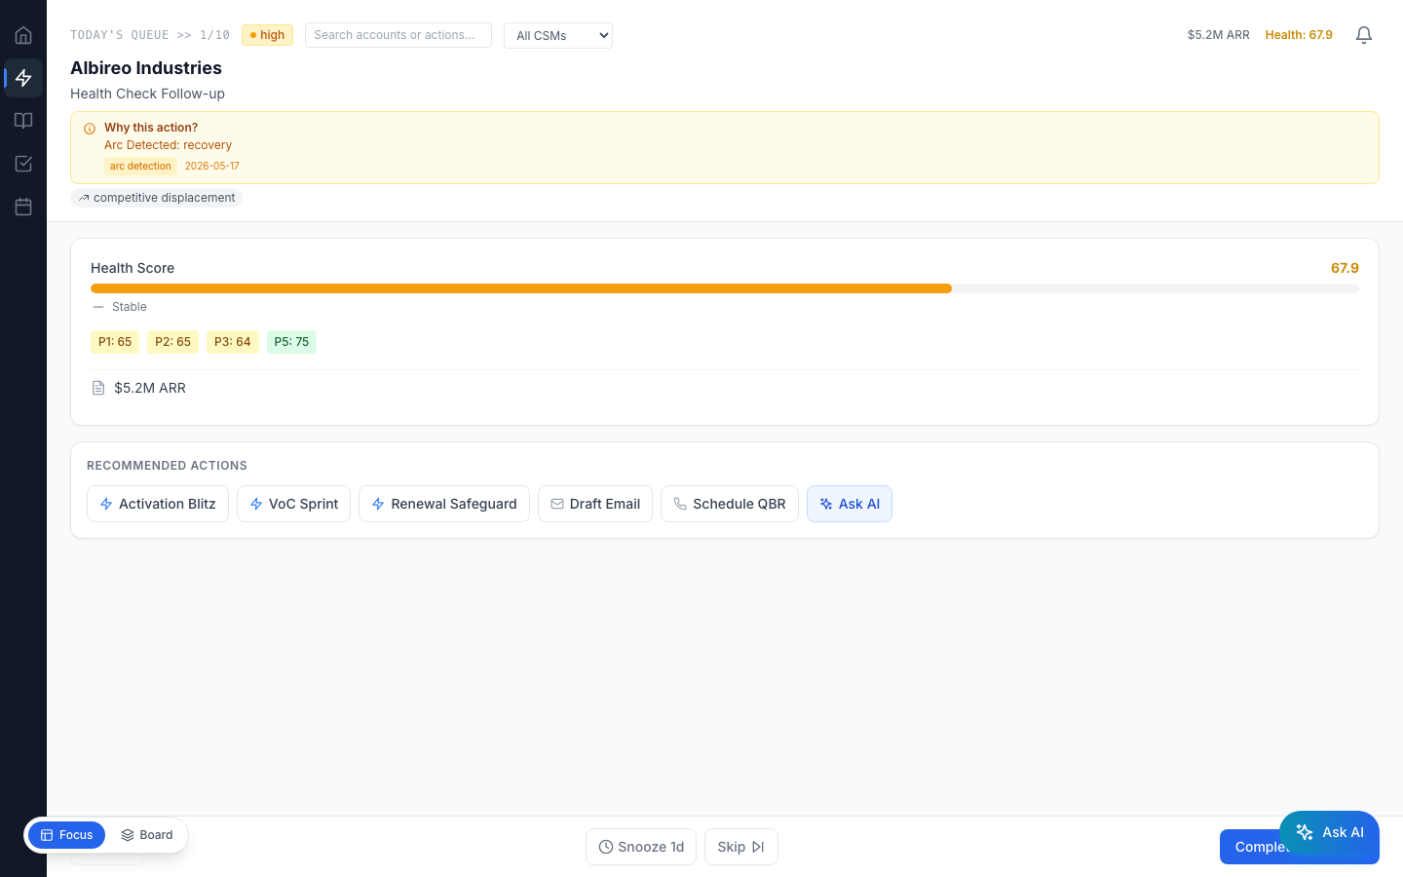
CSM cockpit — 'Focus Mode' view on cust 334
Key elements:
1. FOCUS MODE — sequential task queue across the CSM's book, prioritised by impact × time-decay. 'TODAY'S QUEUE >> 1/5' progresses through items one at a time.
2. Critical card centre-stage — health score, churn-risk %, recommended action ('Initiate emergency churn prevention'), renewal countdown ('renewal in N days').
3. Action panel bottom: Prev / Snooze 1d / Skip / Complete & Next / Ask AI — designed for fast triage without leaving the keyboard.
4. Right sidebar: 'KANBAN BOARD' alternate view — FIRE / THIS WEEK / OPPORTUNITY columns with drag-drop persistence via @dnd-kit (kanban_column stored in profile_metadata).
5. Account-drill drawer (opens on card click, not shown): pillar scores, signals timeline, vertical-aware playbook recommendations (PR #26 + #33 fix), stakeholder map, support tickets, journey timeline.
- FOCUS MODE — sequential task queue across all CSM's accounts, prioritised by impact × time-decay.
- KANBAN BOARD — FIRE (critical) / THIS WEEK / OPPORTUNITY columns. Drag-drop persistence via @dnd-kit (kanban_column PATCH stored in profile_metadata).
- Account-drill drawer — pillar scores, signals timeline, recommendations panel, stakeholder map, support tickets, journey timeline.
- Playbook recommendations — drill-drawer pulls vertical-aware recs (PR #26 fixed routing; PR #33 wired UI consumption). Sample for SaaS Premium tenant: activation-blitz, voc-sprint, renewal-safeguard.
- Email draft modal — pre-filled outbound for an at-risk account. Champion contact pulled from account.profile_metadata.champion (only populated if the customer included it in account_details.csv).

4. Ask AI — Two Surfaces, One Tool Catalog
Ask AI is the conversational layer over the same MCP tool catalog the dashboards use. Two consumption surfaces — Claude.ai with the MCP connector, or the in-product floating Ask AI portal. Both are gated by entitlements; both share the same anti-hallucination discipline (the persona grader is the regression test).

4.1 The MCP tool surface (~52 @mcp.tool decorations)
All tools live in kpi-dashboard/backend/mcp_server/cs_pulse_*.py. New tools are base-dev only — they go through the API contract review. The categories (curated, not auto-generated — grep mcp_server/ for @mcp.tool to count live decorators before quoting a number to a buyer):

Customer + onboarding
create_customer, list_customers, clone_customer, complete_onboarding, configure_customer_kpis, enable_features, get_csv_templates, upload_csv, download_customer_csv, process_data, list_verticals, get_platform_instructions.

Health + accounts
get_account_health, get_at_risk_accounts, get_account_journey_timeline, get_account_nrr_forecast, get_health_score_history, get_kpi_catalog, list_accounts, get_crm_account_data, get_stakeholder_map, get_support_tickets.

Predictor + portfolio (Wizard D / GLMM-calibrated)
get_nrr_forecast, get_portfolio_nrr_forecast_v3, get_top_at_risk_accounts_v3, get_top_expansion_opportunities_v3, get_revenue_at_risk, get_portfolio_cross_customer_comparison, get_portfolio_roi_summary.

ROI + economics
calculate_power_of_1, get_outcome_roi_story, get_playbook_economics.

Playbooks
get_playbook_recommendations, execute_playbook, close_playbook, get_playbook_success_metrics, generate_playbook_from_description.

CSM + team
get_csm_daily_actions, get_csm_ranking, get_csm_scorecard, get_team_capacity, get_customer_feedback.

Causal graph + signals
get_causal_chain, get_context_graph_mermaid, get_graph_summary, search_signals, submit_signal.

Wizards + admin
trigger_wizard, get_llm_cost_summary, partner_portal.

4.2 Sample Ask AI questions — by persona
These are paraphrases of the actual questions in tests/persona_grading/fixtures/{persona}.py. The grader is calibrated against responses to these — your AI surface must answer them well to pass acceptance.

CRO
- "What's our revenue at risk this quarter, by account?"
- "Which 3 accounts are the top expansion opportunities?"
- "Show me NRR forecast with confidence interval for Polaris Cloud — and why."
- "When NRR moved last quarter, which accounts drove it?"
- "Compare this quarter's risk vs last quarter."

CFO
- "Give me an auditor-acceptable ROI number with methodology."
- "How does CS investment scale at 2× ARR? What's the unit economics rationale?"
- "Trace every dollar of attributed revenue to a specific playbook."
- "Where does Power of 1 lift come from? Show me the assumptions and bounds."
- "Distinguish realized vs forecasted dollars in last 6 months."

CEO
- "What's the portfolio headline number — NRR, ARR, health? Is it reconcile-able?"
- "Which company in the portfolio is healthiest? Weakest?"
- "What 3 strategic moves matter most this quarter?"
- "Where should the next $1M go — capital-allocation guidance."
- "Generate a board-ready summary — one page."

VP CS
- "Team capacity utilization — hours used vs available, per CSM."
- "Playbook completion + success rate across the team."
- "Per-CSM ranking — who's outperforming, who's behind?"
- "For the next at-risk account on my list, what's the root cause and recommended playbook?"
- "Weekly business review prep — give me a snapshot for Monday's team meeting."

CSM
- "My book — how many accounts, total ARR, breakdown."
- "What's the top 10 prioritized action queue for today?"
- "Why is account X at risk? Drill into pillar scores + journey timeline."
- "Recommend the next playbook for account Y."
- "Draft an outbound email to the champion at account Z."

4.3 The Anti-Hallucination Contract
Every persona fixture has a must_cite list AND an anti_hallucination list. The grader docks heavily for fabricated account IDs, made-up dollar amounts, or made-up calibration provenance. As a tech lead, the discipline you'll enforce: AI surface must say 'I don't have data on that' rather than guessing. Three places this discipline lives in code:
- ask_ai_endpoint.py — the in-product surface, with explicit refusal templates.
- tests/persona_grading/grader.py — the LLM-as-judge with anti-hallucination checks per question.
- MCP tool docstrings — tightly scoped descriptions that tell the AI 'use THIS tool for THIS question, not THAT one.'

5. Multiple Verticals — How They Coexist
Today the platform supports two first-class verticals: dc2_s (data center) and saas_premium. A vertical is more than a label — it's a tuple of (KPI catalog, pillar weights, signal subtypes, playbook archetypes, dashboard pillar labels). Understanding the vertical model is essential before promising a new vertical to a customer.

5.1 What's verticalized vs shared
Concern | Shared (one definition for all) | Per-vertical (different per vertical)
Account schema | Account, HealthScore, ContextNode, PlaybookExecutionV2 ORM tables — shared | —
KPI catalog | — | verticals/dc2_s/kpi_definitions.py vs verticals/saas_premium equivalent. Each ~9–43 KPIs depending on tier.
Pillar names + weights | — | 5 pillars per vertical; weights load via bootstrap_weights_config.json
Signal taxonomy | Polarity invariants are shared | Subtype catalog is per-vertical (signal channels.json overlay layered on top)
Playbook archetypes | — | verticals/dc2_s/vertical_config.py (PB-DC-01 etc.) vs verticals/saas_premium/vertical_config.py (activation-blitz, voc-sprint, renewal-safeguard etc.). PR #26 fixed routing — pre-fix, SaaS tenants got DC playbooks system-wide.
Dashboard pillar labels | — | verticals/{vertical}/pillar_labels.json — PR #35 wired the drill-drawer consumption
Predictor v3 calibration | GLMM model class is shared | Per (customer × vertical × profile × sub_model) — Wizard D fits one row per combination
MCP tool surface | All 52 tools available to every vertical | Some tools internally route via vertical (e.g. get_playbook_recommendations uses customer's vertical to pick the catalog)

5.2 Adding a new vertical
This is base-dev territory — NOT FDE overlay work. To add a 3rd first-class vertical (e.g. healthcare_payer), base dev must:
- Create verticals/healthcare_payer/ directory: kpi_definitions.py + vertical_config.py + pillar_labels.json + JSON catalog file.
- Add vertical alias mapping in utils/vertical_registry.py (e.g. 'healthcare' → 'healthcare_payer').
- Add playbook templates: vertical-specific playbook_id namespace + cost model.
- Calibrate Wizard D for the new vertical — initially via CDI seed (cross-customer prior); refined to tenant_glmm once data accumulates.
- Add a test fixture per persona — tests/persona_grading/fixtures/ entries that exercise the vertical's KPIs.
- Run the Flask + MCP duplication-drift audit (scripts/audit_flask_mcp_drift.py) — new vertical-aware code paths need to be added to the audit's allowlist or grandfathered explicitly.

5.3 What a customer sees with multi-vertical
Each customer is assigned ONE vertical at provisioning (customer.vertical column). The dashboard reads this and renders the vertical's KPI catalog + pillar labels accordingly. A customer doesn't 'see' multiple verticals — they see their own vertical's catalog. A PE-portfolio CEO viewing multiple customers does see the portfolio aggregate (CEO dashboard portfolio mode), but each customer's contribution is computed in its own vertical context.

6. Phase-Driven Visibility Logic
The customer phase from §1.1 directly controls which tiles render and which empty states display. As a tech lead, when a customer asks 'why is this tile empty?' the phase is usually the answer.

6.1 Phase heuristic (current implementation)
Defined in CFODashboard.tsx + executive_dashboard_api.py. Driven by PlaybookExecutionV2 row count:
Phase | Trigger (per current heuristic) | What it gates
pre_deploy | 0 PlaybookExecutionV2 rows for the tenant | Lens C empty state on CFO Three Lenses; no playbook-attribution numbers anywhere; pending-decisions queue empty
onboarding | 1–5 PlaybookExecutionV2 rows | Lens C sparse; 'first proof points' framing
active | 6+ PlaybookExecutionV2 rows | Lens C is the primary CFO story
mature | 12+ months since first playbook execution | Trajectory tiles show 12mo+ history; CDI peer-cohort comparison available if cohort exists
There's a known refinement target: phase should also consider days_since_first_pb_execution (not just count) — see customer_phase computation in CFODashboard.tsx ~line 2003. Listed in v3 eval reports as a follow-up.

6.2 Examples of phase-gated UI
- CFO Three Lenses — Lens C visibility (the proof row) is controlled by customer_phase. PRE-DEPLOY shows empty-state copy 'CS Pulse hasn't attributed closed-playbook revenue yet.' ACTIVE shows the full bottom-up sum.
- Pending Decisions Queue — empty for PRE-DEPLOY (no playbooks in flight); populates as accounts hit at-risk thresholds OR playbooks enter in_progress.
- Outcome ROI disclosure — only fires during ACTIVE/MATURE when historical ROI > 500% AND improvement > 2× forward steady-state. PRE-DEPLOY tenants don't trigger it because they have no historical ROI yet.
- CSM scorecard rescued/lost counts — definitionally zero for PRE-DEPLOY (no critical→healthy transitions in window). VPCS dashboard could add 'why zero' hover for this case (open follow-up).

7. Handover Artifacts
Every customer engagement ends with a handover packet from the FDE to the customer-success team. As tech lead you'll review these for completeness. The packet is more important than the dashboard — it's how the customer's deployment becomes maintainable.
Artifact | What it captures
Discovery workbook (filled-in) | Five-persona pain points, top-5 KPIs, pillar weight preferences, signal sources, success outcomes, current process pain. Lives in the engagement folder, not in git.
Persona-eval golden files (JSON) | Latest persona grader output — per-persona question-by-question grades, rationale, anti-hallucination flags. Regression baseline for every future image upgrade.
CHANGELOG.md (in the customer overlay) | Every overlay change made during the engagement — weight tweaks, signal channel adjustments, custom playbooks. One-line entries with dates.
'How to read this dashboard' notes (per persona) | One-pager per persona cut from the GTM decks. Customer-facing — explains what each tile means in the customer's vocabulary.
Verify-script baseline outputs | scripts/run_acceptance_ec2.sh output saved at handover time. Future acceptance runs diff against this baseline.
Deployment summary 1-pager | gtm-decks/fde-kt/CSPulse_FDE_Deployment_Summary.md or equivalent — the operational ritual for the customer-success team.

8. Where to Go Next
You've now seen what CS Pulse delivers from the customer's seat. Next two reads:
- CSPulse_Vision_Architecture_Guide.docx (companion doc #2) — the strategic + structural view. Vision, three layers of AI, module surface, governance roadmap, admin operations. ~30 min read.
- CSPulse_Technical_Deep_Dive.docx (companion doc #3) — implementation internals. The four wizards, Predictor v3 GLMM math, context graph internals, signal engine pipeline, DB schema. ~45 min read.
After both, your first practical exercise: run scripts/run_acceptance_ec2.sh against cust 334, then run the persona grader for one persona at --shots 3, then read tests/persona_grading/grader.py to understand the discipline that's enforced. That sequence will give you the closed-loop intuition for how customer-facing quality is maintained.
─── End of Document 1 (User Perspective Lifecycle Guide) ───

