CS Pulse — Vision, Roadmap & Architecture
Tech-lead onboarding · admin-level architectural view
Doc #2 of three. The strategic + structural view of CS Pulse. Where User Perspective (doc #1) shows what customers experience, this doc shows WHY the product is built that way and HOW the system is structured to deliver it. Companion: Technical Deep Dive (doc #3) for the implementation-level internals.
Audience: tech lead joining the team. Outcome: by the end of this doc you can (a) articulate the product vision to a buyer, (b) point at the right module when someone asks 'where does X live?', (c) make architectural calls about what's overlay-customizable vs base-dev territory, and (d) reason about the governance + roadmap pressure CS Pulse is operating under.

1. Vision — What CS Pulse Is
CS Pulse is the AI-native Customer Success platform for PE-backed B2B portfolios. The bumper-sticker is 'Revenue Intelligence over generic AI' — but the underlying thesis is more specific. Three claims define the product:
- CS work has been undermeasured. Most CS platforms (Gainsight, Catalyst, etc.) capture activity volume — not revenue impact. CS Pulse measures the dollar consequence of every CS intervention.
- AI without local context is generic. A Claude or ChatGPT prompt over a CS dataset answers shallow questions. CS Pulse bridges generic LLM capability to the customer's local business DNA via the MCP tool surface — same model, dramatically more useful answer.
- Investment allocation is the unmet question. CRO + CFO buyers ask 'where should the next $1M of CS investment go?' — and that's the question CS Pulse is uniquely positioned to answer, because it has both the leading-indicator layer (signals + qualitative narrative) AND the trailing-indicator layer (KPI rollups), reconciled in one engine.

1.1 The two-layer indicator model (the foundational design choice)
This is the most important conceptual call in CS Pulse and it's worth understanding before reading anything else. Most CS platforms have ONE health-score layer — usually a KPI rollup. CS Pulse has TWO layers, intentionally not reconciled. From session memory (product_two_layer_indicator_design.md):
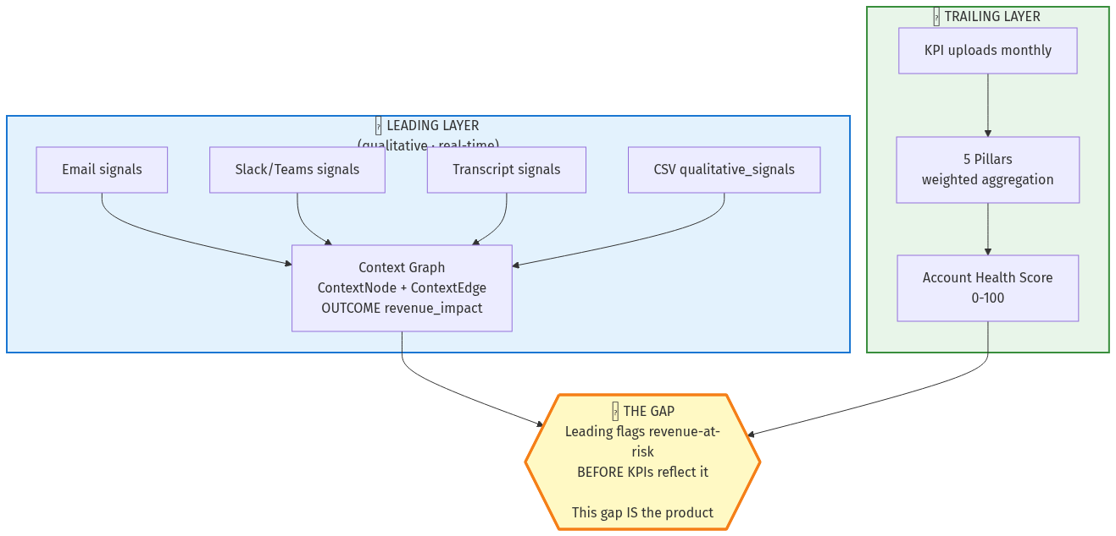
Figure 1 — The two-layer indicator model. Leading layer (signals → context graph) flags revenue-at-risk before KPIs reflect it; trailing layer (KPI rollup) is mathematically rigorous but lagging. The gap between them is the product.
Layer | What it is | Latency
Leading (qualitative) | Signal-driven revenue outcomes. Email/Slack/transcript signals → context graph OUTCOME nodes → revenue-impact attribution. Captures things that haven't yet shown up in the KPI numbers — champion loss, executive sponsor change, NPS decline, escalation patterns. | Real-time as signals arrive
Trailing (quantitative) | KPI rollup health score. Pillars (5) → KPIs (9–43) → weighted aggregation → account health. The traditional CS health score, mathematically rigorous, but lags reality by ~30–90 days because it's KPI-driven. | Monthly with KPI uploads
The GAP between the two layers IS the product. When the leading layer shows revenue-at-risk that the trailing layer doesn't yet reflect, that's CS Pulse's value-add — early warning. When the trailing layer shows risk the leading layer doesn't flag, that's where weight calibration (Wizard C) gets re-examined.
Critical operational consequence: DO NOT filter the narrative layer as a default. It looks 'noisy' compared to the KPI layer because it captures things KPIs don't — but filtering it hides the USP. Apr 20–21 demo session validated this; it's design intent from day one.

1.2 Investment Allocation Intelligence (the positioning)
Per session memory positioning_investment_allocation_intelligence.md, CS Pulse's core positioning to CFO/CRO buyers is: tells CRO/CFO where every CS dollar should go. Built CFO-first (proof — historical defensibility) and CRO-second (growth opportunity — forward expansion). Investment is scaled in Power-of-1 scenarios at 1–2.5% of ARR — not per-playbook unit costs.
This framing changes how every demo flows. Don't lead with 'we score account health.' Lead with: 'every dollar of your CS budget needs an attribution chain back to revenue — and a forward projection. We give you that, in three lenses, with audit-grade provenance.'

1.3 Two-phase product vision
Per session memory project_vision_two_phases.md:
Phase | What it means
Phase 1 (today) | Intelligence layer over existing SoR — sits on top of Salesforce, Gainsight, etc. via CSV onboarding + future SoR connectors. Customer keeps their CRM as the source of truth; CS Pulse provides intelligence + AI surface + governance. ~99% of current deployments.
Phase 2 (roadmap) | AI-native system of record. Replace the CRM for CS workflows entirely — direct ingest from email/Slack/transcripts, native renewal pipeline, native playbook execution. Gated on customer demand + base-dev capacity. Not in active development; vision target.

2. The Three Layers of AI (defensible AI narrative)
Per session memory positioning_three_layers_of_ai.md — CS Pulse's defensible AI narrative for AI-DD reviews. Each layer is a concrete subsystem with named technology. The win: 'AI-native CS platform, three complementary AI layers; competitors have one, none have all three.'

2.1 The three layers
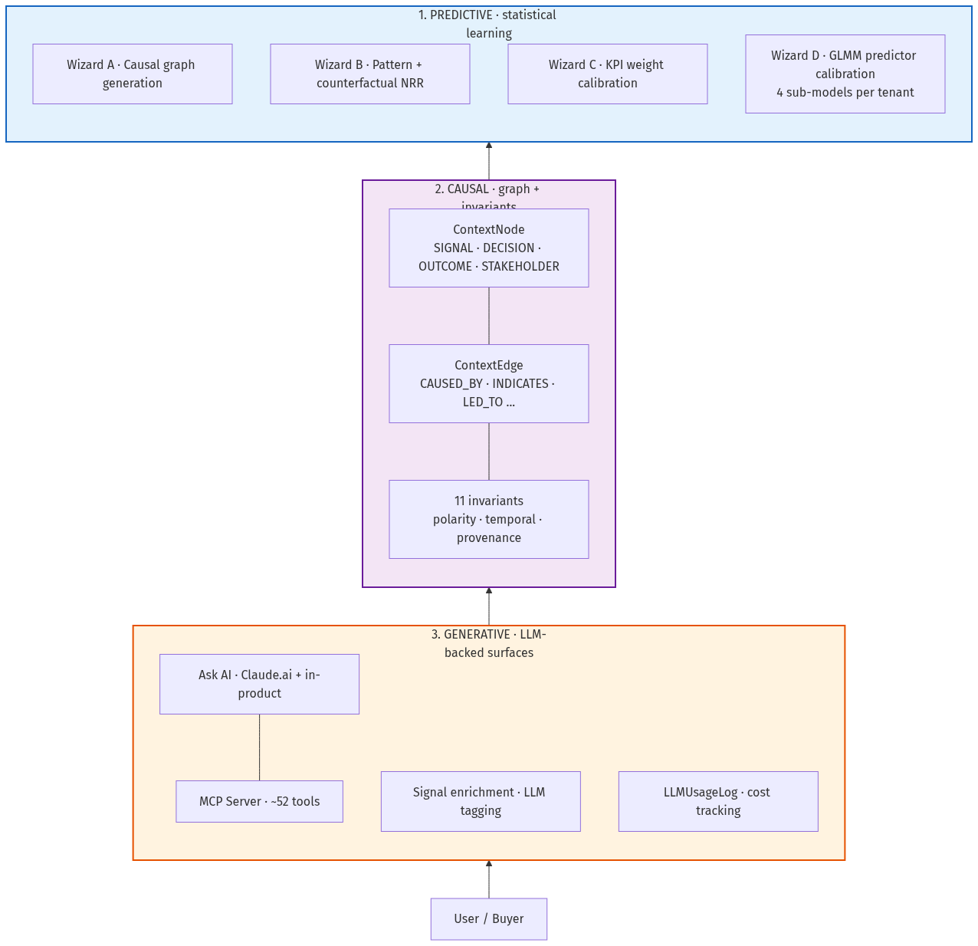
Figure 2 — The three layers of AI in CS Pulse. Bottom-up: user/buyer hits the Generative surface (Ask AI + MCP); generative calls into the Causal layer (context graph + invariants) for trustworthy answers; causal layer leans on the Predictive layer (the 4 wizards) for statistical signal. Competitors typically have one layer; none have all three.
Layer | What it does | Named technology
Predictive (statistical learning) | Forecasts NRR per account on 12mo horizon. Calibrates KPI + signal weights per tenant. Detects pattern signatures across accounts. | Wizard B (counterfactual pattern analysis), Wizard C (KPI weight calibration), Wizard D (GLMM-calibrated predictor v3). Pre-Bayesian frequentist hierarchical model today; Bayesian variant on roadmap.
Causal (graph + invariants) | Maintains a typed, weighted, temporal graph of signals → decisions → outcomes per account. Enforces polarity invariants (a positive signal can't cause a negative outcome). Provides the trace 'why is this account at risk' that the AI surface relies on. | ContextNode + ContextEdge ORM tables, Wizard A (causal graph generation), 11 graph invariants validated in CI + pytest + audit CLI.
Generative (LLM-backed surfaces) | Ask AI tool calls + natural-language summaries. Signal enrichment (LLM tagging of unknown signal subtypes). Explanation generation for forecast drivers. Prompt registry for governance. | Anthropic Claude (primary) + OpenAI (selectable per tenant). MCP server (~52 tools), prompt registry, LLMUsageLog for cost tracking, BYOK roadmap.

2.2 Naming discipline
NEVER call Wizards B + C 'generative AI' in technical or AI-DD contexts. They're predictive ML — statistical hierarchical models, not LLM generation. Confusing the categories has bitten us before; reviewers anchor on it and lose trust. The shorthand 'AI' in customer conversations is fine; the precise terms apply when the buyer's technical team asks.
- Wizards A/B/C/D = Predictive (with A also being causal graph generation).
- Ask AI, signal enrichment, narrative generation = Generative.
- Context graph + invariants = Causal.

2.3 Trust levers (V45 trust framework)
Per session memory the V45 deck enumerates trust levers used in buyer pitches. Levers #6 (self-calibrates from YOUR outcomes — Wizard C) and #7 (per-account explainability — context graph + GLMM drivers) are the strongest defensibility claims. Don't make claims the code can't back; the Apr 27 roadmap note (roadmap_wizard_c_learn_from_context_graph.md) is the prototype gap to close before AI-DD pressure mounts on lever #6.

3. Module Surface (10 modules)
The platform image exposes ten top-level modules. As tech lead you'll touch all of them within your first month. This section is the map; the Technical Deep Dive (doc #3) goes into implementation per module.
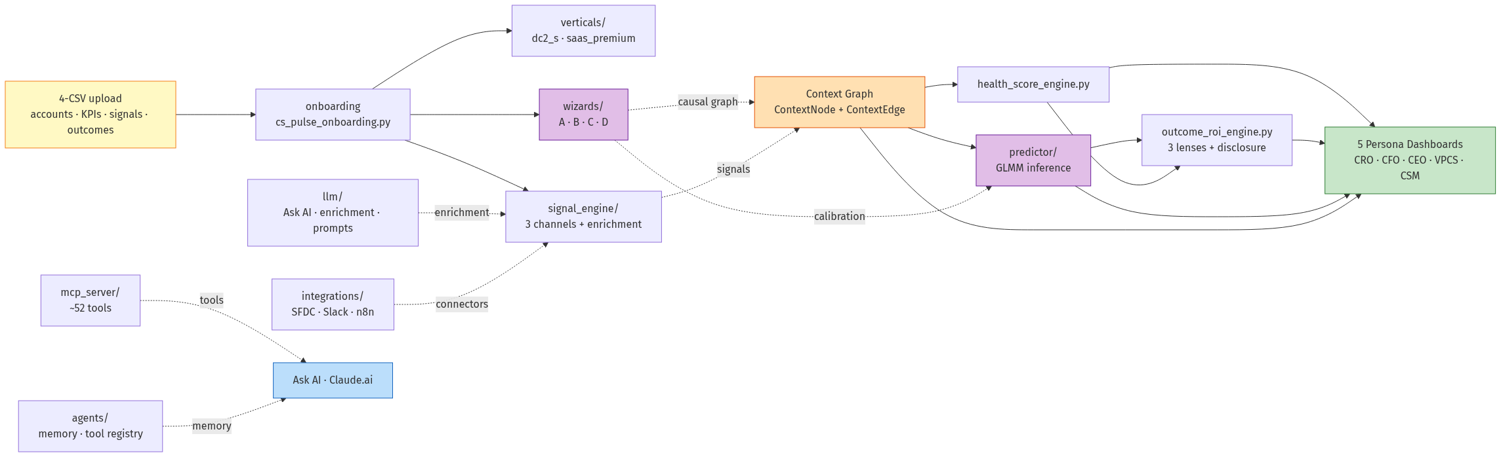
Figure 3 — Module surface + data flow. Yellow = customer upload; purple = wizards + predictor (the predictive core); orange = context graph (the causal layer); blue = AI chat surfaces; green = persona dashboards. Solid arrows = primary data path; dotted = subordinate / enrichment paths.
Module | Capability | Change ownership
predictor/ | Per-account forward NRR forecasting on 12-month horizon. Provides portfolio rollup and per-account explanation surface. GLMM-based. | Base dev
wizards/ | Wizard A (causal-graph generation), Wizard B (pattern + counterfactual analysis), Wizard C (KPI weight calibration), Wizard D (predictor recalibration). | Base dev
signal_engine/ | Qualitative-signal ingestion, deduplication, enrichment, urgency classification, alert dispatch. Three channels: CSV (default), live email forwarding, live Slack/Teams webhooks. | FDE wires channels per tenant; engine itself is base-dev
verticals/ | Vertical-specific KPI catalogs, pillar weights, and overlays. Default verticals: dc2_s, saas_premium. Customer overlays live here under verticals/customer{N}-{vertical}/. | FDE owns customer overlays; base dev owns vertical modules
mcp_server/ | MCP tool surface — ~52 @mcp.tool-decorated callables that expose the platform to Claude.ai, Ask AI, and external agents. | Base dev owns signatures + auth
outcome_roi_engine.py | Historical proof and forward projection of CS ROI using Power-of-1 scaling. Three layers: historical / forward / bridge. Disclosure logic for non-repeatable historical gains. | Base dev
health_score_engine.py | Account-level health score derived from KPI rollups with reference-range scoring. Loads weights from CustomerConfig → bootstrap_weights_config.json → kpi_definitions.py fallback chain. | Base dev
agents/ | Agent memory, tool registry, event subscribers for autonomous workflows. Memory + recall via memory_remember / memory_recall MCP tools. | Base dev
llm/ | LLM-backed features: Ask AI, signal enrichment, explanation generation, prompt registry, cost tracking (LLMUsageLog table + record_usage discipline). | Base dev
integrations/ | Third-party connectors — Salesforce, Slack, email (SendGrid inbound), webhook receivers, n8n workflow handoff. | FDE configures per tenant; base dev owns connector code

3.1 Customer-facing surfaces (what each module contributes)
Five persona dashboards plus Ask AI consume from the modules above. The lookup is roughly:
- CRO Dashboard ← predictor/ + signal_engine/ + outcome_roi_engine.py + context graph
- CFO Dashboard ← outcome_roi_engine.py + predictor/ + wizards/ (Wizard B for counterfactual) + context graph
- CEO Dashboard ← predictor/ portfolio rollup + signals summary
- VPCS Dashboard ← wizards/ + signal_engine/ + per-CSM aggregations
- CSM Cockpit ← signal_engine/ + recommendations engine + context graph drill-down
- Ask AI (both Claude.ai + in-product) ← mcp_server/ tool catalog

4. Multi-Tenant Architecture

4.1 The customer entity
Every tenant is a Customer row in the customers table (kpi-dashboard/backend/models.py:11). Tenant isolation is enforced at every query boundary — there is no cross-tenant data leakage path by design. Every API call must resolve to a customer_id; the auth middleware (auth_middleware.py:get_current_customer_id) blocks requests that can't.
Field | Role
customer_id (int) / uuid (str) | Primary key + UUID. Both work as identifiers (post UUID migration). UUID preferred in new code; integer ID still works for backwards compatibility.
vertical | First-class vertical: dc2_s or saas_premium today. Drives KPI catalog, pillar labels, playbook archetypes.
tier | Subscription tier — enterprise, etc. Drives entitlements.
allowed_account_ids (CustomerApiKey) | Per-key account scoping — supports per-CSM API keys that only see their book.
profile_metadata (JSON) | Flexible per-tenant config — sub-vertical (saas_enterprise vs saas_startup), industry vertical labels, CSM org structure.

4.2 The vertical layer
Two first-class verticals (dc2_s, saas_premium) loaded via utils/vertical_registry.py with a DB → JSON catalog → Python fallback chain. The JSON catalog approach is ~80% complete: new verticals can be added by dropping a JSON file in config/, with no Python deploy required for KPI catalog changes.
What's verticalized — see User Perspective Guide §5.1 for the full table. Critical things the tech lead should know are first-class-per-vertical:
- KPI catalog (verticals/{vertical}/kpi_definitions.py + config/{vertical}_kpi_catalog.json)
- Playbook templates (vertical_config.py) — PR #26 fixed a long-running bug where SaaS tenants got DC playbooks system-wide
- Pillar labels rendered on dashboards (PR #35 wired drill-drawer consumption)
- Wizard D calibration — one (customer × vertical × profile × sub_model) row per active calibration

4.3 The customer phase layer (lifecycle gating)
Customer phases drive dashboard tile visibility. See User Perspective Guide §6 for the user-side view. Architecturally:
- Phase is COMPUTED at request time, not stored. PRE-DEPLOY / ONBOARDING / ACTIVE / MATURE derived from PlaybookExecutionV2 row count + (planned) first-PB-execution timestamp.
- Phase determines: empty-state copy, tile filtering, disclosure logic, what the persona grader expects.
- CFO Three-Lenses uses customer_phase to gate Lens C visibility. Disclosure logic in outcome_roi_engine.py uses it indirectly via the historical-ROI heuristic.

5. Roadmap State
What's shipped, what's in flight, what's deferred. As tech lead you'll need this to set customer expectations and to prioritize base-dev requests against. Sources: session memory MEMORY.md index, gtm_readiness_assessment.md, governance_15_model_unblock_criteria.md.

5.1 Shipped (production-ready as of May 22 2026)
- CFO Three-Lenses with full A/B/C honesty UI (PR #38 Phase 0–2, PR #43 Wizard B label fix).
- CRO Phases 0–5 honesty UI (commit 904184fed) — metric guide, context-graph strip, pre-proof banner, ARR exposure footnote, period_meta echo, Phase 5 proof path.
- Pending Decisions Queue v1 (PR #39) — exec-altitude action list on CRO + CFO sidebars.
- Historical ROI disclosure (PR #20 backend + PR #40 UI) — auditor-grade caveat when non-repeatable gains dominate.
- Account-column ORM drift audit (PR #32) + Flask + MCP duplication-drift audit (PR #37) — both now CI gates.
- EC2 acceptance harness (commit dfae039f5) — scripts/run_acceptance_ec2.sh + ACCEPTANCE_* env knobs + persona grading orchestration.
- FDE KT versioned (PRs #41/#42) — playbook v1.2, discovery workbook, eval reports, generators.
- Predictor v3 (Wizard D-calibrated GLMM) — 4 sub-models per (customer × vertical × profile), portfolio rollup live for cust 334.
- Persona grading framework (tests/persona_grading) — 5 personas × 5–7 questions, LLM-as-judge with letter grades, ~$3–5/run.

5.2 In flight / pending
- Real bootstrap CIs (replace ci_method: placeholder_uncalibrated) — Phase 1 task #4 in the NRR roadmap. CRO-3/4/8 + CFO-10 stay partial-credit until this lands.
- CFO-2 product question — should realized defensive ROI surface from outcome CSVs at ingest, or only from closed playbook executions over time? Carries from v3 eval reports.
- Wizard C edge-aware weight column (Tier 2 calibration) — secondary column consuming context graph trustworthy-edge count. Trigger: ≥3 customers with ≥30 LLM-enriched edges + AI-DD probe.
- Wizard C should learn from context-graph OUTCOMEs (not HealthScore) — roadmap_wizard_c_learn_from_context_graph.md. Closes V41/V44/V45 pitch claims that are currently ahead of code.
- Decision Queue write-back v2 — state transitions (approve/escalate/defer), ContextNode audit trail, notification fan-out. Conditional on customer feedback after the next round of demos.
- Bayesian Wizard D (tenant_bayes fit_type) — gated on data volume + statistical hire.
- Per-customer Anthropic API key (BYOK) — column exists in plan, 18 callers currently bypass the resolution helper. ~half-day finish; only promote out of backlog when a buyer asks.
- Cross-product uncertainty propagation — 5 user-facing point estimates (health, RaR, ROI, NRR, renewal-prob) ship without CIs today. ~1wk/surface for disclosure tier.

5.3 Governance roadmap
Per project_governance_layer_apr20.md, the platform shipped 7 governance docs in April 2026: AI_GOVERNANCE_FRAMEWORK + MODEL_INVENTORY (15 models) + CHANGE_MANAGEMENT + AUDIT_TRAIL_REQUIREMENTS + DRIFT_MONITORING + GOVERNANCE_ROADMAP (beta disclosure) + SOC2/RBAC v1.1 refresh.
15-model unblock fast path (per governance_15_model_unblock_criteria.md):
- MOD-007 prompt register — first unblock.
- MOD-002 approval gate — closes 9 of 15 by reuse.
- MOD-008 admin UI — completes the wave.
- MOD-003 (renewal probability model) + MOD-012 — hard-blocked, separate launch decision required.

5.4 Phase 2 vision (AI-native SoR)
Replacing the customer's CRM-as-SoR for CS workflows. Direct ingest from email/Slack/transcripts (already exists as signal engine), native renewal pipeline (gap), native playbook execution (partial — PlaybookExecutionV2 exists, customer-self-service playbook authoring does not). Not in active development; framed as a 2-year vision.

6. Competitive Positioning
Tech lead should be able to articulate why a customer would pick CS Pulse over Gainsight, Catalyst, or a roll-your-own. The competitive matrix (per session memory Session 10 ref + GTM decks) anchors on three axes.

6.1 Three competitive axes
Axis | What CS Pulse claims | Where competitors fall short
Revenue attribution | Every CS dollar back to a specific playbook + outcome (Lens C bottom-up). Audit-traceable to Salesforce renewal records. | Most platforms measure CSM activity volume (touches, email sends, QBR cadence). They don't roll up to attributed revenue with audit-grade provenance.
Forward forecast with CIs | Predictor v3 — per-account 12mo NRR forecast with calibrated 90% CI bands. GLMM per (customer × vertical × profile × sub_model). Driver attribution via feature contributions. | Most platforms ship rule-based 'churn risk score' without statistical calibration, no CI bounds, no driver decomposition.
AI surface depth | ~52 MCP tools exposing every analytical surface. Native Claude.ai integration. Persona grader regression-tests AI quality. Anti-hallucination contract enforced. | Most platforms have a chat-bot widget that summarizes their own dashboards. They don't expose tool calls to external AI; they don't have a regression framework for AI quality.

6.2 Three places competitors actually win
- Maturity / market presence: Gainsight is 10+ years deep with thousands of deployments. CS Pulse is < 1 year old in production. Buyer risk-aversion plays in their favor for very-large-enterprise deals.
- Salesforce integration depth: Gainsight Salesforce-edition is the de-facto SoR for many CS teams. CS Pulse is intelligence-layer-over-Salesforce; replacing SF as SoR is Phase 2 vision.
- Reporting templates: Gainsight has decades of pre-built reports for every CS metric anyone has ever asked for. CS Pulse takes a different bet — fewer pre-built reports, deeper AI surface.

6.3 The right way to lose a deal
If a customer prioritizes 'comprehensive Salesforce-native reporting over a rich AI surface' — that's a Gainsight customer. Don't try to win it. Focus CS Pulse pitches on CRO + CFO buyers in PE-backed B2B portfolios where 'where should the next $1M of CS investment go' is the unmet question, and the answer involves forward NRR forecasting + audit-grade attribution.

7. Admin Operations
What an internal admin (or tech lead) actually does day-to-day to operate the platform. Not a runbook — that's in the FDE Playbook §3 — but the structural view of which knobs exist and what they control.

7.1 Feature toggles
Per kpi-dashboard/backend/feature_toggles.py and CustomerConfig DB columns. Toggles are per-customer; flipping one for one tenant doesn't affect others.
Toggle | What it controls | Typical setting
CONTEXT_GRAPH | Whether ContextNode/ContextEdge are populated + queried. Master switch for the two-layer indicator model. | ON for every new tenant (default)
FEATURE_SIGNAL_ENGINE | Platform-level — whether signal_engine/ API surface is registered. Gates live email/Slack/transcript ingest. | ON at the platform level (compose); per-tenant live ingest OFF until DPA signed (see FDE Playbook §2.4)
FEATURE_PREDICTOR_V3_UI | Whether the React UI renders the PredictorV3Tile. False → falls back to Wizard B's older counterfactual tile. | ON for tenants with active Wizard D calibration
FEATURE_ASK_AI_V2 | Whether /api/executive/ask-v2 is wired. Anti-hallucination + tool-routing improvements. | ON globally as of v2.14.7
story_arcs, signal_edges, stakeholder_tracking, decision_lifecycle, outcome_economics, industry_benchmarks | Per-customer sub-toggles for context-graph features. Allow gradual enablement. | Most ON by default; story_arcs requires manifest seed data

7.2 Entitlements
Per-tenant entitlement record (visible on login response) gates feature surfaces. Default enterprise tier has all true. Common entitlements:
- dashboards, data_upload, health_scores, approval_queue, revenue_intelligence — base feature gates
- rag_queries, copilot_integration, multi_provider — AI feature gates
- mcp_connectors — controls whether the MCP server is reachable for this tenant
- agent_loop, agent_memory_shared — agent feature gates (recall + write)
- decision_matrix, playbook_triggers, signal_analyst, power_of_1 — intelligence feature gates
- api_key_self_service — whether tenant admins can issue API keys themselves

7.3 Weight hierarchy (Wizard C source of truth)
Three-tier resolution order. The platform always reads in this priority — DO NOT bypass.
- CustomerConfig DB columns (dc2s_pillar_weights, dc2s_kpi_weights) — Wizard C calibrated, highest priority.
- verticals/customer{N}-{vertical}/journey/config/bootstrap_weights_config.json — FDE-managed customer overlay.
- kpi_definitions.py weight_l1 / weight_l2 defaults — fallback when neither above is set.
All scoring paths (utils/score_calculator.py, verticals/dc2_s/api_routes.py) consume from this chain. NEVER hardcode pillar weights or KPI weights inline — always use the resolver.

7.4 Per-customer Anthropic API key (BYOK — partial)
Today every tenant uses the platform's Anthropic key; cost attribution is per-customer via the LLMUsageLog table. BYOK is partially implemented — get_anthropic_api_key(customer_id) helper exists but the CustomerConfig.anthropic_api_key_encrypted column is missing AND 18 callers bypass the helper to read env directly. Half-day finish; promote out of backlog when a buyer asks. Don't ship marketing claiming BYOK is available.

7.5 Health-score thresholds (standardized)
Centralized in kpi-dashboard/backend/config/health_thresholds.json — single source of truth. NEVER hardcode 70 or 50.
- Critical: 0–49 (score < 50)
- At-risk: 50–69 (50 ≤ score < 70)
- Healthy: 70–100 (score ≥ 70)
Backend imports: utils.health_thresholds. Frontend imports: utils/healthThresholds. API: GET/PUT /api/dc2s/config/health-thresholds (Settings UI can adjust boundaries per tenant). Boundary changes propagate to every tile + every classifier function in the same request.

8. Engineering Principles (what the team holds itself to)
Not aspirational. These are the principles that have caught real bugs in production, encoded in session memory and enforced by CI audits. Read these before opening your first PR.

8.1 Verify model schema before writing queries
MUST DO: run Model.__table__.columns.keys() OR read the model definition before writing any debug/query script. NEVER guess column names from class names. Cost of violation: 30+ minutes chasing phantom bugs (Apr 14 2026 incident — journey_data vs journey_json field name guess caused a full HealthScore-fallback tangent when the data was there all along).

8.2 Revert fixes built on a wrong diagnosis
When you discover a fix was built on a misdiagnosis, git revert it right away. NEVER rationalize keeping dead code as a 'safety net.' It adds DB query overhead, masks future real bugs, and the commit message becomes a lie. If the problem doesn't exist, the fix shouldn't exist.

8.3 Account-column drift audit (PR #32) — CI-enforced
Code that reads acct.<col> for <col> not in the Account ORM model 500s in production. The audit walks AST attr-access; catches all three forms (acct.health_score, acct.assigned_csm, acct.is_active). 9 latent violations were drained from playbook_triggers_api.py alone when the audit first ran. Documented in FDE Playbook §3.11.
Canonical replacements:
- acct.health_score → batched HealthScore-table join
- acct.assigned_csm → (acct.profile_metadata or {}).get('assigned_csm')
- acct.name / status / id / arr → account_name / account_status / account_id / revenue (real column names)
- acct.products (no relationship) → one-shot Product.query distinct lookup

8.4 Flask + MCP duplication-drift audit (PR #37) — CI-enforced
Same logical function lives in mcp_server/*.py AND Flask route file (api_v1_routes.py, executive_dashboard_api.py, outcome_roi_api.py, playbook_recommendations_api.py). When one is fixed, the other drifts silently. Buyer demos hit either path depending on entry point. 3 real instances landed in May 2026 — B-1 (team_capacity health), PR #30 (team_capacity response shape), PR #33 (vertical routing). The audit catches signature_drift, response_key_drift, helper_drift.

8.5 Shift-left validation
Catch issues upstream, don't expect downstream to validate. Upload validates types/enums/ranges → ingest validates FK/temporal/dedup → wizards assume clean data. The Layer 1 (CSV schema) validator catches 80%+ of customer-side data issues; Layer 2 (FK + temporal cross-CSV) is deferred until a real customer hits it.

8.6 Every LLM call site proven tracked, not assumed tracked
Apr 20 2026 incident — 6 production LLM callers (including MOD-007) were silently bypassing record_usage(). $0.45 of real Anthropic spend invisible to the cost dashboard. Lesson: import / doc / comment is NOT proof; only a grep-verified matching record_usage() call is. Add a record_usage() check to every PR that adds an LLM caller.

8.7 Governance limitations auto-spawn a CR
Tier-1 model-card 'known limitations' are NOT documentation — they're pending CRs (change requests). Apr 20 incident — MOD-004 'Layer C flags but does not block' known limitation got logged not CR'd; surfaced in buyer AI-DD the next day. Treat governance limitations as actionable backlog, not as disclosure-only.

8.8 Intuitive file naming
File names should let a reader infer purpose without opening the file. build_panel.py not panel.py. Pair files with companions (build_panel.py ↔ build_panel.sql). Drop the package name inside domain folders. Established May 7 2026 with predictor/panel.py → build_panel.py rename.

8.9 Cold-start sanity step after every rebuild
Per principle_cold_start_sanity_rebuild.md — every rehydrate/rebuild MUST be followed by a 5-minute cold-start probe (register new tenant via load-driver, exercise every MCP tool end-to-end, walk all 5 dashboards). Second proof point came May 17 when bug B-1 sat latent for 6 weeks because nobody ran end-to-end after the May 12 rebuild.

9. Where to Go Next
You now have the strategic + structural view. Read sequence:
- CSPulse_Technical_Deep_Dive.docx (doc #3) — implementation internals. The four wizards in depth, Predictor v3 GLMM math, context graph + invariants, signal engine pipeline, DB schema, LLM cost tracking. ~45 min read.
- CSPulse_FDE_Playbook.docx (in gtm-decks/fde-kt/) — operational + deploy. Most useful for understanding the customer-facing engagement model.
- MEMORY.md (in ~/.claude/projects/.../memory/) — session memory index. The deepest source of decision history; cross-references topic files (positioning, governance, roadmap, etc.).
First practical exercise after the three KT docs: open kpi-dashboard/backend/wizards/wizard_d_predictor_calibrator.py and trace one calibration end-to-end — what trigger_wizard('d') does, what coefficients it writes to predictor_calibrations, how predictor/inference.py reads them, how they surface on the CFO dashboard's FORECAST NRR tile. That single trace gives you the full predictive-AI layer in your head.
─── End of Document 2 (Vision, Roadmap & Architecture) ───

