Work case 2

Made by Yevhen Lytvyniuk

At the beginning I have installed a virtual machine called WMware Workstation and begun to install Linux OS on it.

VMware Workstation lets you create, run, and manage virtual machines. Basic actions include creating machines, installing operating systems, configuring the network, creating snapshots, sharing files, and configuring resources.

At first I had to open a virtual machine app, It looked like this:

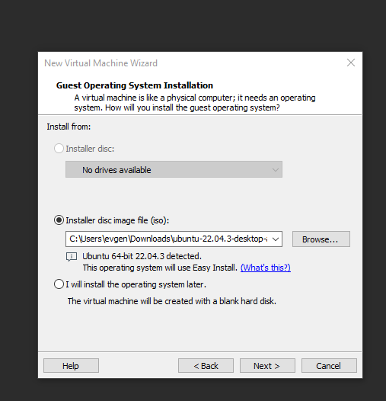

I had to choose my iso file with OS Linux Ubuntu. Than I have made some configuration things like making a username for my Linux system and choose the password.

After all I`ve started a virtual machine on Linux and it was like usual Ubuntu installation: choosing a language of interface, doing some actions with disks and system at all.

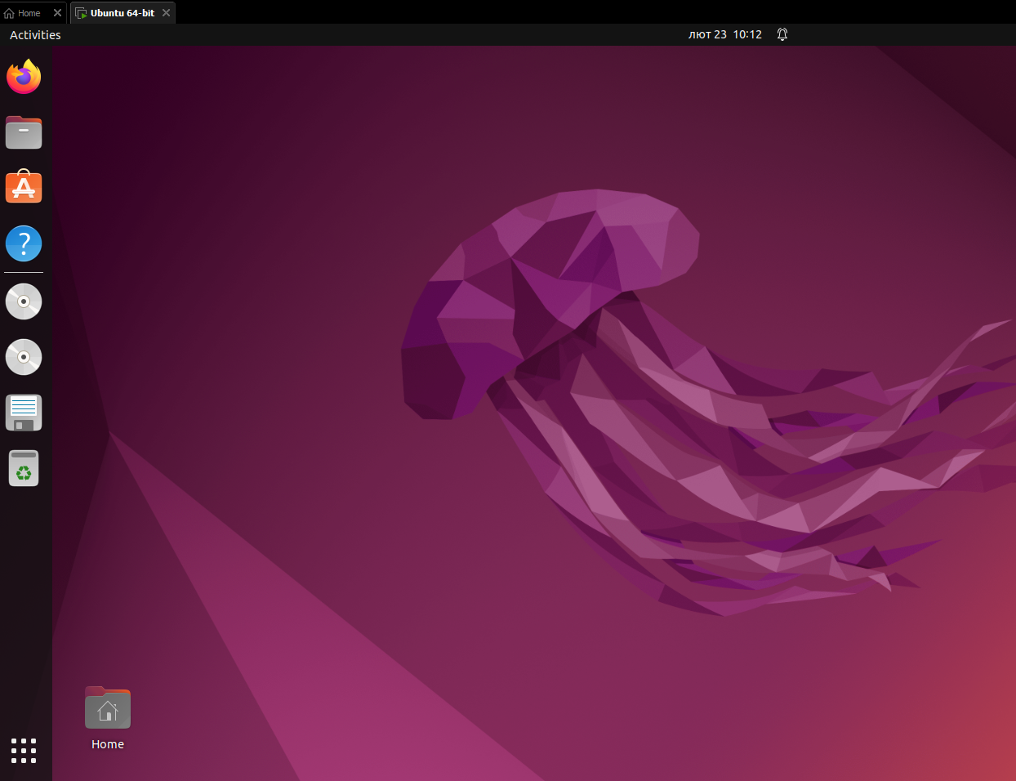

So after that I started installing GNOME graphical shell and everything that it demanded, but before that. I used these commands in terminal:

sudo apt update

sudo apt install gnome-session gdm3

reboot

After rebooting the system I've chosen GNOME in “Gear” on the bottom right on Login Screen.

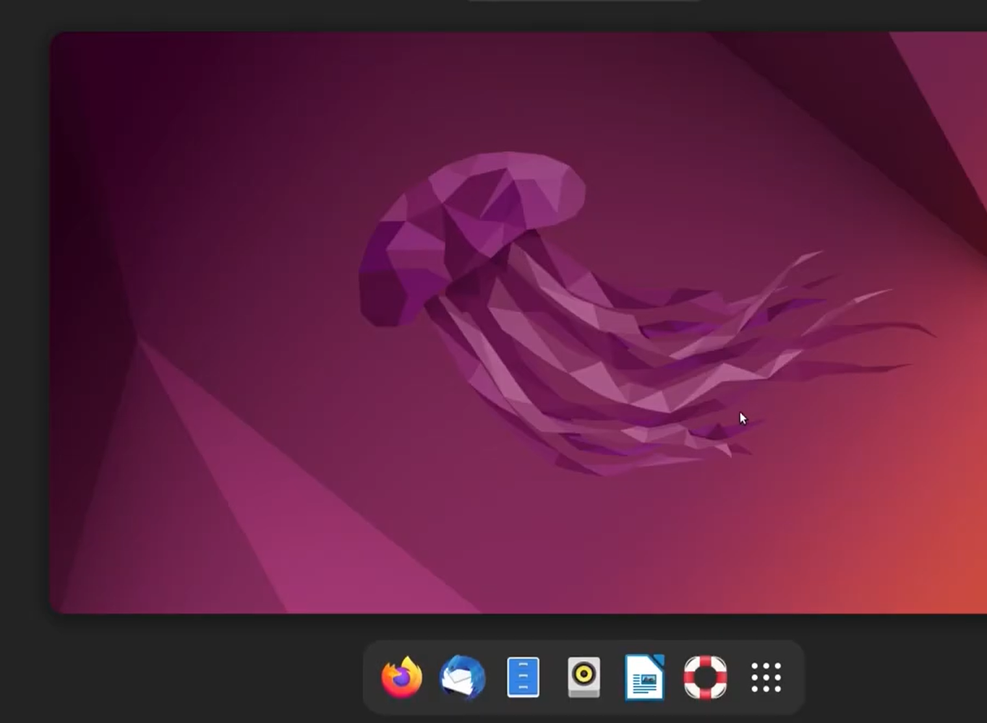

So after that I completely ended doing my task.

P.S. All the processes from the beginning were very hard to do because of the problems and errors that appeared throughout the task. I spent a lot of time for solving those problems and reinstalling all the packages. In my opinion, didn't do the tasks correctly, but I put maximum effort into the task and in parallel I remembered all my English skills)

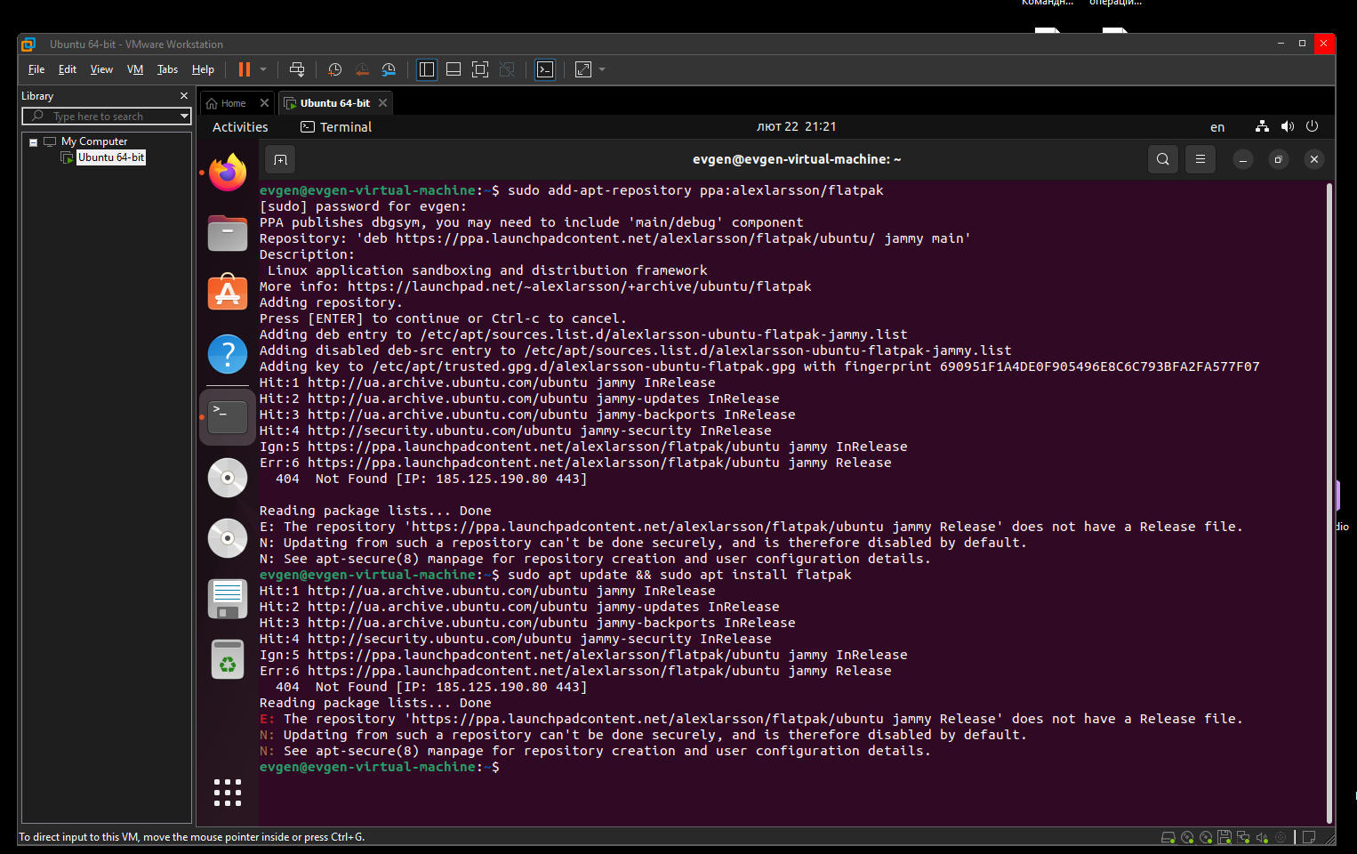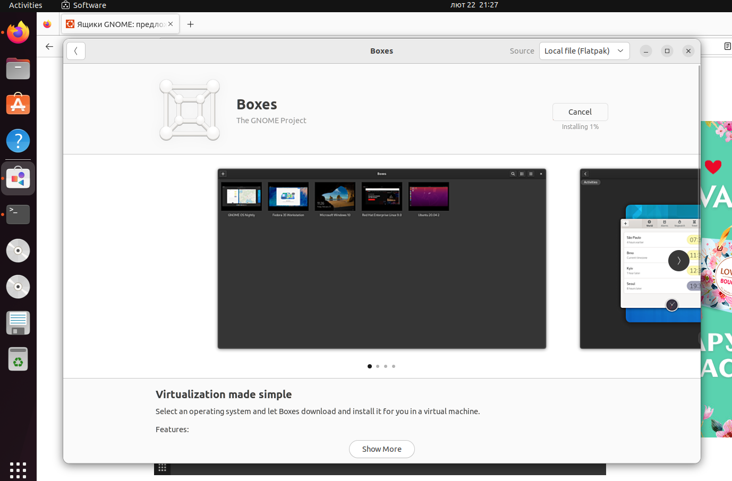

After all these activities I have started a program called GNOME and was preparing a new virtual machine inside a virtual machine ;)

I had to install a ISO file in it one more time, configure some options and create a disk for OS.(And there was a little problem with disk storage, as it turns out, 20GB is not enough for a virtual machine with a virtual machine inside of it;)) You can see it here:  
  
  
Task 2 made by Melikhov Danylo.

**Creating a new virtual machine:**

In the VMware vSphere console interface, select the "Virtual Machines" section.

Click on the "Create / New Virtual Machine" button.

Choose the type of virtual machine (e.g., Windows or Linux).

Set the parameters of the virtual machine, such as the number of processors, amount of RAM, disk space, etc.

Load the operating system image or install it from an ISO file.

**Selecting/adding available hardware for the virtual machine:**

In the console interface, select the virtual machine for which you need to add hardware.

Click on the "Edit Settings" button.

Add new devices such as network adapters, additional disks, USB devices, etc.

Configure the parameters of each device according to the requirements.

**Network configuration and connection to Wi-Fi access points:**

Select the virtual machine and click on the "Edit Settings" button.

Add or configure a network adapter for the virtual machine.

Choose the type of network (standard network or network connected through Wi-Fi).

For Wi-Fi connection, enter the necessary authentication details (SSID, password, etc.).

**Ability to work with external storage (flash memory):**

In the console interface, select the virtual machine.

Click on the "Edit Settings" button.

Add a new USB controller or USB device.

Connect the external storage (flash memory) to the virtual machine by selecting it from the list of available USB devices.