Work case 4

1. Made by Melikhov Danylo

- Дайте розгорнуте визначення таким поняттям як «пакет» та «репозиторій».

* Package:

In the context of software, a package is an archive or compiled unit of software that contains executable code, libraries, configuration files, documentation, and other resources necessary to install and run a program correctly on a particular platform or operating system. Packages are typically used to organize and distribute software, allowing for convenient installation and updating of programs across multiple devices.

* Repository:

A repository is a centralized or distributed repository where software packages are stored along with metadata and other information needed to manage and distribute them. Repositories usually contain not only the source code of packages, but also ready-to-install executables, dependency descriptions, program versions, etc. Repositories are used to organize access to software, update and distribute it, as well as to collaborate on projects between developers.

- Надайте короткий огляд існуючих менеджерів пакетів у Linux. Охарактеризуйте їх основні можливості.

* APT (Advanced Package Tool):

The primary and standard package manager for Ubuntu and its derivative distributions. Provides a simple and convenient way to install, update, and uninstall packages. Allows you to manage package dependencies and resolve conflicts between them.

* Snap (Snapcraft):

A packaging system that allows you to install packages with libraries that are independent of the system. Provides an isolated environment for packages that allows you to install and use different versions of programs on the same computer. Allows users to safely and easily install programs that can be updated automatically.

Made by Bumazhny Mykola

2. Визначте який менеджер пакетів використовує ваш дистрибутив Linux. Опишіть основні команди для роботи з ним:

My Linux distribution, Ubuntu, uses the APT (Advanced Package Tool) package manager to manage software packages. The basic commands for working with APT in Ubuntu include:

* Install package:

sudo apt install package_name

This command installs the specified package and all its dependencies.

* Update the list of packages:

sudo apt update

This command updates the availability and version information of packages from all available repositories.

* Updates installed packages:

sudo apt upgrade

This command updates all installed packages to their latest versions.

* Uninstall a package:

sudo apt remove package_name

This command removes an installed package, leaving its configuration files.

* Complete removal of the package:

sudo apt purge package_name

This command completely removes the installed package along with its configuration files.

* Search for the package:

apt search search_term

This command searches for packages that contain the specified search_term in their names or descriptions.

* Displays information about the package:

apt show package_name

This command displays detailed information about the specified package, such as version, description, and list of dependencies.

3. Made by Lytvyniuk Yevhen

1) VLC Media Player

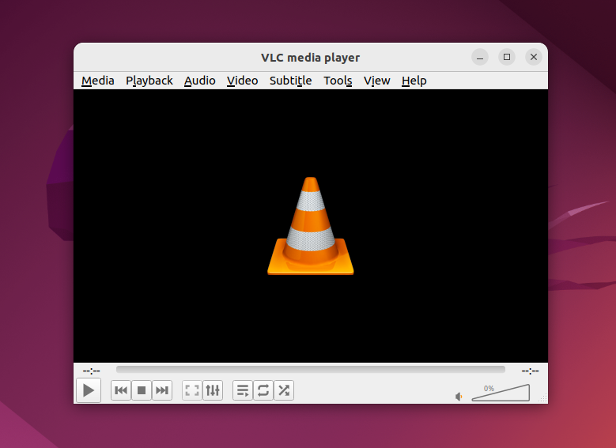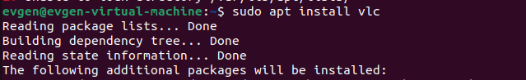

2)VS Code

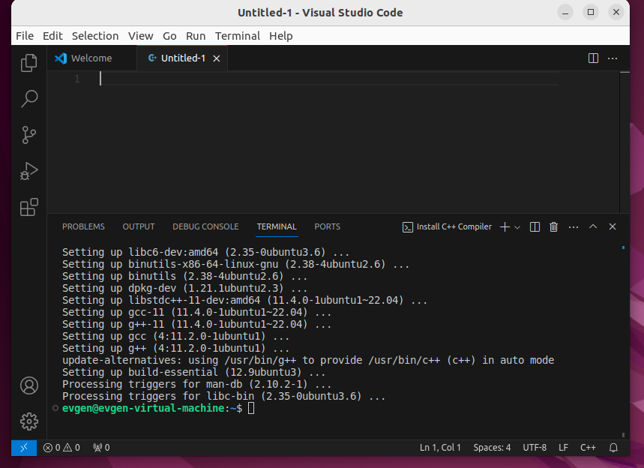

4.

* The Ubuntu Software application store:

The Ubuntu app store makes it easy to find and install a variety of applications. To do this, you usually need to open Ubuntu Software, find the desired application using the search or categories, and then click the "Install" button.

For example, you can find and install the well-known text editor VS Code by simply searching for "Visual Studio Code" in the store and clicking the "Install" button.

* Synaptic package manager:

Synaptic is a graphical interface for managing packages in Ubuntu. It allows you to install, uninstall, and update packages, as well as manage dependencies.

After installation, open Synaptic, enter your administrator password to gain access, and use the search and selection options to find and select packages to install.