DDoS Attack Simulation using Kali Linux and an Apache2 Web Server

Contents:
- DDoS Definition
- What is Kali Linux
- What is a Web Server
3.1 HTTP vs HTTPS
3.2 HTTP Methods
- The Cyber Kill Chain
4.1 Reconnaissance
4.2 Weaponization
4.3 Delivery
4.4 Exploitation
4.5 Installation
4.6 Command and Control
4.7 Actions on Objectives
- Simulating The Attack
5.1 Setup and Tools
5.2 Steps to Execute the Attack
5.3 Observations and Impact
- Conclussions

1. DDoS Definition
According to Fortinet a DDoS (Distributed Denial of Service) attack is a cybercrime where the attacker floods a server with internet traffic to prevent users from accessing connected online services and sites.
The reason for such a cybercrime varies based on the attacker motifs, which could be revenge (the attacker being a former employee), exploiting cyber weakness, gain attention and therefore popularity within the hacking community, financial reasons (installing ransomware on the servers) or even to express disapproval regarding something that the target company is doing.
The largest attack of this kind occured in February 2020 to AWS (Amazon Web Services) overtaking an earlier attack on GitHub two years prior.
Due to the attack’s low level of complexity, the number of such attacks has increased. For example, in this blog, Cloudflare states that last year their autonomous DDoS defense systems automatically detected and mitigated 8.5 million DDoS attacks, where most attacks took place at the Network and Transport Layers of the OSI Model with the rest being Application Layer attacks.

2. What is Kali Linux
As stated on it’s official website, Kali Linux is an open-source, Debian-based Linux distribution which allows users to perform advanced penetration testing and security auditing.
This distribution has several hundred tools, configurations, and scripts with industry-specific modifications that allow users to focus on tasks such as computer forensics, reverse engineering, and vulnerability detection.

3. What is a Web Server
A web server is an endpoint in the internet where users can request a web page through the help of HTTP or HTTPS.
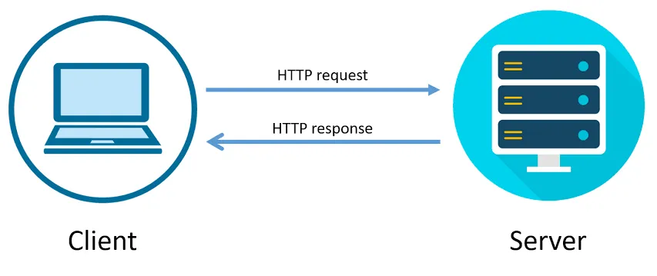Figure 1: Simple HTTP Client-Server Communication

3.1 HTTP VS HTTPS
The main difference between HTTP and HTTPS is that HTTP sends data in plaintext which makes it easier for an attacker situated between the client and the server, to intercept the traffic. HTTPS however, uses encryption for secure communication via TLS (Transport Layer Security) formerly known as SSL (Secure Socket Layer) hence HTTPS is sometimes also referred to as HTTP over TLS or HTTP over SSL.

3.2 HTTP Methods
As mentioned in the MDN documentation on HTTP request methods, HTTP defines a set of methods that indicate the purpose of the request and what is expected if the request succeeds.
The most popular HTTP methods are GET which retrieves data from the server, POST adds data to an existing file or resource, PUT updates or replaces an existing file or resource on the server and DELETE which deletes data from the server.

4. The Cyber Kill Chain
4.1 Reconnaissance
In this step of the kill chain, an attacker gathers as much information as possible about the target (i.e. server IP or vulnerabilities)
4.2 Weaponization
The attacker proceeds to create a malicious tool such as a script to facilitate further steps in executing the attack.
4.3 Delivery
The attack vector is delivered, such as sending packets or initiating requests.
4.4 Exploitation
Quite self-explanatory, the attacker exploits vulnerabilities to achieve their goal.
4.5 Installation
The attacker may install malicious software on the target
4.6 Command and Control
If necessary, the attacker establishes control over the compromised system.
4.7 Actions on Objectives
The final stage of the kill chain which involves the attacker’s goal.
5. Simulating The Attack
The experiment has been conducted in a controlled environment
5.1 Setup and Tools
In order to simulate a DDoS attack we need a target and obviously the attacker machine and eventually a computer system controlled by the attacker.
For this task I’ve started an Apache2 Web Server on a virtual machine running Sparky Linux.
The configurations are as followed:
Install the apache2 service:
sudo apt update
sudo apt install apache2

Start the service:
sudo systemctl start apache2
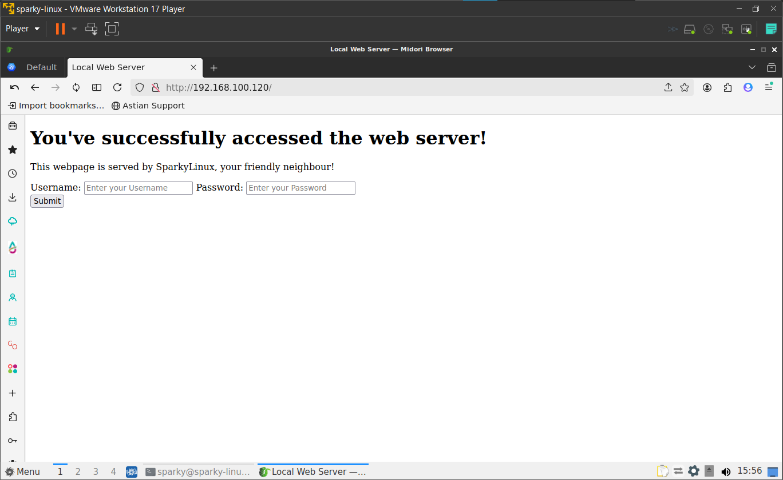
sudo systemctl enable apache2

Check service status:
sudo systemctl status apache2

Create a simple web page:
sudo nano /var/www/html/index.html

Reload the service:
sudo systemctl reload apache2

