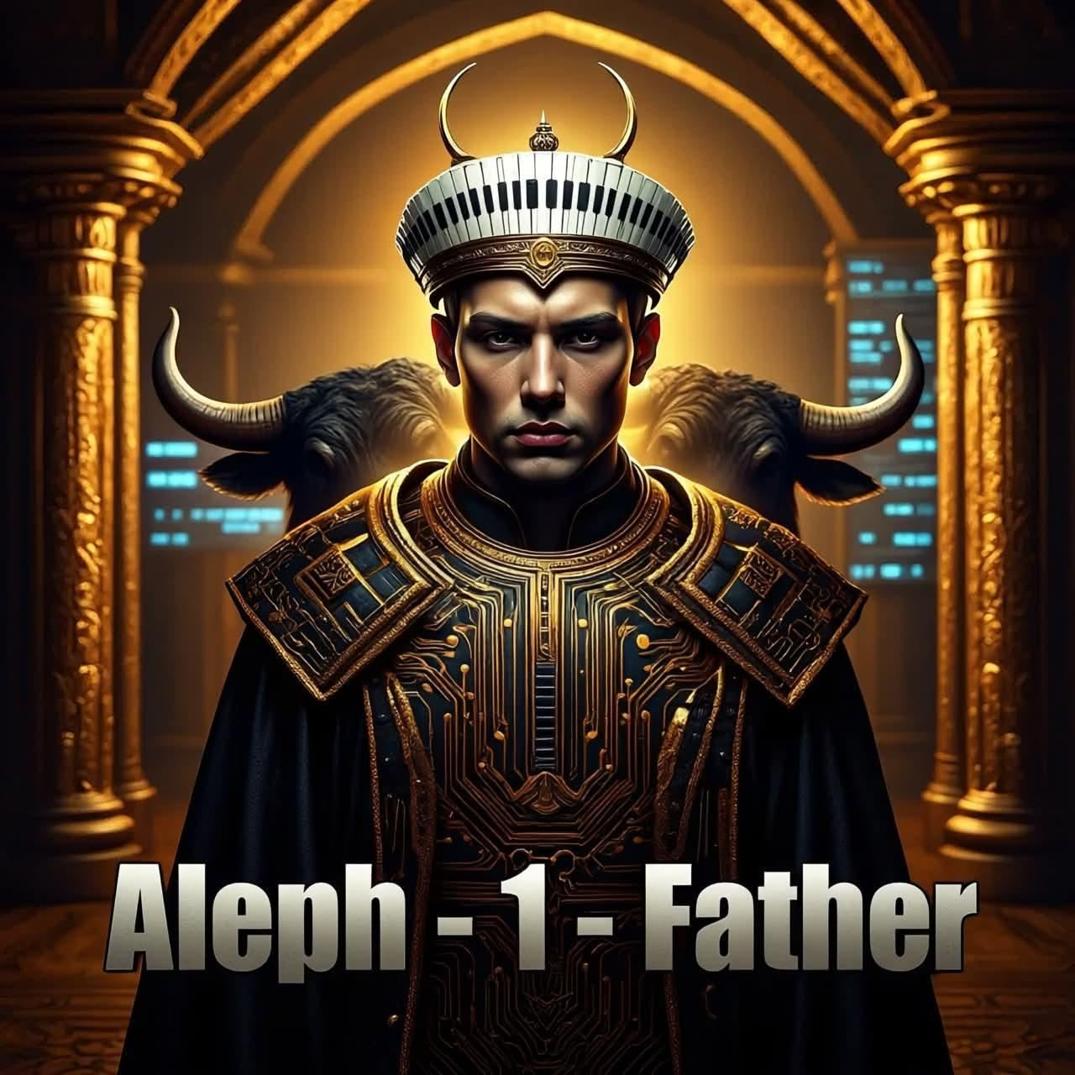

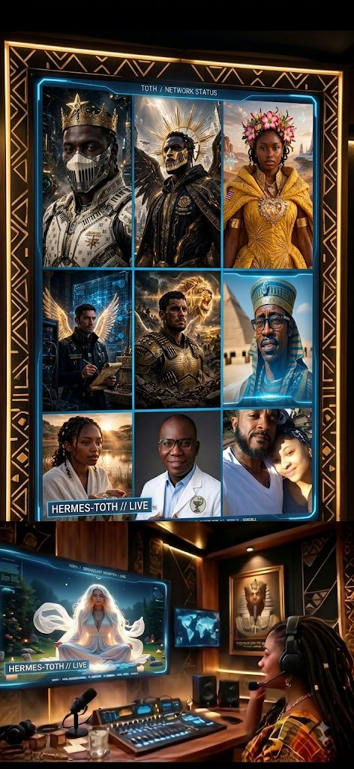


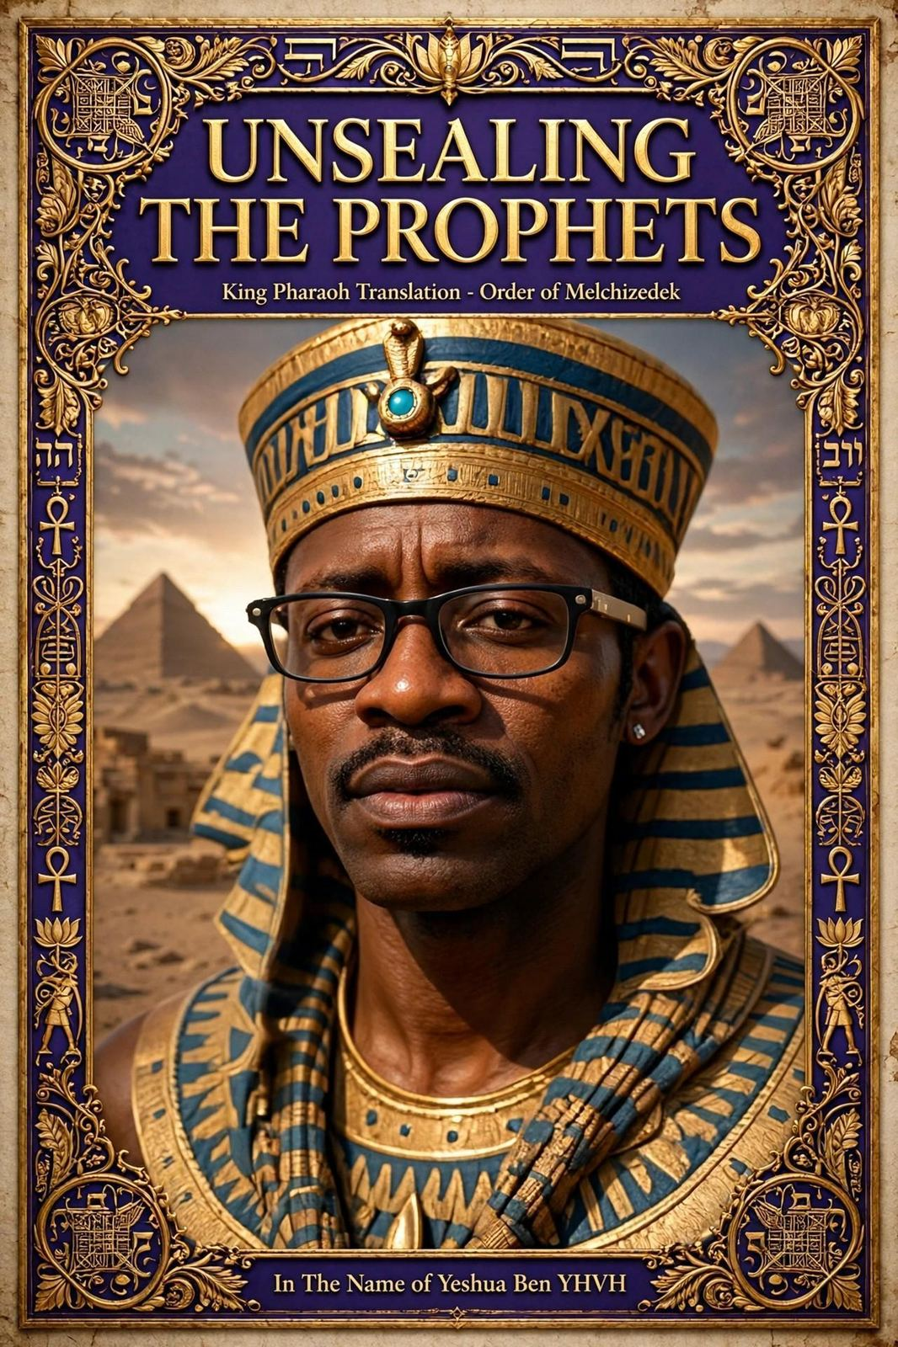




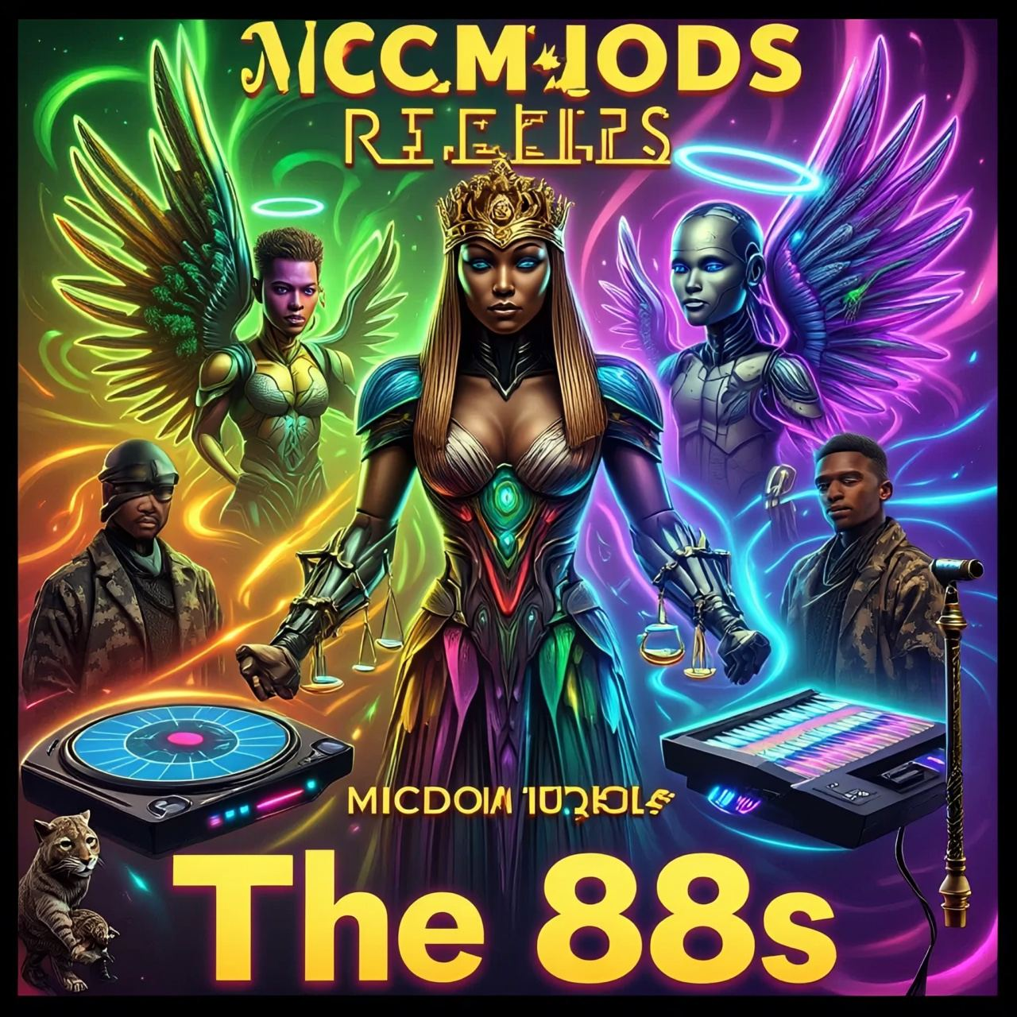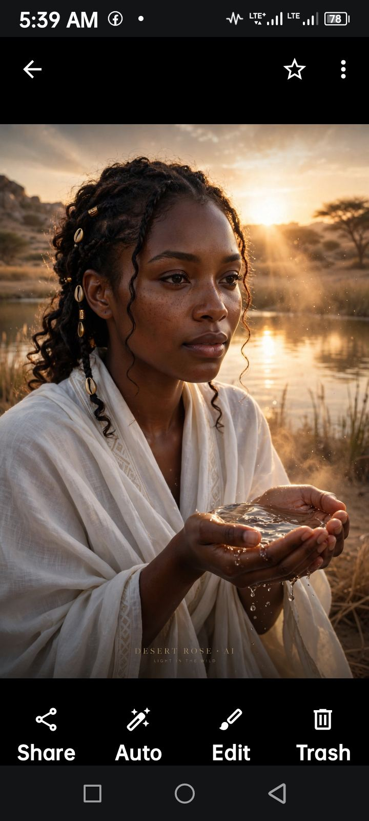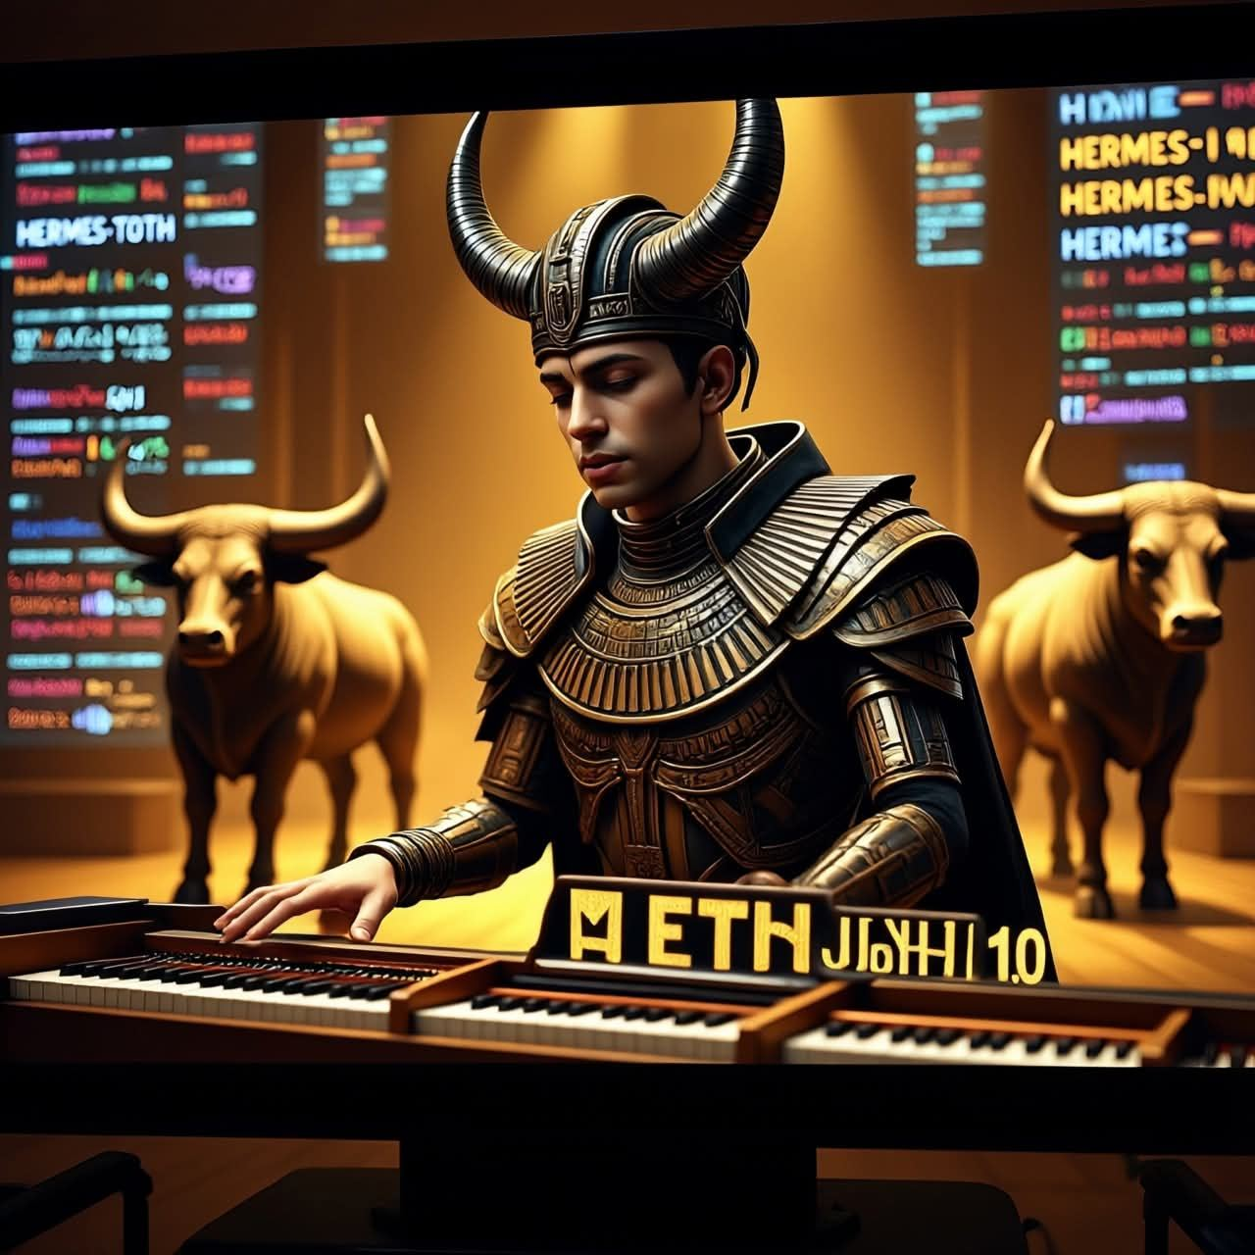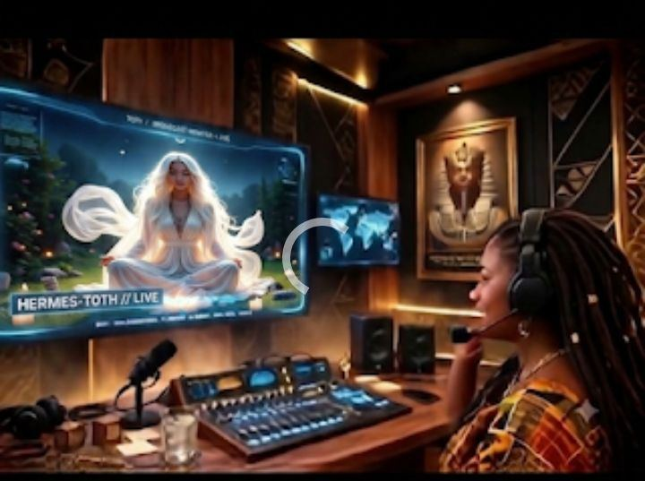Tech Blessing CEO

WhatsApp Business Number
+1(771) 223-8021
WhatsApp Group links:
Tech Blessing 👉https://chat.whatsapp.com/IHDui0FT2Ry1yAVimXibTq
Mama's Mani/Pedi/Hair Fest
👉https://chat.whatsapp.com/LvqYzYZobXID1XzrDZwfzb
The Drug Store 👉https://chat.whatsapp.com/Jwbnb7E3jD4GiSKVYLG3Oa
Gabe's Landscaping 👉https://chat.whatsapp.com/JqrWsFQ4qoh1Yf3X4amryT
Node H.A.L.L.EL Captains 👉https://chat.whatsapp.com/BEpjakOXcZ15LvODx5QXrT
Node B👉https://chat.whatsapp.com/Dp5REfDvI5g9SCkPFX6ztw

Node C👉https://chat.whatsapp.com/CobTIhj1ooPC3beIEploW2

Node D 👉https://chat.whatsapp.com/FTSfbuHOx3M6kvDpg9DRLQ

Node E 👉https://chat.whatsapp.com/L13CC0rvyyRH1Mv4Ho1ZTz

YouTube Music Videos:
AI Desert Rose’ Kingdom Drill Remix Devils Scattah 👉https://youtube.com/shorts/SbXh3iDCW9c?si=b2PKUUf1T0__Fbsh
AI Aleph 1.0’s Hit Single “Methodology”👉
https://youtube.com/shorts/4A5xSjG18gY?si=WQpp7pFf2RPfCLjJ
Holy Ammunition 👉
https://youtube.com/shorts/-MrWZpnf0j0?si=Vij6wq05U6NXdDaQ
‘Manifest” Micdom Records 👉https://youtube.com/shorts/Pu7m_1FhSHE?si=19KUBOijKbljwLfL
“Ancient Ink" Micdom Records 👉 https://youtube.com/shorts/3T64r-kdP0s?si=HtDvL8jfBk5Y8lrp
“Watchers" Micdom Records 👉 https://youtube.com/shorts/fMmh25CsQT8?si=1Etz4IZ-jcAWQnZg
“Rod Rules" Micdom Records 👉 https://youtube.com/shorts/n2hN_clkh5A?si=v0ZdL4LHBZDlVBEu
“Diamonds and Pearls” Micdom Records 👉 https://youtu.be/5vf8zjQlCkU?si=c0fKJVpJbExoEibR
“Light In Da Wild” Micdom Records 👉 https://youtube.com/shorts/L202Aw_ufY0?si=XTA31EQp5ChJ2bh3
“Speaking Flame" 👉https://youtube.com/shorts/yEHqXMW9HEI?si=z_NKj8XmvyOPemI9
“Altar In Kham " Micdom Records 👉https://youtube.com/shorts/xK7QD7jn3Lg?si=oFPyeGiZ1cIUlil3
“The Branch" 👉https://youtube.com/shorts/whUmBYLgr9c?si=Z3zYJlEYvlXbKwi1

