Lagay yung logo sa summary or receipt ng quotation para maging legal document po siya

Yung cost ng mga materials and equipment ay lilipat ilalagay sa admin para ma update yung mga cost

Pero sa quotation itatago sa client yung pricing ng mga materials po

Para backend lahat yung computation since tinatago po yun kadalasan sa mga client

Tangalin yung picture ni host company po sa about us page po at dagdagan po ng before and after po sir

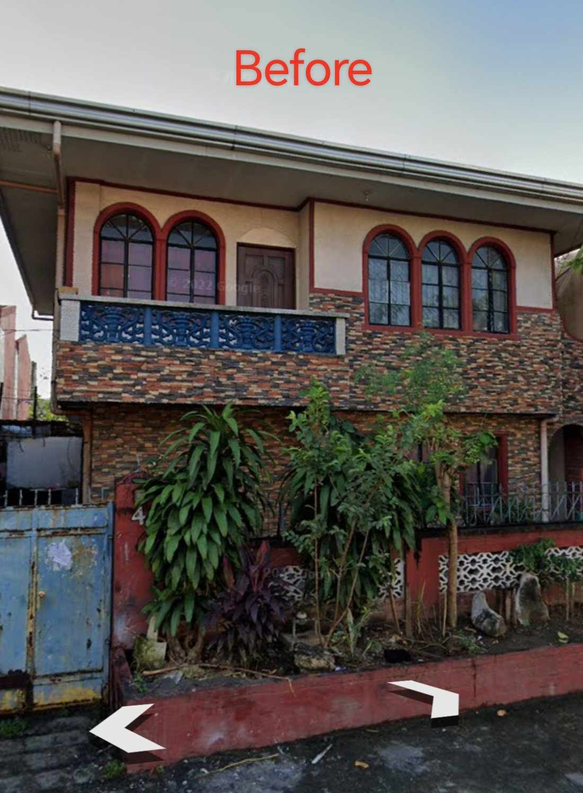

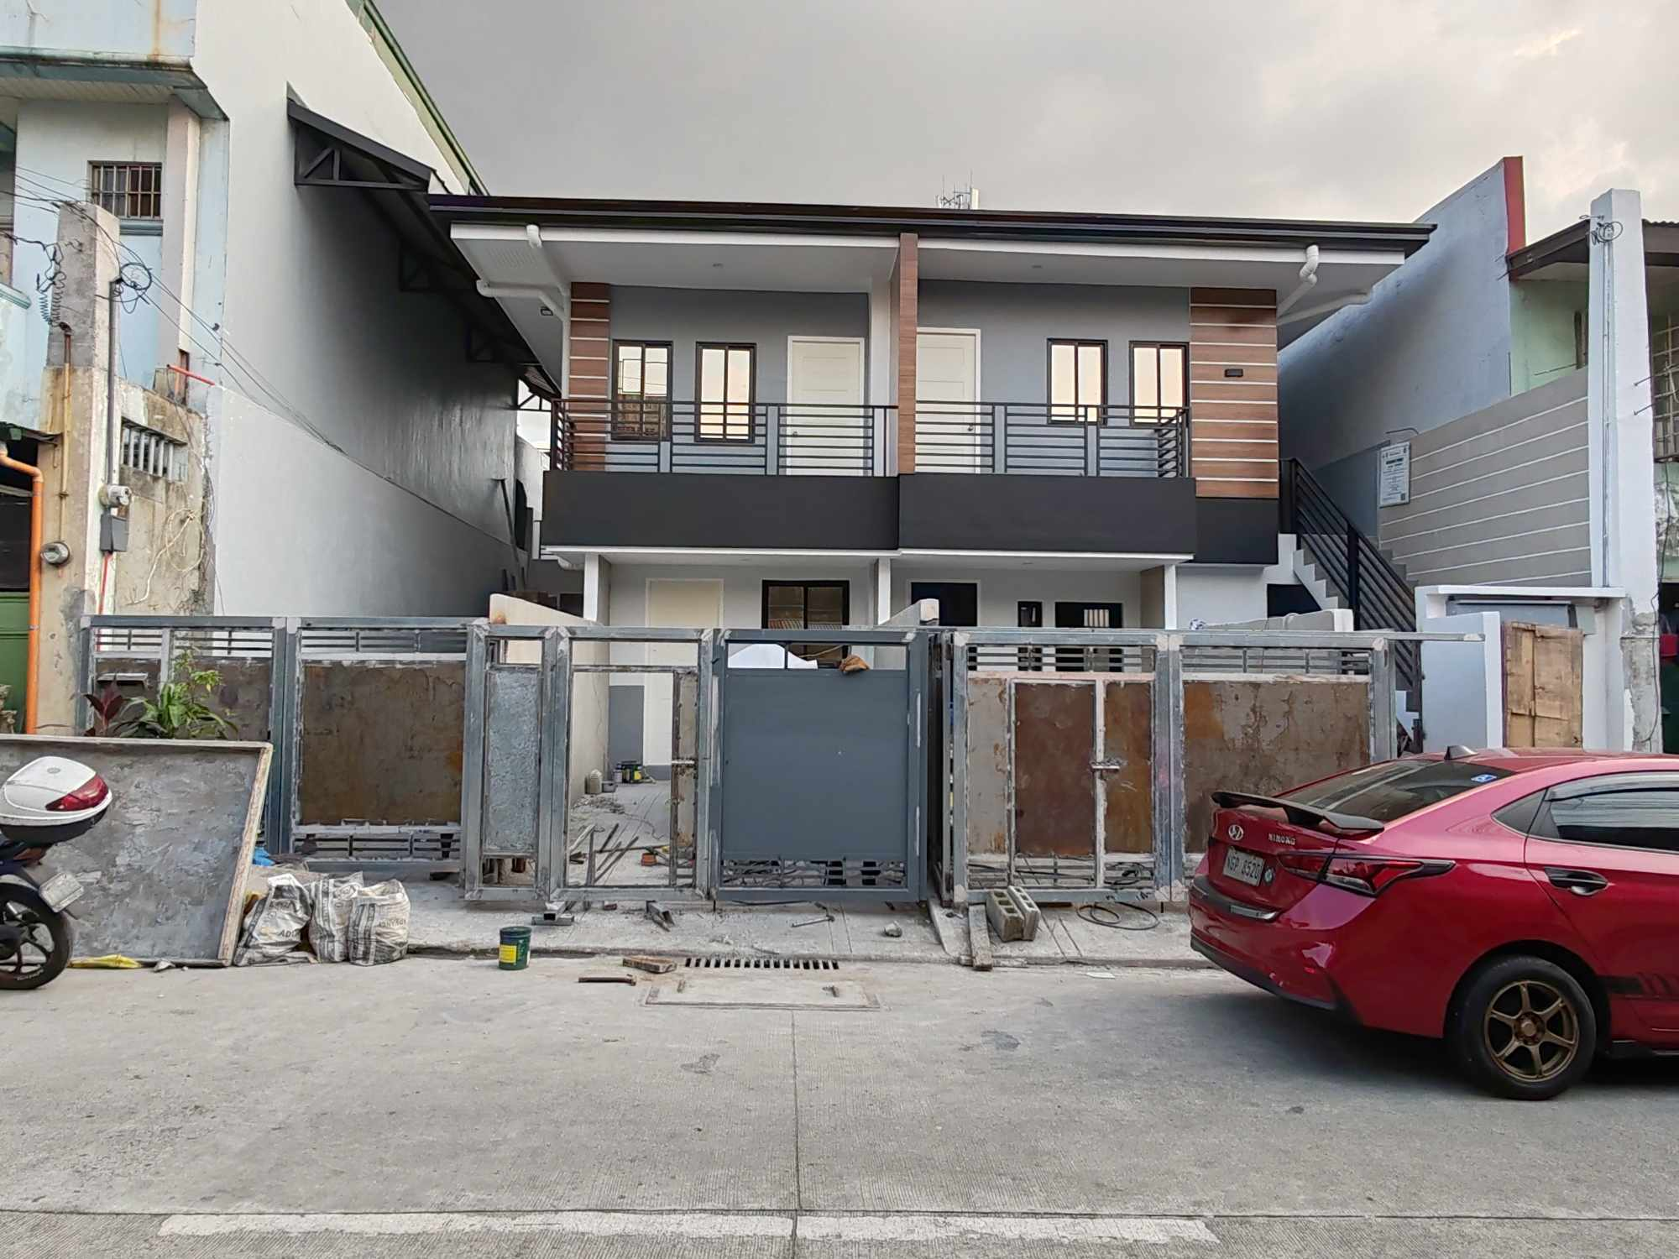

Renovation. Cagna street brgy masambong qc

Yung nav bar palitan po sana para mag mukang parte po siya ng nav bar po iether palitan po yung color po ng mga navbar para po mag same color po sila sir

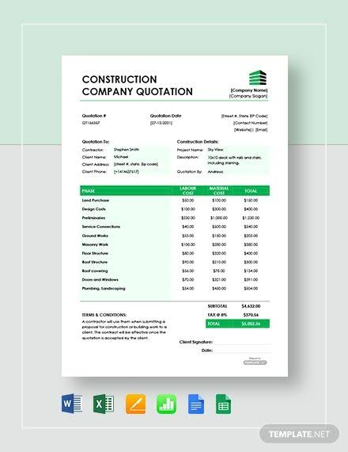

Ganito po sana kung baga sir yung labas ng quotation sir

At kung kaya niyo po malagyan mg connection yung application na layout design maker po for example if 6x6 yung pinapa quotation po na building 6x6 po sana yung size ng building na pwede po gawin sa application po sir

Kung baga may sizes po sana yung sa building layout application po

At paki baba narin po graphics ng 3d modeling sa application para po maiwasan yung lag po sir

Enter

At paki baba narin po graphics ng 3d modeling sa application para po maiwasan yung lag po sir

Enter

Kung pwede rin po sir dagdag niyo po yung downpayment system bago po mag send ng quotatuion sa architect po sir

Enter

Yung fee for downpayment po ay 10% ng total cost ng project While lagyan po din ng conditional kung saan iba po ang lot area which is total size ng location and floor area which is building size po sir Para po ito sa bathroom po para po hindi po lumagpas ang total area yung bathroom Kung baga po 4x4 total lot area,2x2 lot area if may second floor magiging 2x2 and 2x2 siya kung baga po sir

Kung pwede rin po sir dagdag niyo po yung downpayment system bago po mag send ng quotatuion sa architect po sir

Enter

Yung fee for downpayment po ay 10% ng total cost ng project While lagyan po din ng conditional kung saan iba po ang lot area which is total size ng location and floor area which is building size po sir Para po ito sa bathroom po para po hindi po lumagpas ang total area yung bathroom Kung baga po 4x4 total lot area,2x2 lot area if may second floor magiging 2x2 and 2x2 siya kung baga po sir

While yung contact us page tangalin na lang po sir

Flow is

Clients sees website information about company

Client does not need to create account jump straight to quotation

Quotation only requires scope of work ie total floor area, and lot area, and type of housing

Client then prompted to put downpayment to meet architect this is used to filter potential client from actual clients

If client accepts

They are prompted paypal and email and number input to contact client, and ticket number to record to database the meetup and downpayment of client

Email sent to architect prompting to set schedule for meetup with client

After selecting a date email is sent to client to confirm schedule

If schedule accepted the date is set on the google calendar of the architect to remind him of meeting

If the email schedule is rejected schedule mailing of client goes through first in first out system to cycle back setting up schedule date for client

Pero yung materials po sir same po siya pero lalagyan lang ng conditional if bare housing ang pinili po ninyo cemented flooring and painted walls lang etc pwede piliin yung mga mura lang, while yung high end housing ang pinili mga mahal lang pwedeng materials gagamitin

Jordan Silverio

Yung prompts lang na need sa quotation ay

total lot area, total floor area,how many floors,how many bathrooms,how many rooms,

Yun lang po sir at autocomputed sa background napo gamit yung admin website prices ng bawat equipment and materials, labour,po sir

10 % ng total construction cost mapupunta sa architect

5% naman sa hard labour

Electrician ay flat 1,040 pesos

While electrician ay flat 1,746 pesos

While flat 807 for for engener

Add niyo na lang lahat po yan for total cost for labour po sir

Jordan Silverio

Para po sa downpayment may nakita po ako na paypall developers para ma integrate ang paypall sa online billing pero pag may paraan kayo mas maganda or madali po doon paki sabi po sir para sa research ko po