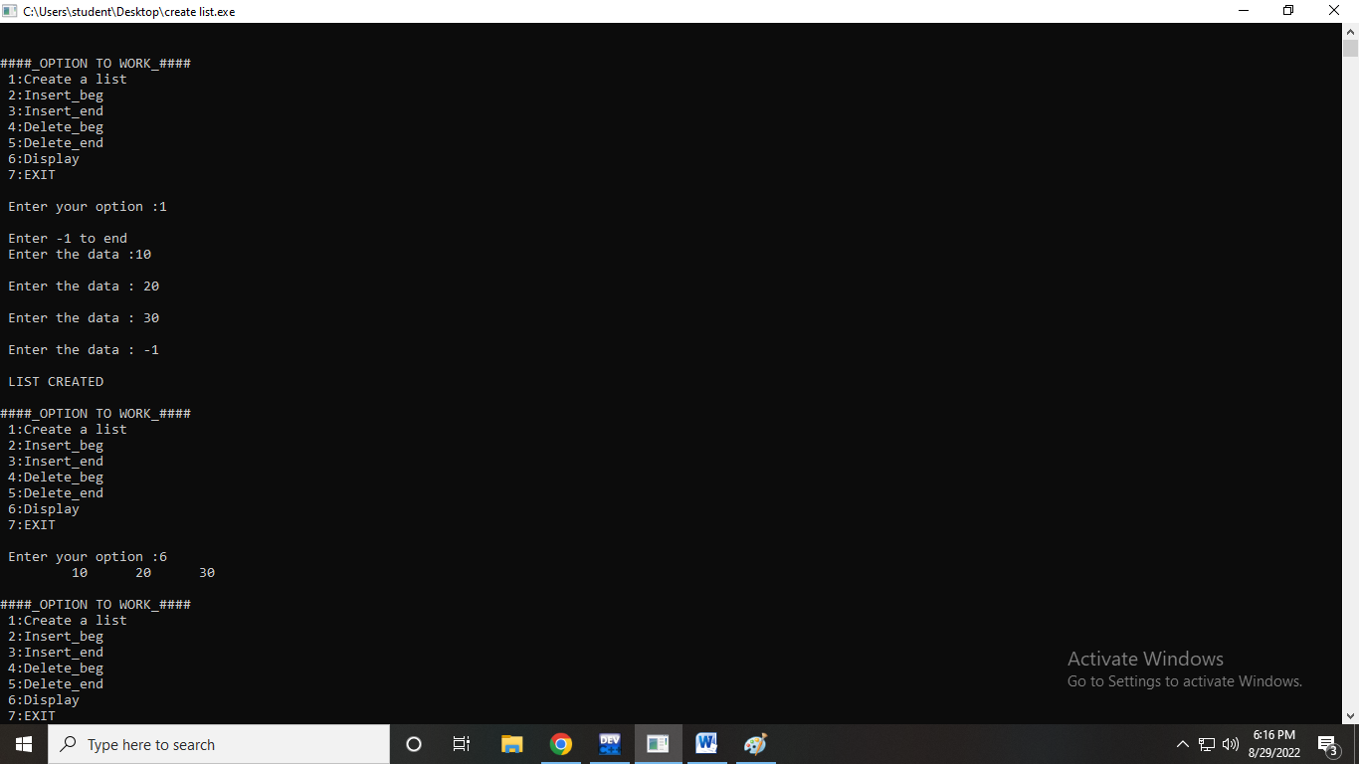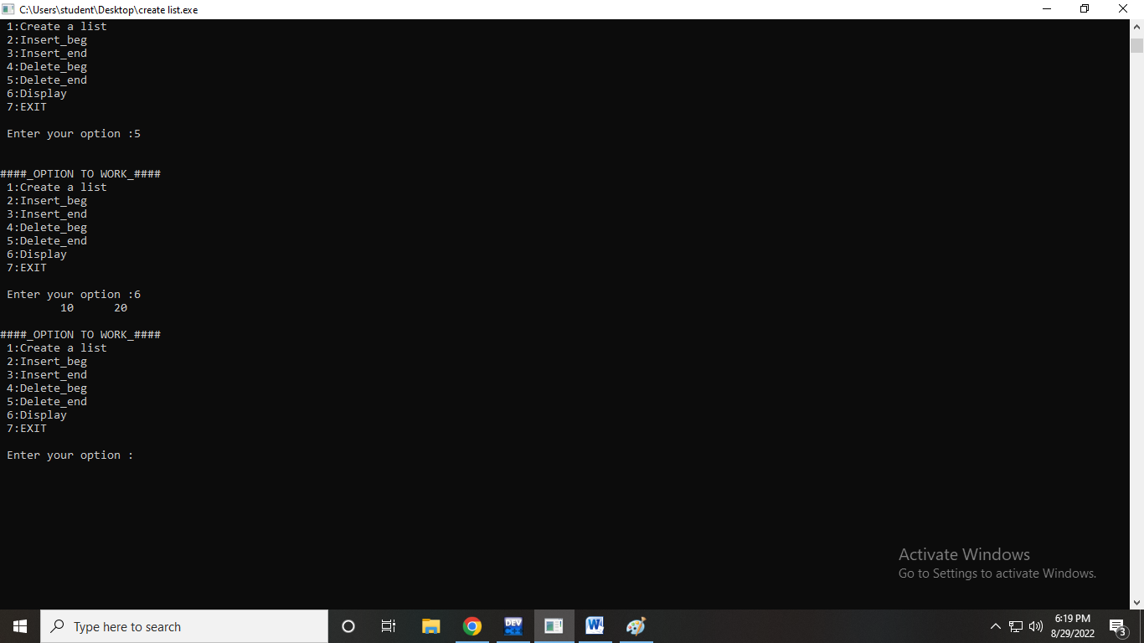

PROGRAM CODE:

#include<stdio.h>

#include<stdlib.h>

#include<conio.h>

#include<malloc.h>

struct node

{

int data;

struct node *next;

};

struct node *start = NULL;

struct node *create(struct node*);

struct node *insert_beg(struct node*);

struct node *insert_end(struct node*);

struct node *delete_beg(struct node*);

struct node *delete_end(struct node*);

struct node *display(struct node*);

int main(int argc,char*argv[]){

int option;

do

{

printf("\n\n####_OPTION TO WORK_####");

printf("\n 1:Create a list");

printf("\n 2:Insert_beg");

printf("\n 3:Insert_end");

printf("\n 4:Delete_beg");

printf("\n 5:Delete_end");

printf("\n 6:Display");

printf("\n 7:EXIT");

printf("\n\n Enter your option :");

scanf("%d",&option);

switch(option)

{

case 1: start = create(start);

printf("\n LIST CREATED");

break;

case 2: start =insert_beg(start);

break;

case 3: start =insert_end(start);

break;

case 4: start =delete_beg(start);

break;

case 5: start =delete_end(start);

break;

case 6: start =display(start);

break;

}

}while(option !=7);

getch();

return 0;

}

struct node*create(struct node*start)

{

struct node *new_node,*ptr;

int num;

printf("\n Enter -1 to end");

printf("\n Enter the data :");

scanf("%d", &num);

while(num!=-1)

{

new_node=(struct node*)malloc(sizeof(struct node));

new_node-> data=num;

if(start==NULL)

{

new_node->next=NULL;

start=new_node;

}

else

{

ptr=start;

while(ptr->next!=NULL)

ptr=ptr->next;

ptr->next=new_node;

new_node->next=NULL;

}

printf("\n Enter the data : ");

scanf("%d", &num);

}

return start;

}

struct node *insert_beg(struct node*start)

{

struct node*new_node;

int num;

printf("\n Enter the data :");

scanf("%d", &num);

new_node =(struct node*)malloc(sizeof(struct node));

new_node-> data =num;

new_node-> next =start;

start = new_node;

return start;

}

struct node *insert_end(struct node*start)

{

struct node*ptr, *new_node;

int num;

printf("\n Enter the data :");

scanf("%d", &num);

new_node =(struct node*)malloc(sizeof(struct node));

new_node-> data =num;

new_node-> next =NULL;

ptr=start;

while(ptr->next!=NULL)

ptr=ptr->next;

ptr->next=new_node;

return start;

}

struct node *delete_beg(struct node*start)

{

struct node*ptr;

ptr=start;

start=start->next;

free(ptr);

return start;

}

struct node*delete_end(struct node*start)

{

struct node*ptr, *preptr;

ptr=start;

while(ptr->next!=NULL)

{

preptr =ptr;

ptr=ptr->next;

}

preptr->next=NULL;

free(ptr);

return start;

}

struct node *display(struct node*start)

{

struct node *ptr;

ptr=start;

while(ptr !=NULL)

{

printf("\t %d",ptr->data );

ptr=ptr->next;

}

return start;

}