**INDIA'S AGRICULTURAL CROP PRODUCTION ANALYSIS**

**(1997-2021)**

**PROJECT WORK SUMMITTED BY**

**NAME:**

**GOPINATH(TEAM LEADER)**

**KARTHICK**

**KESAVAPRASAD**

**MOHAMMEDKAIF**

**UNDER THE GUIDANCE OF**

**DR.J.JOTHIBOSU**

**HEAD OF DEPARTMENT**

**GOVERNMENT ARTS AND SCIENCE COLLEGE FOR MEN**

**KRISHNAGIRI-635001**

(AFFILIATED TO PERIYAR UNIVERSITY)

OCTOBER -2023

DASH BOARD-1

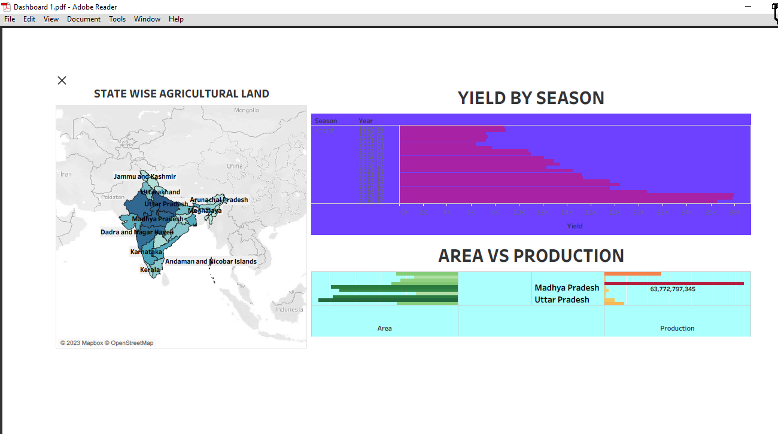

**DASH BOARD-2**

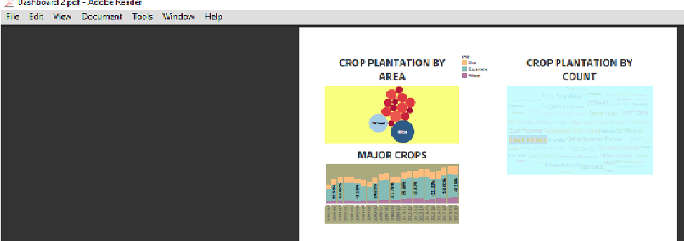

**DASH BOARD-3**

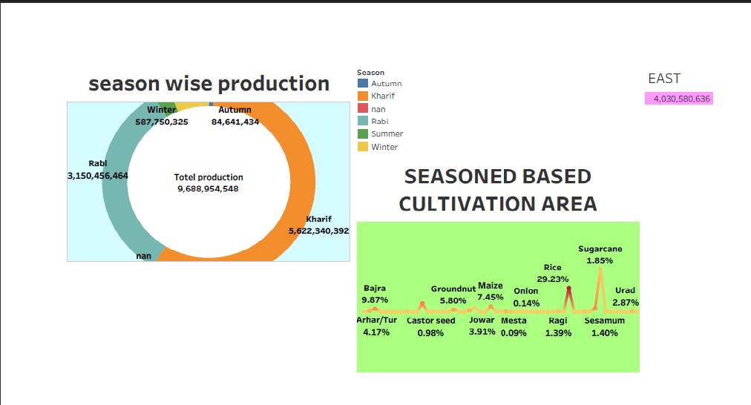

**STORY-1**

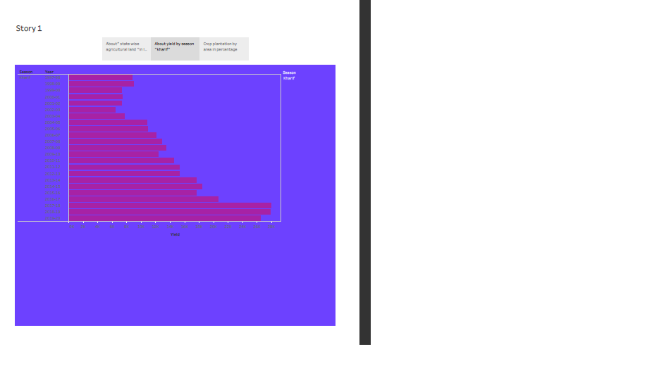

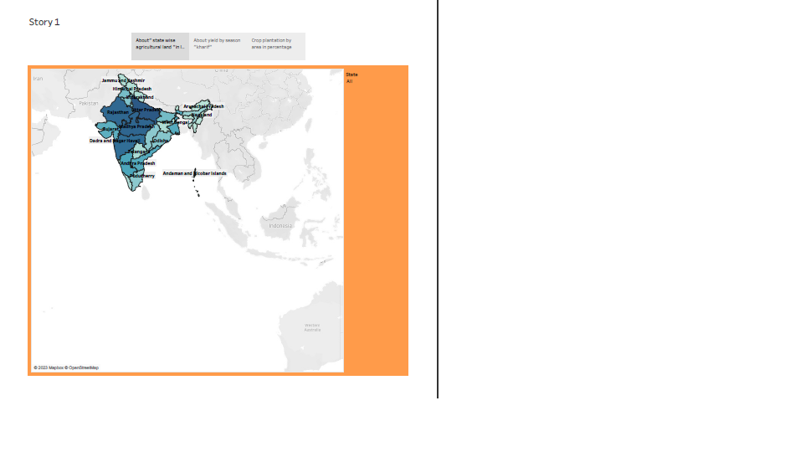

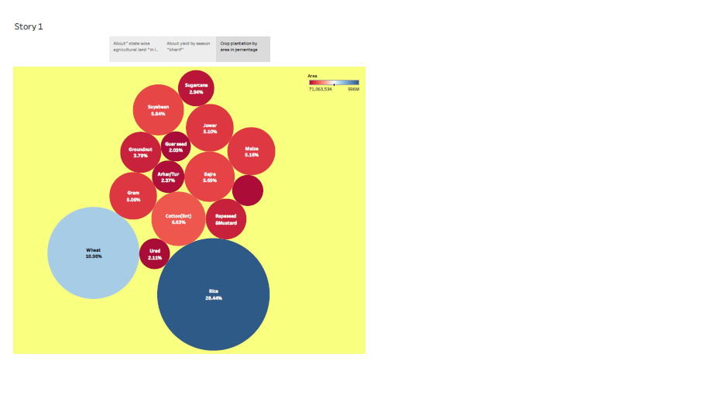**STORY-2**

