Subject Name: **Front-End Engineering**

Subject Code: **CS186**

Cluster: **iGamma**

Department: **DCSE**

Group:**19**



**Submitted By:**

**-Vidhi Thakur**

**-2110992088**

**TIC-TAC-TOE GAME**

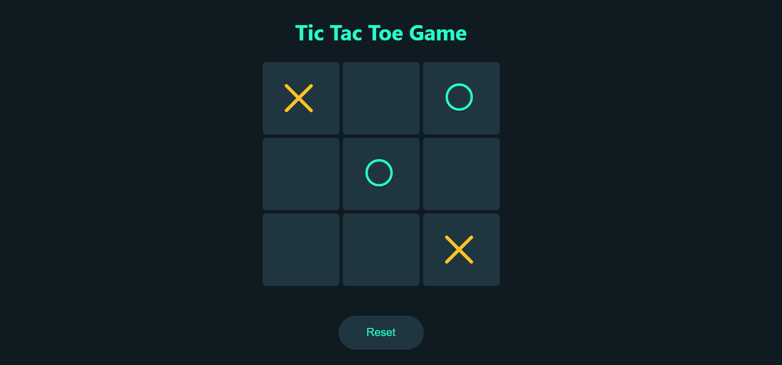

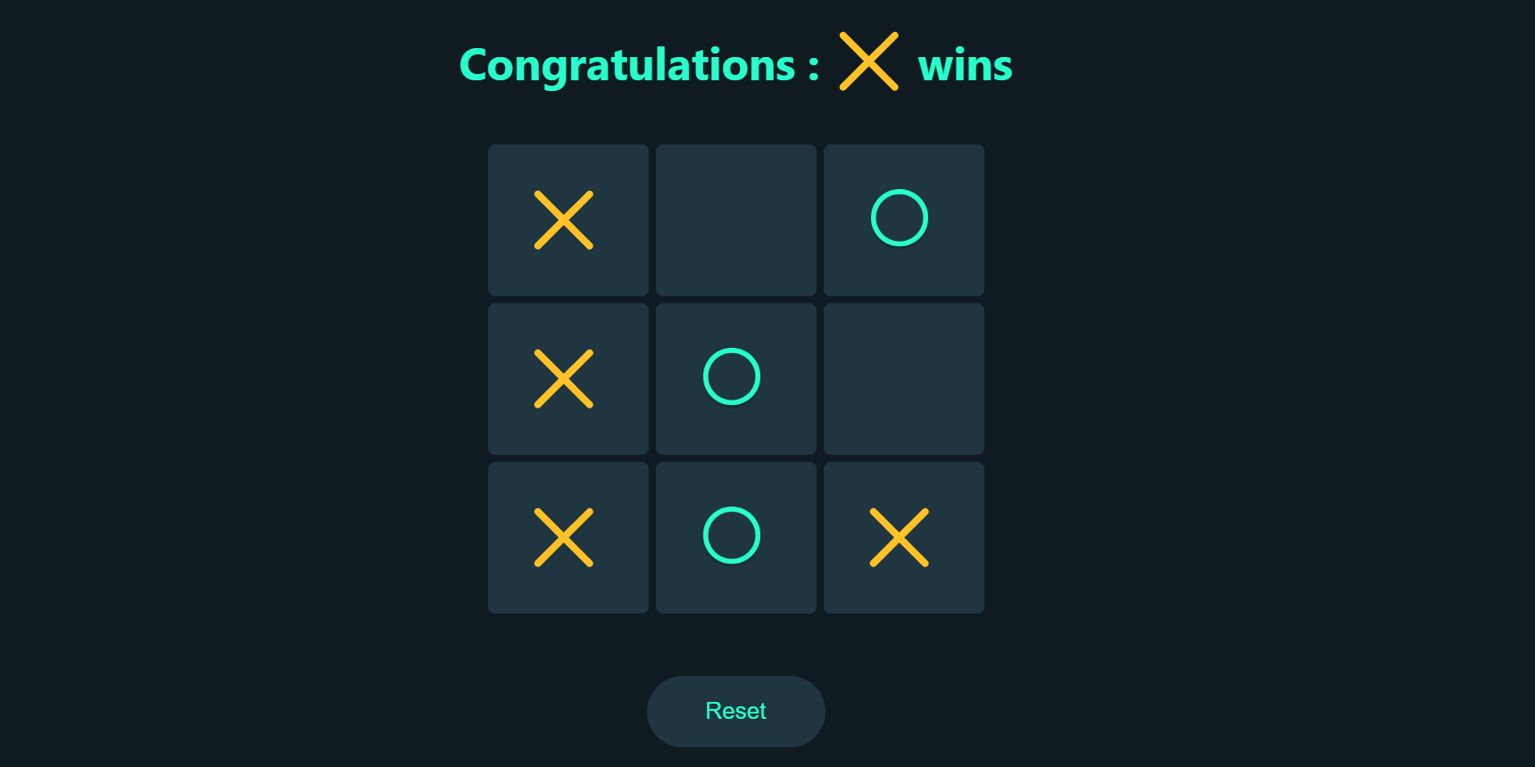

**About The Project**

The "Tic Tac Toe Game using React" is a web-based implementation of the classic Tic Tac Toe game, built using the popular JavaScript library, React. It offers an interactive and enjoyable gaming experience for users of all ages while also serving as a practical exercise in web development, React programming, and front-end design.

1. **Game Logic:** The game logic ensures that it follows the traditional rules of Tic Tac Toe. It correctly detects a win, draw, or ongoing game and displays the outcome to the players.
2. **Turn-Based Play:** Players take turns to make their moves, and the current player's turn is clearly indicated, making the game easy to follow.
3. **Game Reset:** After a game is completed, players have the option to restart the game and play again, ensuring hours of entertainment.

GitHub Link:

<https://github.com/21vidhi/Tic-Tac-Toe-game>

**Tech Stack:**

* React JS
* CSS
* JavaScript
* HTML

# Features:

* Interactive gameplay
* Responsive Design
* User-friendly Interface
* React-powered

**Project Structure:**

The project's structure is organized around React components, which include the game board, individual squares, and the main game component. This structure ensures modularity and maintainability.

**Game Rules:**

The game adheres to the traditional Tic Tac Toe rules:

* Two players take turns marking squares with "X" and "O."
* The game board consists of a 3x3 grid.
* The first player to form a row, column, or diagonal with their symbol wins.
* If no player achieves this, the game ends in a draw.

**Code and Implementation:**

The project's code is structured using React components and follows best practices for component-based development. It utilizes the React state to manage game state, handle user interactions, and update the game board. Code snippets were shared to illustrate key parts of the implementation.

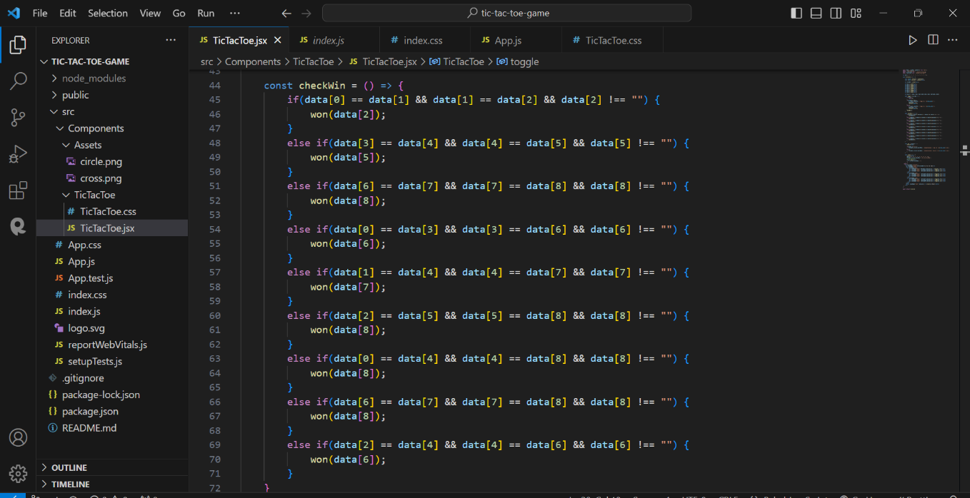

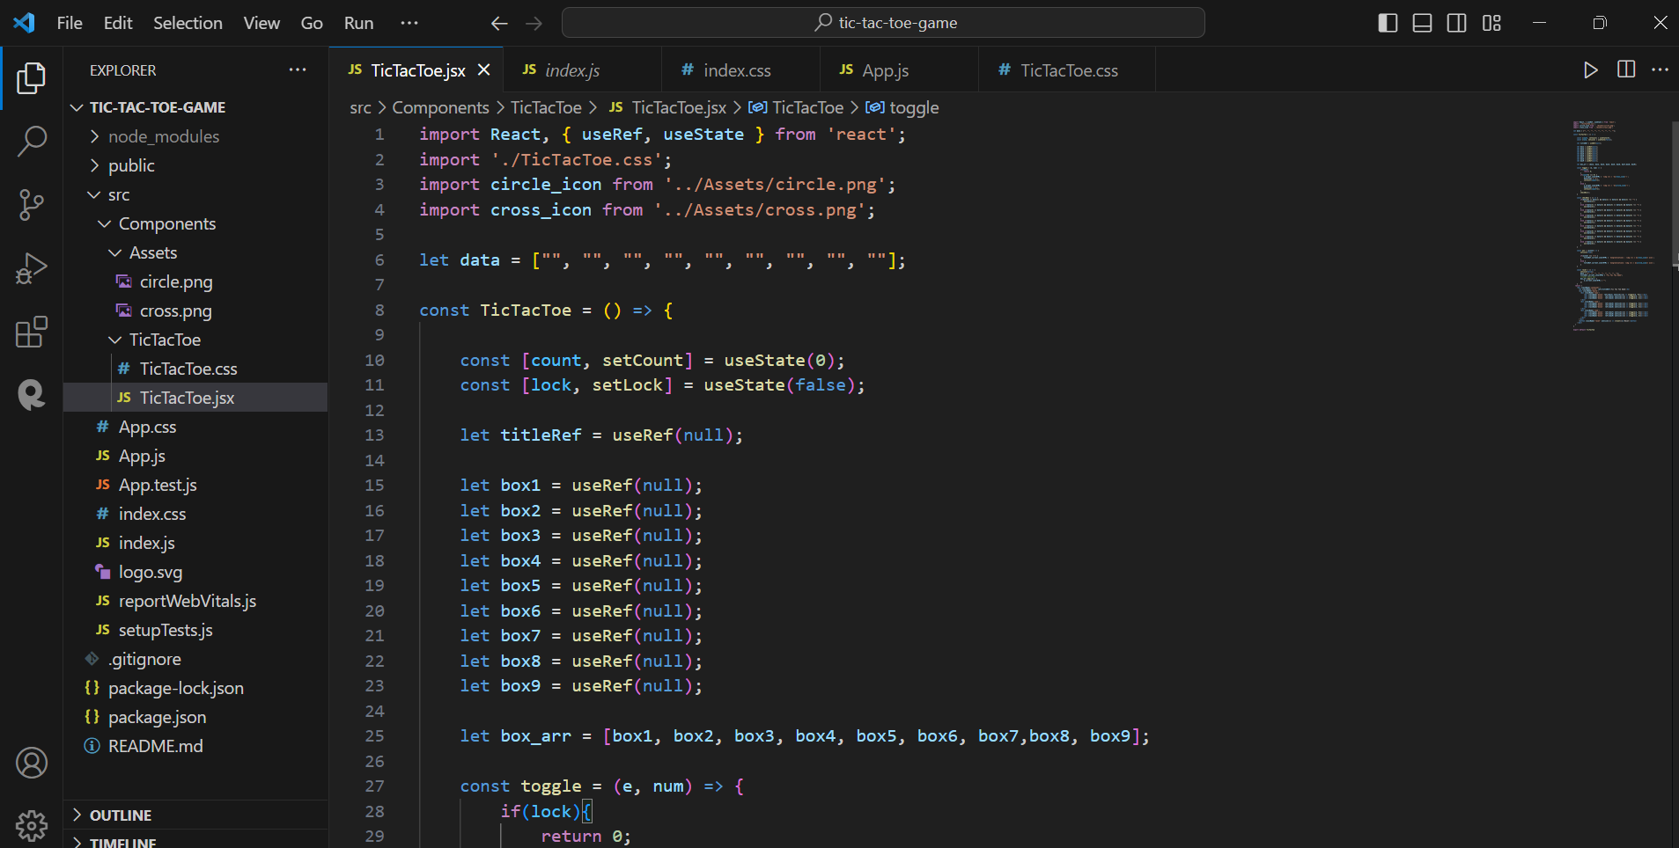

**FLOW CHART:**

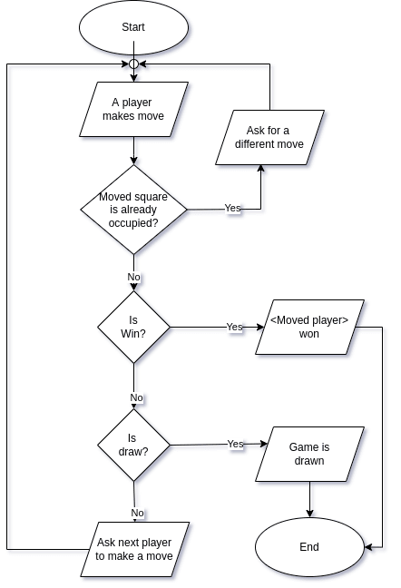

**Folder Structure:**

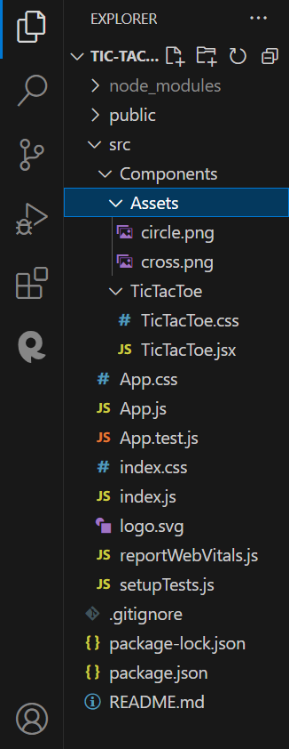

**Conclusion:**

In conclusion, our Tic Tac Toe React project has been a journey of learning, development, and a testament to the endless possibilities that the world of web development offers. We set out to create a classic game in a modern web application framework and achieved our goal, all while gaining valuable insights and experiences along the way. We harnessed the power of React, a leading JavaScript library for building user interfaces, to create a dynamic and interactive gaming experience. The project enabled us to delve into game development, learning the intricate logic required to make Tic Tac Toe function smoothly.