4.3 Procedural Based Simulation
The procedural-based simulation evaluated is a reengineered version of an earlier PC-based VR application. To assess the usability, performance, and instructional effectiveness of the standalone VR upgrade, a heuristic evaluation was conducted involving six domain experts from academic and technical backgrounds.
Heuristic evaluation is a widely recognized usability inspection method that allows researchers and designers to identify interface issues based on established usability principles. Originally proposed by Jakob Nielsen and Rolf Molich [40], the method involves having a small group of evaluators systematically review a system using a set of heuristics such as feedback visibility, user control, error prevention, and consistency. Unlike user testing, which involves empirical observation, heuristic evaluation leverages expert judgment to uncover design flaws early in development.
This evaluation method is particularly useful for identifying usability problems in the early design stages or after major system revisions. It is cost-effective, does not require large-scale participant recruitment, and enables rapid feedback cycles. Each evaluator reviews the system independently and records observed usability issues along with severity ratings, which are later aggregated to form a comprehensive view of the system’s strengths and limitations.
For this study, participants independently interacted with the standalone VR simulation and completed a structured checklist designed in Excel. The checklist included 13 heuristic categories, which were further divided into a total of 28 sub-categories. Each sub-category was rated by all evaluators, allowing for comprehensive coverage of usability concerns across the simulation. In addition to numerical severity ratings, evaluators provided qualitative feedback through open-ended comments. These insights offered contextual details about specific issues, clarified ambiguous scores, and provided targeted recommendations for improvement.
Usability issues were rated using a five-point severity scale:
- 0 – Not a usability problem
- 1 – Cosmetic issue
- 2 – Minor usability problem
- 3 – Major usability problem
- 4 – Usability catastrophe

4.3.1 Participant Demographics
A total of six evaluators participated in the heuristic evaluation, each bringing distinct academic or technical expertise relevant to the VR simulation. The participants were selected to ensure a multidisciplinary perspective, reflecting a range of insights from education, design, and engineering domains.
The group included two doctoral students from the Information Science and Learning Technologies program, offering expertise in instructional design and learning technologies. An assistant professor from the School of Engineering, with a background in virtual reality and game development, contributed a strong focus on system usability and technical fidelity. Two assistant professors from the School of Visual Studies brought perspectives on interface design, visual communication, and user experience. The final participant was a doctoral student in Electrical and Computer Engineering, who regularly works with the real-world laboratory equipment that the simulation is designed to replicate. This participant contributed insights on procedural accuracy and alignment with actual lab practices.
The diverse backgrounds of these participants, including virtual reality, engineering, visual design, and instructional technology, ensured a comprehensive and well-informed evaluation of the simulation from multiple disciplinary viewpoints.

4.3.2 Severity Rating Overview
These evaluators who rated 28 sub-categories distributed across 13 main heuristic categories. This process resulted in a total of 168 severity scores. These ratings were grouped according to their assigned severity level, ranging from 0 to 4, to assess the overall usability performance of the simulation.
Figure 23 presents the proportional distribution of all ratings. A majority, 67.1%, received a severity score of 0, indicating that most components were perceived as free of usability issues. This suggests that the simulation’s core interactions and interface design were generally well received.
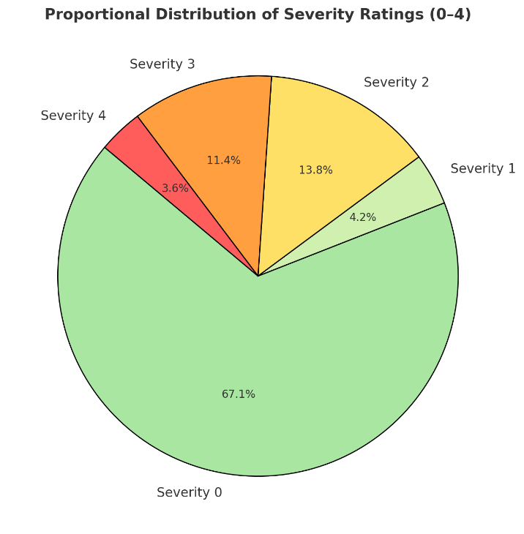
Figure 22: Distribution of severity ratings from heuristic evaluation.

The remaining 32.9% of ratings were distributed across the other severity levels. Severity 2 accounted for 13.8%, reflecting minor usability concerns that may cause some user hesitation but are unlikely to prevent task completion. Severity 3 made up 11.4%, pointing to more substantial issues that could disrupt user performance if not addressed. Severity 4, though less frequent at 3.6%, reflected critical usability problems requiring immediate revision.

4.3.3 Distribution of Severity Ratings Per Heuristic Category
To further assess usability performance across distinct aspects of the simulation, severity ratings were grouped by heuristic evaluation category. This approach helped identify which categories were generally perceived as well-designed and which exhibited recurring usability concerns. Figure 24 displays the distribution of severity levels (0–4) across all 13 heuristic categories. Each bar corresponds to the total number of ratings received per category, with the total based on the number of sub-categories it contains. For example, a category with four sub-categories evaluated by six participants would generate 24 ratings.
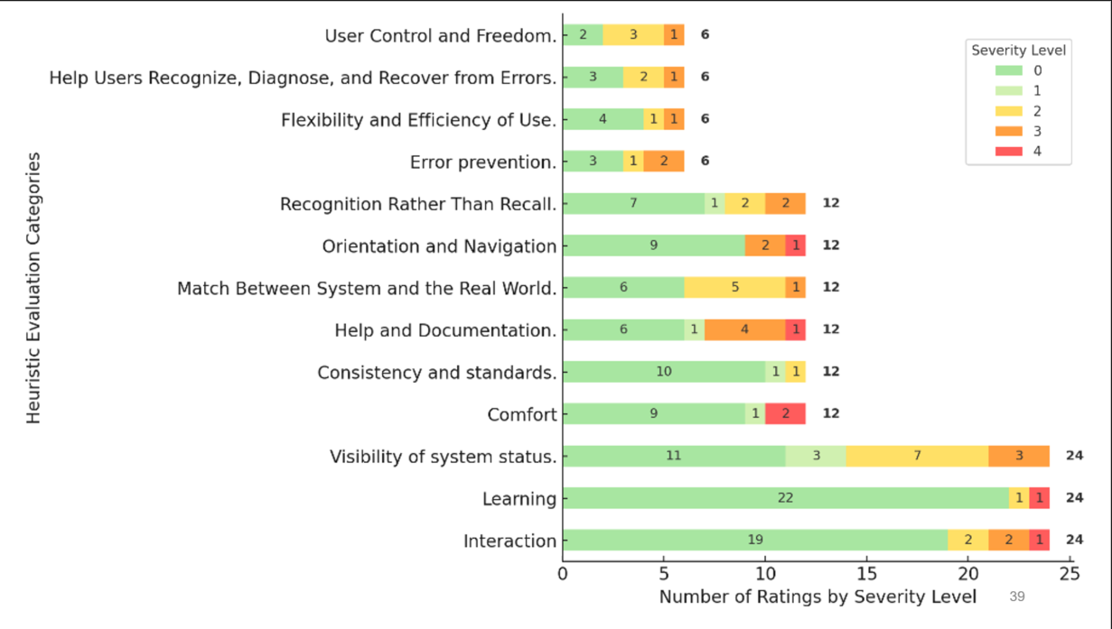
Figure 23: Severity level distribution across 13 heuristic evaluation categories.
Some categories, such as Learning and Consistency and Standards, demonstrated strong performance. Learning received 22 out of 24 ratings at Severity 0, suggesting that the simulation's instructional components were generally clear and well-integrated. Consistency and Standards also performed well, with most of its ratings falling within the Severity 0 to 1 range, indicating that design conventions and interface behavior met user expectations.
In contrast, categories like Visibility of System Status, Help and Documentation, and Comfort revealed more mixed results. Visibility of System Status, for example, showed a wide range of severity levels, including multiple ratings at Severity 2 and 3. Help and Documentation included four Severity 2 ratings and one Severity 4, suggesting gaps in user support or task guidance. Comfort received a combination of Severity 3 and 4 ratings, highlighting potential physical or environmental usability concerns within the VR experience.
These mixed severities across categories help identify not just gaps in system design but also patterns in participant perception. In several cases, even when fewer evaluators rated an issue with high severity, the nature of the concern was shared across individuals. For example, in the Comfort category, two participants assigned a Severity 4 rating and both suggested the addition of alternative locomotion techniques. One evaluator explicitly noted, “Consider including different ways of locomotion into the VR environment.” While only two out of six participants flagged this issue, the agreement in their qualitative feedback and the high severity assigned suggest that it may significantly affect user comfort and navigation. Instances like these highlight the importance of considering both the severity level and the consistency of participant suggestions when prioritizing usability refinements.

4.3.4 Categorizing Heuristic Issues Based on Implementation Status
While the previous analysis focused on the distribution and severity of heuristic issues, it is equally important to consider the development context in which these issues were evaluated. This simulation is a reengineered version of a previously developed system. The current version was focused on delivering a functional end-to-end user experience. Several components, particularly those related to instructional detail, contextual guidance, and system responsiveness, were still under development at the time of evaluation and were not intended to represent finalized designs.
To better understand the significance of the severity ratings, all qualitative and quantitative feedback was reviewed and grouped into seven development-based categories. These categories help distinguish between issues that represent actionable usability concerns and those that are already accounted for in the planned development roadmap. This classification supports clearer prioritization by indicating which issues require immediate attention and which are likely to be resolved through ongoing iteration.
As shown in Figure 25, several high-severity ratings were associated with features that are currently under development. For example, three Severity 4 issues in the Post-Session Feedback and Results and PreLab Guidance categories are expected to be addressed as those components reach final implementation. Likewise, two Severity 4 ratings under Technical Functionality and UI Behavior were related to suggestions for adding additional locomotion techniques. This is an area already under consideration for future updates.
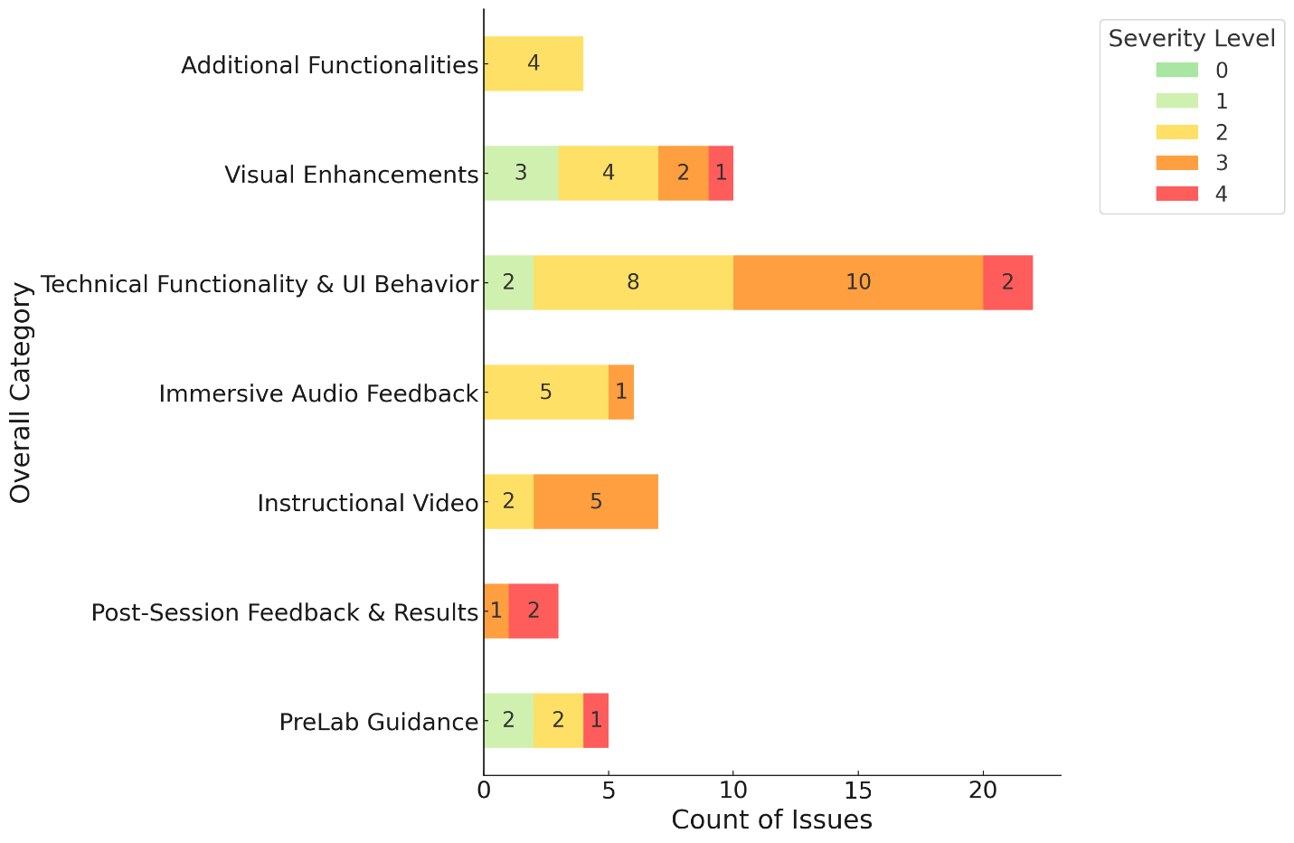
Figure 24: Severity distribution of heuristic issues grouped by development status categories.
Several Severity 3 ratings included requests for more modular control features. One participant suggested, “Consider adding a 'Restart Task' function that allows users to reset the task manually.” While valuable, this type of modularity conflicts with the simulation’s intentionally sequential instructional design, which is intended to guide learners through a fixed learning flow. In contrast, more situational feedback such as “There was no information to tell the learners to close the photoresist bottle lid” offers highly actionable insights for improving immersive detail and instructional cues.
Although some of these concerns are tied to systems still in progress, the overall feedback pointed to strong performance in key areas. Evaluators responded positively to the simulation’s functionality, with no major concerns raised about performance despite the experience running on standalone headsets. The system was tested on both Meta Quest Pro and Quest 2 devices, and participants consistently reported smooth interaction and stable operation.
It is also noteworthy that out of the six Severity 4 ratings identified across all feedback, four were provided by a single evaluator. While this does not diminish the value of those concerns, it suggests that severity perceptions can differ between individuals. However, the repetition of certain suggestions among participants, such as requests for improved locomotion or feedback clarity, reinforces their significance for future refinement.
This additional categorization enabled a more informed assessment of whether certain usability problems require immediate design intervention or are expected to be resolved through the existing development plan. However, the relatively small sample size limits the generalizability of these findings. As such, future evaluations with a broader pool of participants will be essential to validate and extend these early insights. Ultimately, this analysis not only highlights current areas for improvement but also reflects the iterative and evolving nature of the simulation’s design and implementation.

