1. Which product categories contribute 2. What is the monthly sales trend over time? the most to overall sales and profit?

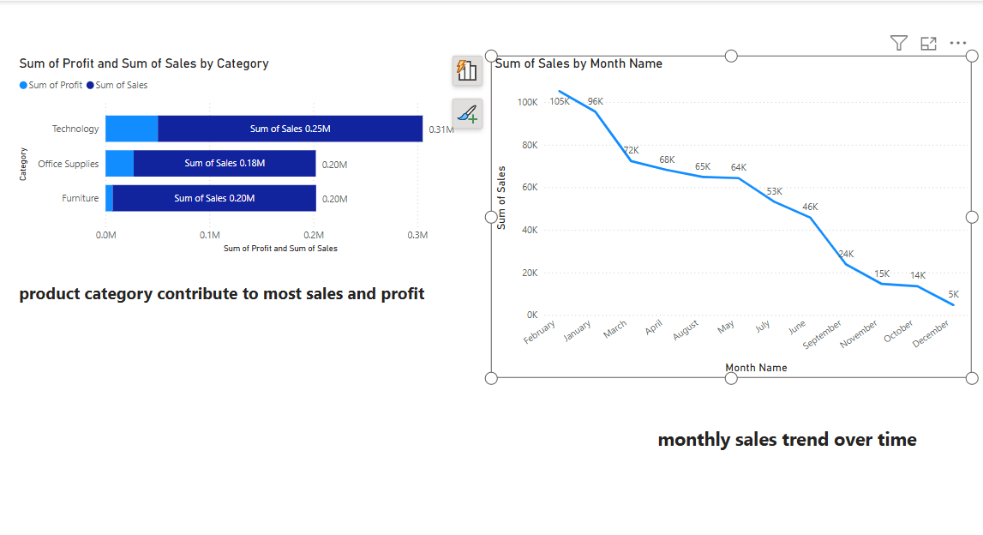

3.Which regions are most profitable and which are running at a loss?

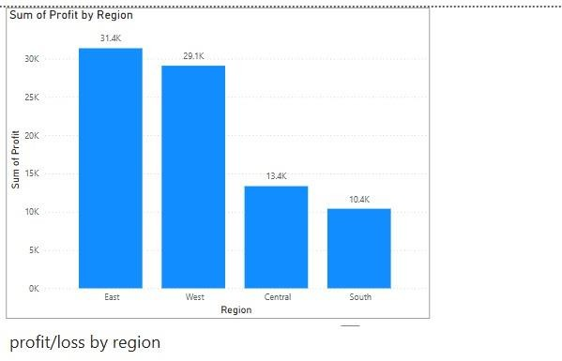

4.How do different customer segments perform in terms of sales and profitability?

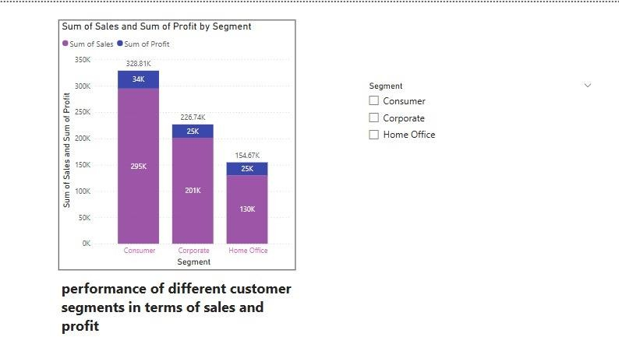

5.Which shipping modes are most used 6. Which cities or states have the highest and how do they impact delivery time and profit? number of orders?

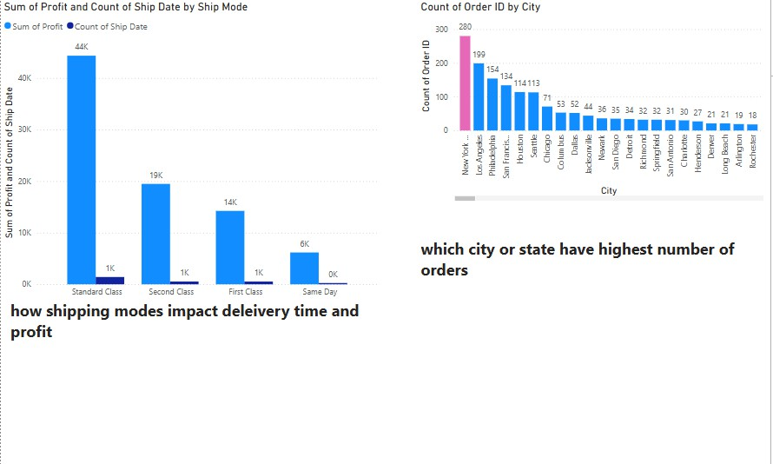

7. What are the top 10 products by sales? 8. How does discounting affect profitability?

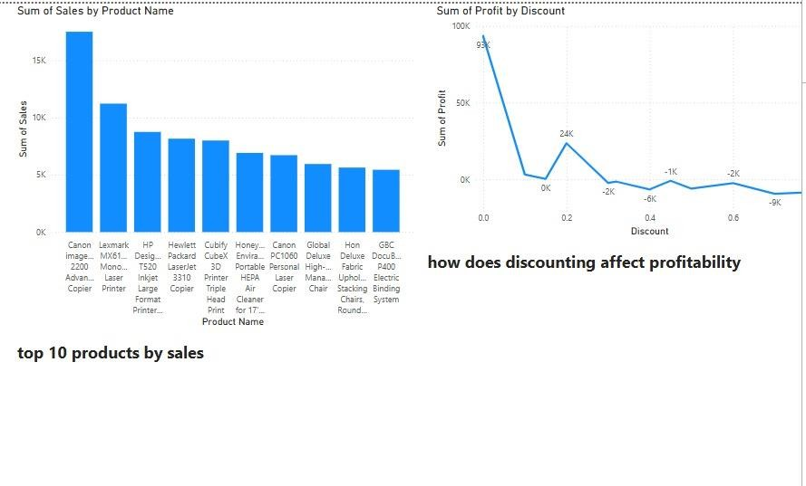

9. What’s the profit margin by sub-category? 10. How do sales vary by segment and region

Combined?

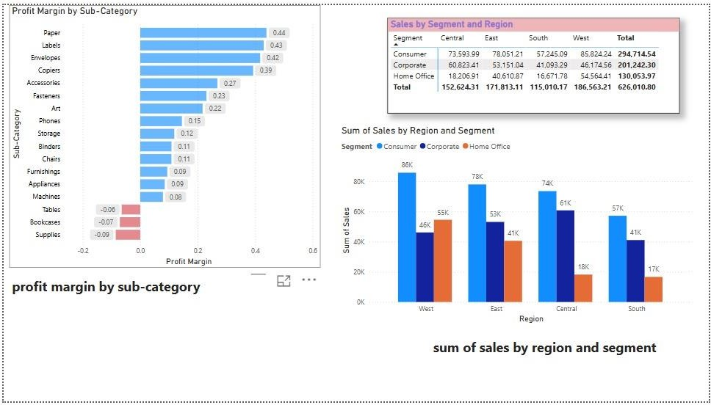

11. How many unique customers do we 12. Which segments respond best to discounts? serve by region or segment?

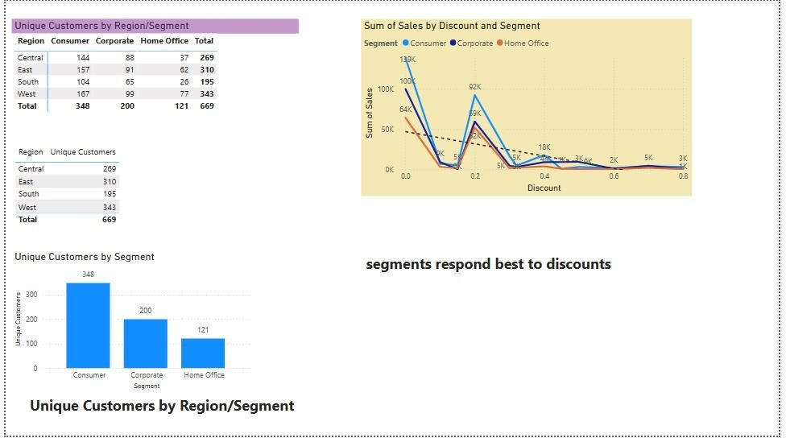

13. What is the current total profit compared to last month?

