TRAVEL

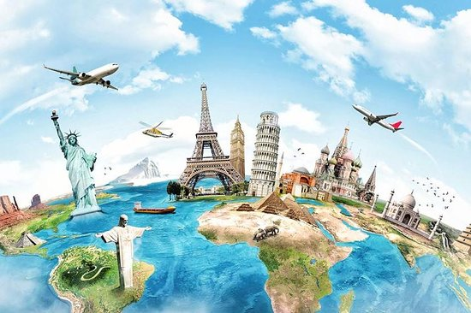

Ever since I was little all I have wanted to do was travel. I love discovering new places and exploring them to the max. All I want to do in the future is to hike and climb and explore new places. I want to travel and explore, if only it was a real job. Most people might say that they were just born that way, and others say they had to find their inner explorer. If I had to choose my favorite vacation it would be hiking through the trees . Or the day trips to the rock climbing gym, are ten times more fun for me than shopping. Sure the beach and relaxing at a beach house is nice but if I had a say we would be ocean kayaking instead. If I am to be honest I'm probably not having the greatest time if there is not any bit of danger involved. There is no way to explain my strong interest in adventure and travel, then that it is just who I am.

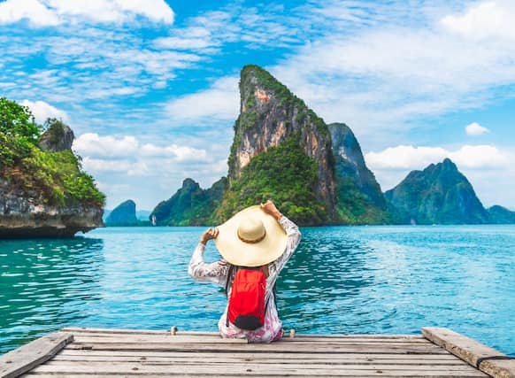

Travelling is an amazing way to learn a lot of things in life. A lot of people around the world travel every year to many places. Moreover, it is important to travel to humans. Some travel to learn more while some travel to take a break from their life. No matter the reason, travelling opens a big door for us to explore the world beyond our imagination and indulge in many things.

Travelling is an incredibly vital part of life. It is the best way to break your monotonous routine and experience life in different ways. Moreover, it is also a good remedy for stress, anxiety and depression.

Traveling is the ultimate education and it never fails as a teacher. It teaches you things no class can about the world and yourself. Seeing a historical spot and being in the environment it is in teaches you what no text book can. Most people hear about what is happening in the world through the bias not understanding media. However, if you are a traveler the real world influences you in a way the media will never be able to. We understand how the world works with its many cultures and lifestyles. Being a part of and experiencing different cultures broadens your views of the world and changing’s what you think of the world. Having expanded knowledge and understanding about culture is not the only thing travelers have. Finding your true self and learning about who you are is the best thing about being a traveler. There is no better way to find yourself because when you travel you open yourself up to millions of opportunities.

All in all, it is no less than a blessing to be able to travel. Many people are not privileged enough to do that. Those who do get the chance, it brings excitement in their lives and teaches them new things. No matter how a travelling experience may go, whether good or bad, it will definitely help you learn.