**Program:**

**Index.html:**

<!DOCTYPE html>

<html>

<head>

<meta charset="utf-8">

<meta http-equiv="Content-Security-Policy" content="default-src 'self' data: https://ssl.gstatic.com 'unsafe-eval'; style-src 'self' 'unsafe-inline'; media-src *; img-src 'self' data: content:;">

<meta name="format-detection" content="telephone=no">

<meta name="msapplication-tap-highlight" content="no">

<meta name="viewport" content="initial-scale=1, width=device-width, viewport-fit=cover">

<meta name="color-scheme" content="light dark">

<link rel="stylesheet" href="css/index.css">

<title>User Login</title>

</head>

<body>

<div class="header">

<img src="img/logo.png" alt="Header Image">

<h1>Login</h1>

</div>

<div class="container">

<label for="username">Username:</label>

<input type="text" id="username" placeholder="Enter your username">

<label for="password">Password:</label>

<input type="password" id="password" placeholder="Enter your password">

<button id="resetButton">Reset</button>

<button id="submitButton">Submit</button>

</div>

<script src="cordova.js"></script>

<script src="js/index.js"></script>

</body>

</html>

**Index.js:**

document.addEventListener("deviceready", onDeviceReady, false);

function onDeviceReady() {

document.getElementById("resetButton").addEventListener("click", resetForm);

document.getElementById("submitButton").addEventListener("click", submitForm);

}

function resetForm() {

document.getElementById("username").value = "";

document.getElementById("password").value = "";

}

function submitForm() {

var username = document.getElementById("username").value;

var password = document.getElementById("password").value;

if (username === "example" && password === "password") {

alert("Login successful!");

} else {

alert("Login failed. Please check your credentials.");

}

}

**Index.css:**

.header {

text-align: center;

}

.header img {

width: 100%;

max-width: 300px;

display: block;

margin: 0 auto;

}

.container {

text-align: center;

margin: 20px;

display: flex;

flex-direction: column;

align-items: center;

justify-content: center;

}

input {

width: 40%;

padding: 10px;

margin: 5px 5px;

}

button {

background-color: #007bff;

color: white;

padding: 10px 20px;

border: none;

cursor: pointer;

margin-top: 10px;

margin-bottom: 10px;

}

button:hover {

background-color: #0056b3;

}

**OUTPUT:**

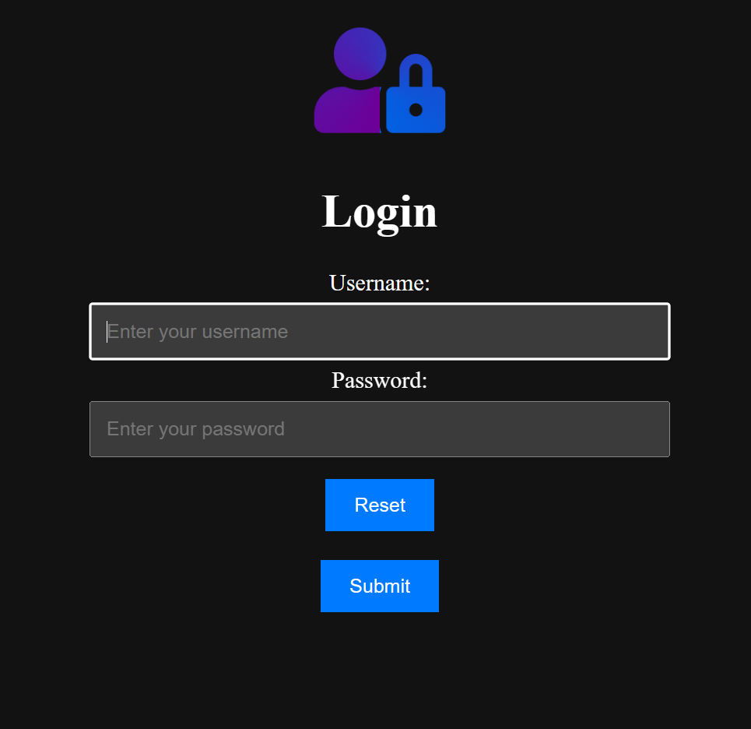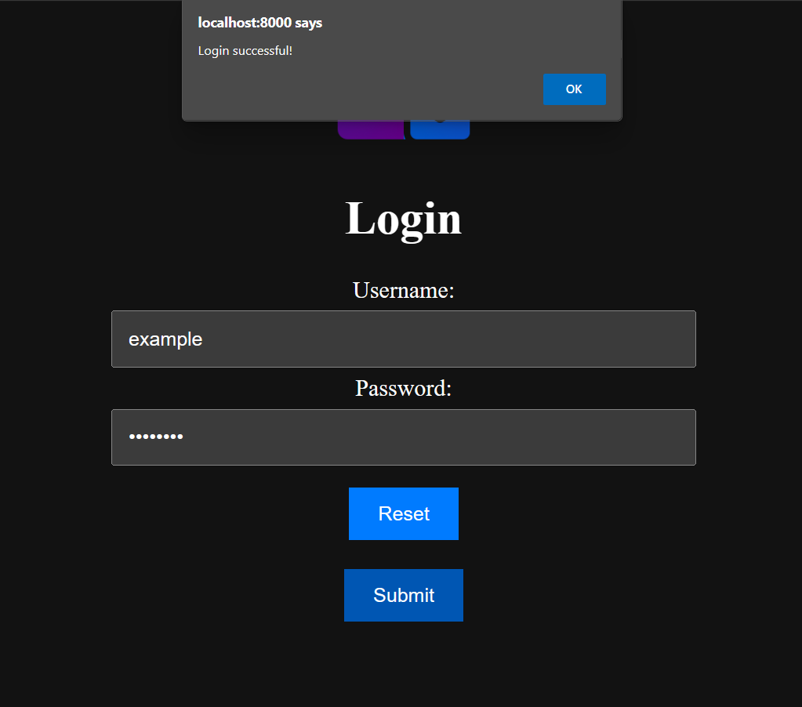

**PROGRAM:**

**Index.html**

<!DOCTYPE html>

<html>

<head>

<meta charset="utf-8">

<meta http-equiv="Content-Security-Policy" content="default-src 'self' data: https://ssl.gstatic.com 'unsafe-eval'; style-src 'self' 'unsafe-inline'; media-src *; img-src 'self' data: content:;">

<meta name="format-detection" content="telephone=no">

<meta name="msapplication-tap-highlight" content="no">

<meta name="viewport" content="initial-scale=1, width=device-width, viewport-fit=cover">

<meta name="color-scheme" content="light dark">

<link rel="stylesheet" href="css/index.css">

<title>Current Location</title>

</head>

<body>

<h1>Current Location</h1>

<div id="location"></div>

<script type="text/javascript" src="js/map.js"></script>

<script src="cordova.js"></script>

<script src="js/index.js"></script>

</body>

</html>

**Index.js**

index.js

document.addEventListener("deviceready", onDeviceReady, false);

function onDeviceReady() {

navigator.geolocation.getCurrentPosition(onSuccess, onError);

}

function onSuccess(position) {

var latitude = position.coords.latitude;

var longitude = position.coords.longitude;

var locationElement = document.getElementById("location");

locationElement.innerHTML = "Latitude: " + latitude + "<br>Longitude: " + longitude;

}

function onError(error) {

alert("Error getting location: " + error.message);

}

**OUTPUT:**

