2.  
The sun is made up of four layers. The main layer is the innermost called the core. Just above the core is the photosphere, above that the chromosphere, and above that the corona; the outer most layer of the sun's atmosphere. The temperature of the corona is the second highest of all the other layers of the sun topped only by the temperature of the core.

In doing the research I noted that the temperature of the corona was mostly recorded in a range such as 1,000,000 to 2,000,000 K, whereas the temperatures of the other layers were more exact numbers. This is because the temperature drops slowly as you move from the corona into space. The variance in temperature is also due to the fact that the sun's corona has no defined boundary. So where one person measured can be further out than another leading to that person determining a lower temperature. Though the corona's temperature is high it's molecules are so far apart that the gases release little heat. If a person were to stand on the sun's corona they wouldn't burn, they would freeze in the near vacuum of the corona.

3.

|  |  |
| --- | --- |
| DIAMETER OF THE SUN | 1,392,000 km |
| THE TEEMPERATURE OF THE SUN | 5505 °C |
| THE TEMPERATURE OF THE PHOTOSPHERE | 5 780 kelvin |
| THE TEMPERATURE OF THE EARTH WITHOUT SUNSHINE | 4500 °C |

4.

The name of the sun’s cooler is known as SUNSPOT.

Sunspots are cooler regions of the photosphere that appear dark because of the lower temperature of 3.800 kelvin versus 5.700 degrees kelvin. Sunspots can vary in size up to 50.000 in diameter

5.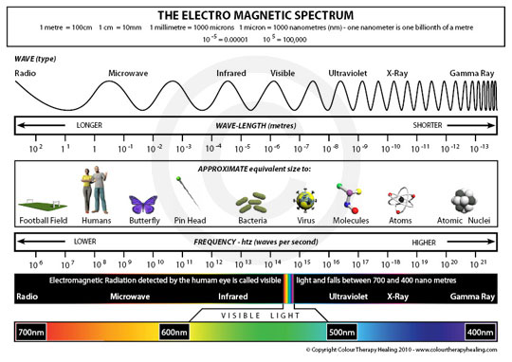

6.

Definition:

EMISSIVITY: the ability of a surface to emit radiation, measured as the ratio of the energy radiated by a surface to that radiated by a blackbody at the same temperature. Symbol ε

ALBEDO: Albedo or reflection coefficient is the diffuse reflectivity or reflecting power of a surface. It is defined as the ratio of reflected radiation from the surface to incident radiation upon it. Being a dimensionless fraction, it may also be expressed as a percentage, and is measured on a scale from zero for no reflecting power of a perfectly black surface, to 1 for perfect reflection of a white surface.

7.

Description:

The easly hunters gatheres:

Hunters were usually men. Hunters were always on the move following herds until they discovered that they could make the herds go where they want them. Hunters used the tools and weapons that they made themselves to hunt. They learned to organize their own hunts. They used a trap called a pitfall that was basically a big whole covered in grass, twigs, etc. Hunting was done both individually and in groups. Even after the development of agriculture, some hunters continued to hunt because it was their way of life and they liked it the way it was. They didn't see the point in changing the way that they lived.

Although they didn't want to change the way that they lived, some people were forced to, because the people that grew crops moved into their hunting space and drove the animals away. The farmers didn't mean to do this but it made the hunters have to change the way that they lived extremely.

People who gathered fruit, berries, roots, nuts etc. were usually women.

They were usually on the move following plants. Agriculture moved in and changed the lives of many gatherers, but some stayed the way they were, because they liked it and it was the way they lived their life. Population was increased and there were not enough plants for all of the people to pick, so this changed the way many people lived. If the environment didn't have enough food to supply, the women couldn't gather the food it had left, because it was so hard to get to the berries, veggies, fruits, etc.

The advanced huntergatheres

Is the society in one in which most or all food is obtained from wild plants and animals, in contrast to agricultural societies which rely mainly on domesticated species. Hunting and gathering was the ancestral subsistence mode of Homo, and all modern humans were hunter-gatherers until around 10,000 years ago. Following the invention of agriculture hunter-gatherers have been displaced by farming or pastoralist groups in most parts of the world. Only a few contemporary societies are classified as hunter-gatherers, and many supplement, sometimes extensively, their foraging activity with farming and/or keeping animals.

Microsoft® Encarta® 2009. © 1993-2008 Microsoft Corporation. All rights reserved.

Google

<http://en.wikipedia.org/wiki/Hunter-gatherer>

http://www.google.com.gh/#q=advanced+hunter+gatherer&hl=en&prmd=imvns&ei=IF-XTv2vMMnd0QGtrrm_BA&start=30&sa=N&bav=cf.osb&fp=38afa6598b4df57b&biw=1366&bih=559