**Exercise 1: Setting Up JUnit**

**Scenario:**

You need to set up JUnit in your Java project to start writing unit tests.

Steps:

1. Create a new Java project in your IDE (e.g., IntelliJ IDEA, Eclipse).

2. Add JUnit dependency to your project. If you are using Maven, add the following to your

pom.xml:

<dependency>

<groupId>junit</groupId>

<artifactId>junit</artifactId>

<version>4.13.2</version>

<scope>test</scope>

</dependency>

3. Create a new test class in your project.

<?xml version="1.0" encoding="UTF-8"?>

<project xmlns="http://maven.apache.org/POM/4.0.0"

xmlns:xsi="http://www.w3.org/2001/XMLSchema-instance"

xsi:schemaLocation="http://maven.apache.org/POM/4.0.0

http://maven.apache.org/xsd/maven-4.0.0.xsd">

<modelVersion>4.0.0</modelVersion>

<groupId>com.example</groupId>

<artifactId>JUnitSetupProject</artifactId>

<version>1.0-SNAPSHOT</version>

<properties>

<maven.compiler.source>22</maven.compiler.source>

<maven.compiler.target>22</maven.compiler.target>

<project.build.sourceEncoding>UTF-8</project.build.sourceEncoding>

</properties>

<dependencies>

<dependency>

<groupId>junit</groupId>

<artifactId>junit</artifactId>

<version>4.13.2</version>

<scope>test</scope>

</dependency>

</dependencies>

<build>

<plugins>

<plugin>

<groupId>org.apache.maven.plugins</groupId>

<artifactId>maven-surefire-plugin</artifactId>

<version>2.22.2</version>

<configuration>

<includes>

<include>**/*Test.java</include>

</includes>

</configuration>

</plugin>

</plugins>

</build>

</project>

**Calculator.java:**

package com.example;

public class Calculator {

public int add(int a, int b) {

return a + b;

}

public int subtract(int a, int b) {

return a - b;

}

public int multiply(int a, int b) {

return a * b;

}

public int divide(int a, int b) {

if (b == 0) {

throw new ArithmeticException("Cannot divide by zero");

}

return a / b;

}

}

**CalculatorTest.java:**

package com.example;  
import org.junit.Test;  
import static org.junit.Assert.*;  
public class CalculatorTest {  
 @Test  
 public void testAdd() {  
 Calculator calc = new Calculator();  
 *assertEquals*(10, calc.add(6, 4));  
 }  
 @Test  
 public void testSubtract() {  
 Calculator calc = new Calculator();  
 *assertEquals*(2, calc.subtract(6, 4));  
 }  
 @Test  
 public void testMultiply() {  
 Calculator calc = new Calculator();  
 *assertEquals*(24, calc.multiply(6, 4));  
 }  
 @Test  
 public void testDivide() {  
 Calculator calc = new Calculator();  
 *assertEquals*(2, calc.divide(8, 4));  
 }  
 @Test(expected = ArithmeticException.class)  
 public void testDivideByZero() {  
 Calculator calc = new Calculator();  
 calc.divide(5, 0);  
 }  
}

**Output:**

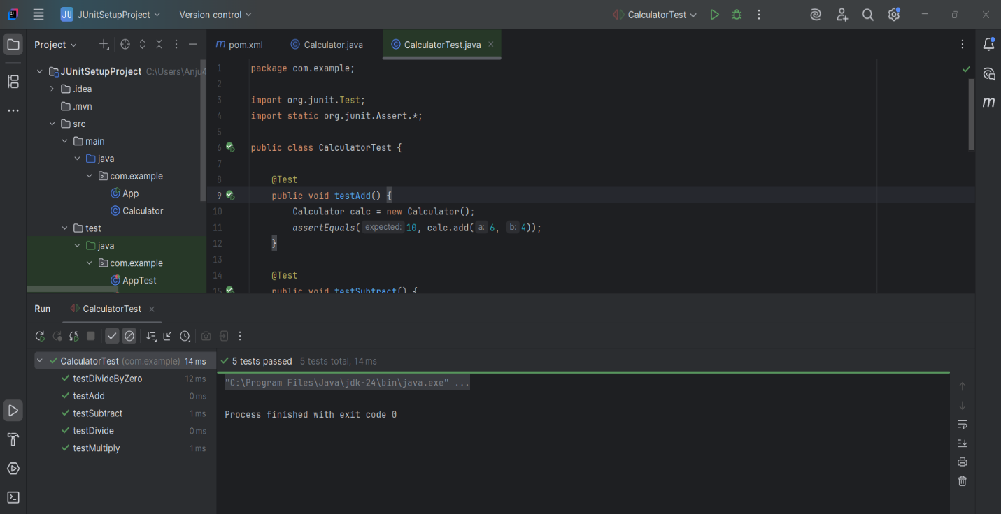

**Exercise 3: Assertions in JUnit**

**Scenario:**

You need to use different assertions in JUnit to validate your test results.

Steps:

1. Write tests using various JUnit assertions.

Solution Code:

public class AssertionsTest {

@Test

public void testAssertions() {

// Assert equals

assertEquals(5, 2 + 3);

// Assert true

assertTrue(5 > 3);

// Assert false

assertFalse(5 < 3);

// Assert null

assertNull(null);

// Assert not null

assertNotNull(new Object());

}

}

**Assertions.java**

package com.example;  
  
import org.junit.Test;  
import static org.junit.Assert.*;  
  
public class AssertionsTest {  
  
 @Test  
 public void testAssertions() {  
 // Assert equals  
 *assertEquals*(5, 2 + 3);  
  
 // Assert true  
 *assertTrue*(5 > 3);  
  
 // Assert false  
 *assertFalse*(5 < 3);  
  
 // Assert null  
 *assertNull*(null);  
  
 // Assert not null  
 *assertNotNull*(new Object());  
 }  
}

**Output:**

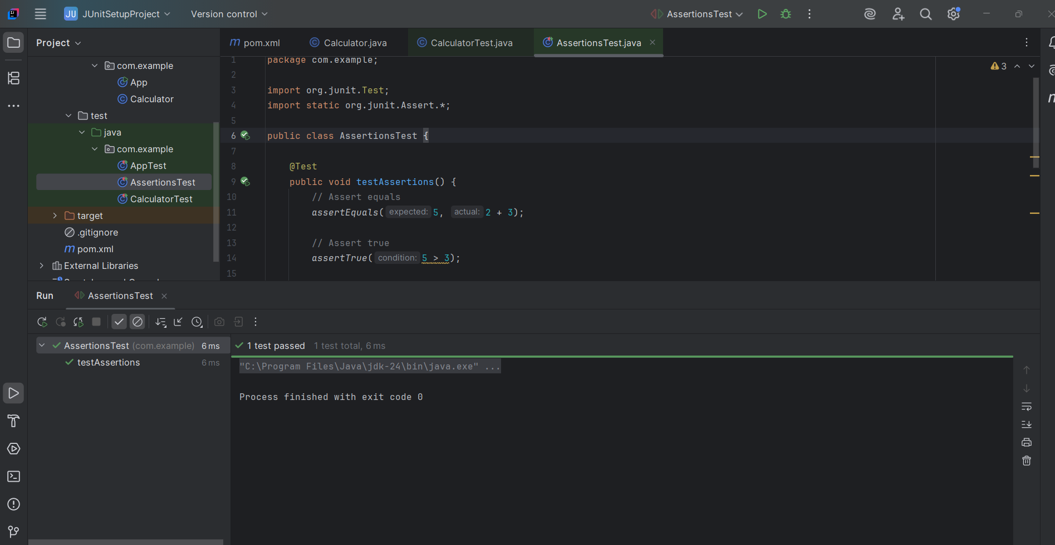

**Exercise 4: Arrange-Act-Assert (AAA) Pattern, Test Fixtures, Setup and**

**Teardown Methods in JUnit**

**Scenario:**

You need to organize your tests using the Arrange-Act-Assert (AAA) pattern and use setup

and teardown methods.

Steps:

1. Write tests using the AAA pattern.

2. Use @Before and @After annotations for setup and teardown methods.

<dependencies>

<dependency>

<groupId>junit</groupId>

<artifactId>junit</artifactId>

<version>4.13.2</version>

<scope>test</scope>

</dependency>

</dependencies>

**Calculator.java:**

package com.example;

public class Calculator {

public int add(int a, int b) { return a + b; }

public int multiply(int a, int b) { return a * b; }

}

**CalculatorLifecycleTest.java:**

package com.example;

import org.junit.After;

import org.junit.Before;

import org.junit.Test;

import static org.junit.Assert.*;

public class CalculatorLifecycleTest {

private Calculator calculator;

@Before

public void setUp() {

calculator = new Calculator();

System.out.println("setUp() called");

}

@After

public void tearDown() {

System.out.println("tearDown() called");

}

@Test

public void testAdd() {

int result = calculator.add(5, 3);

assertEquals(8, result);

}

@Test

public void testMultiply() {

int result = calculator.multiply(4, 2);

assertEquals(8, result);

}

}

**Output:**

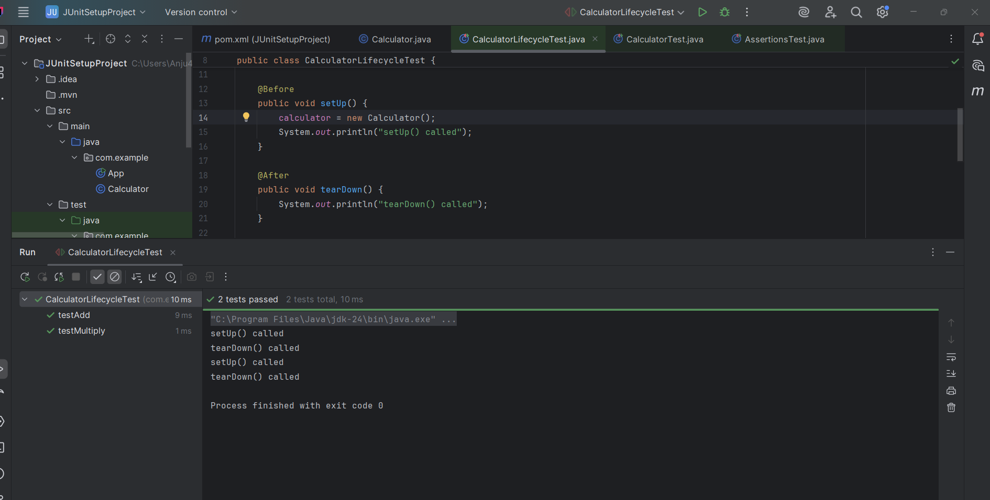

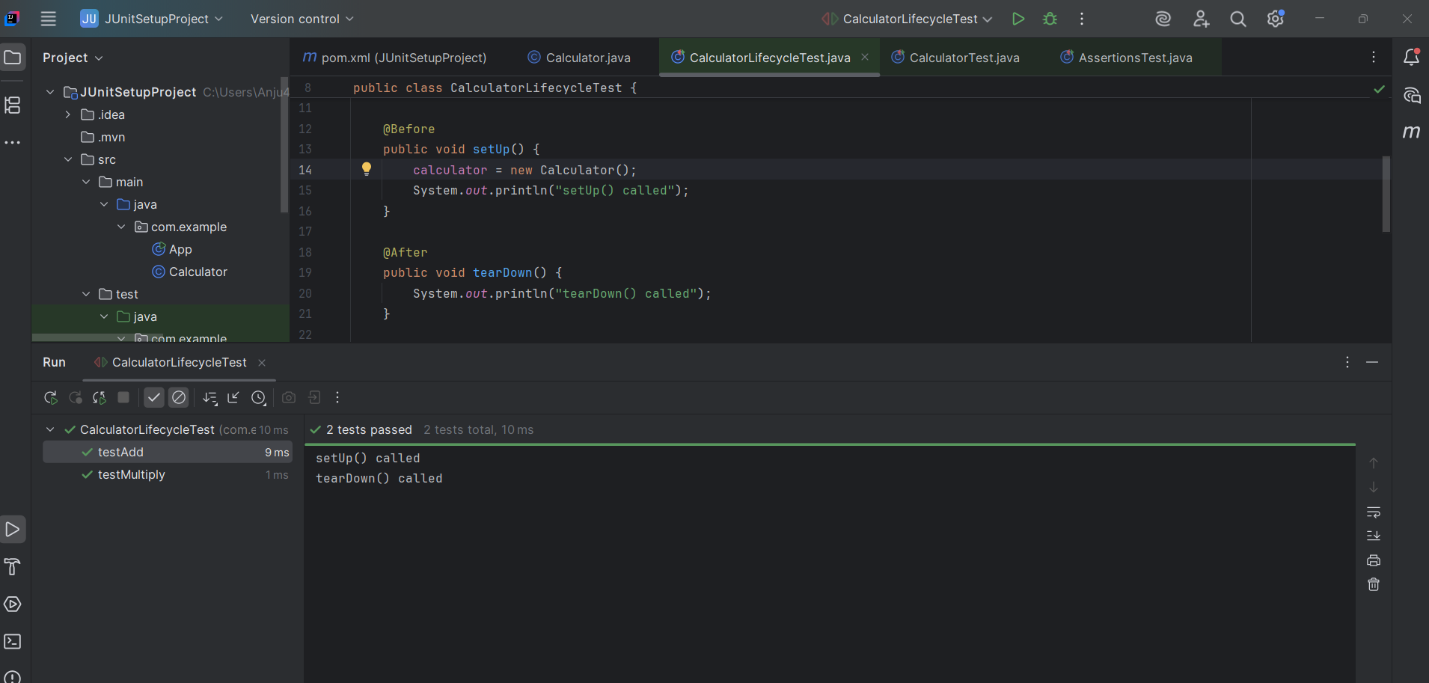

**Mockito Hands-On Exercises**

**Exercise 1: Mocking and Stubbing**

**Scenario:**

You need to test a service that depends on an external API. Use Mockito to mock the

external API and stub its methods.

Steps:

1. Create a mock object for the external API.

2. Stub the methods to return predefined values.

3. Write a test case that uses the mock object.

Solution Code:

import static org.mockito.Mockito.*;

import org.junit.jupiter.api.Test;

import org.mockito.Mockito;

public class MyServiceTest {

@Test

public void testExternalApi() {

ExternalApi mockApi = Mockito.mock(ExternalApi.class);

when(mockApi.getData()).thenReturn("Mock Data");

MyService service = new MyService(mockApi);

String result = service.fetchData();

assertEquals("Mock Data", result);

}

**Pom.xml:**

<project xmlns="http://maven.apache.org/POM/4.0.0"

xmlns:xsi="http://www.w3.org/2001/XMLSchema-instance"

xsi:schemaLocation="http://maven.apache.org/POM/4.0.0

http://maven.apache.org/xsd/maven-4.0.0.xsd">

<modelVersion>4.0.0</modelVersion>

<groupId>com.example</groupId>

<artifactId>MockitoDemoProject</artifactId>

<version>1.0-SNAPSHOT</version>

<properties>

<maven.compiler.source>17</maven.compiler.source>

<maven.compiler.target>17</maven.compiler.target>

<project.build.sourceEncoding>UTF-8</project.build.sourceEncoding>

</properties>

<dependencies>

<dependency>

<groupId>org.junit.jupiter</groupId>

<artifactId>junit-jupiter-api</artifactId>

<version>5.9.3</version>

<scope>test</scope>

</dependency>

<dependency>

<groupId>org.junit.jupiter</groupId>

<artifactId>junit-jupiter-engine</artifactId>

<version>5.9.3</version>

<scope>test</scope>

</dependency>

<dependency>

<groupId>org.mockito</groupId>

<artifactId>mockito-core</artifactId>

<version>5.7.0</version>

<scope>test</scope>

</dependency>

</dependencies>

<build>

<plugins>

<plugin>

<groupId>org.apache.maven.plugins</groupId>

<artifactId>maven-surefire-plugin</artifactId>

<version>3.0.0-M8</version>

</plugin>

</plugins>

</build>

</project>

**ExternalApi.java:**

package com.example;

public interface ExternalApi {

String getData();

}

**MyService.java:**

package com.example;

public class MyService {

private ExternalApi api;

public MyService(ExternalApi api) {

this.api = api;

}

public String fetchData() {

return api.getData();

}

}

**MyServiceTest.java:**

package com.example;

import org.junit.jupiter.api.Test;

import static org.junit.jupiter.api.Assertions.*;

import static org.mockito.Mockito.*;

public class MyServiceTest {

@Test

public void testExternalApi() {

ExternalApi mockApi = mock(ExternalApi.class);

when(mockApi.getData()).thenReturn("Mock Data");

MyService service = new MyService(mockApi);

String result = service.fetchData();

assertEquals("Mock Data", result);

System.out.println("Test Output: " + result);

}

}

**Output:**

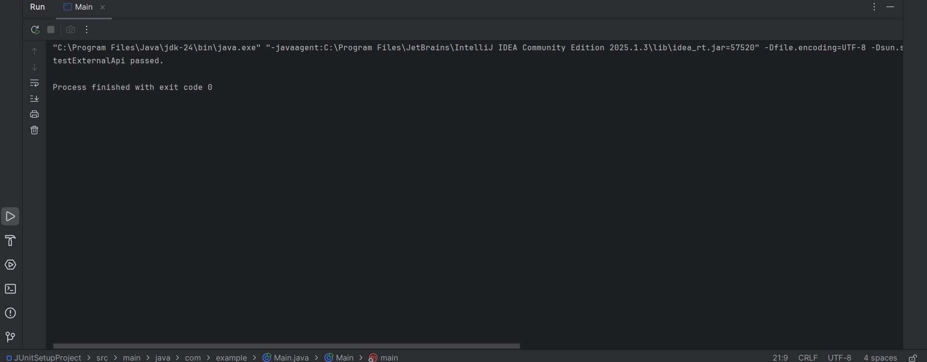

**Exercise 2: Verifying Interactions**

**Scenario:**

You need to ensure that a method is called with specific arguments.

Steps:

1. Create a mock object.

2. Call the method with specific arguments.

3. Verify the interaction.

Solution Code:

import static org.mockito.Mockito.*;

import org.junit.jupiter.api.Test;

import org.mockito.Mockito;

public class MyServiceTest {

@Test

public void testVerifyInteraction() {

ExternalApi mockApi = Mockito.mock(ExternalApi.class);

MyService service = new MyService(mockApi);

service.fetchData();

verify(mockApi).getData();

}

}

**Pom.xml:**

<project xmlns="http://maven.apache.org/POM/4.0.0"

xmlns:xsi="http://www.w3.org/2001/XMLSchema-instance"

xsi:schemaLocation="http://maven.apache.org/POM/4.0.0 https://maven.apache.org/xsd/maven-4.0.0.xsd">

<modelVersion>4.0.0</modelVersion>

<groupId>com.example</groupId>

<artifactId>MockitoVerifyDemo</artifactId>

<version>1.0-SNAPSHOT</version>

<properties>

<maven.compiler.source>17</maven.compiler.source>

<maven.compiler.target>17</maven.compiler.target>

</properties>

<dependencies>

<!-- JUnit 5 -->

<dependency>

<groupId>org.junit.jupiter</groupId>

<artifactId>junit-jupiter-api</artifactId>

<version>5.9.3</version>

<scope>test</scope>

</dependency>

<dependency>

<groupId>org.junit.jupiter</groupId>

<artifactId>junit-jupiter-engine</artifactId>

<version>5.9.3</version>

<scope>test</scope>

</dependency>

<dependency>

<groupId>org.mockito</groupId>

<artifactId>mockito-core</artifactId>

<version>5.7.0</version>

<scope>test</scope>

</dependency>

</dependencies>

<build>

<plugins>

<plugin>

<groupId>org.apache.maven.plugins</groupId>

<artifactId>maven-surefire-plugin</artifactId>

<version>2.22.2</version>

</plugin>

</plugins>

</build>

</project>

**ExternalApi.java:**

package com.example;

public interface ExternalApi {

String getData();

}

**MyService.java:**

package com.example;

public class MyService {

private ExternalApi api;

public MyService(ExternalApi api) {

this.api = api;

}

public String fetchData() {

return api.getData();

}

}

**MyServiceTest.java:**

package com.example;

import org.junit.jupiter.api.Test;

import static org.mockito.Mockito.*;

public class MyServiceTest {

@Test

public void testVerifyInteraction() {

ExternalApi mockApi = mock(ExternalApi.class);

MyService service = new MyService(mockApi);

service.fetchData();

verify(mockApi).getData();

}

}

**Output:**

