**1.SingletonPatternExample**

**Logger.java**

**package** singletonPattern;

**public** **class** Logger {

**private** **static** Logger *singleInstance*;

**private** Logger() {

System.***out***.println("Logger instance created.");

}

**public** **static** Logger getInstance() {

**if** (*singleInstance* == **null**) {

*singleInstance* = **new** Logger();

}

**return** *singleInstance*;

}

**public** **void** log(String message) {

System.***out***.println("[LOG]: " + message);

}

}

**LoggerTest.java**

package singletonPattern;

public class Loggertest {

public class Main {

public static void main(String[] args) {

Logger logger1 = Logger.*getInstance*();

logger1.log("This is the first log message.");

Logger logger2 = Logger.*getInstance*();

logger2.log("This is the second log message.");

if (logger1 == logger2) {

System.*out*.println("Both logger instances are the same (Singleton verified).");

} else {

System.*out*.println("Different instances exist (Singleton failed).");

}

}

}

}

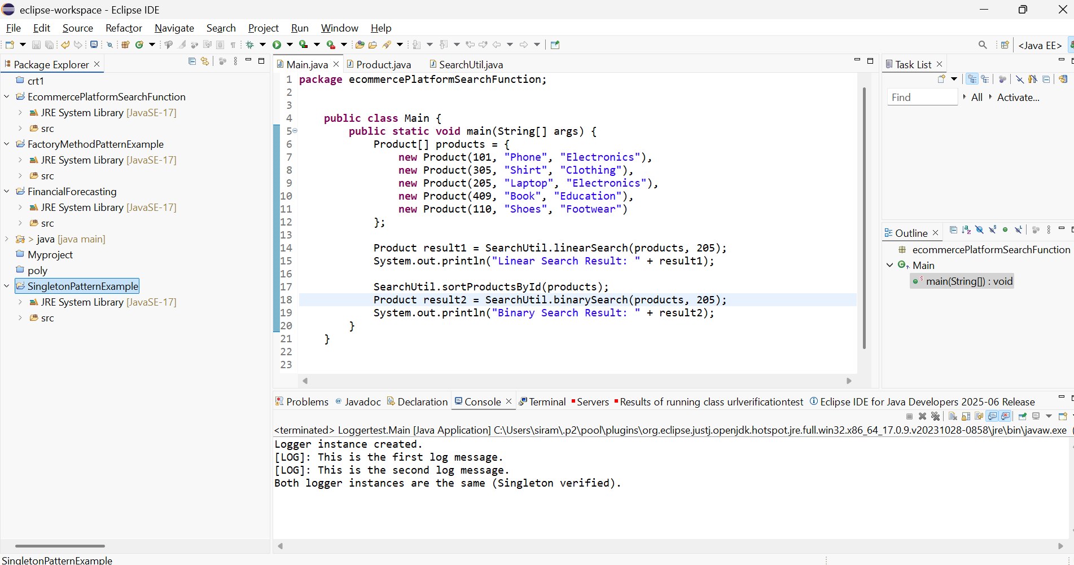

**2.FactoryMethodPatternExample**

**Document.java**

package factoryMethodPatternExample;

public interface Document {

void open();

}

**DocumentFactory.java**

package factoryMethodPatternExample;

public abstract class DocumentFactory {

public abstract Document createDocument();

}

**ExcelDocument.java**

package factoryMethodPatternExample;

public class ExcelDocument implements Document {

public void open() {

System.*out*.println("Opening Excel document.");

}

}

**ExcelDocumentFactory.java**

package factoryMethodPatternExample;

public class ExcelDocumentFactory extends DocumentFactory {

public Document createDocument() {

return new ExcelDocument();

}

}

**Main.java**

package factoryMethodPatternExample;

public class Main {

public static void main(String[] args) {

DocumentFactory wordFactory = new WordDocumentFactory();

Document wordDoc = wordFactory.createDocument();

wordDoc.open();

DocumentFactory pdfFactory = new PdfDocumentFactory();

Document pdfDoc = pdfFactory.createDocument();

pdfDoc.open();

DocumentFactory excelFactory = new ExcelDocumentFactory();

Document excelDoc = excelFactory.createDocument();

excelDoc.open();

}

}

**PdfDocument.java**

package factoryMethodPatternExample;

public class PdfDocument implements Document {

public void open() {

System.*out*.println("Opening PDF document.");

}

}

**PdfDocumentFactory.java**

package factoryMethodPatternExample;

public class PdfDocumentFactory extends DocumentFactory {

public Document createDocument() {

return new PdfDocument();

}

}

**WordDocument.java**

package factoryMethodPatternExample;

public class WordDocument implements Document {

public void open() {

System.*out*.println("Opening Word document.");

}

}

**WordDocumentFactory.java**

package factoryMethodPatternExample;

public class WordDocumentFactory extends DocumentFactory {

public Document createDocument() {

return new WordDocument();

}

}

